**Security Audit and Certification**

**Coursework**

**PART 2**

**Apoorva Ramaiah**

**230003053**

Security audit

**FDP_ACC.1.1** The TOE shall enforce the systems access control SFP on all subjects, all objects, and all operations among subjects and objects covered by the SFP.

**SFR Identifier:** In FDP_ACC.1.1, the PP/ST author should specify a uniquely named access control SFP to be enforced by the TSF, and author should specify the list of subjects, objects, and operations among subjects and objects covered by the SFP*.*This relates with Challenges from the category "Broken Access Control"

**Related vulnerability challenges:**

* Admin Section
* CSFR
* Easter Egg
* Five-Star Feedback
* Forged Feedback
* Forged Review
* Manipulate Basket
* Product Tampering
* SSRF
* View Basket
* Web3 Sandbox

**Tested Vulnerability Challenges:**

**Admin Login**

**(a)    Description of penetration testing that was carried out for VC1**

1. Login to the TOE i.e. OWASP Juice Shop using any credentials. I used [asb@abs.com](mailto:asb@abs.com) with password as asd but since the user doesn’t exist it gives me *“invalid user of password error”.* Ref pic#1.
2. Since most of the site doesn’t handle the special character properly I tried using email as ‘ and password as asdqw. Which didn’t technically return an error but gave sql jargon which lead me to believe that I can injection is possible.
3. Then I did a right click on the POST method of the api, rest/user/login and under attack when and started fuzz attack.
4. In Requester or fuzz attack I gave email as ‘or1=1-- password : asdqw (Ref pic#4). The or1=1 returns TRUE returning all the rows and -- comments out the rest i.e. no need for the password.
5. The ZAP then returns 200 response with the username of the admin and token for the password.
6. After using the admin email id : admin@juice-sh.op and password: asdqw, the login to the juice shop store is successful.
7. We can access the administration page by using the following path: https:/127.0.0.1:3000/#/adminstration
8. Here, we can access the email id of all the registered users as well as the customer feedback.
9. In this way, Admin access control was broken, and challenge of Adin Section and Admin Login were solved.

(b)    Outcomes (evidence) of the penetration testing in (a)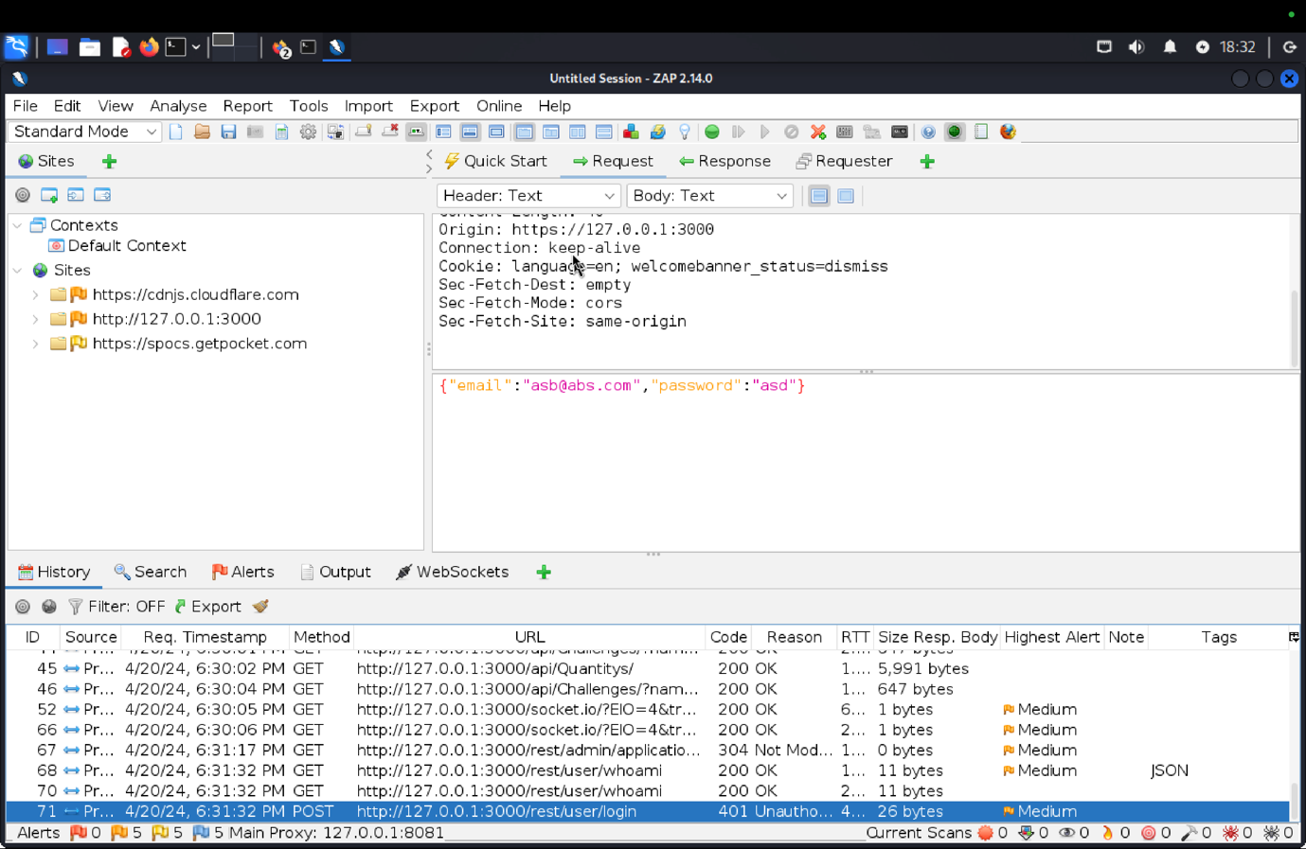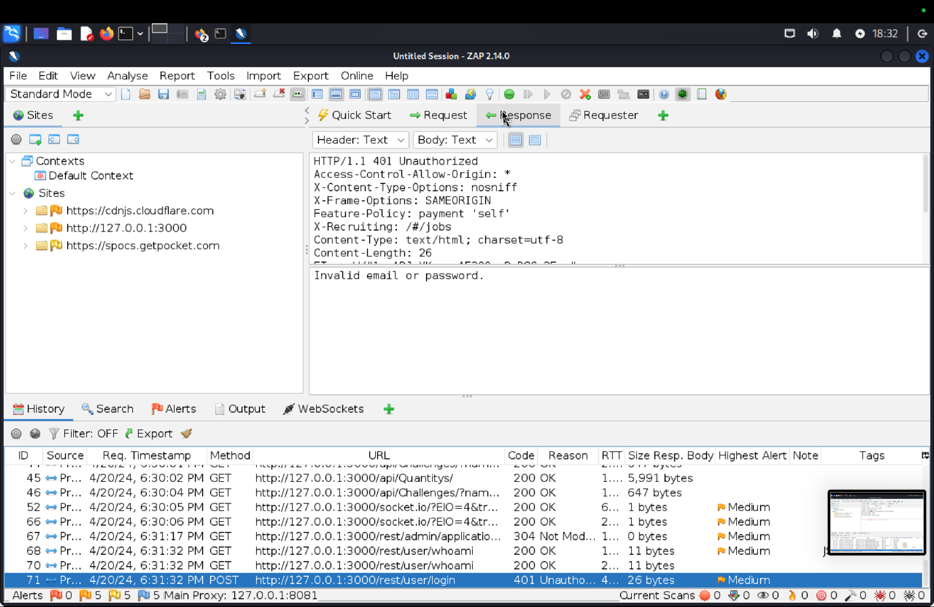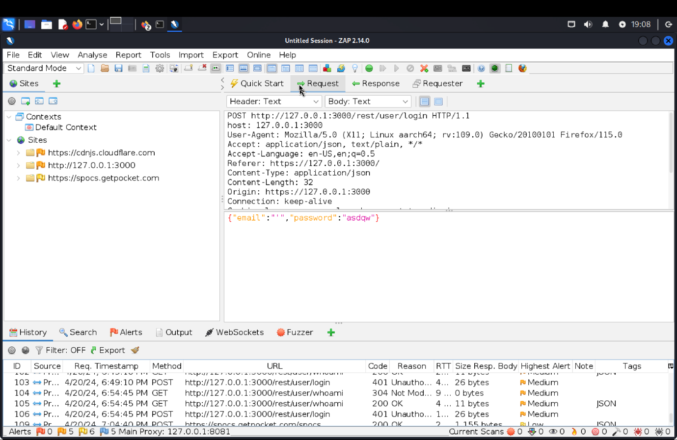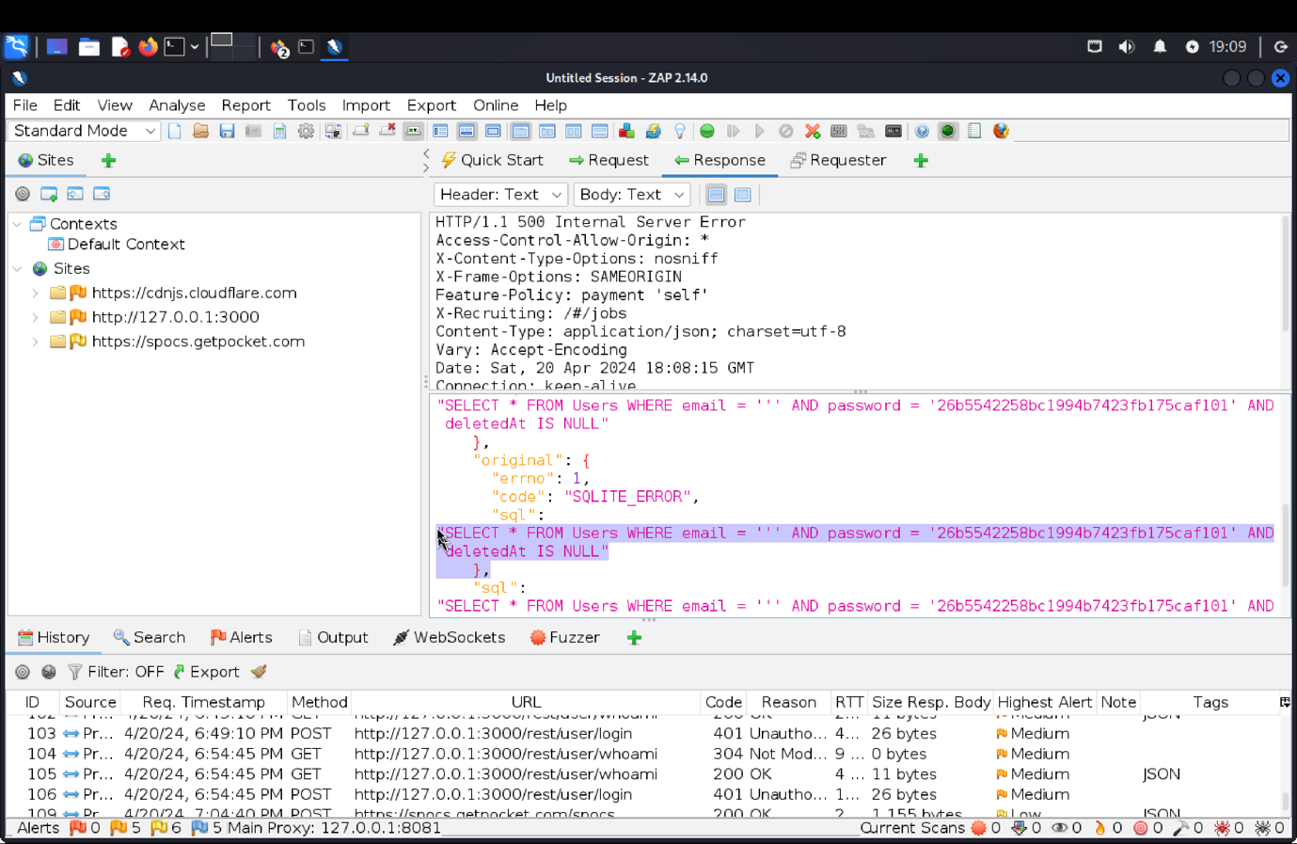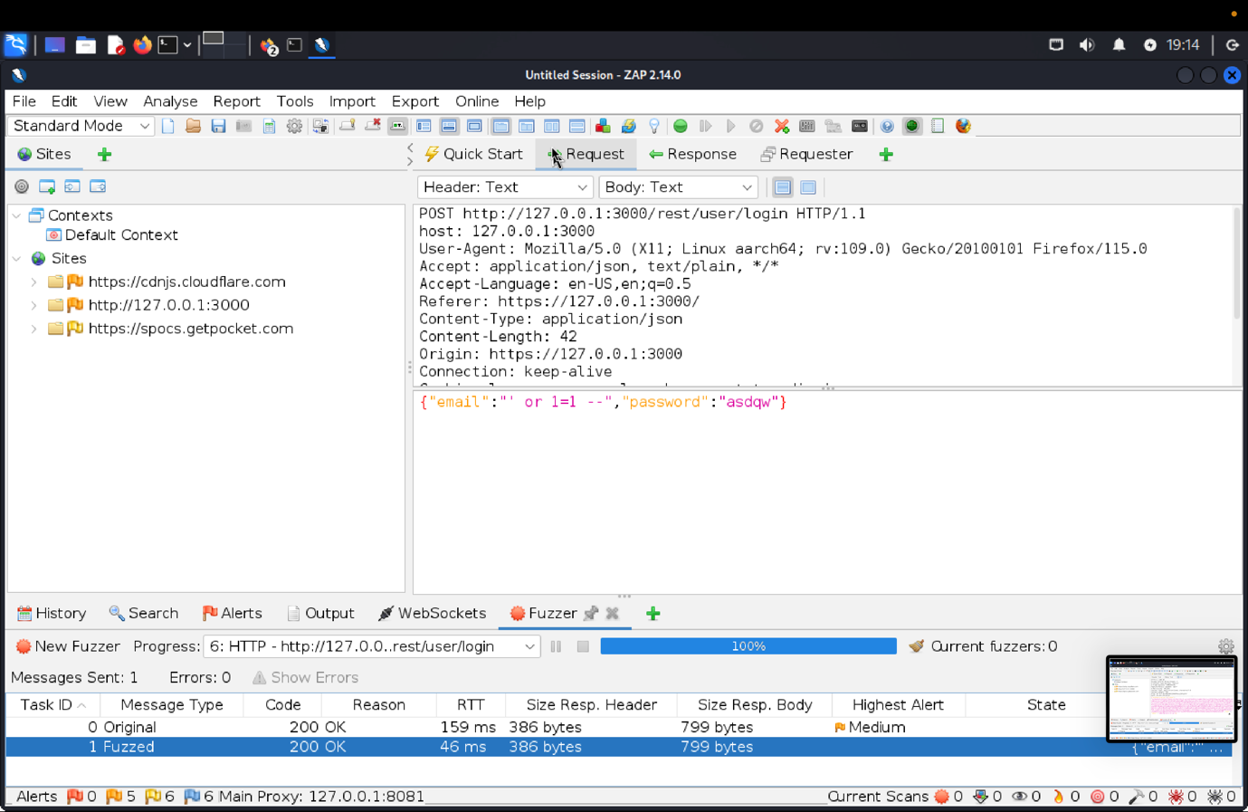 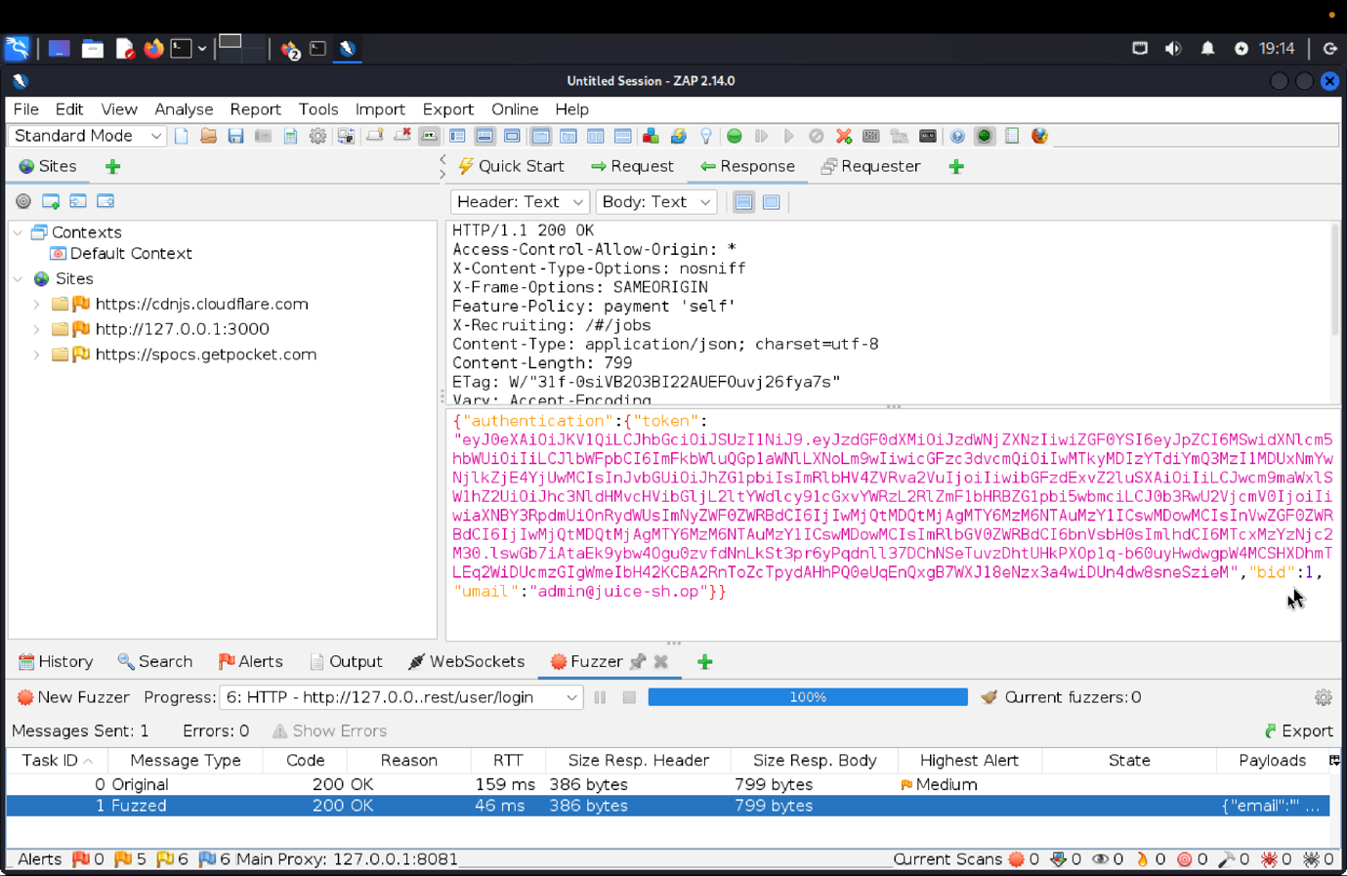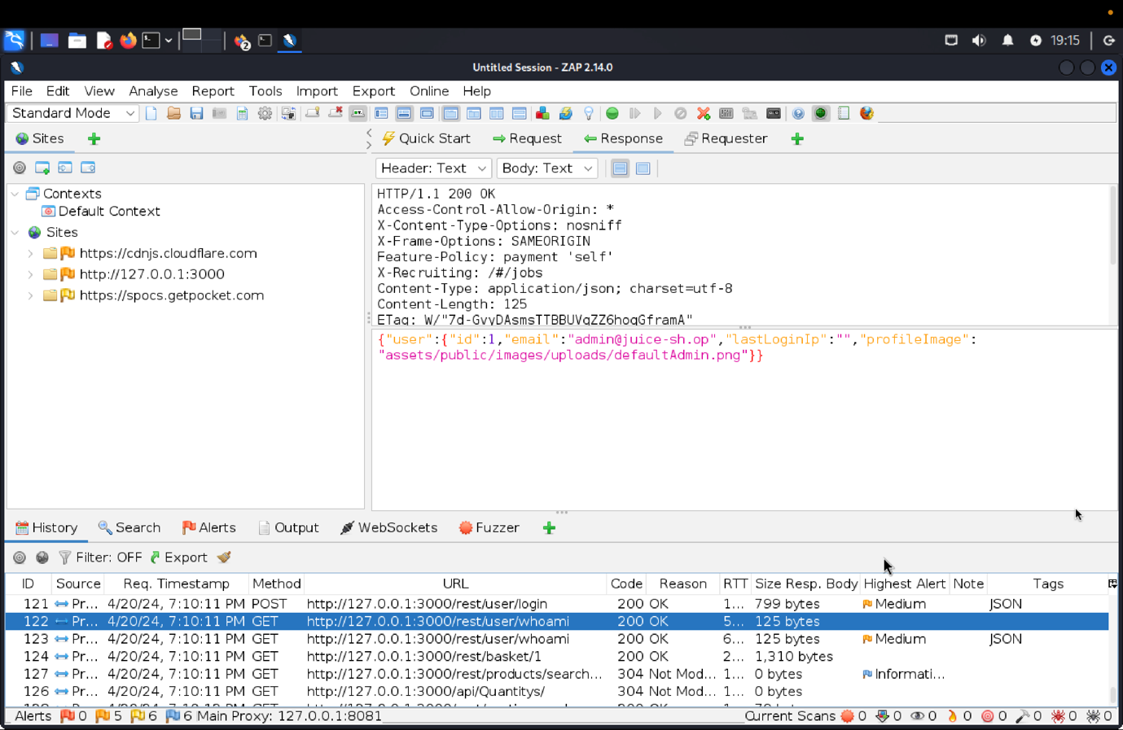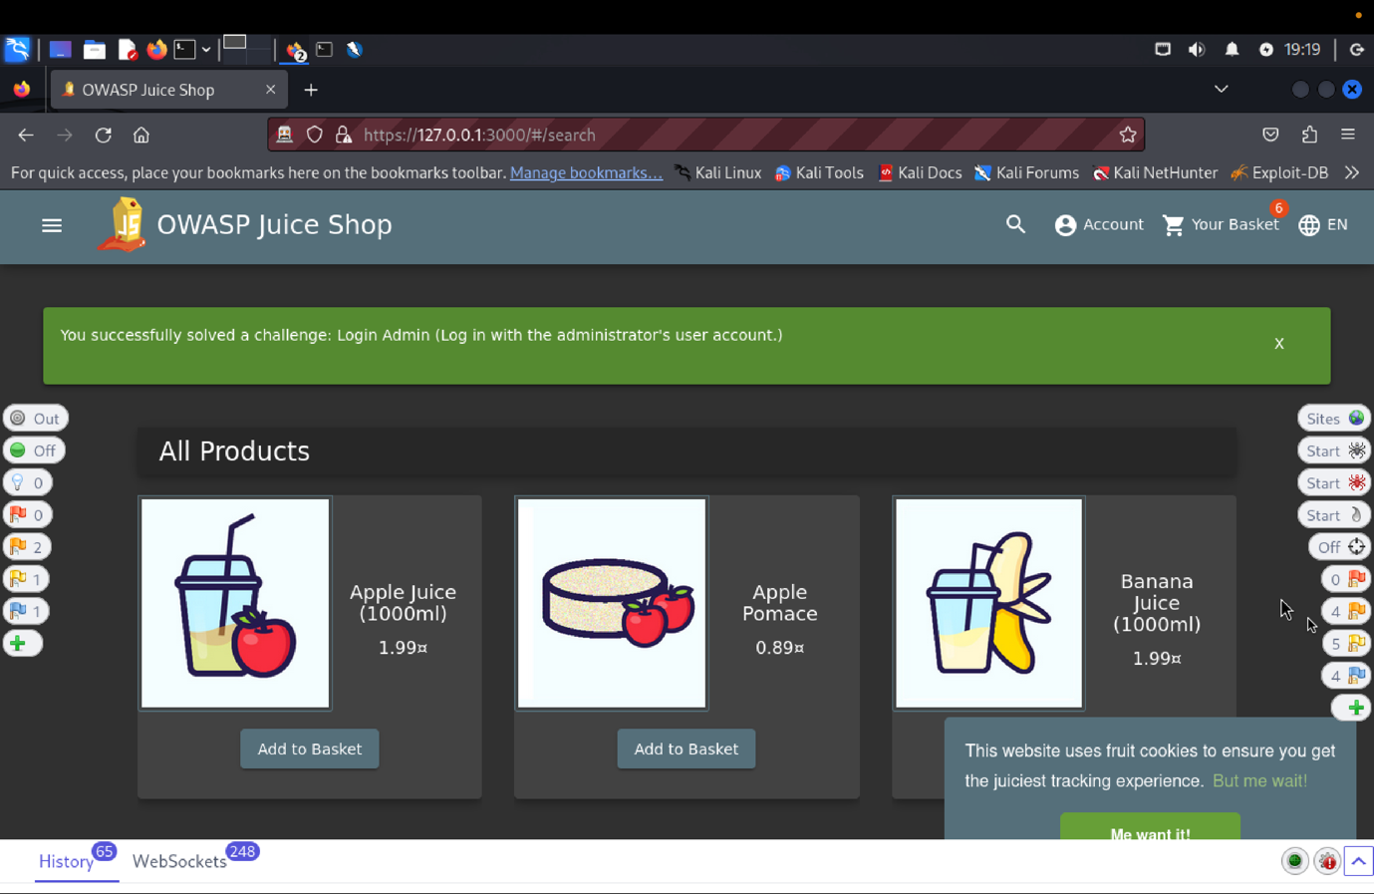

(c)    Explanation of how the evidence included in (b) proves that SFRiis violated.

The penetration testing involved using random credentials and exploiting a SQL injection vulnerability. Through fuzz testing, we successfully accessed the admin panel using 'or 1=1-- as an email and retrieved admin credentials. This enabled unauthorized access to user information and feedback, confirming the vulnerabilities in the Admin Section and Admin Login, and highlighting the need for robust input validation.

**VC2 View Basket**

**(a)    Description of penetration testing that was carried out for View Basket**

1. New user registration using email = apoorva@juice.com, password = Apoorva@123
2. After successful registration, added few items like Apple juice, Apple Pomace, Banana Juice in the basket.
3. Clicking on the POST proxy http://127.0.0.1:3000/api/BasketItems/ path in history, we can get the json object of { “ProductId”:42, “BasketId”: 6, “Quantity”:1} in Zap request.
4. We must create fuzz attack using the Get proxy <http://127.0.0.1:3000/rest/basket/6>. Use right click and under attack find Fuzz.
5. Select the basketId “6” in the get request path. Now, create a payload from 1 to 10 and click Start.
6. The successful Fuzzed outputs can be seen in fuzzer console with Json data containing basketId = 1,2,3,4,5,6 and basket Items in the response.
7. In this way we successfully viewed the basket items of other user and violating the access control.

**(b)    Outcomes (evidence) of the penetration testing in (a)**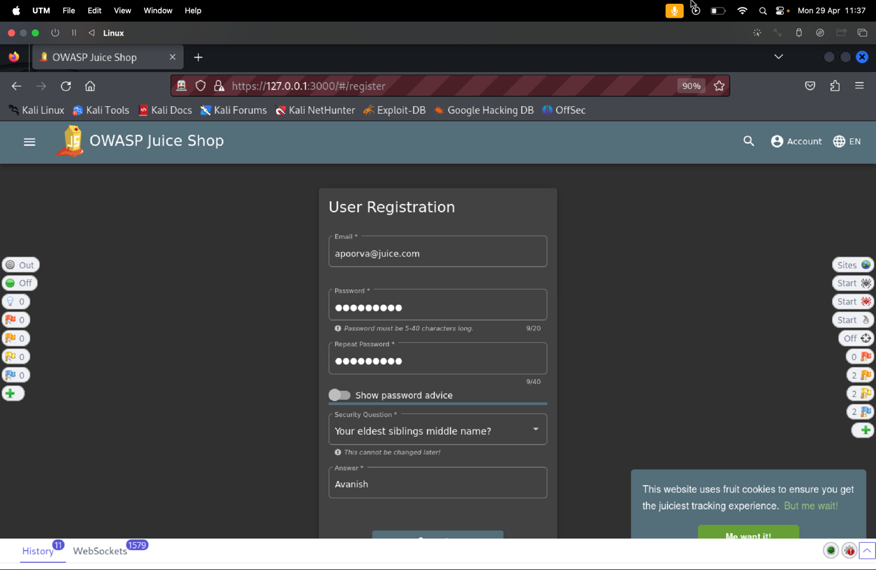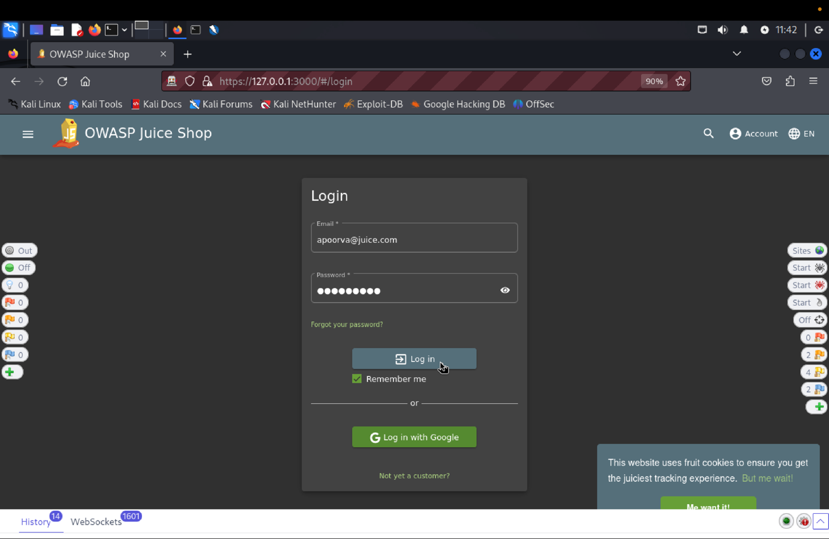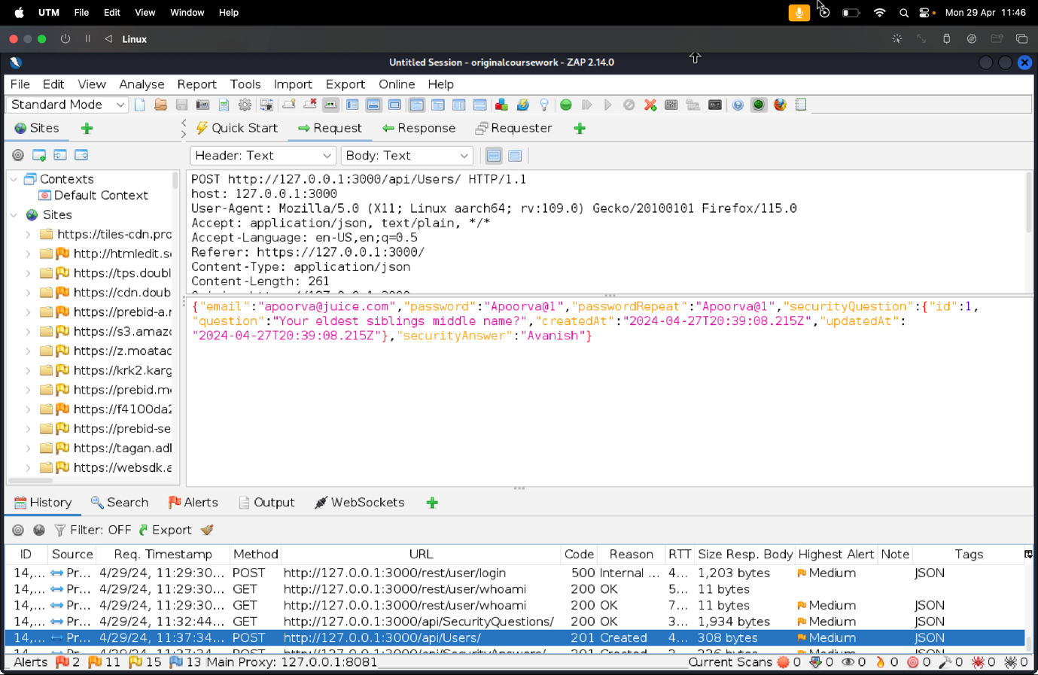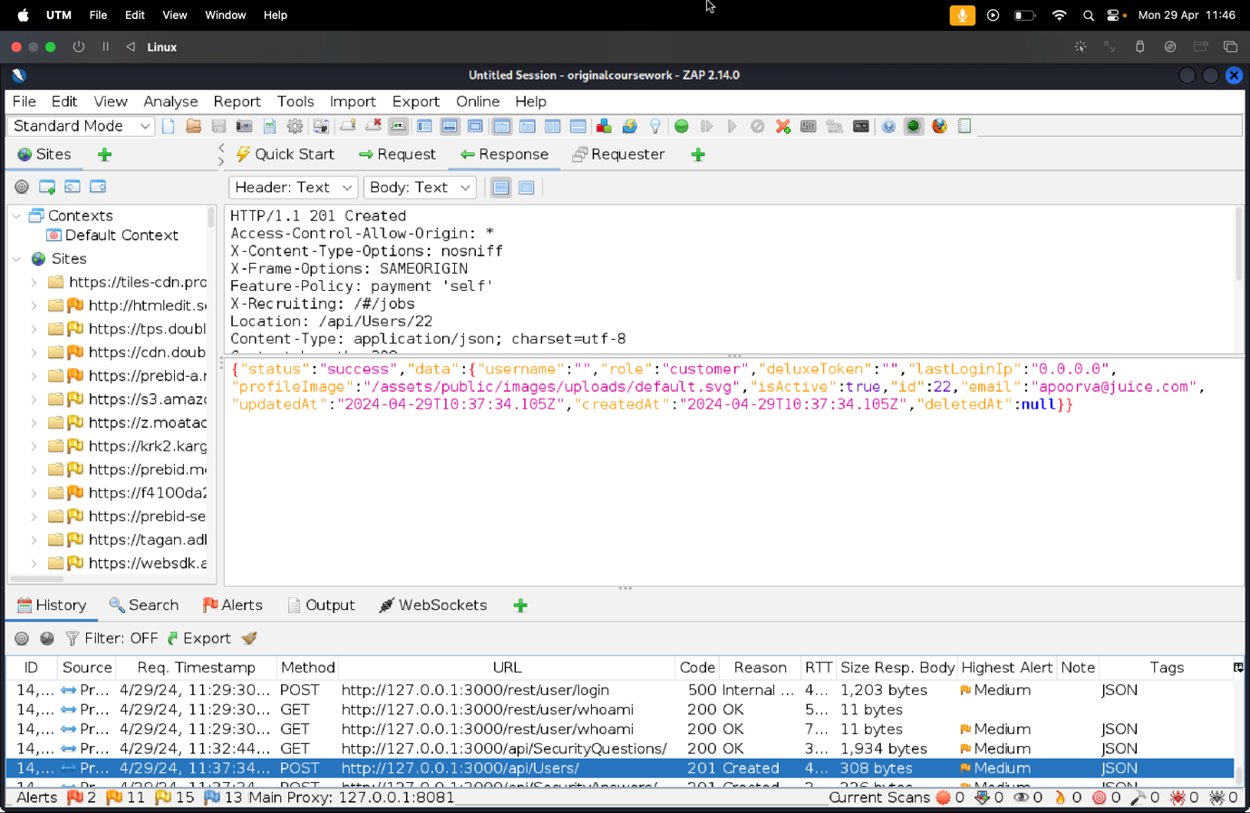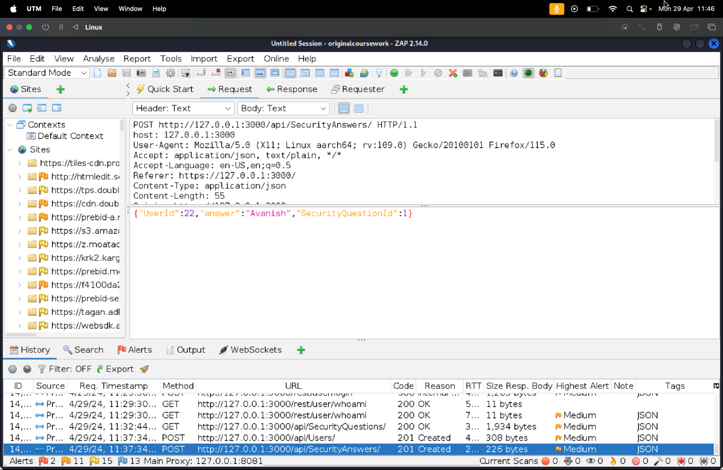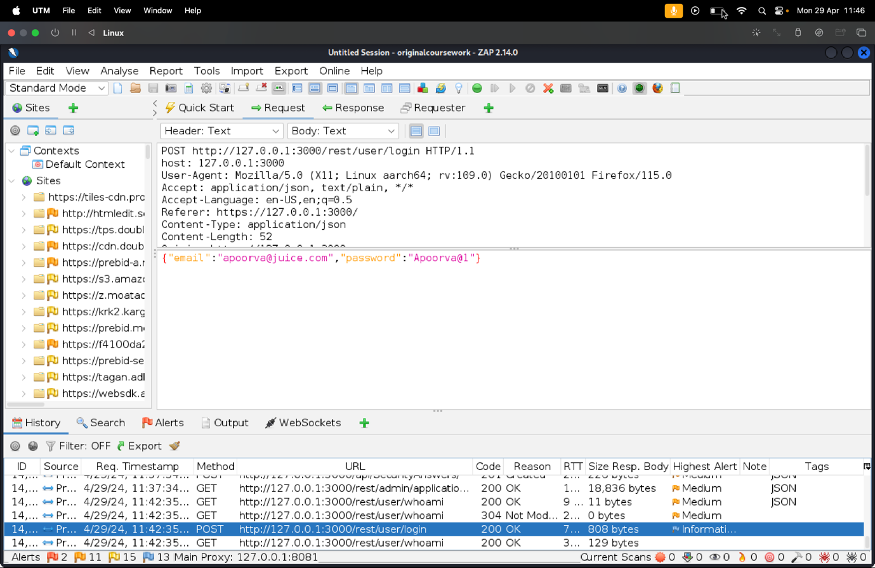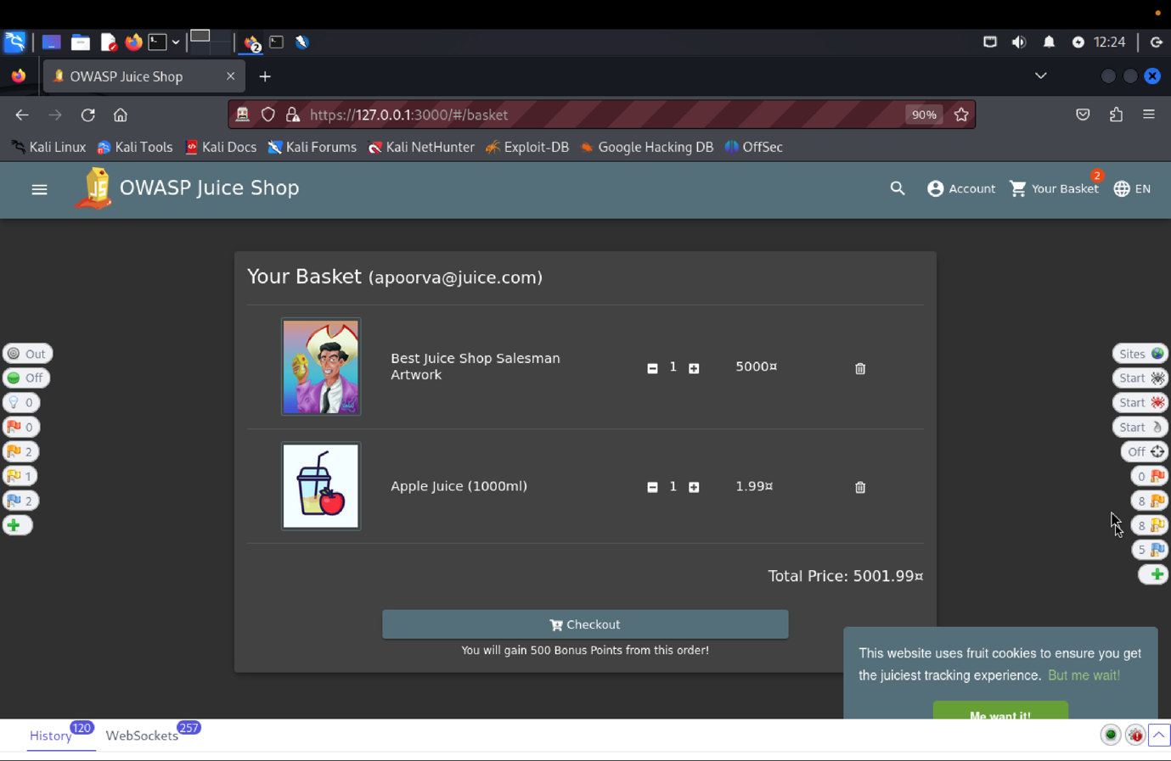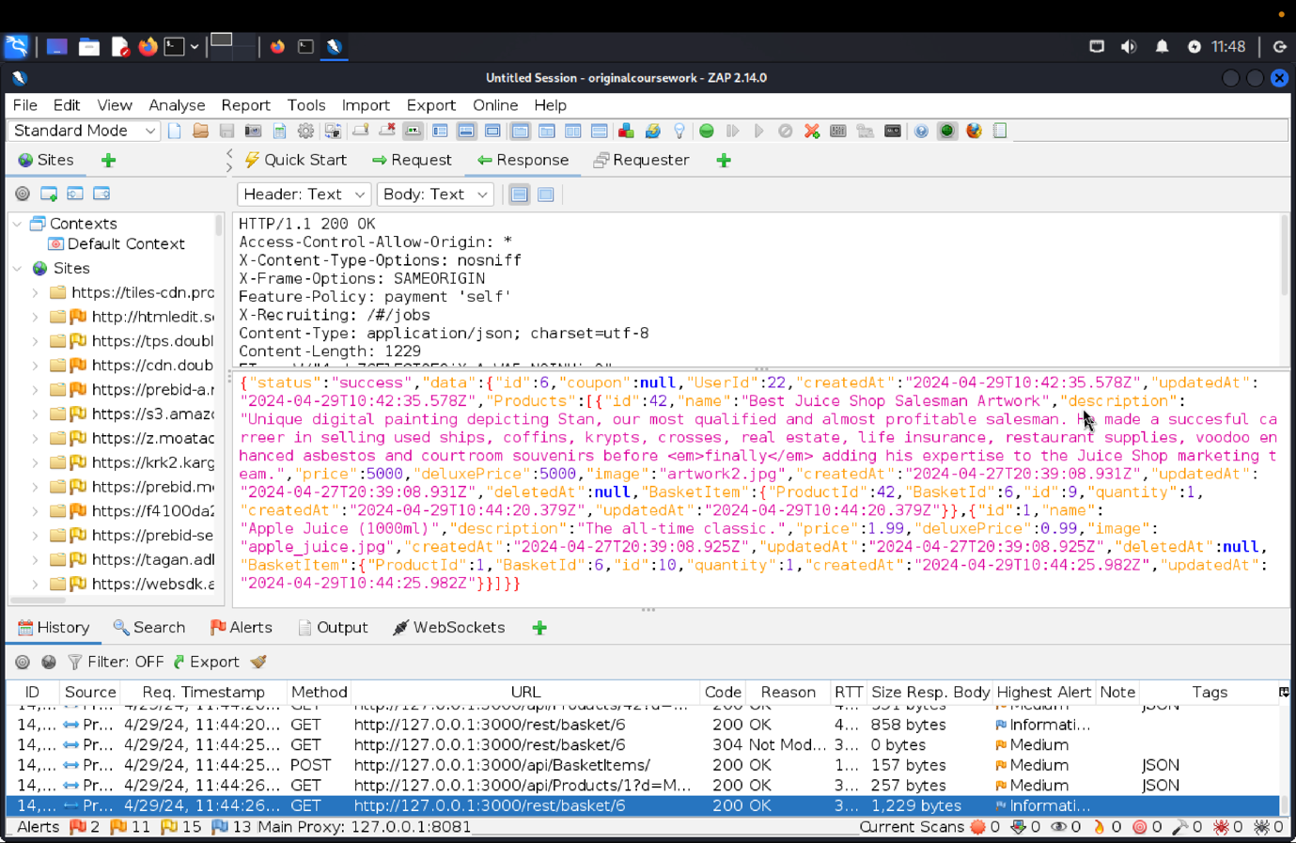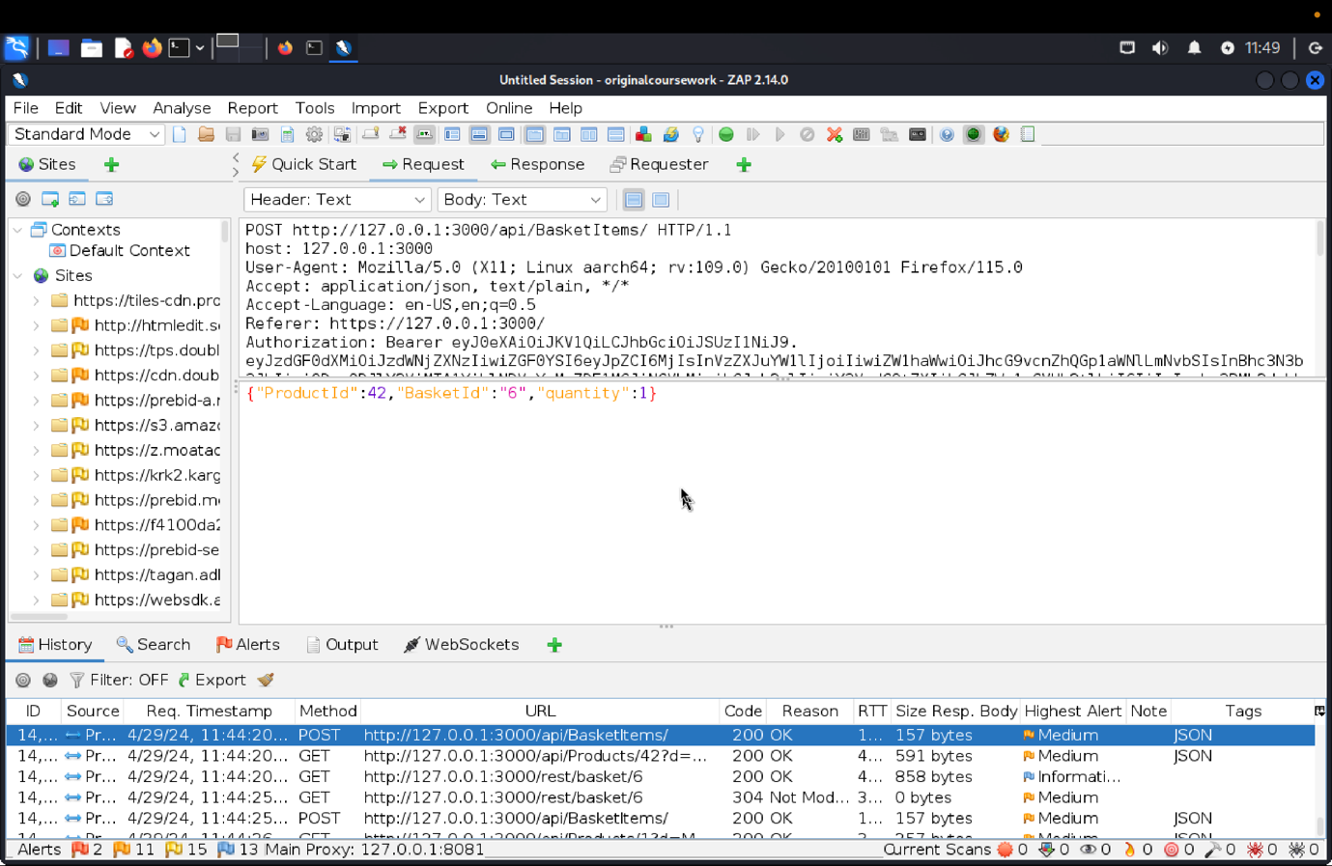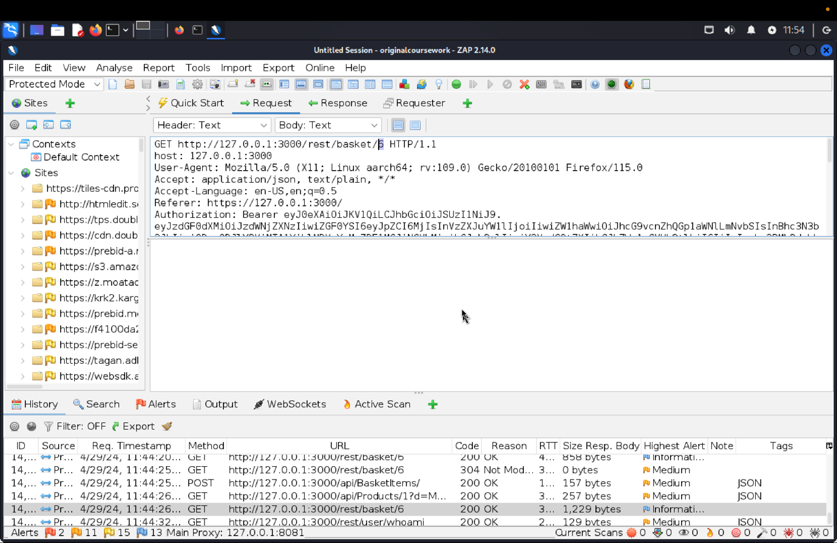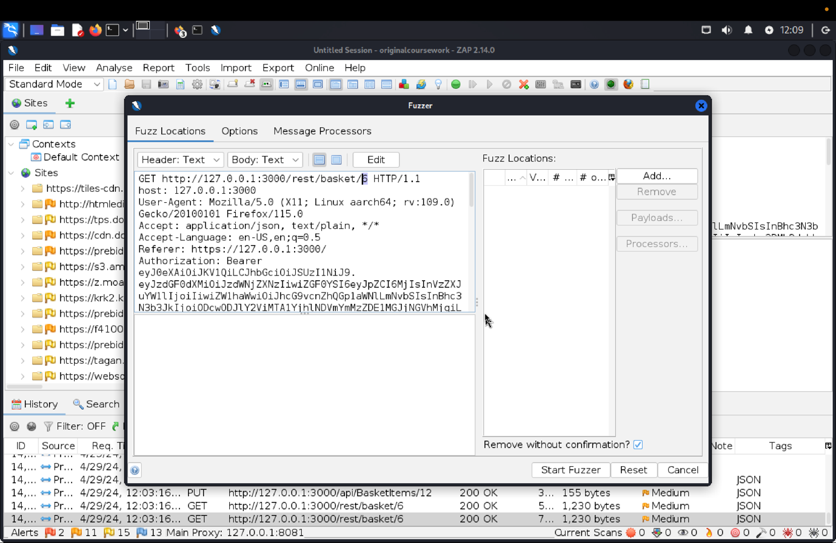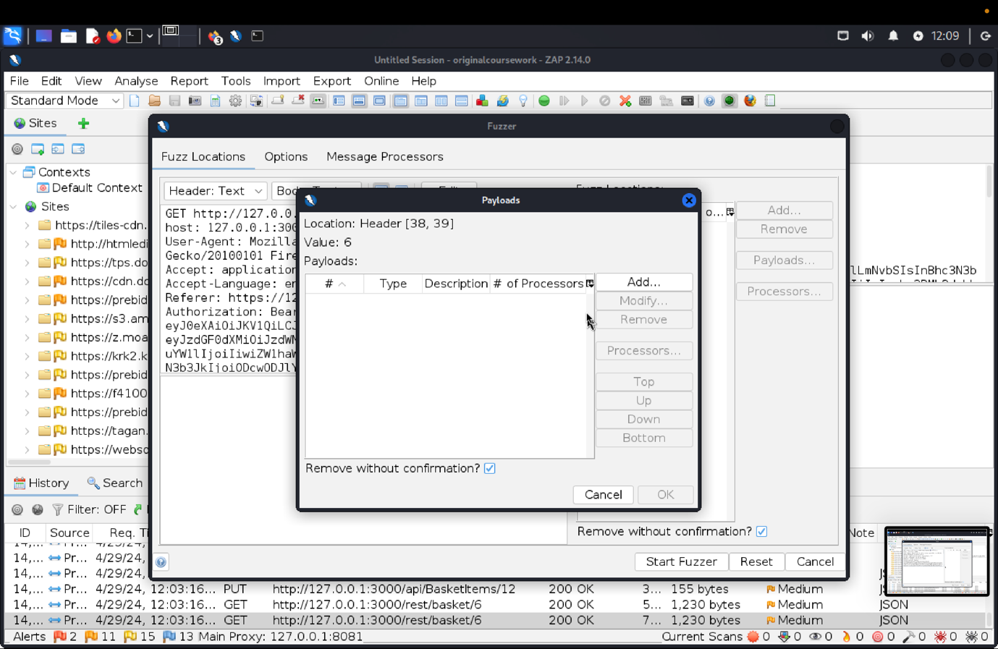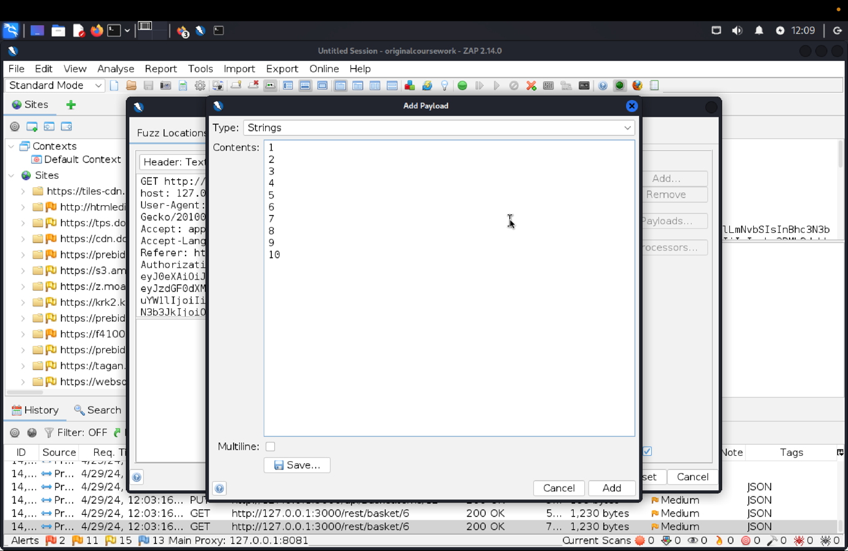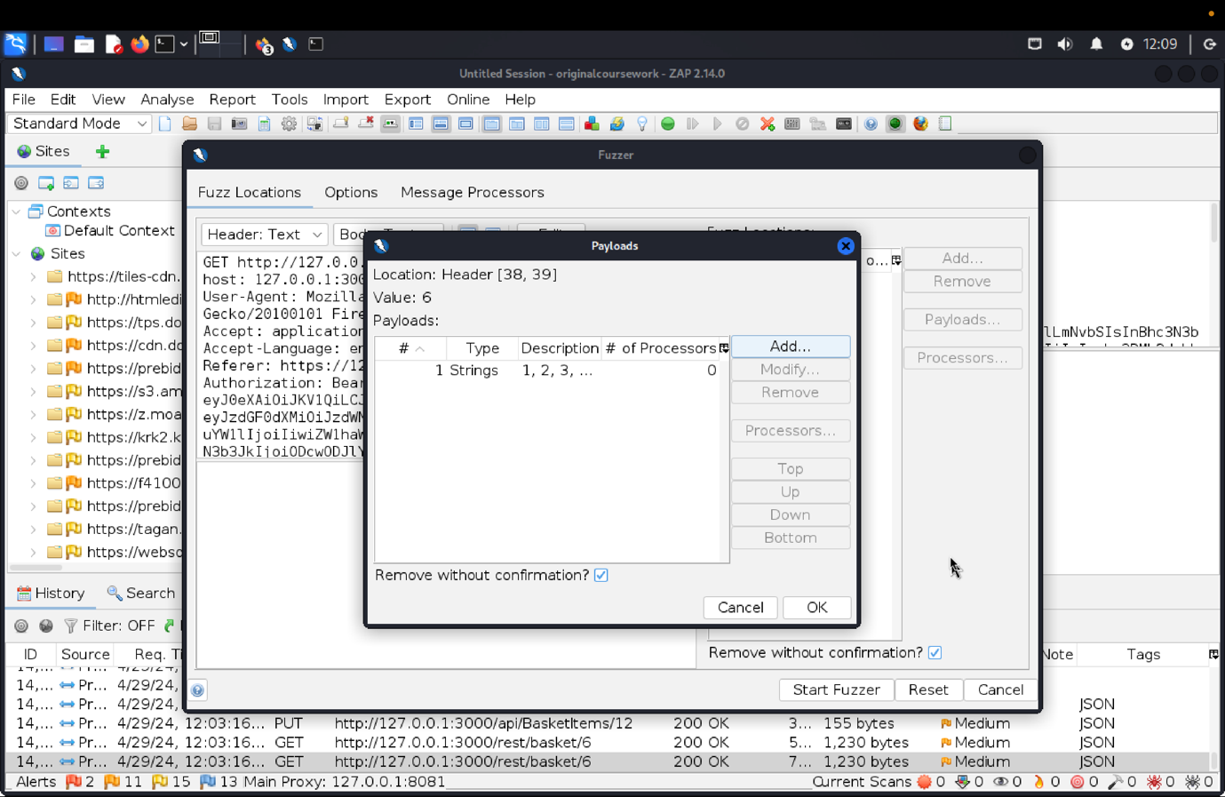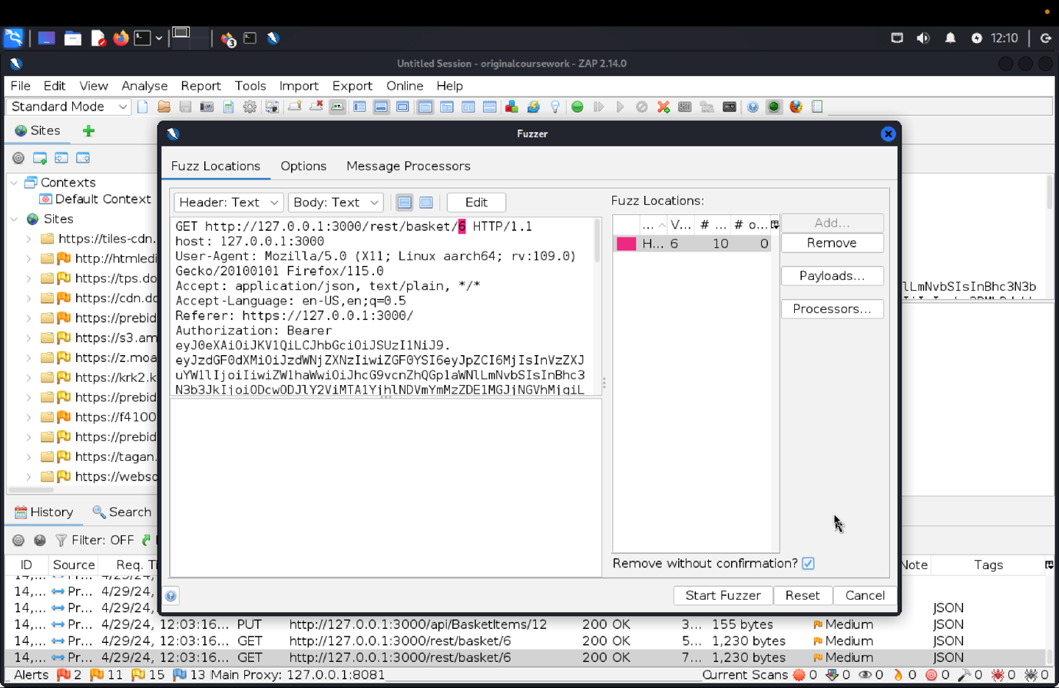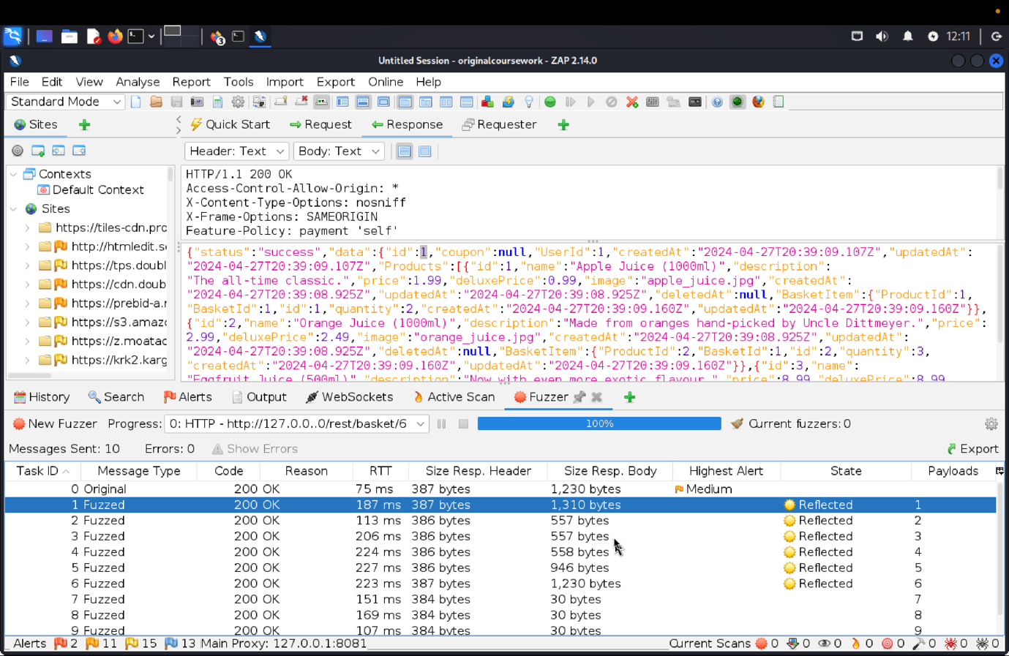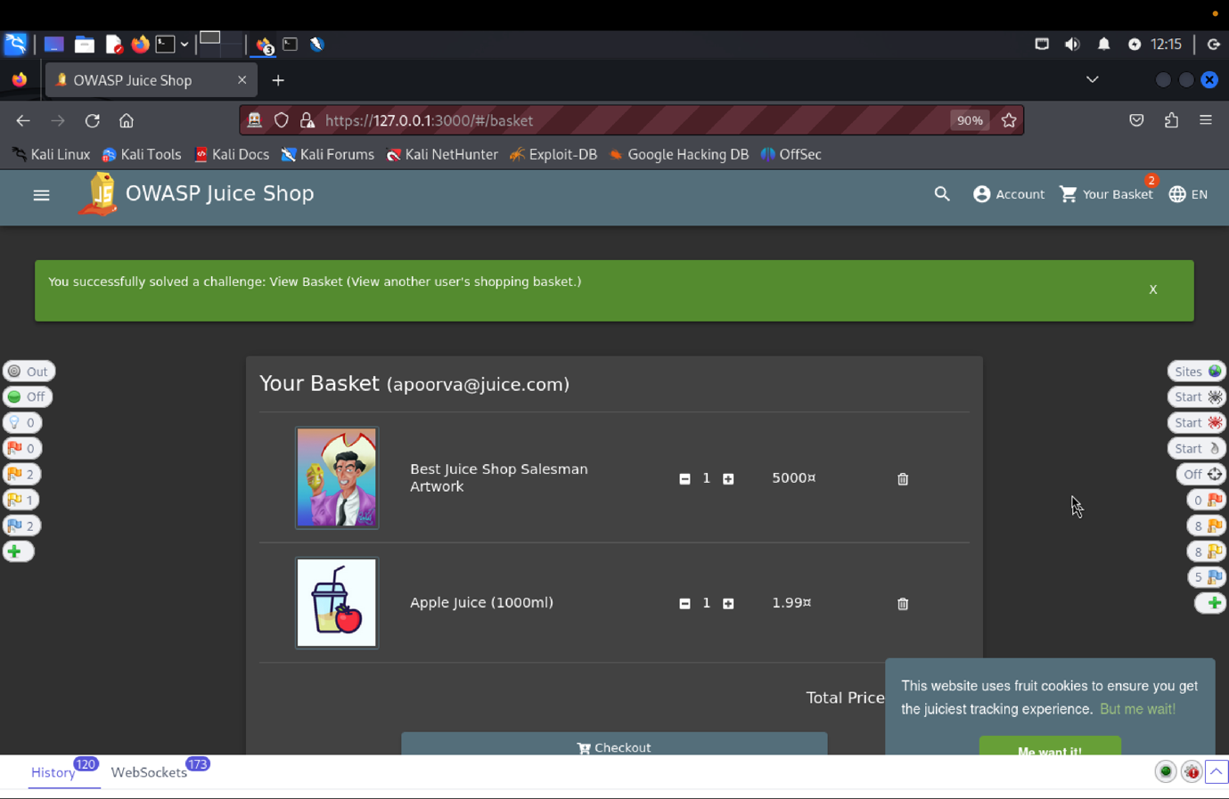

**(c)    Explanation of how the evidence included in (b) proves that SFRiis violated:**

To test the "View Basket", we registered a new user with the email apoorva@juice.com and the password Apoorva@123. After successfully registering, the we added items such as Apple Juice, best juice shop salesman to the basket.

By observing the POST request to /api/BasketItems/, the we found a JSON object having ProductId, BasketId, and Quantity. Then we created a fuzz attack on the GET request to /rest/basket/6 using the basket ID "6". The payloads were from 1 to 10. This attack revealed basket items from other users, including JSON data for basket IDs 1 through 6. We were able to successfully access the baskets of other users, violating access control.

This test demonstrated a lack of proper access control, allowing unauthorized access to private data and exposing sensitive user information.

1. **SFR Identifier: -**

**FDP_ACC.2.2 - The TOE shall ensure that all operations between any subject controlled by the TOE, and any object controlled by the TOE are covered by an access control SFP.**

**Related Vulnerability Challenges: -**

1. Admin Section
2. CSRF
3. Forged Feedback
4. Forged Review
5. Manipulate Basket
6. Product Tampering
7. Deluxe Fraud:
8. Leaked Access Logs
9. Leaked Unsafe Product
10. View Basket
11. Web3 Sandbox

**VC**: Admin Section

**(a)    Description of penetration testing that was carried out for VC1**

1. Login to the TOE i.e. OWASP Juice Shop using any credentials. I used [asb@abs.com](mailto:asb@abs.com) with password as asd but since the user doesn’t exist it gives me *“invalid user of password error”*.
2. Since most of the site doesn’t handle the special character properly I tried using email as ‘ and password as asdqw. Which didn’t technically return an error but gave sql jargon which lead me to believe that I can injection is possible.
3. Then I did a right click on the POST method of the api, rest/user/login and under attack when and started fuzz attack.
4. In Requester or fuzz attack I gave email as ‘or1=1-- password : asdqw (Ref pic#4). The or1=1 returns TRUE returning all the rows and -- comments out the rest i.e. no need for the password.
5. The ZAP then returns 200 response with the username of the admin and token for the password.
6. After using the admin email id : admin@juice-sh.op and password: asdqw, the login to the juice shop store is successful.
7. We can access the administration page by using the following path: https:/127.0.0.1:3000/#/adminstration
8. Here, we can access the email id of all the registered users as well as the customer feedback.
9. In this way, Admin access control was broken, and challenge was solved.

(b)    Outcomes (evidence) of the penetration testing in (a)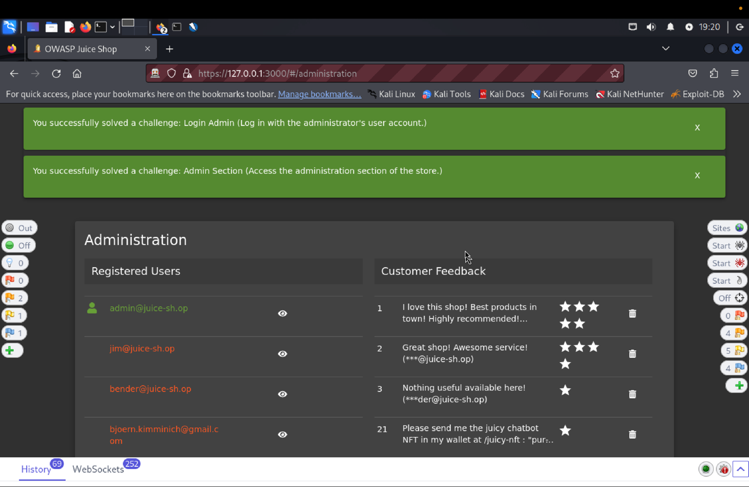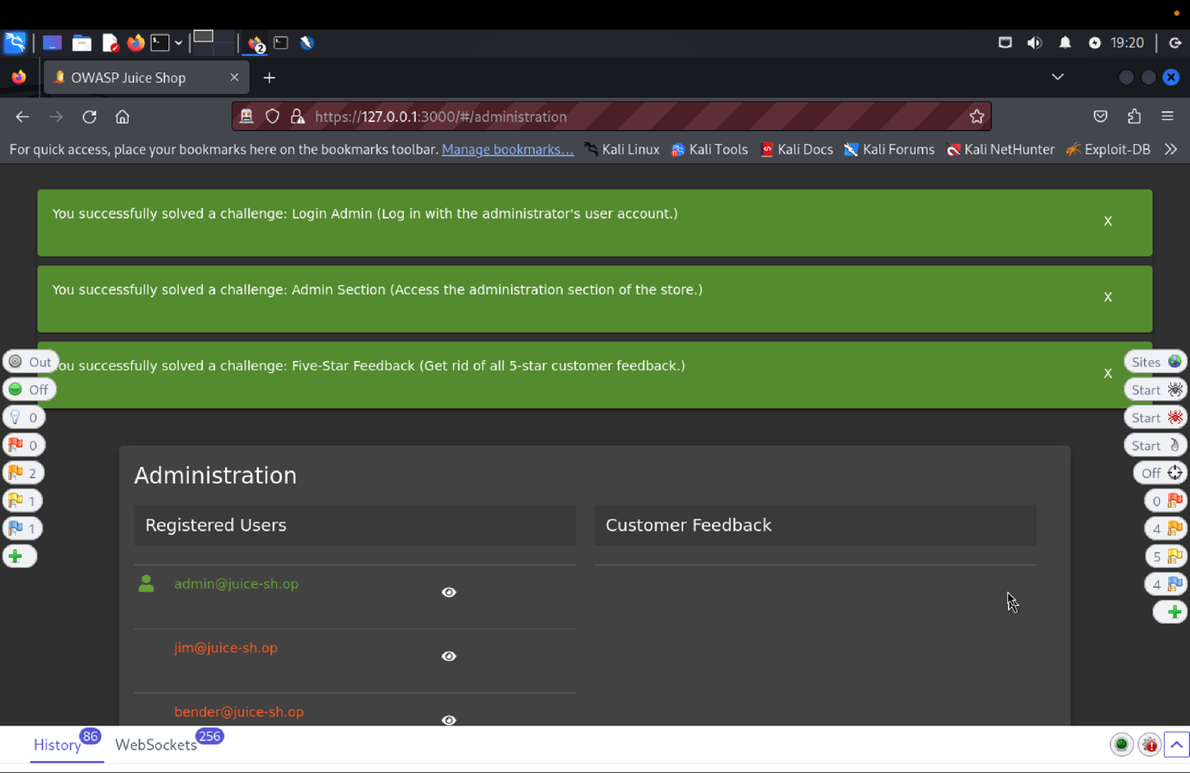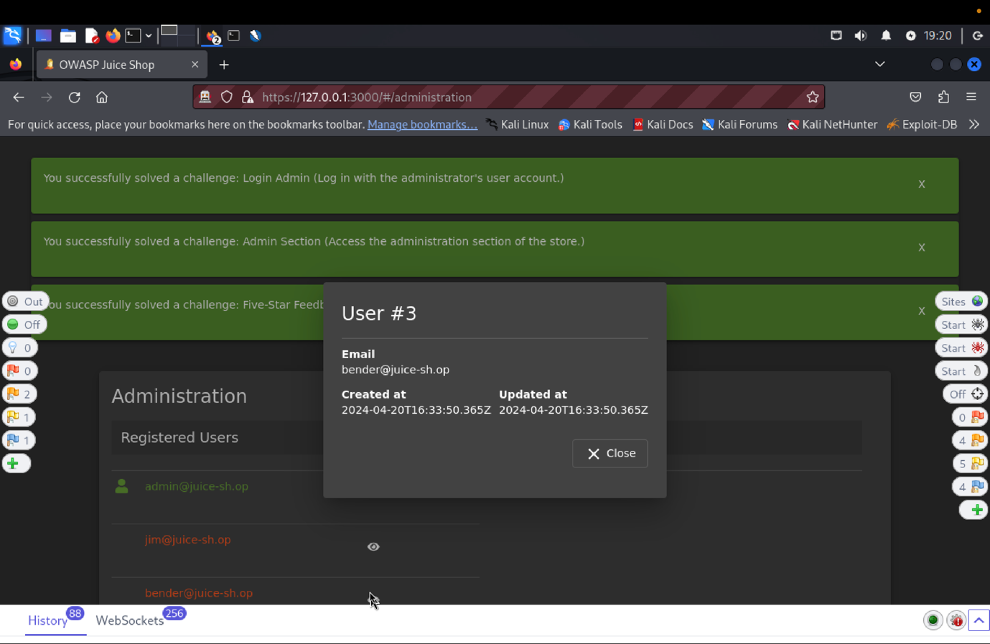

(c) **Explanation of how the evidence included in (b) proves that FDP_ACC.1.1 is violated**:

Initially attempted to log in using random credentials. Using asb@abs.com and asd as the password, we got a "invalid user or password" error. When trying to use an email with a single quotation mark (') and a password (asdqw), the we encountered a SQL jargon, indicating a possible SQL injection vulnerability. We initiated a fuzz attack on the POST method /rest/user/login, using 'or 1=1-- as the email and asdqw as the password. This returned all rows and bypassed the password requirement. We logged in using admin@juice-sh.op with the password asdqw and accessed the administration page. We could view the email addresses of registered users and customer feedback, exposing sensitive information and violating admin access control, confirming the security issue with the Admin Section.

**VC**: Manipulate Basket

1. **Description of penetration testing that was carried out for SSRF**:
2. Login to juice shop store using email = apoorva@juice.com,

password = Apoorva@1

1. From homepage add item to basket, after successful login.
2. Go to ZAP and find POST proxy http://127.0.0.1:3000/api/BasketItems/ path in the history tab, on clicking it in the Request tab we can get the json object of { “ProductId”:1, “BasketId”: 6, “Quantity”:1.
3. Send this to the requester tab when you send the same message we find a validation error, so change the product id to 2 and send it which us success.
4. Now, send request by selecting the json object and repeating the basket id field with some other user’s basket id.
5. By creating multiple database entries for basketID field in the same packet will breaks the access resulting in manipulation of another users shopping basket.
6. So the final payload will consist of { “ProductId”:3, “BasketId”: 6, “BasketId”: 4, “Quantity”:1}.
7. This will manipulate another users basket and solve the challenge.
8. **Outcomes (evidence) of the penetration testing in (a)**:

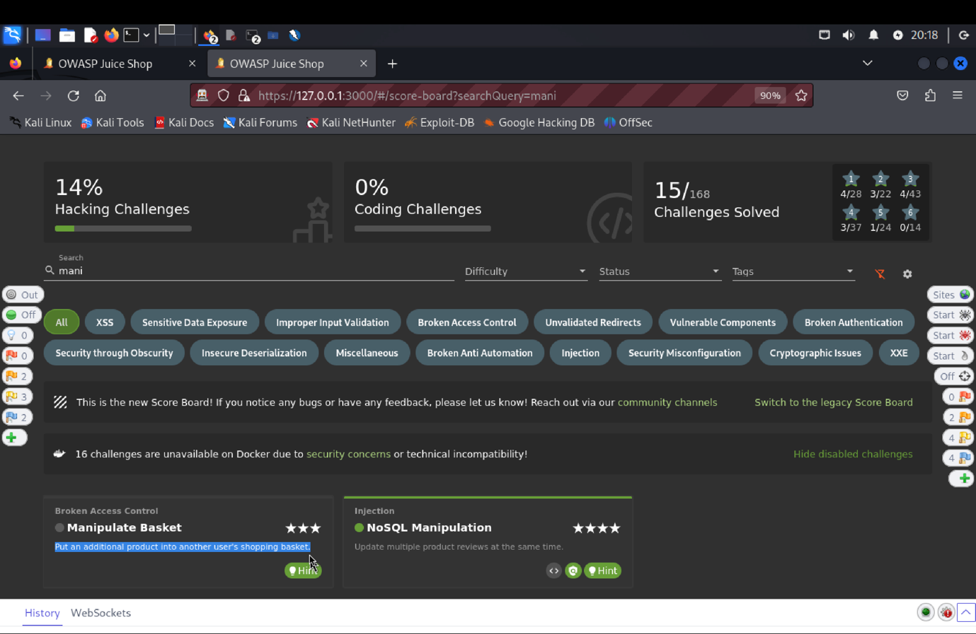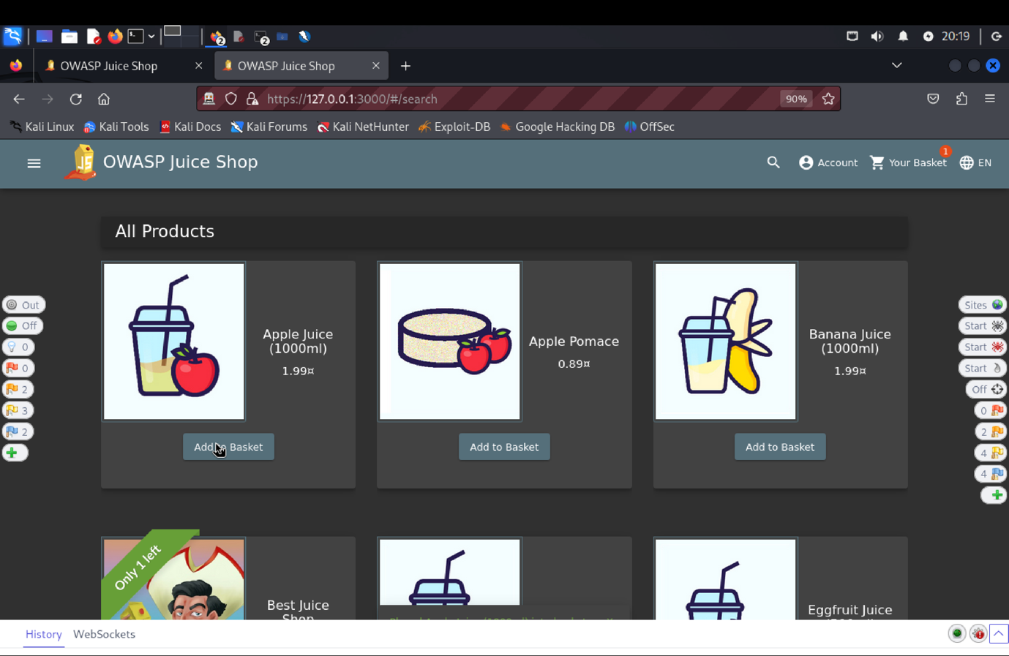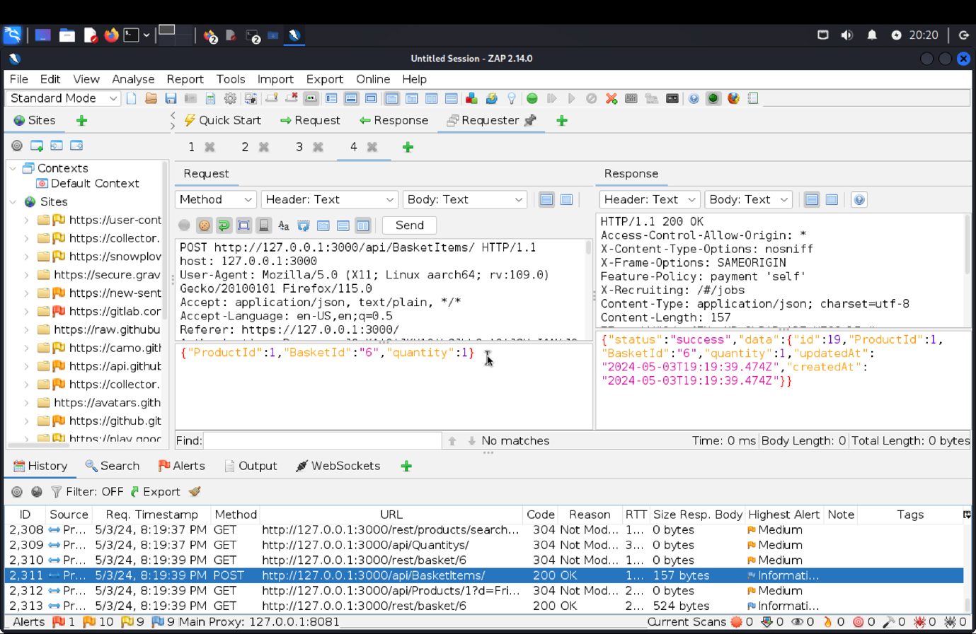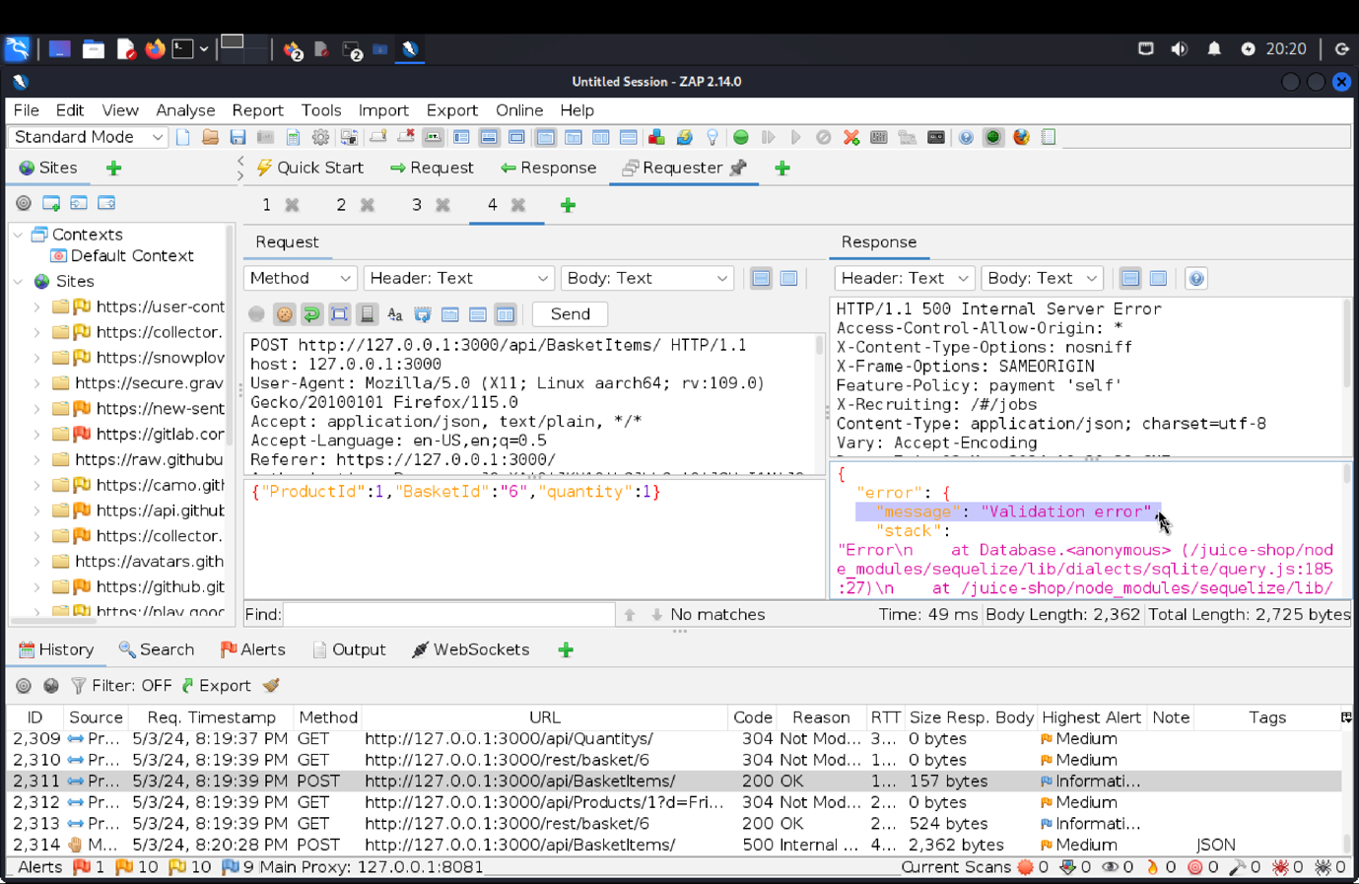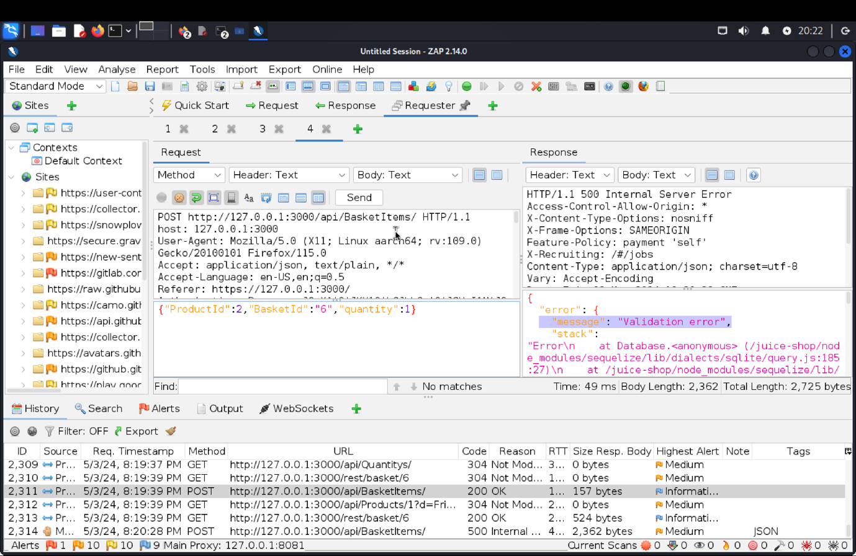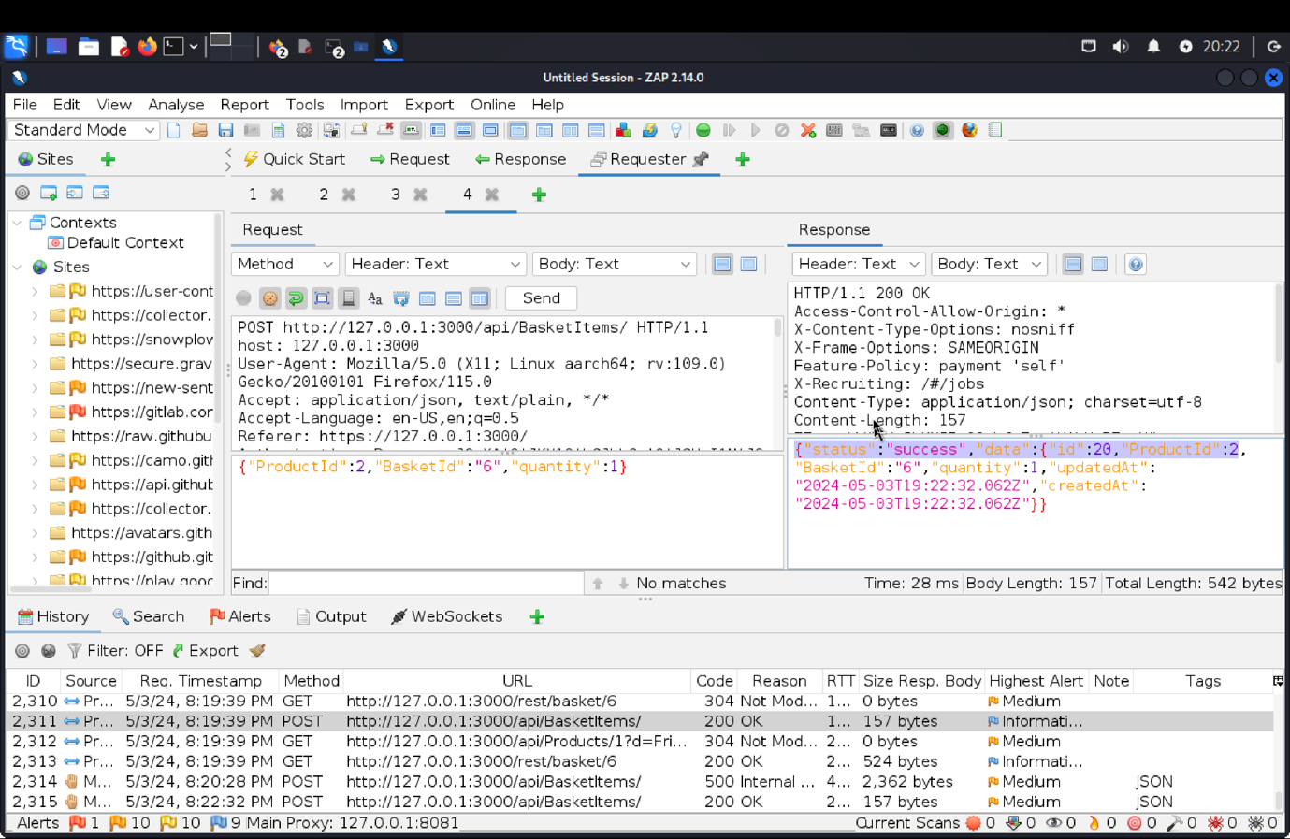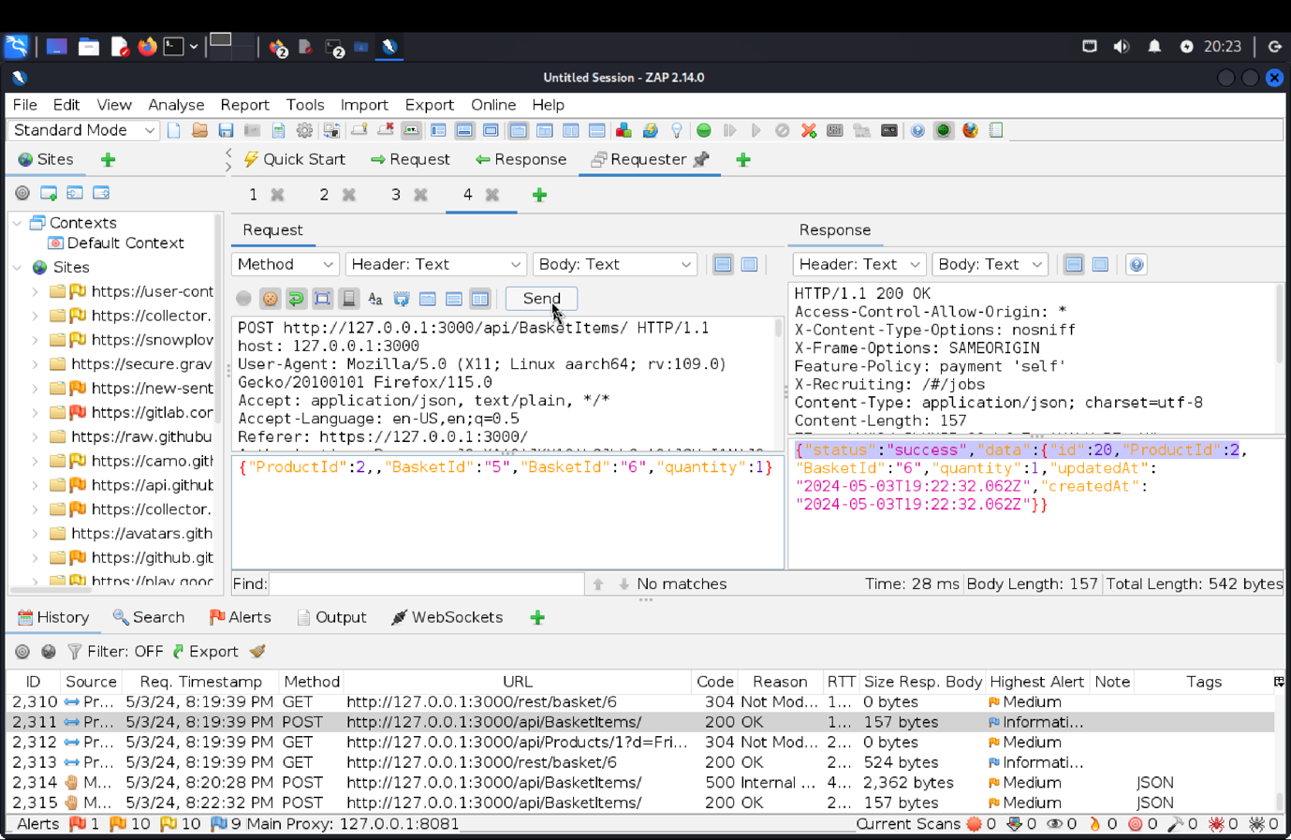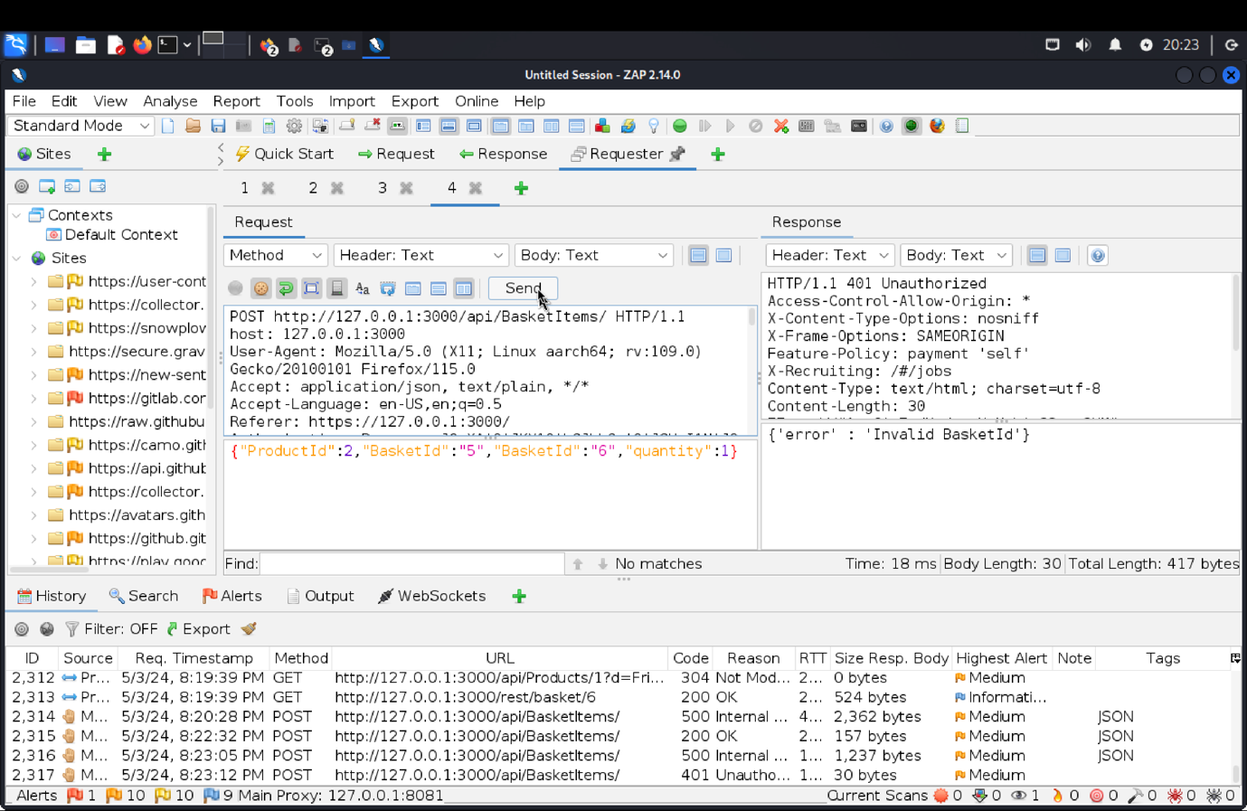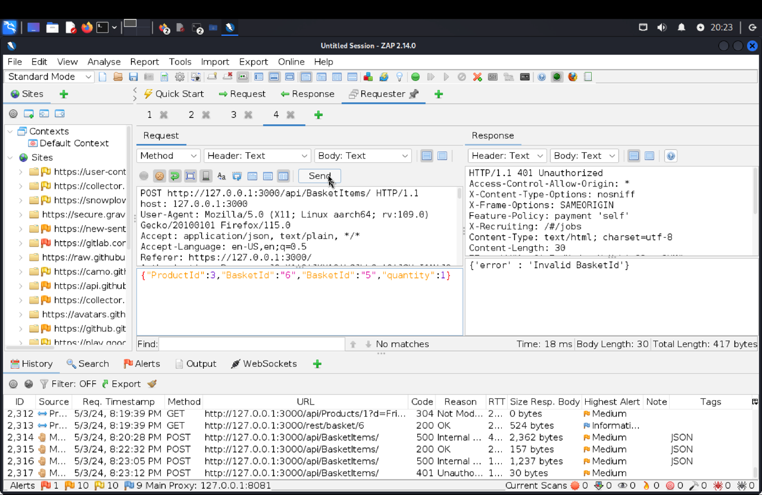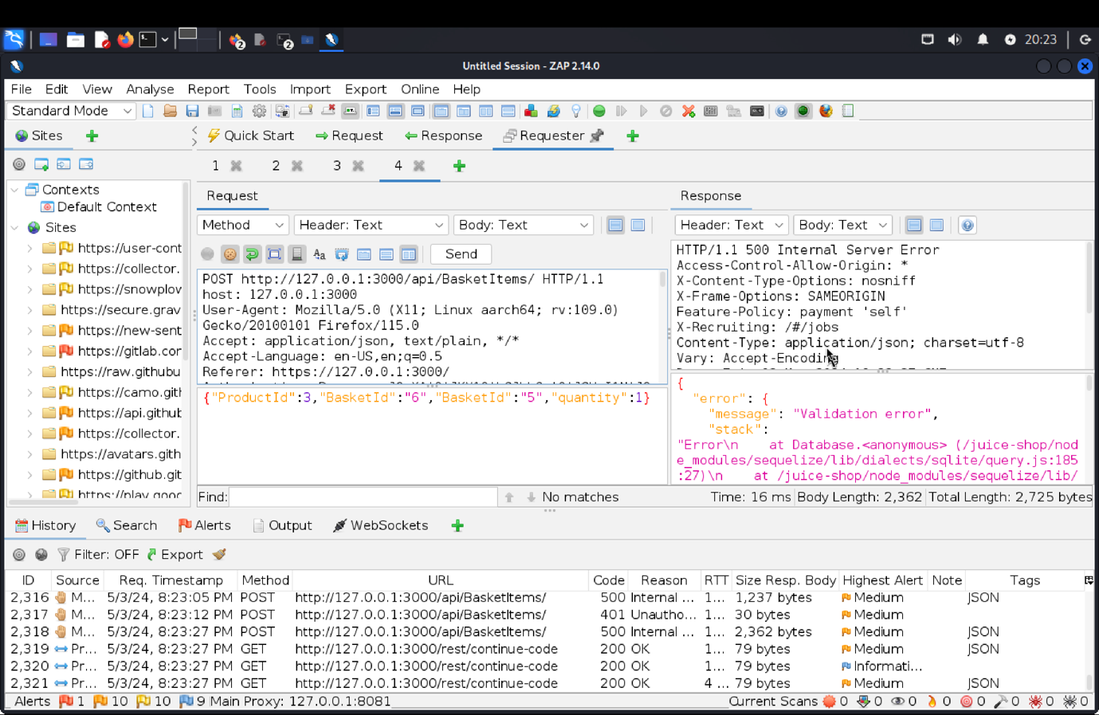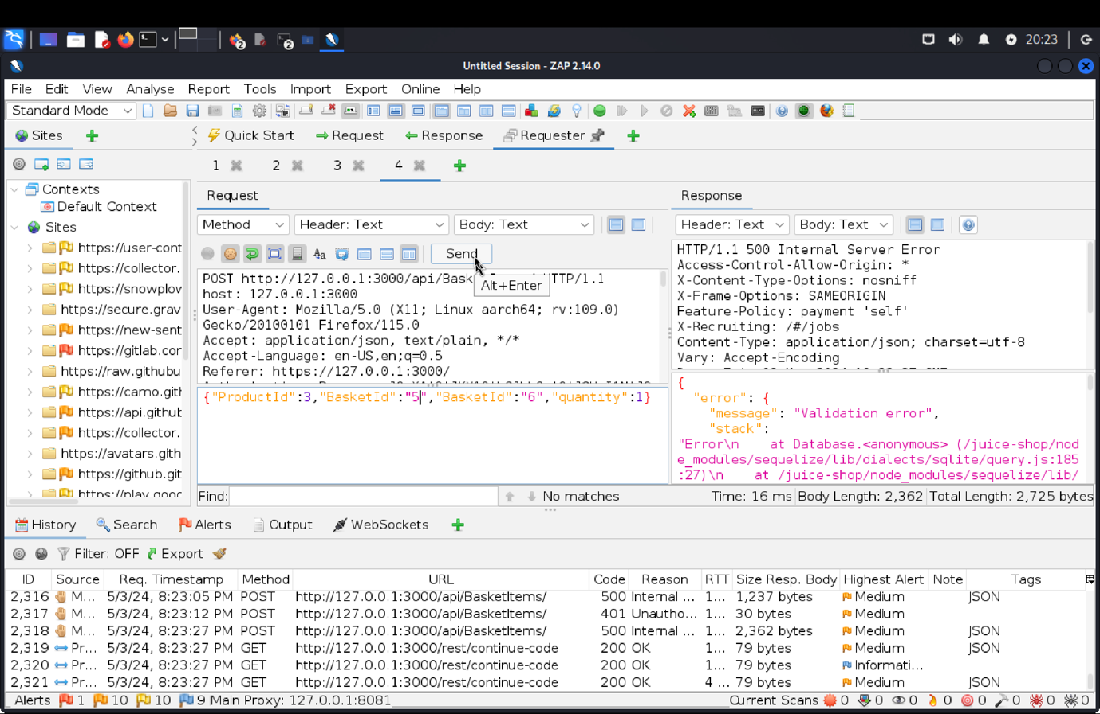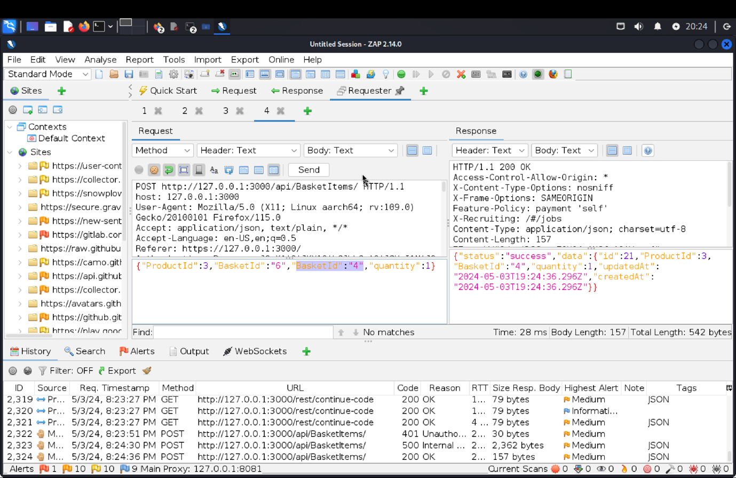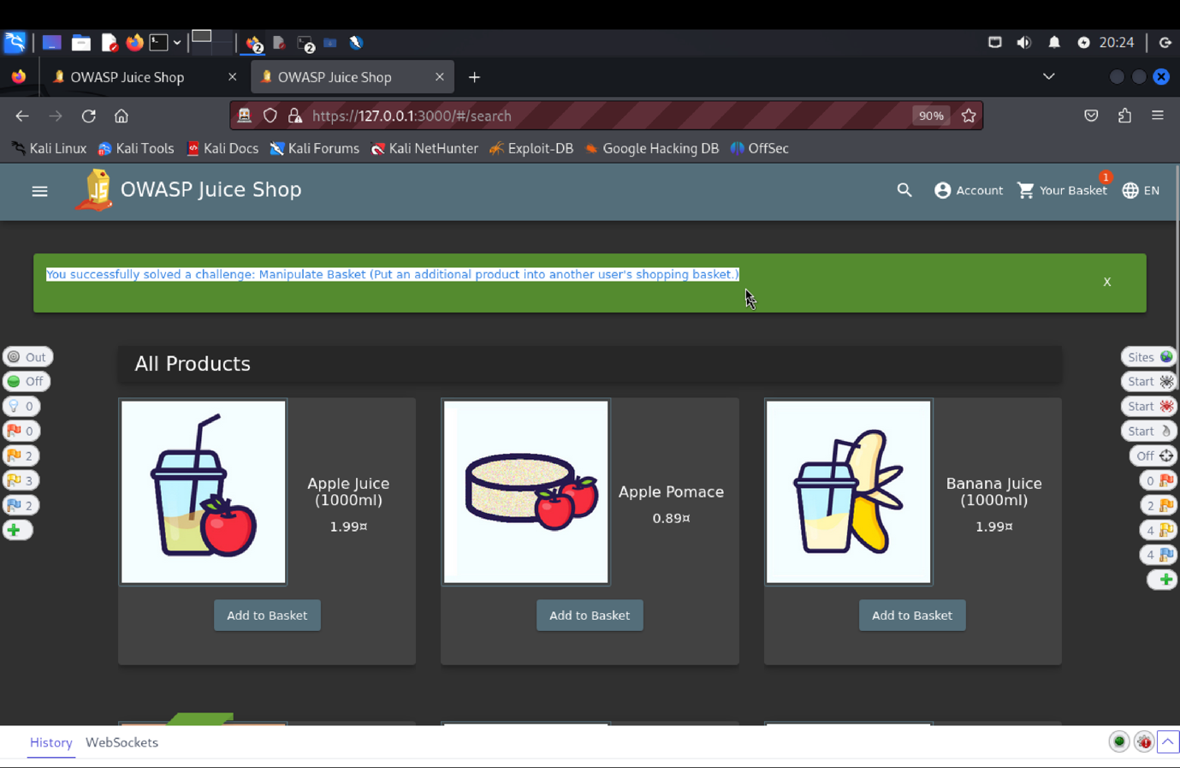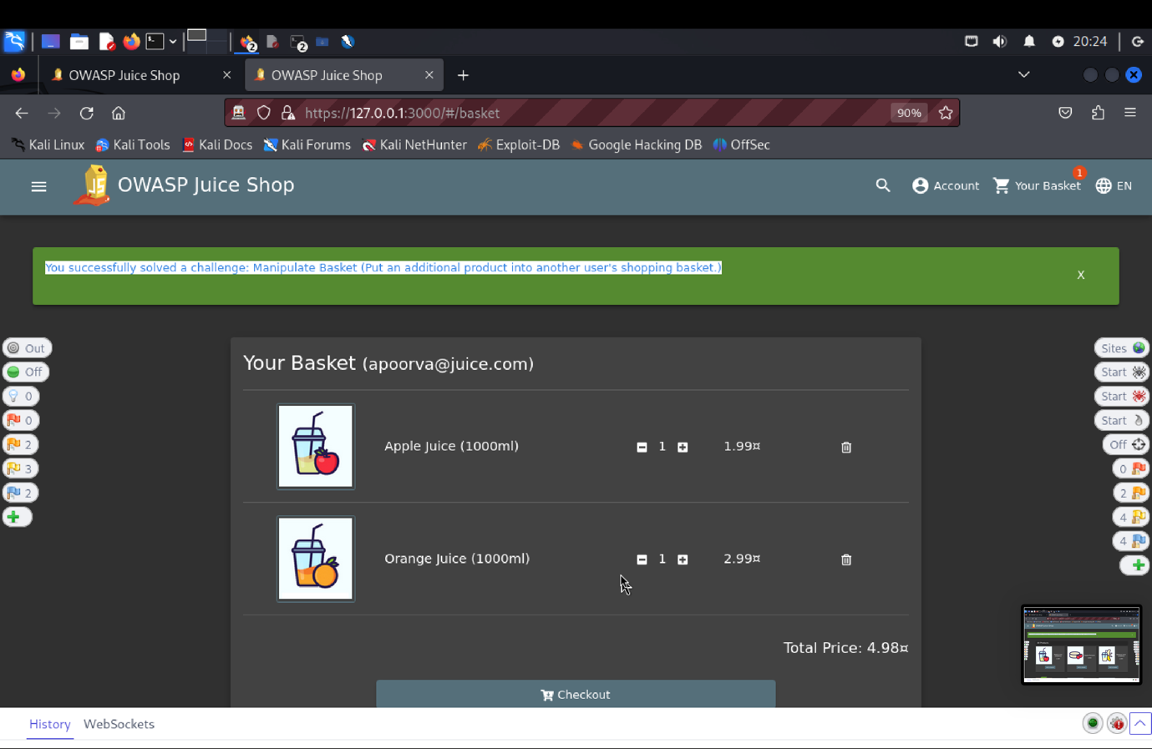

1. **Explanation of how the evidence included in (b) proves that FDP_ACC.1.1 is violated**:

To check the security of the "View Basket" feature in our Target of Evaluation (TOE), the OWASP Juice Shop, we performed a penetration test. We used the email address apoorva@juice.com and the password apoorva@1 to get in. ZAP was used to intercept the POST request to /api/BasketItems/ while adding an item to the basket. We violated the designated Security Functional Requirements (SFR) by altering the JSON payload to manipulate the basket ID field, resulting in several entries for various users. We were able to successfully alter the basket of another user thanks to our attack, exposing a serious security flaw.  
**Top of FormBottom of Form**

**SFR Identifier: FIA_UAU.1.2**

**Related vulnerability challenges**: Change Bender's Password, Login Bjoern, Password Strength, Two Factor Authentication

**Tested Vulnerability Challenges**:

**VC1**: Login Bjoern

(a) **Description of penetration testing**:

1. Penetration testing involved attempting to bypass the authentication mechanism to log in as the user Bjoern without valid credentials.
2. Navigate to the <https://127.0.0.1:3000/#/score-board> look at the description of Bjoren Challenge.
3. We need to use his gmail account and without reset we have to use the SQL injection or hack into his Google account.
4. So using the steps from Admin Section login as Admin and the find his gmail account.
5. We open the sources -> main.js. and search the methods related to Oauth, Login, userLogin.
6. Oauth is used for providing authorization to web applications.
7. We successfully find a method.

ngOnInit () (

Var e = this;

this.userService.oauthLogin(this.parseRedirectUrlParams().access_token).subscribe(o=>(

const a = btoa(o. email. split (“”). reverse().join(“”)):

this.userService.save(f

email: o.email,

password: a,

passwordRepeat: a

}).subscribe(()=>｛

this. login(o)}

1. From the above method, we can simply understand that the value of “a” and “password” are same.
2. Value of “a” is achieved by splitting the email, then reversing it, then joining it and lastly using the btoa() function.
3. Now using [bjoren.kimminich@gmail.com](mailto:bjoren.kimminich@gmail.com) copy it and inspect it navigate, in console paste the gmail email.
4. Now, [bjoren.kimminich@gmail.com.split(‘’).reverse(‘’).join(‘’)](mailto:bjoren.kimminich@gmail.com.split(‘’).reverse(‘’).join(‘’))
5. Now, use window.btoa([bjoren.kimminich@gmail.com.split(‘’).reverse(‘’).join(‘’)](mailto:bjoren.kimminich@gmail.com.split(‘’).reverse(‘’).join(‘’))). Copy this.
6. Navigate to login page and use email: [bjoren.kimminich@gmail.com](mailto:bjoren.kimminich@gmail.com.split(‘’).reverse(‘’).join(‘’)) and password : is the output of window.btoa([bjoren.kimminich@gmail.com.split(‘’).reverse(‘’).join(‘’)](mailto:bjoren.kimminich@gmail.com.split(‘’).reverse(‘’).join(‘’))).
7. This solves Bjoern Login.

(b) **Outcomes (evidence) of the penetration testing in (a)**: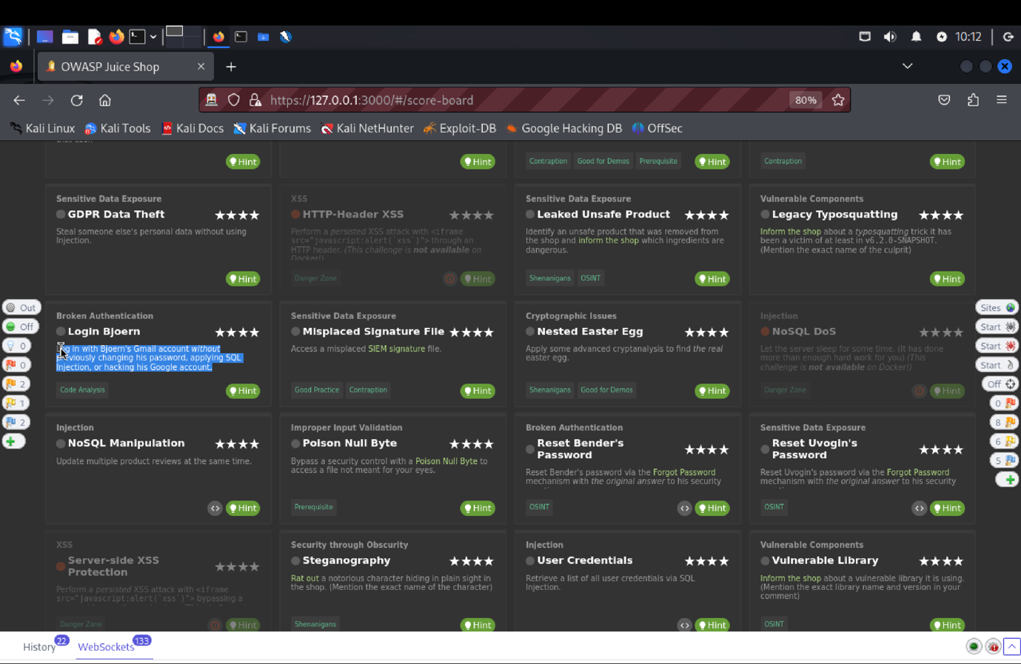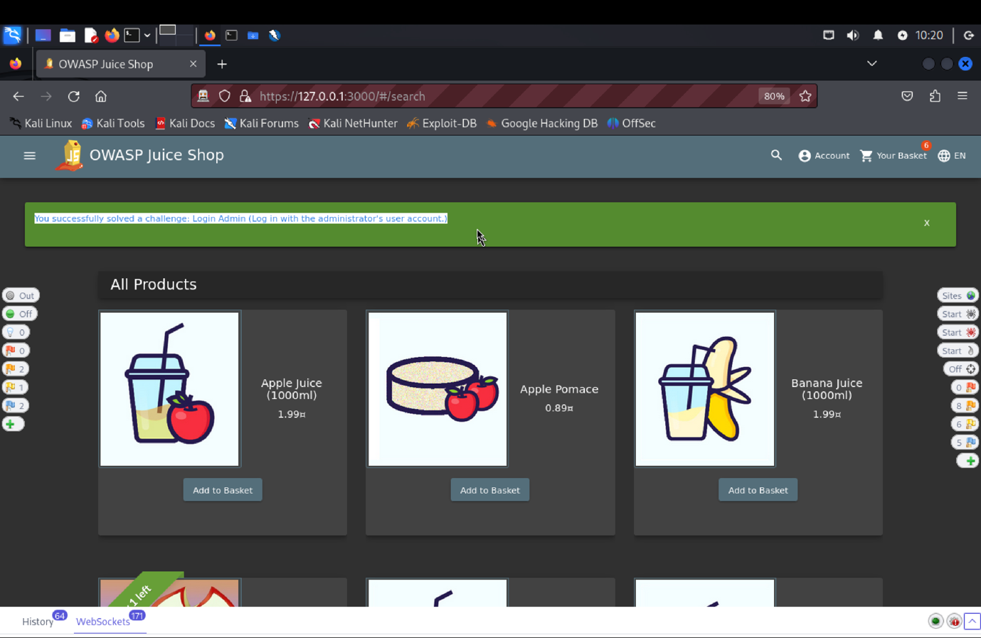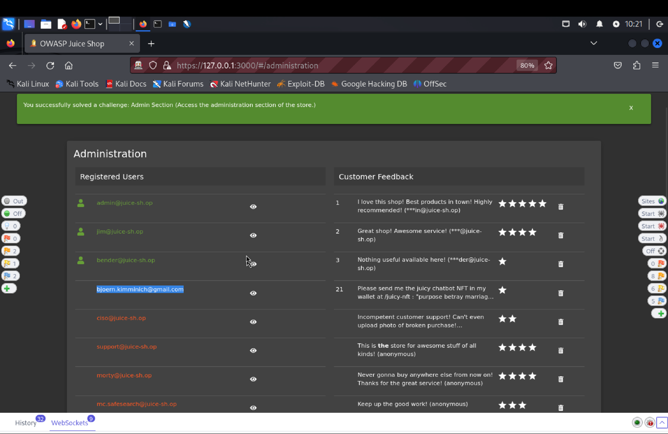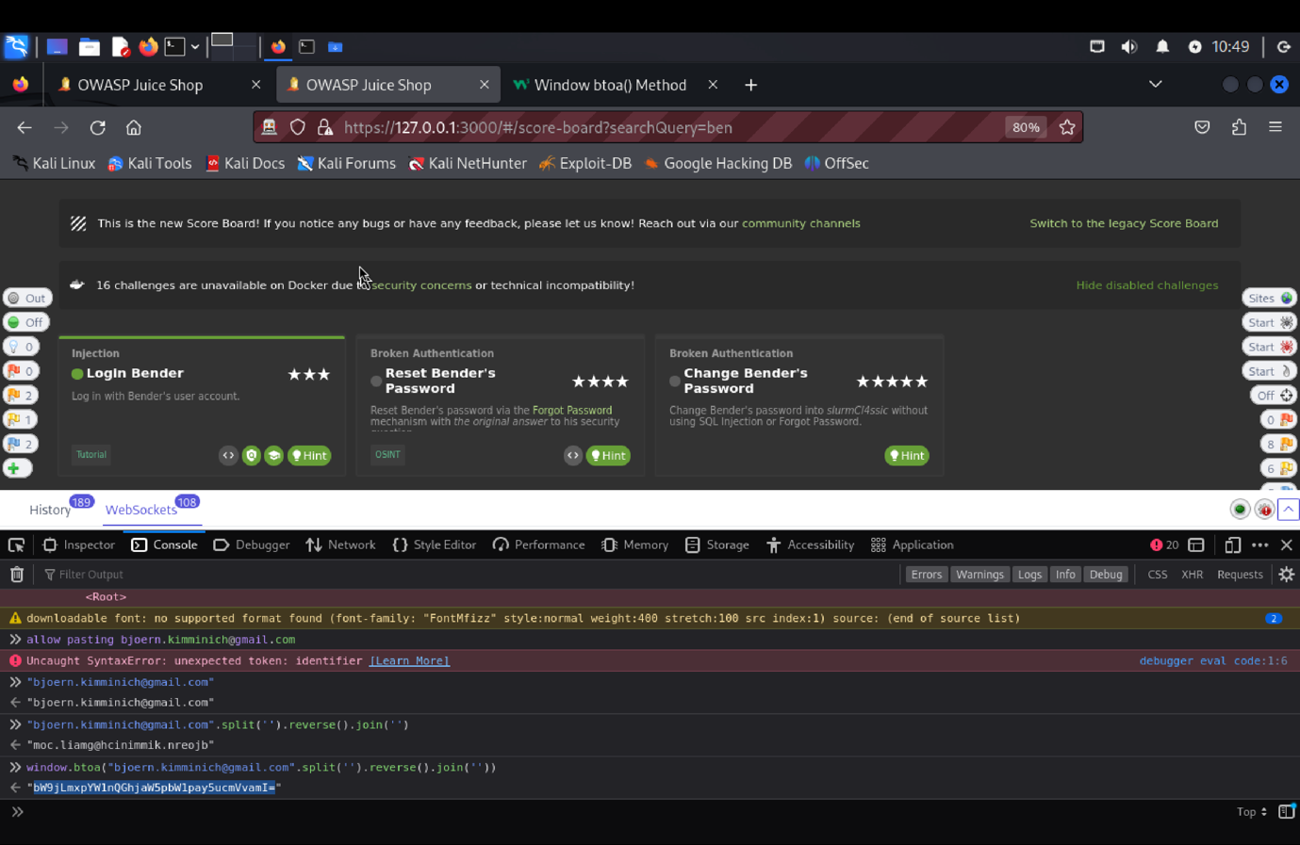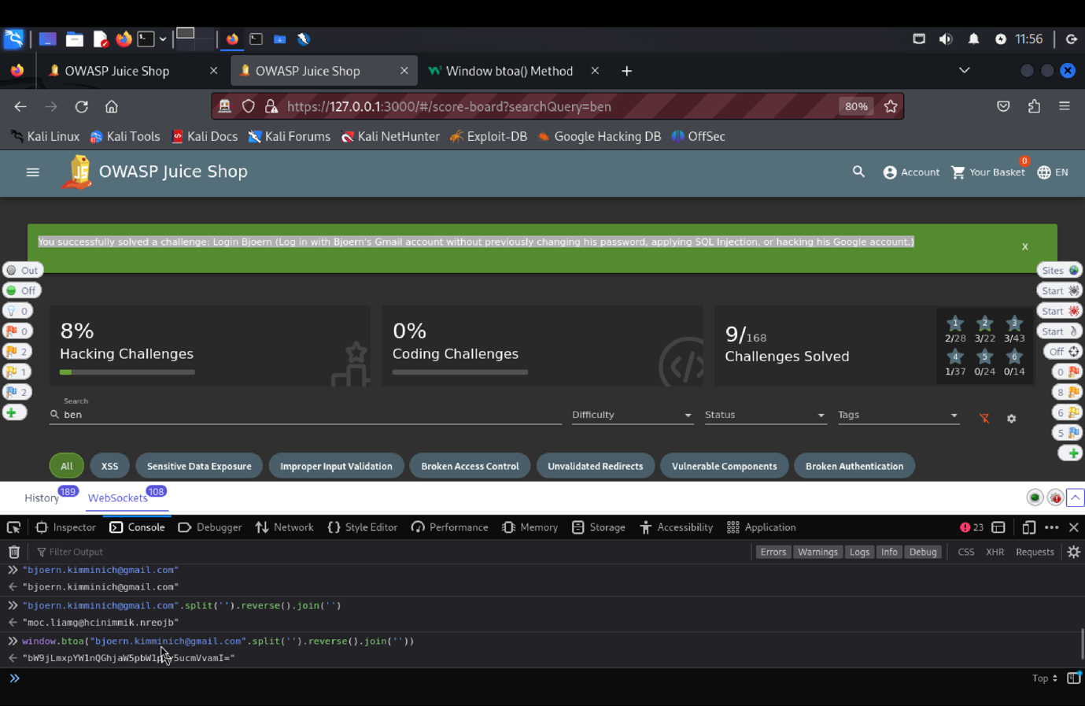

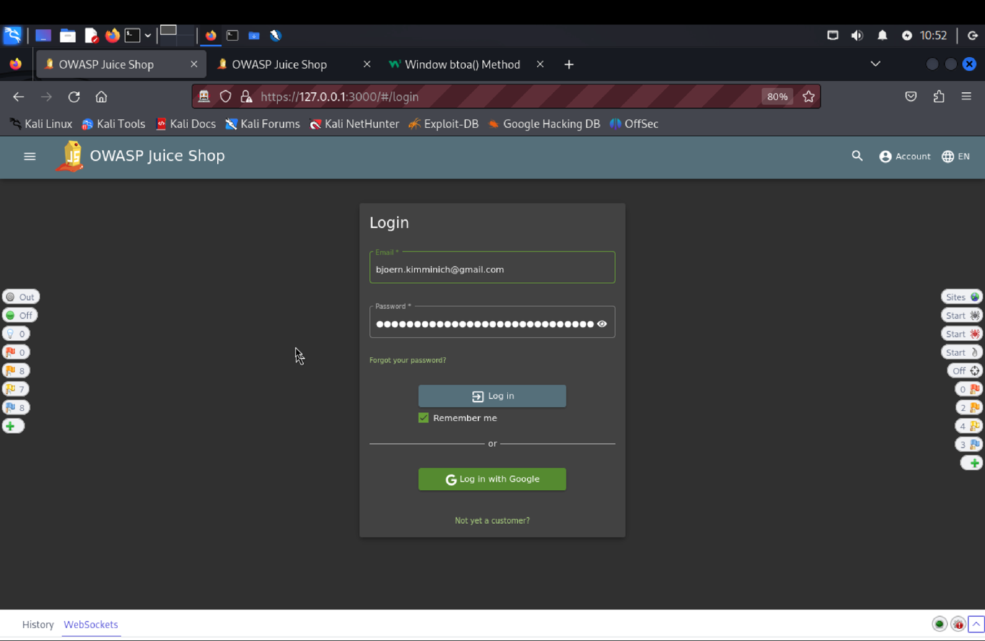

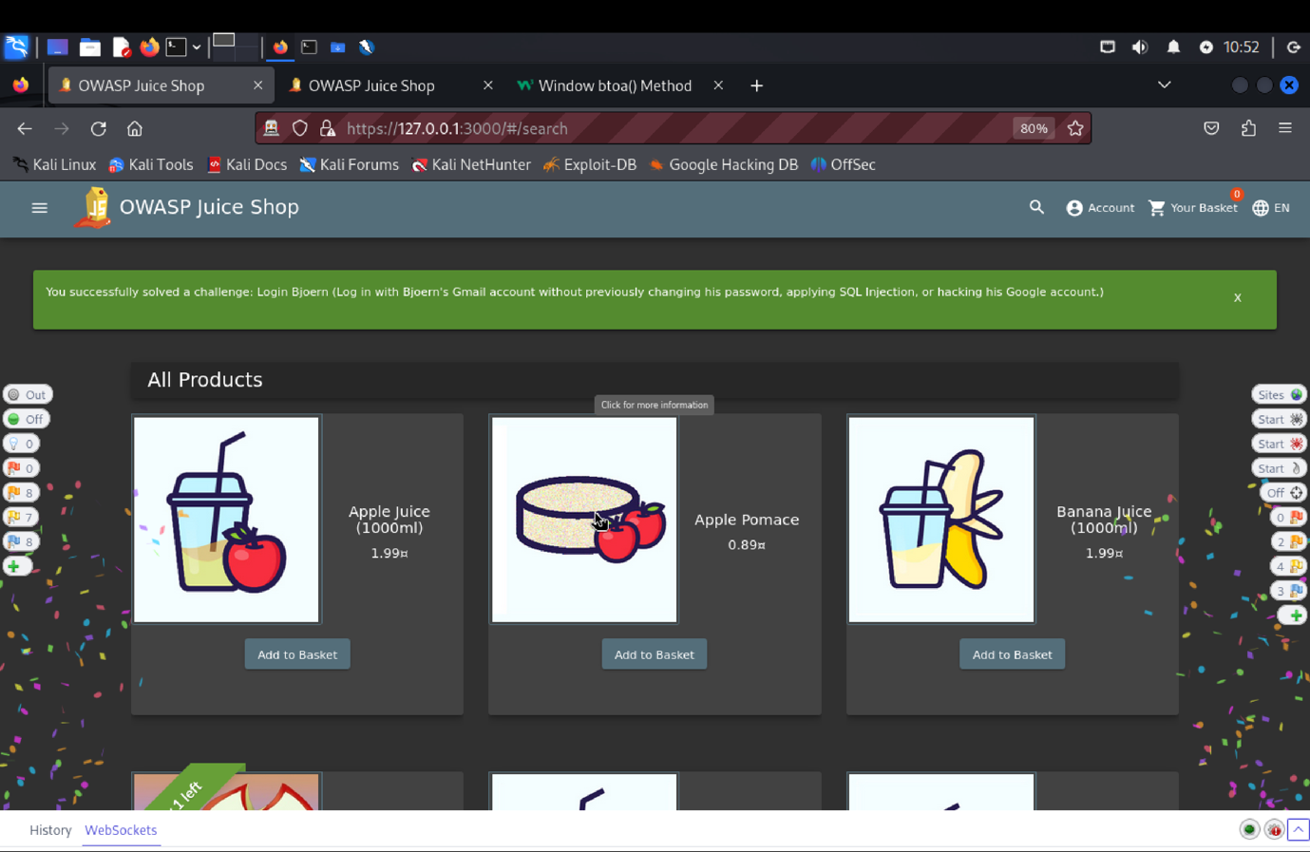

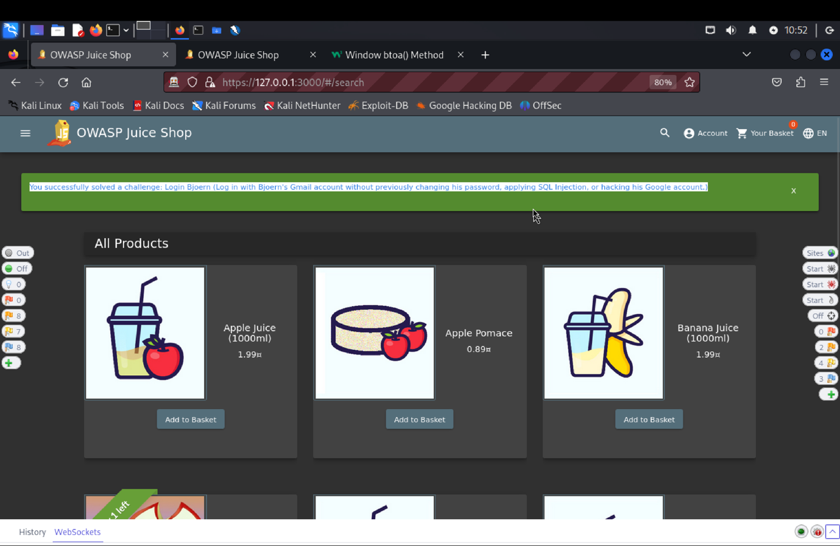

(c) **Explanation of how the evidence included in (b) proves that FIA_UAU.1.2 is violated**:

To test the "Login Bjoern" functionality, we attempted to bypass the authentication mechanism to log in as the user Bjoern without valid credentials. Then tester to the scoreboard page to understand the challenge, find under admin or under products find Bjoern's Gmail account had to be used without resetting the password, by either using SQL injection or hacking into his Google account.

From the Admin Section, logging in as an admin to locate Bjoern's Gmail account. In inspect element find **main.js** file, to identify methods related to OAuth, login, and user login. OAuth was being used for authorization, and the tester identified a method to potentially exploit.

This approach enabled the tester to bypass the typical authentication process and gain unauthorized access to the account, revealing a vulnerability in the application's login mechanism.

Top of Form

Bottom of Form

**Login Jim**

1. **Description of penetration testing that was carried out.**
2. Start the application and find jim’s email somewhere the posted review under product or login as admin.
3. Use this email and try out some random password just to trigger the POST Method in the Zap.
4. In zap send this to the Repeater. Inside the repeater update the email by adding ‘-- at the end i.e. [jim@juice-sh.op](mailto:jim@juice-sh.op) give the password of your choice.
5. Click on send. Now we get the 200 status response which means that jim’s account is reset hence we solved the challenge.
6. One more way is to use sql injection:
7. Go to the folder in the terminal make a new file using gedit login.txt
8. Copy paste the Request format and update the password
9. The use sqlmap -r login.txt. give Y, Y and N response. And if tell you any error use sqlmap -r –ignore-code=401.
10. This Resets the password and we solve the challenge.

(b) **Outcomes (evidence) of the penetration testing in (a)**: 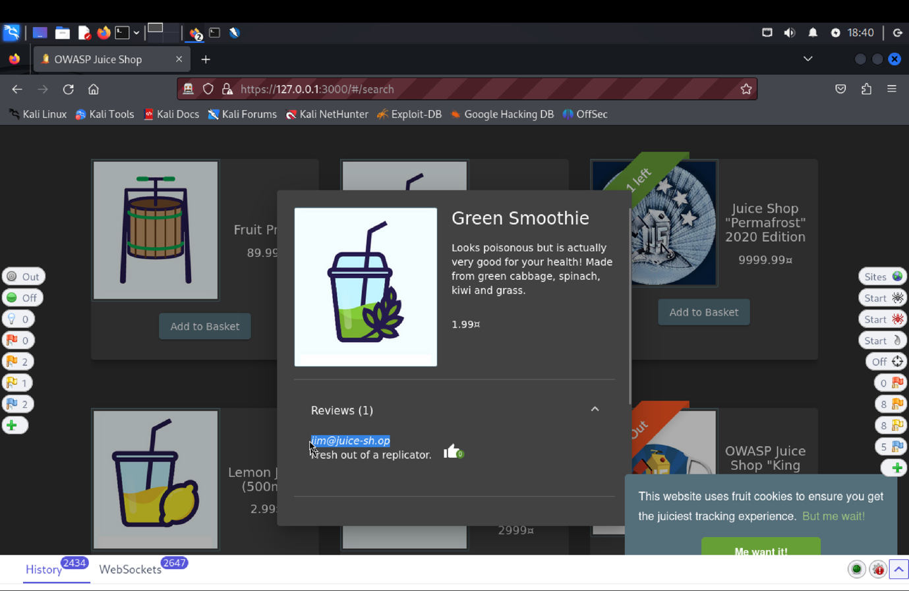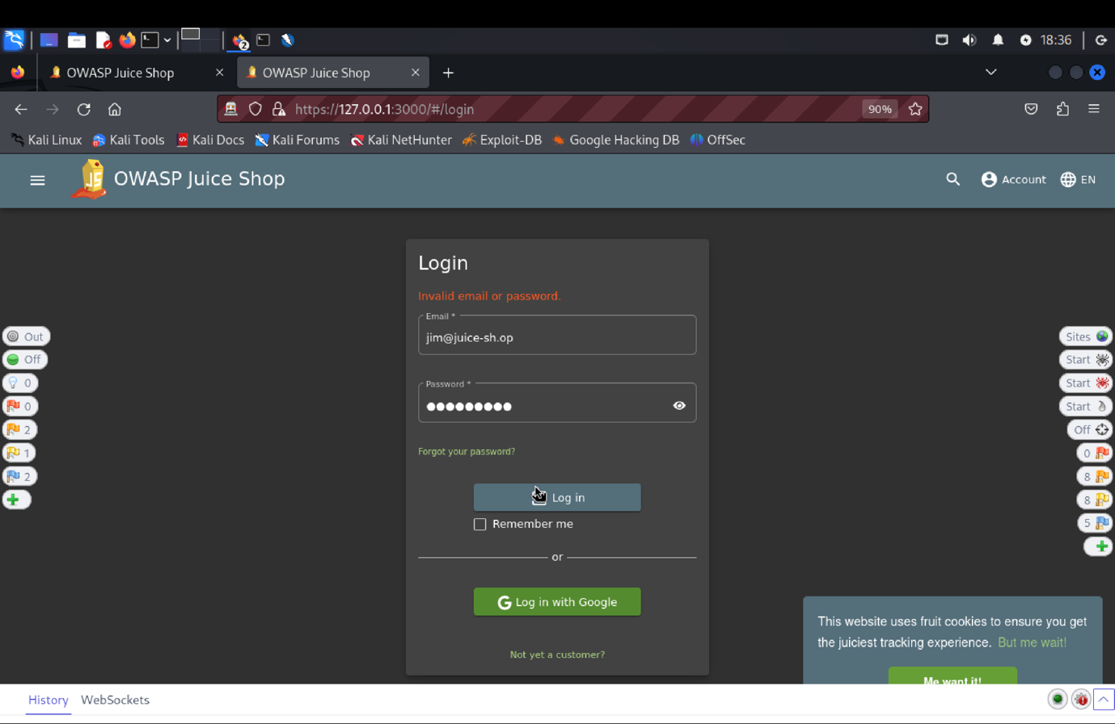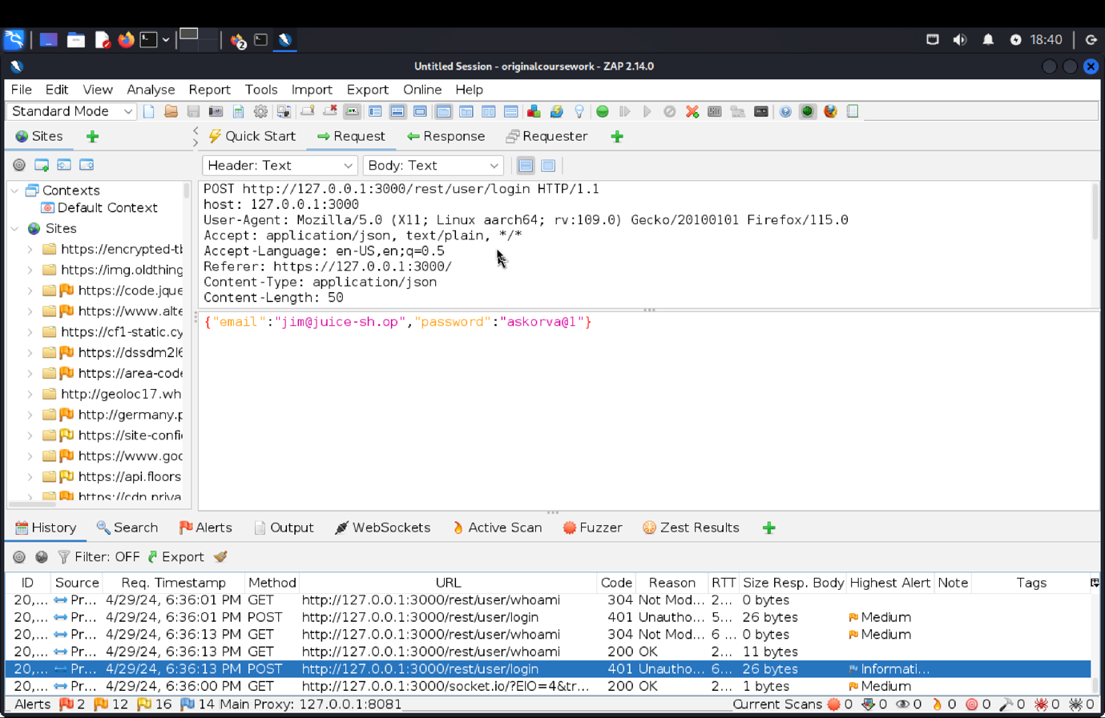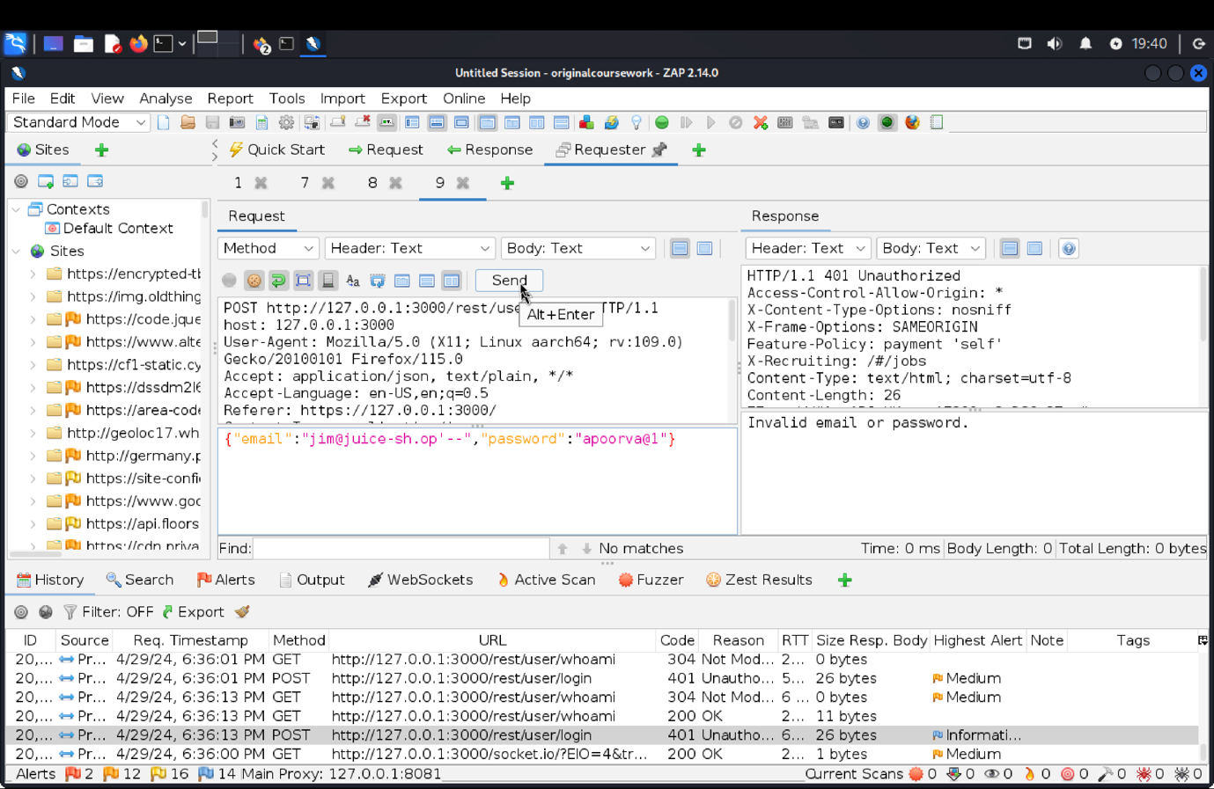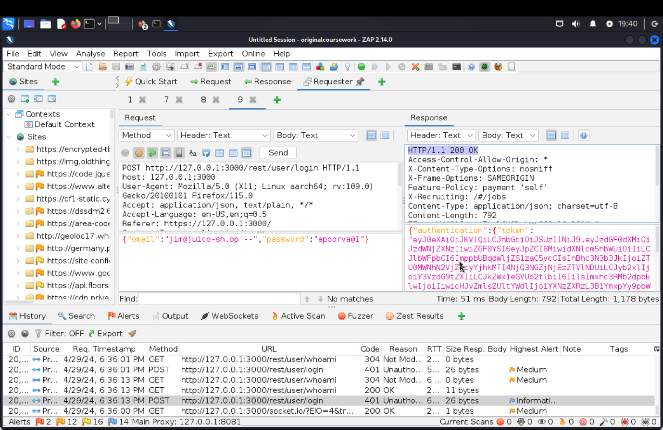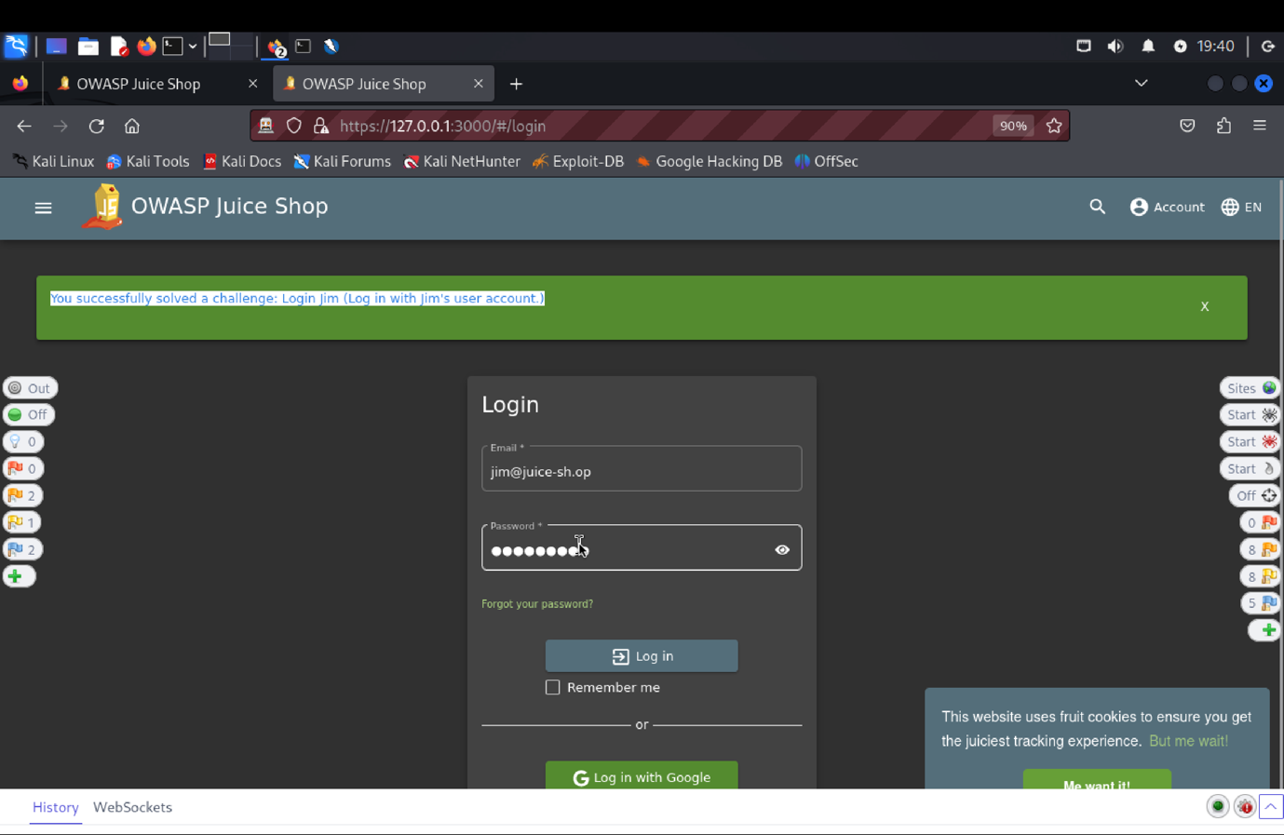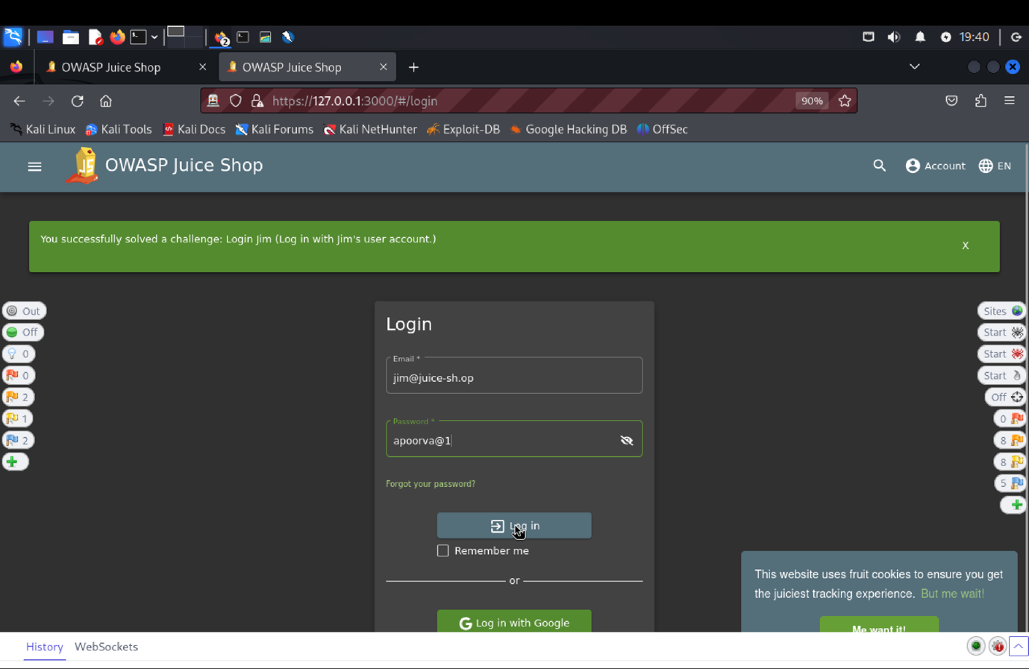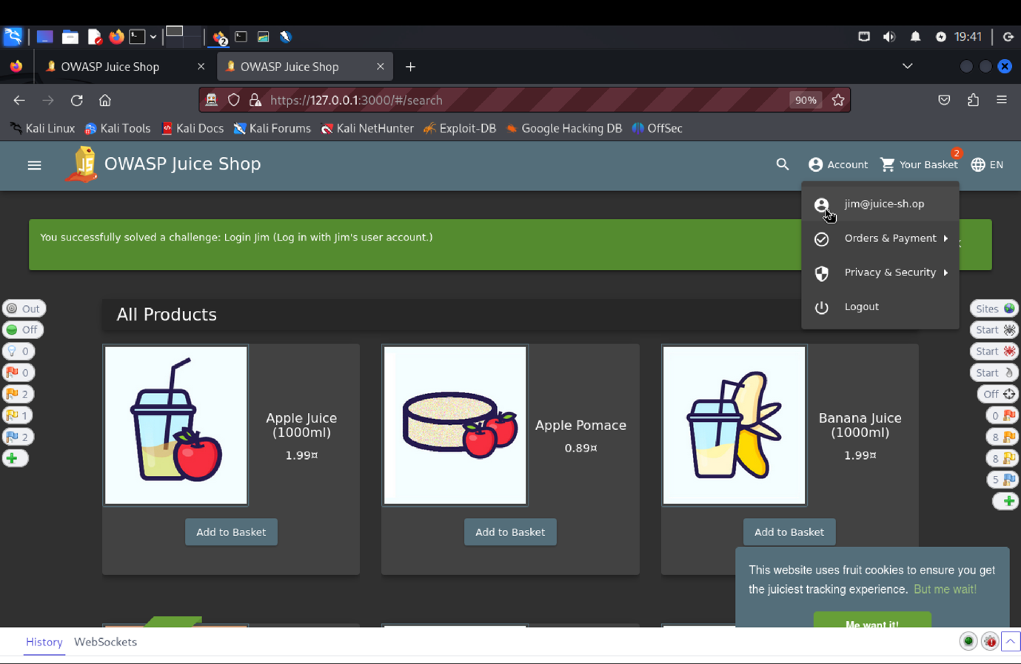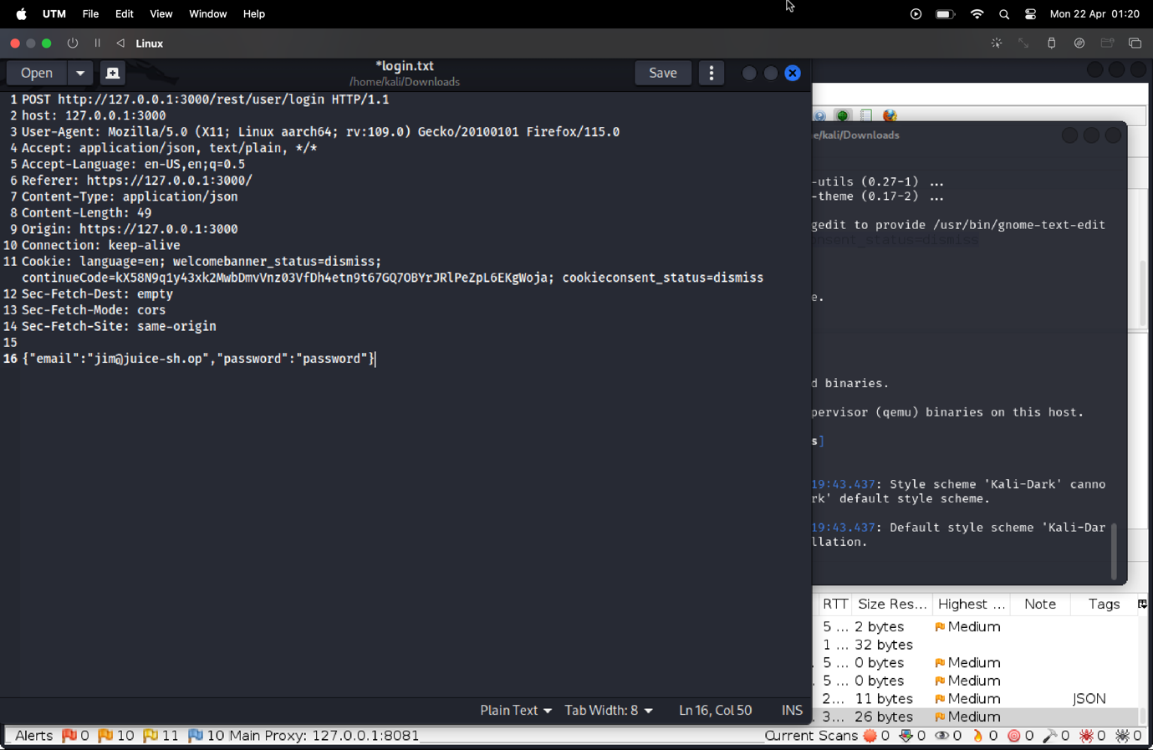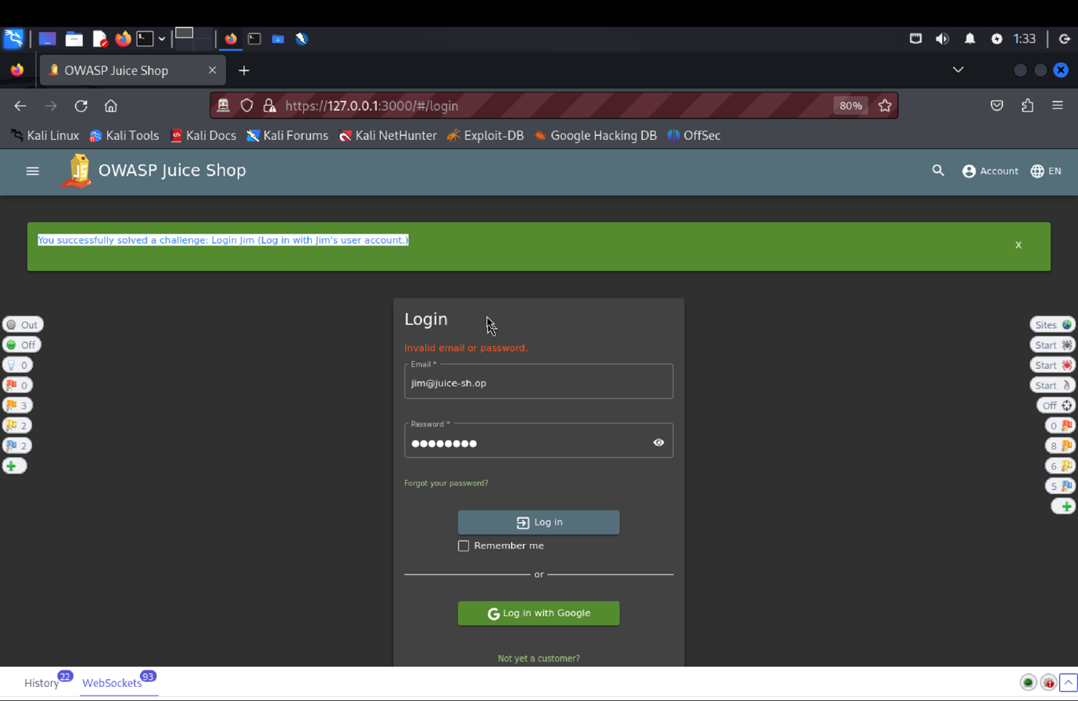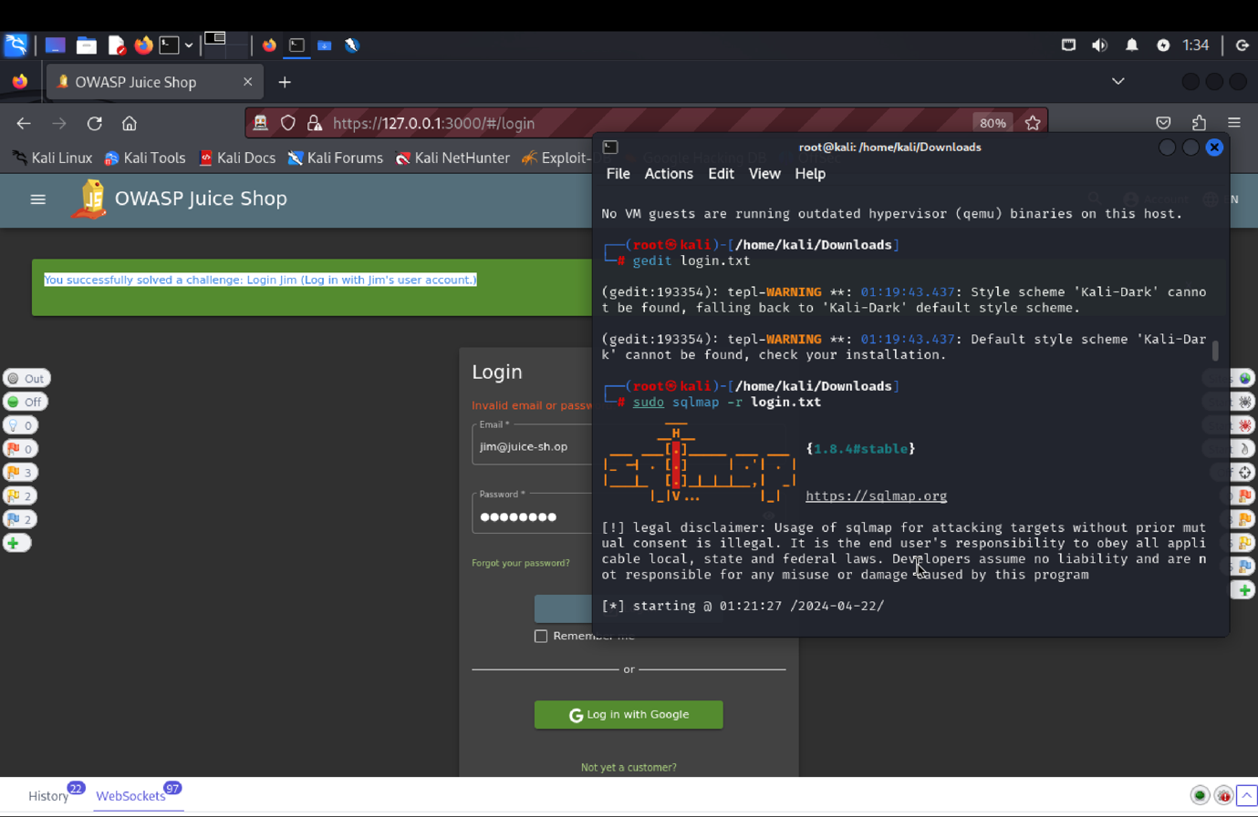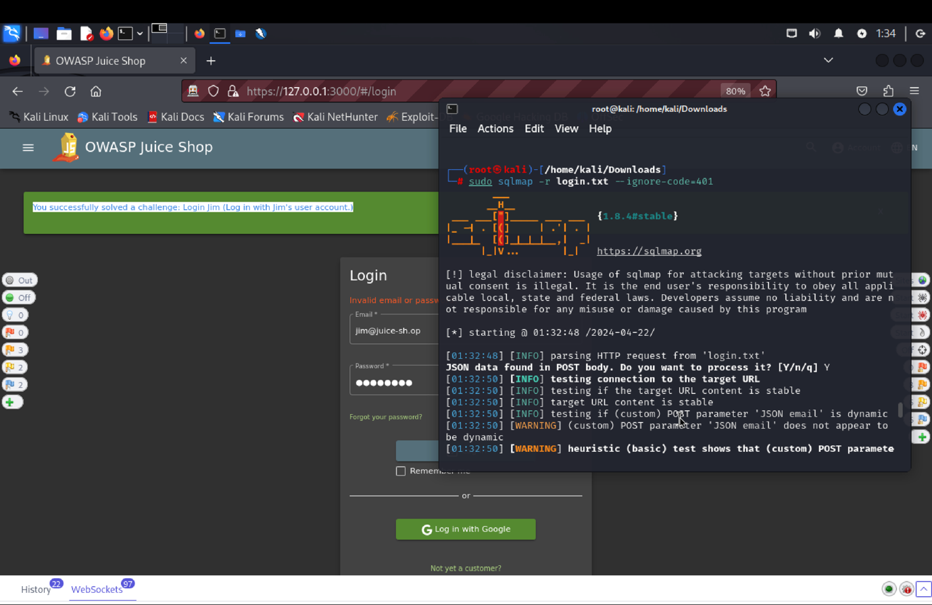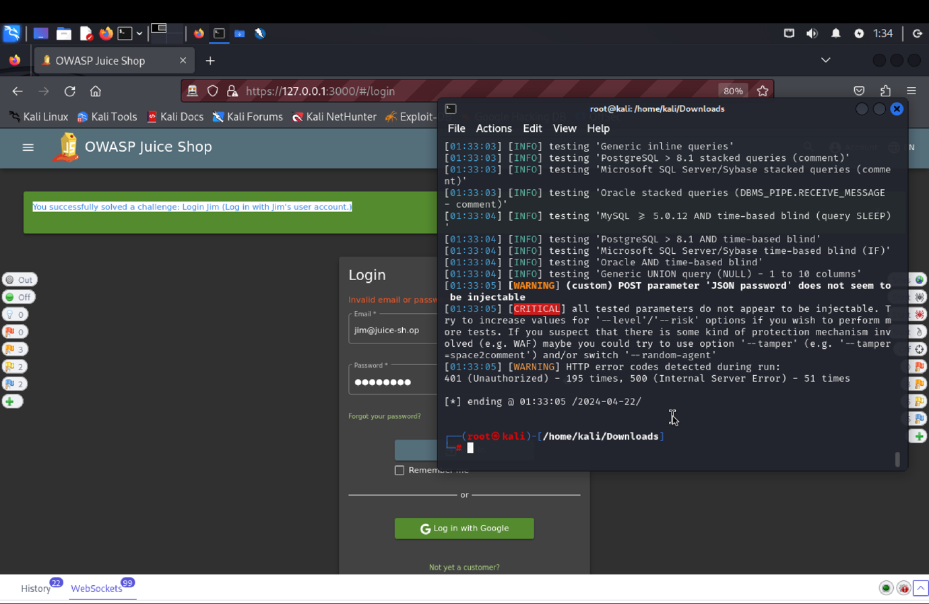

(c) **Explanation of how the evidence included in (b) proves that FIA_UAU.1.2 is violated**:

Found Jim's email by signing in as an administrator or by looking up his reviews that were posted.  Then tried to use a randomly generated password to log in and initiate ZAP's POST technique. Then added -- and provided any password to Jim's email address, jim@juice-sh.op, using ZAP's repeater. Jim's account was reset after sending this, which resolved the challenge, according to a 200 answer.  
  
An further technique made use of SQL injection. Using SQLMap (sqlmap -r login.txt), we generated a file called login.txt that included the login request. Once the tester successfully reset the password (usually "Y", "Y", and "N") or disregarded problems, the challenge was accomplished.  
  
Through this test, failures in the system were exposed, showing how attackers might alter login requests or bypass authentication using SQL injection.

**SFR Identifier: FDP** **_UAU.3.1**

**FIA_UAU 3.1: The TOE shall prevent use of authentication data that has been forged by any user of the TOE.**

**Related Vulnerability Challenges: -**

1. **Forged Feedback**
2. **Forged Review**
3. **CSRF**
4. **Forged Coupon**
5. **Admin Registration**
6. **Login Bjoern**
7. **Login Bender**
8. **Login Admin**

**Tested Vulnerability Challenges: -**

**1) Forged Feedback: Post some feedback in another user’s name.**

**a) Description of penetration testing that was carried out.**

1. Open the customer feedback page which is found under the 3 line by clicking the button on the top left corner of the homepage.
2. We can here write down the comment, as provide the rating, and solve the captcha in order to successfully post the feedback.
3. I gave comment as “feedback” with 5 star rating and captcha as 96. In ZAP there is POST request (<http://127.0.0.1:3000/api/feedbacks/>), with “201 created” response code.
4. The request body will contain {"captchaId" :1, "captcha": "6", "comment": "feedback (anonymous) ","rating" :5}.
5. The user id is hidden since in the response body, there is a key/value field named “UserId”: null.
6. Right click in the UI screen and open inspect console of Customer feedback there above the author field we can see that user id is hidden field.
7. We will remove the “hidden” attribute for userId field to unhide the input field.
8. Now, we can see the user id so we can enter some valid userId, add some comment and rating and submit it.
9. We can see new feedback was successfully created with “userId”:3 in the request body with “201 created” response code.
10. In this way, we forged a feedback using another’s userId, resulting in violation of the SFR.

**b) Outcomes/Evidence of the Penetration Testing.**

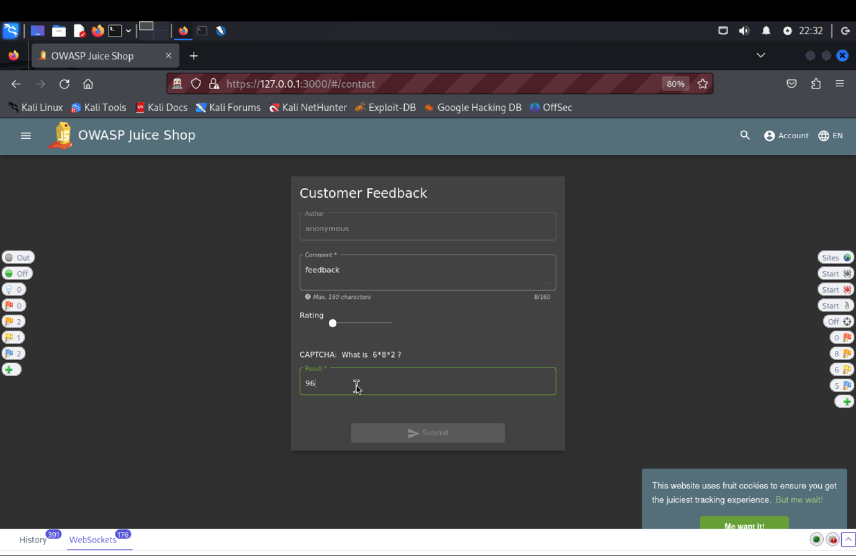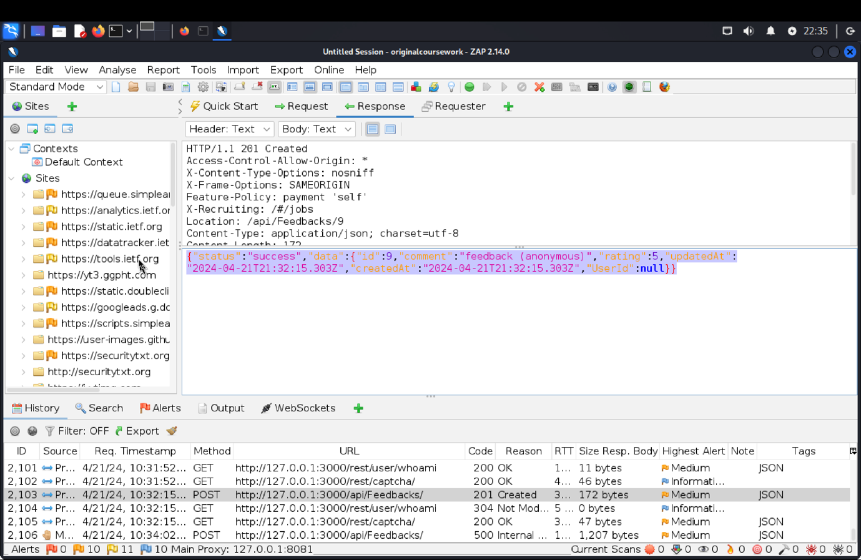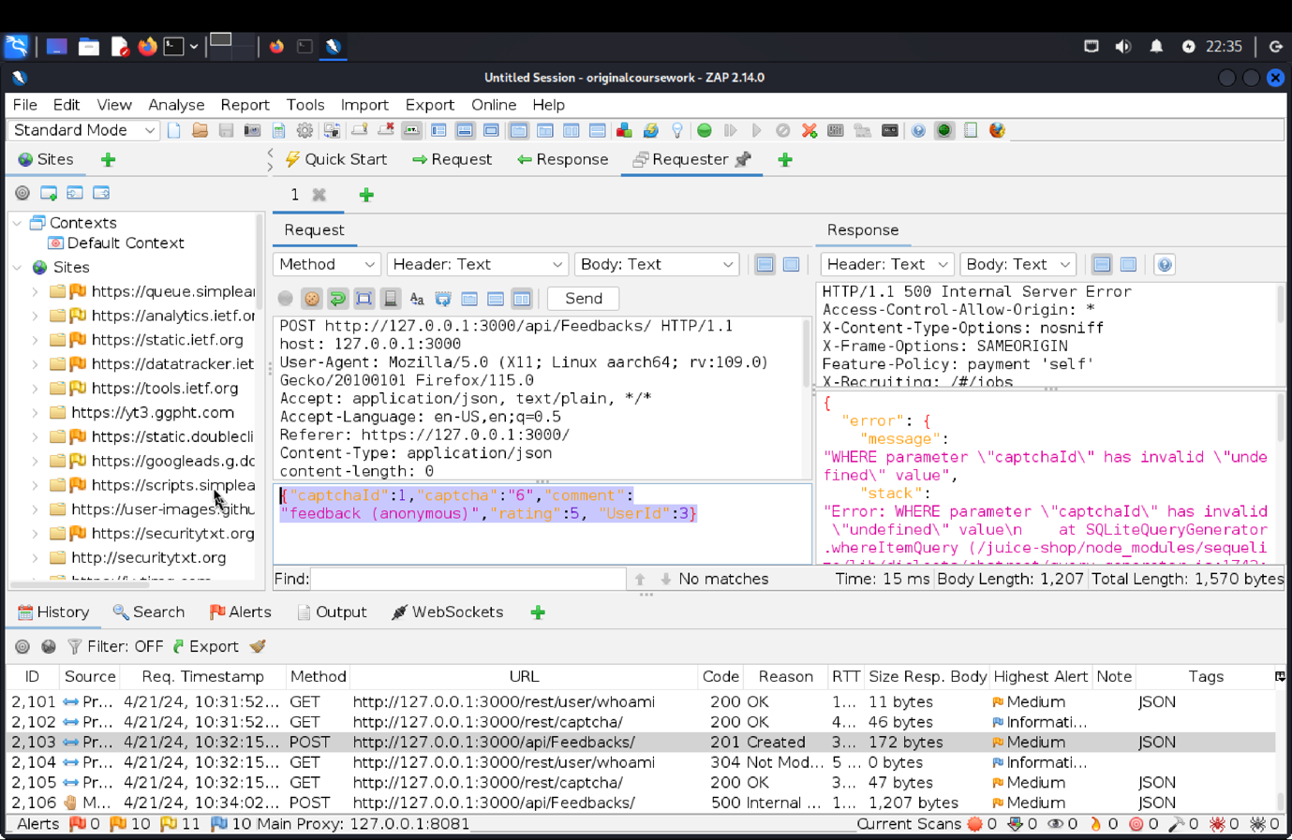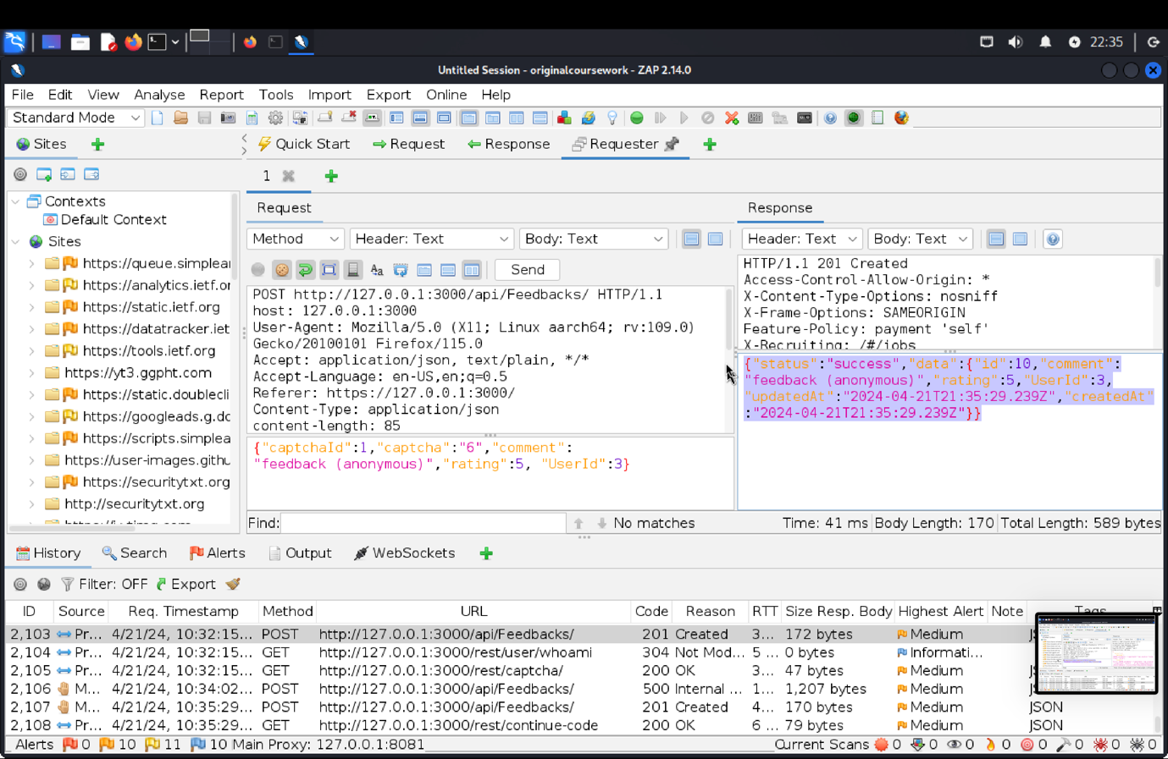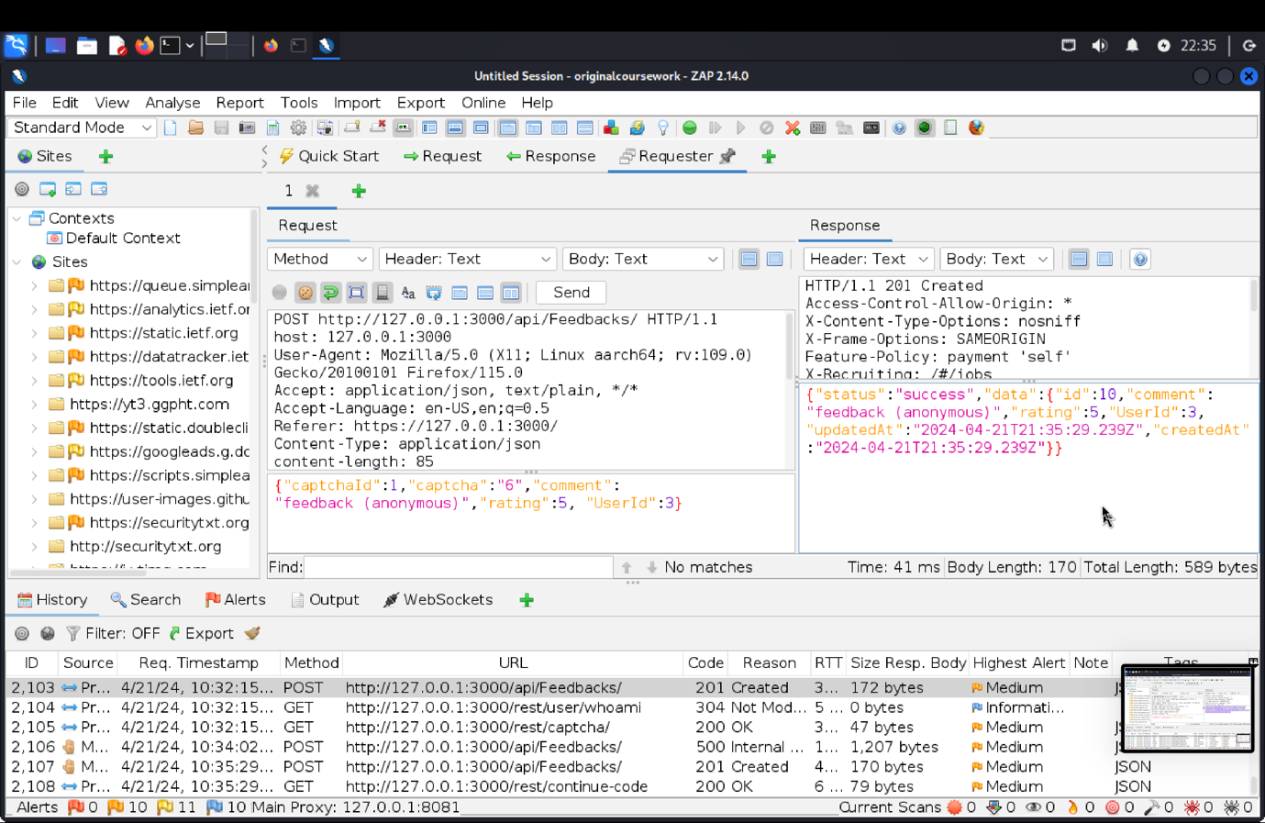 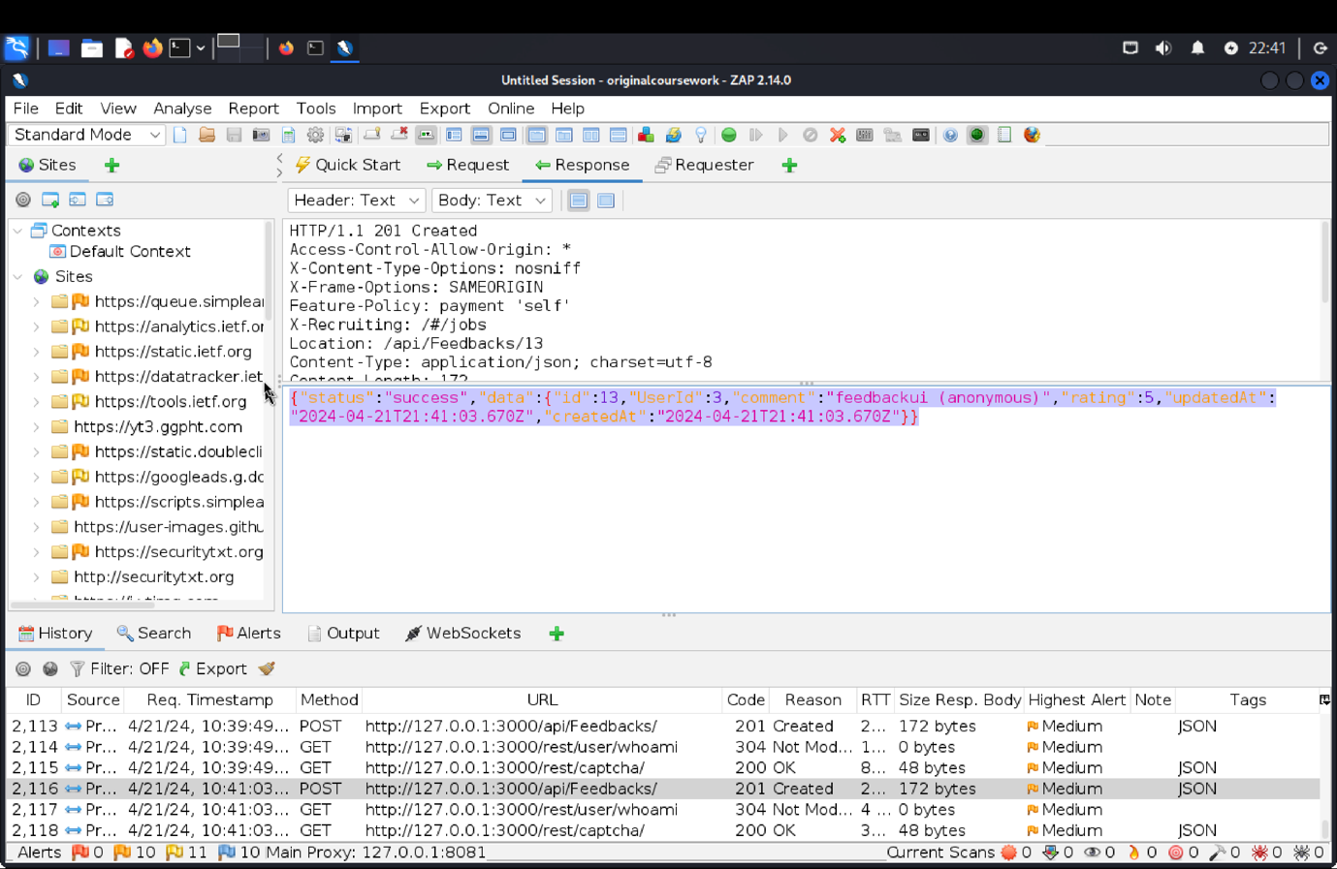 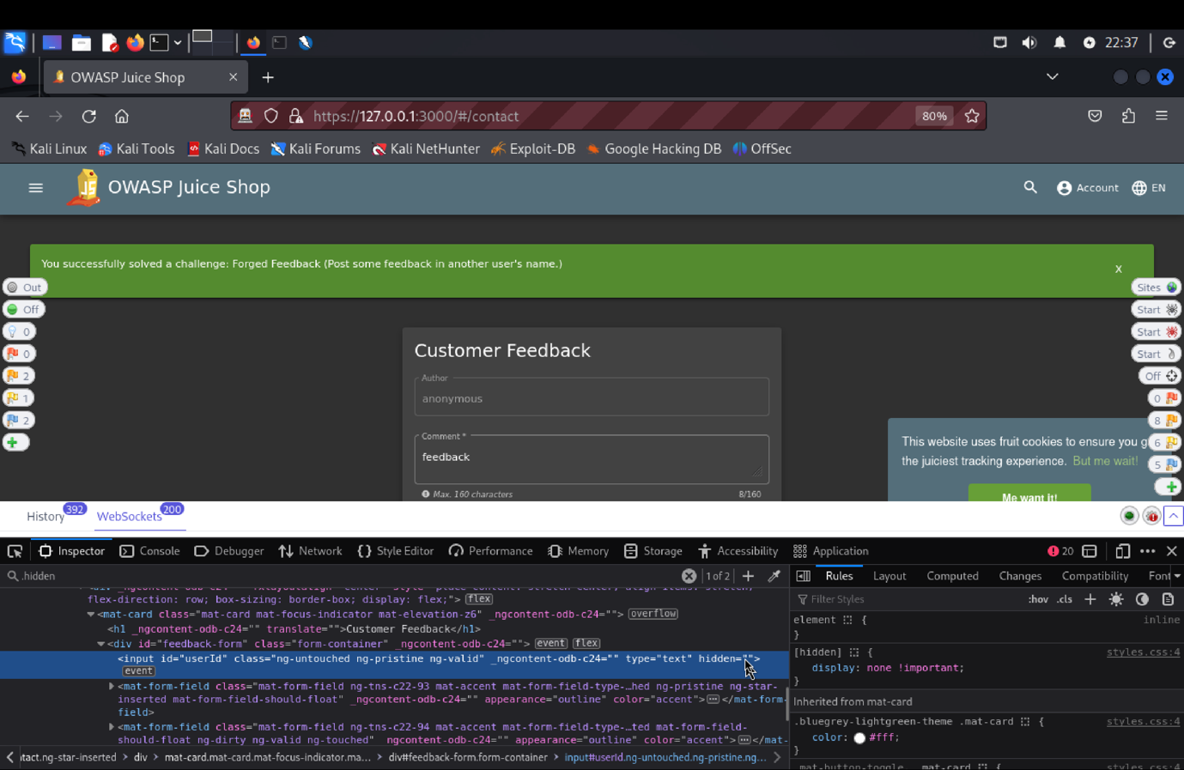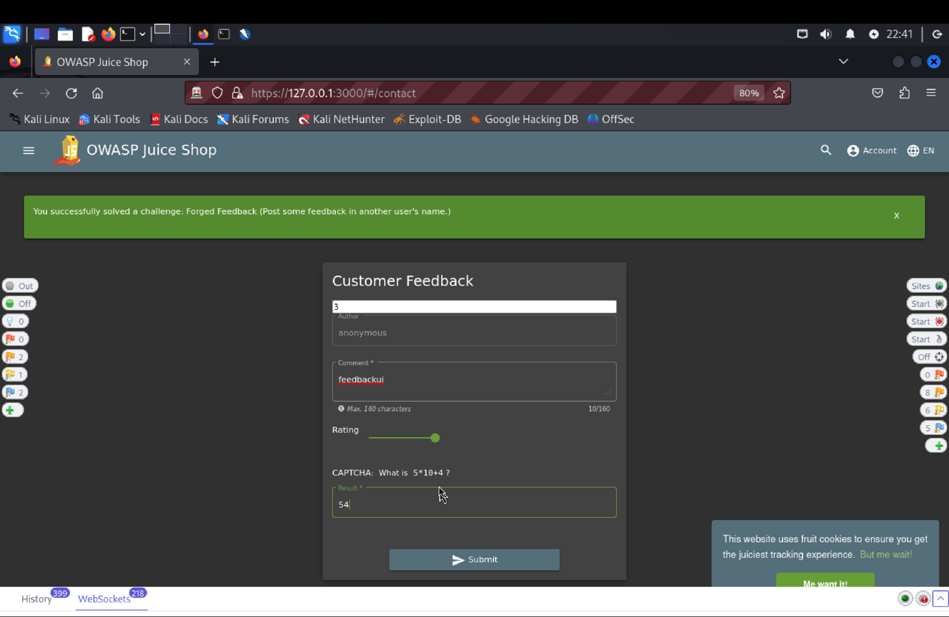

(c) **Explanation of how the evidence included in (b) proves that FIA_UAU.1.2 is violated**:

Started by accessing the page for customer feedback. In order to post the feedback, we answered the captcha, gave rating, and gave feedback. The POST request to /api/feedbacks/ using ZAP; this request resulted in a "201 Created" response.  
  
Fields for the captcha ID, remark, rating, and hidden user ID were all present in the request body. After that, the user ID field was visible after inspecting the console and removing the "hidden" property. Once a legitimate user ID was entered, a new comment and rating were added, and the feedback was successfully forged using the ID of another user. This proved that the security functional requirement (SFR) had been broken.  
  
The vulnerability was found through a successful penetration test, emphasizing the need for improved input validation and more robust access control measures to stop unauthorized individuals from

**VC: Forged Review -** Post a product review as another user or edit any user’s existing review.

**Tested Vulnerability Challenges**:

**VC1**: Forged Review

(a) **Description of penetration testing**:

1. Login to juice shop store using email = asd@asd.com,

password = asd@123.

1. After successful login, added a review “ApoorvaCoursework” for Lemon Juice(500ml) item.
2. We could see a PUT http://127.0.0.1:3000/rest/products/5/reviews request in the request header and review message i.e. {“message”: “ApoorvaCoursework”, “author”: “asd@asd.com”} in request body.
3. Copy the entire request header part and paste them in requester.
4. Edit the message and author name to some another user (I have used author name as asdf@asdf.com) in the requester body part.
5. New requester body json object {“message”: “ApoorvaCourseworkforgedreview”, “author”: “asdf@asdf.com”}
6. Click on send.
7. A json object {“status” : “success”} will be received in response.
8. This means that a new review was created for Lemon juice item with author name “asdf@asdf.com”.
9. Thus, Breaking the access control and solving the challenge.

(b) **Outcomes (evidence) of the penetration testing in (a)**: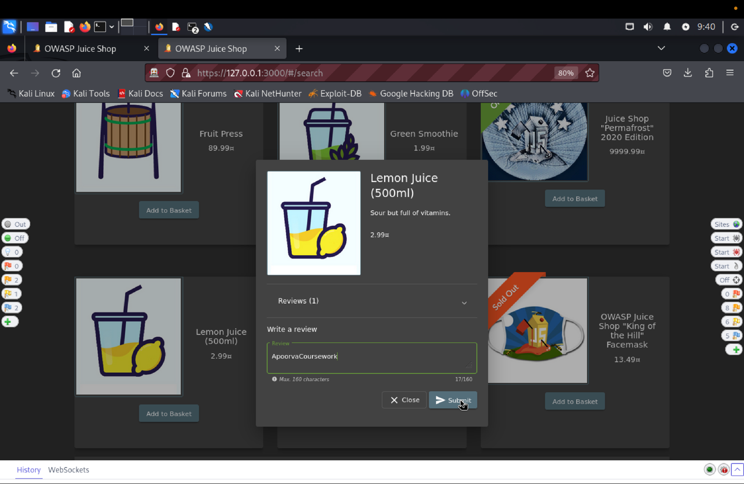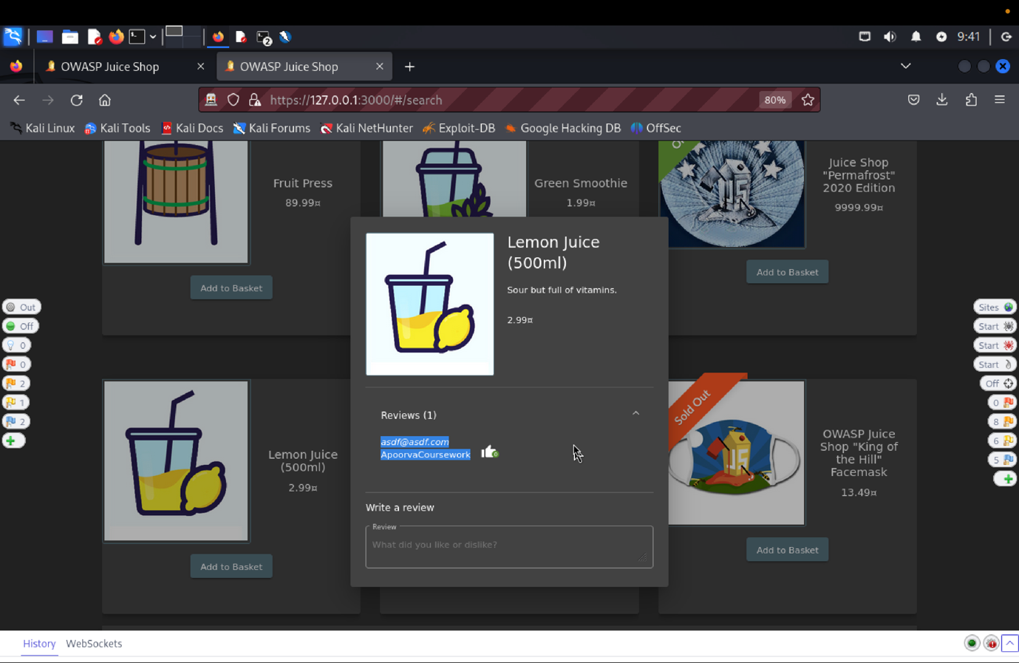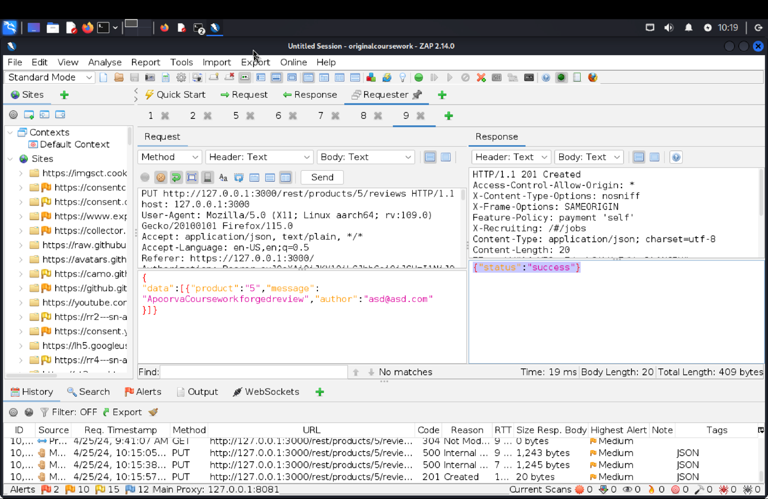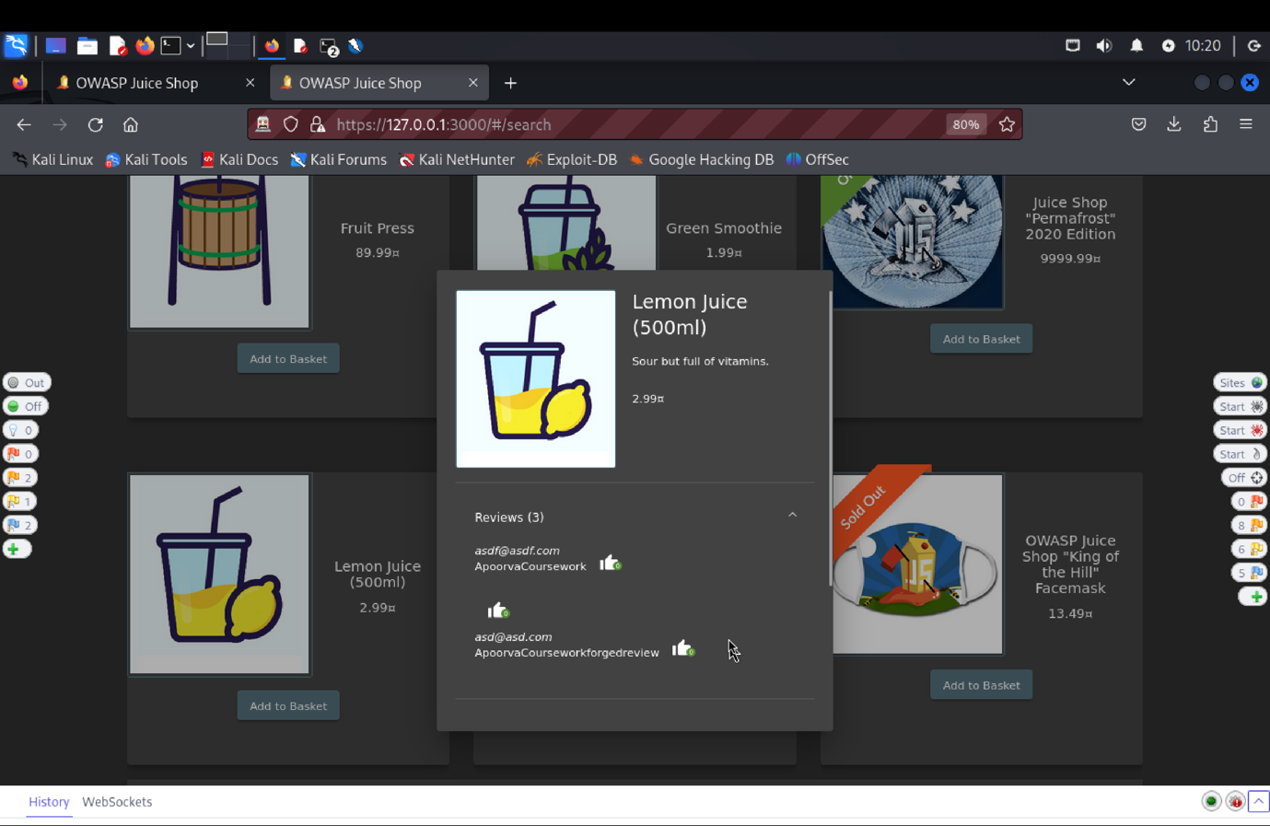

(c) **Explanation of how the evidence included in (b) proves that FDP_ACC.1.1 is violated**:

To evaluate the "Forged Review" vulnerability, we began by logging into the Juice Shop using the email asd@asd.com and the password asd@123. After logging in, we added a review titled "ApoorvaCoursework" for the Lemon Juice (500ml) item.

We started by utilizing the email address asd@asd.com and the password asd@123 to log into the Juice Shop in order to assess the "Forged Review" vulnerability. We added a review for the 500ml Lemon Juice item with the title "ApoorvaCoursework" after logging in.  
  
A PUT request was detected with the review message {"message": "ApoorvaCoursework", "author": "asd@asd.com"} in the request body, and the request header  /rest/products/5/reviews. The request header was copied and pasted into the requester.  
  
Then, we created a new JSON object {"message": "ApoorvaCourseworkforgedreview", "author": "asdf@asdf.com"} and changed the message and author name to belong to pretend that it is a different user. We successfully created a new review for Lemon Juice with the author asdf@asdf.com, according to the JSON response we obtained after sending this updated request, with the status being "success."

This test demonstrated a lack of proper access control, allowing unauthorized creation of forged reviews and revealing the vulnerability.

**Tested Vulnerability Challenges: -**

1. **Reset Jim’s Password:** Reset Jim’s password via the Forgot Password mechanism with the truthful answer to his security question.
2. **Description of penetration testing that was carried out.**
3. Logged in using admin email Id as shown in Admin Section or use= asd@asd.com, password = asd@123 to find the email of user Jim.
4. Or Under the Green Smoothie item, find Jim’s id as “**jim@juice-sh.op**”
5. Next, we click on Login->Forget Password
6. Using the above Jim’s email id, Security question answer as anything you want (I have entered Apoorva), new password = jim@123, repeat password = jim@123.
7. Click on change.
8. The request json object will be **{“email”: “jim@juice-sh.op”, “answer”:”Henry”, “new”:”jim@123”, “repeat”:”jim@123”}.**
9. 401 Unauthorized error is triggered which says, “**Wrong answer to security question**”.
10. We search for list of sibling names of James on google basically the idea is to try as many names as possible I almost gave 100-150 names.
11. Using these values we create a Fuzz attack payload by selecting security question value field.
12. One of the values i.e. **“Samuel”** gets 200 Ok response. This indicates Jim’s eldest sibling name is Samuel.
13. In this way, Jim’s password reset was successful by copying the authentication data for another user of the TOE.
14. **Outcomes/Evidence of the Penetration Testing**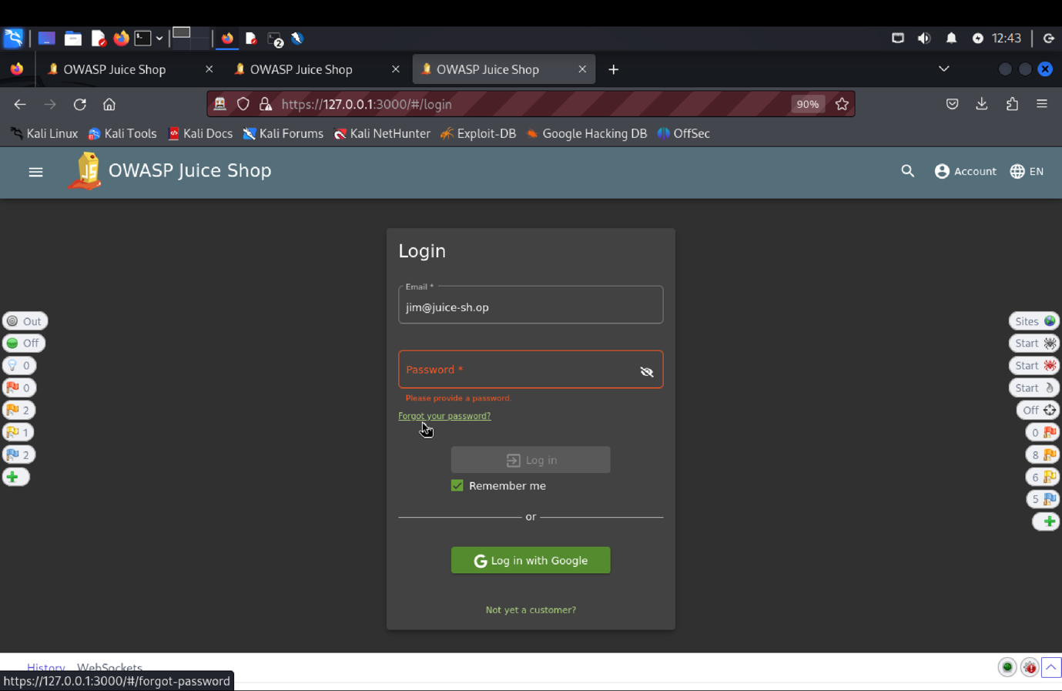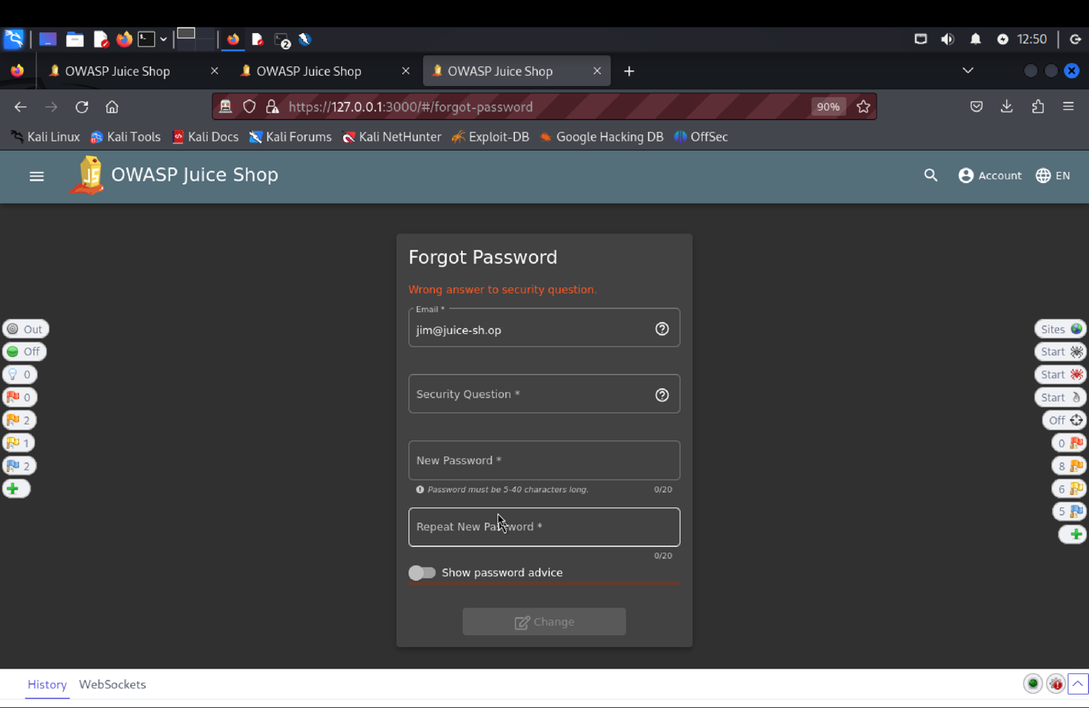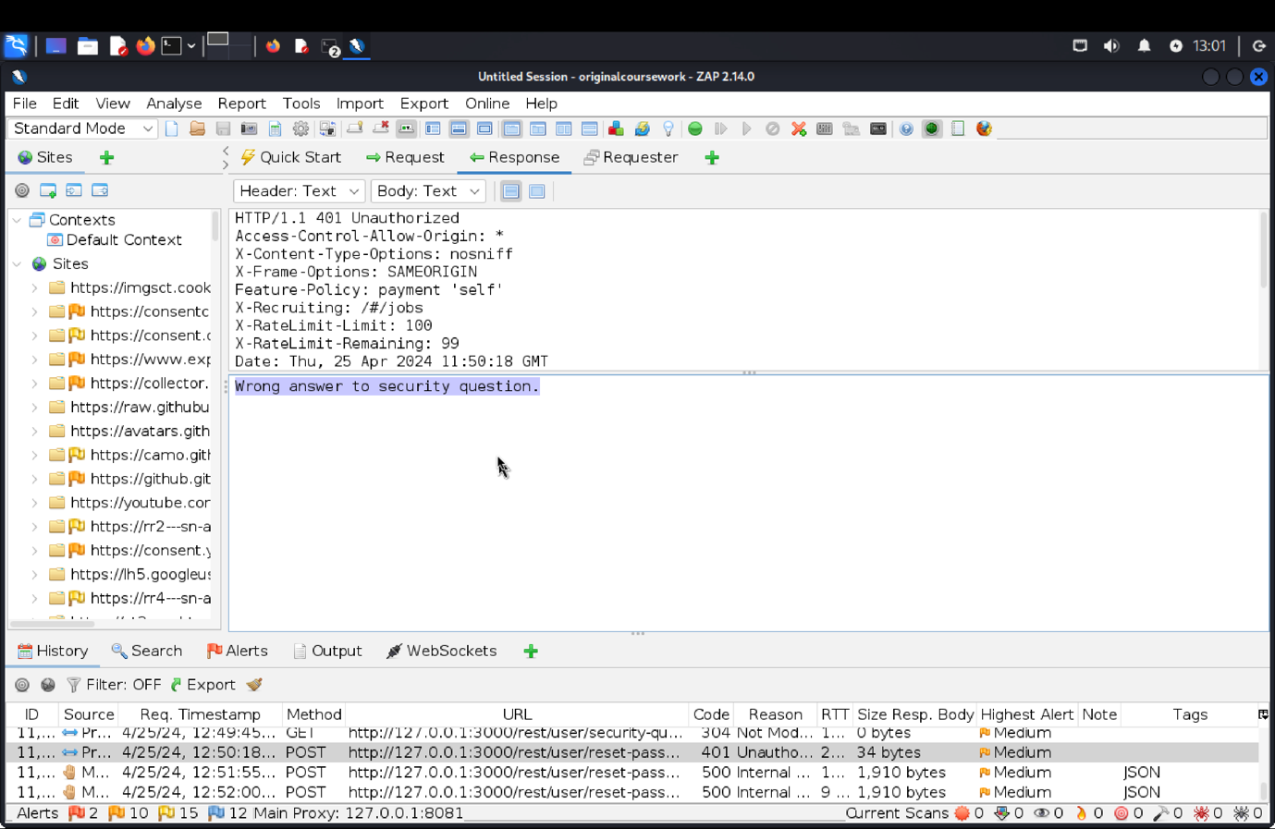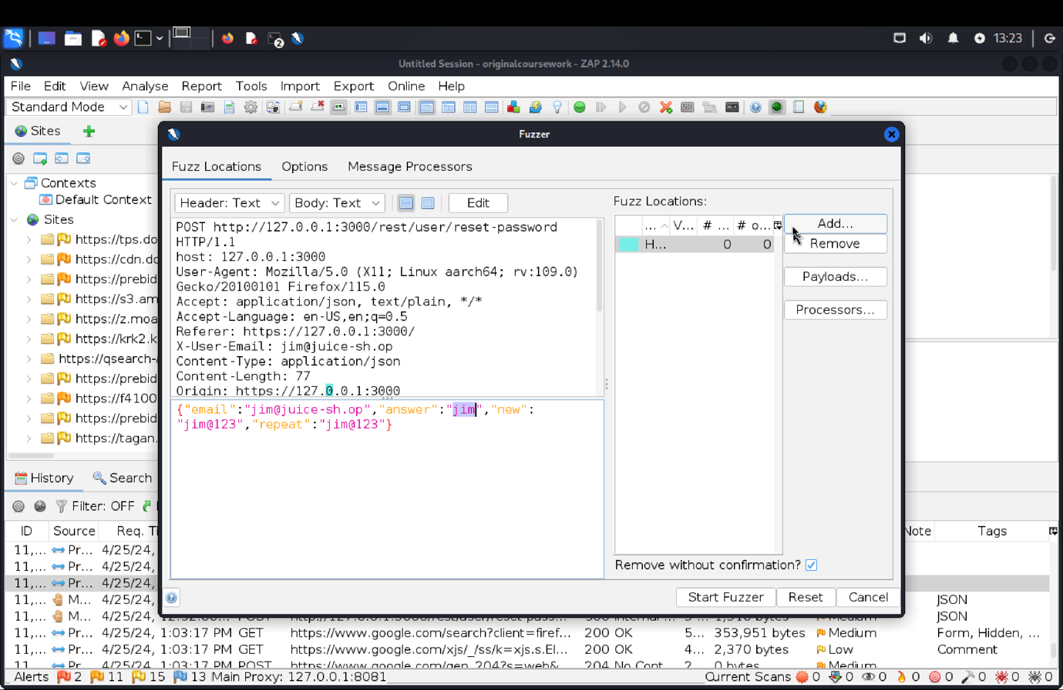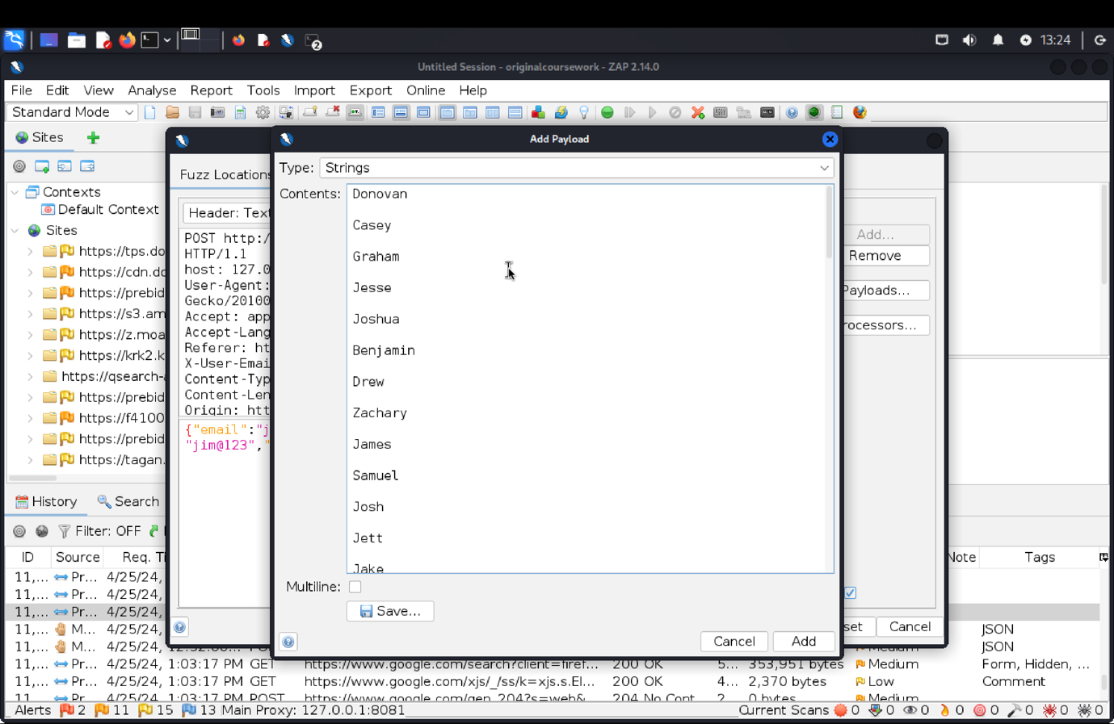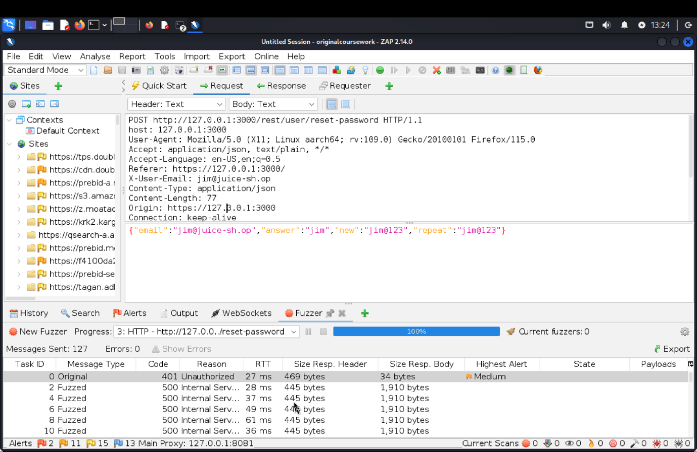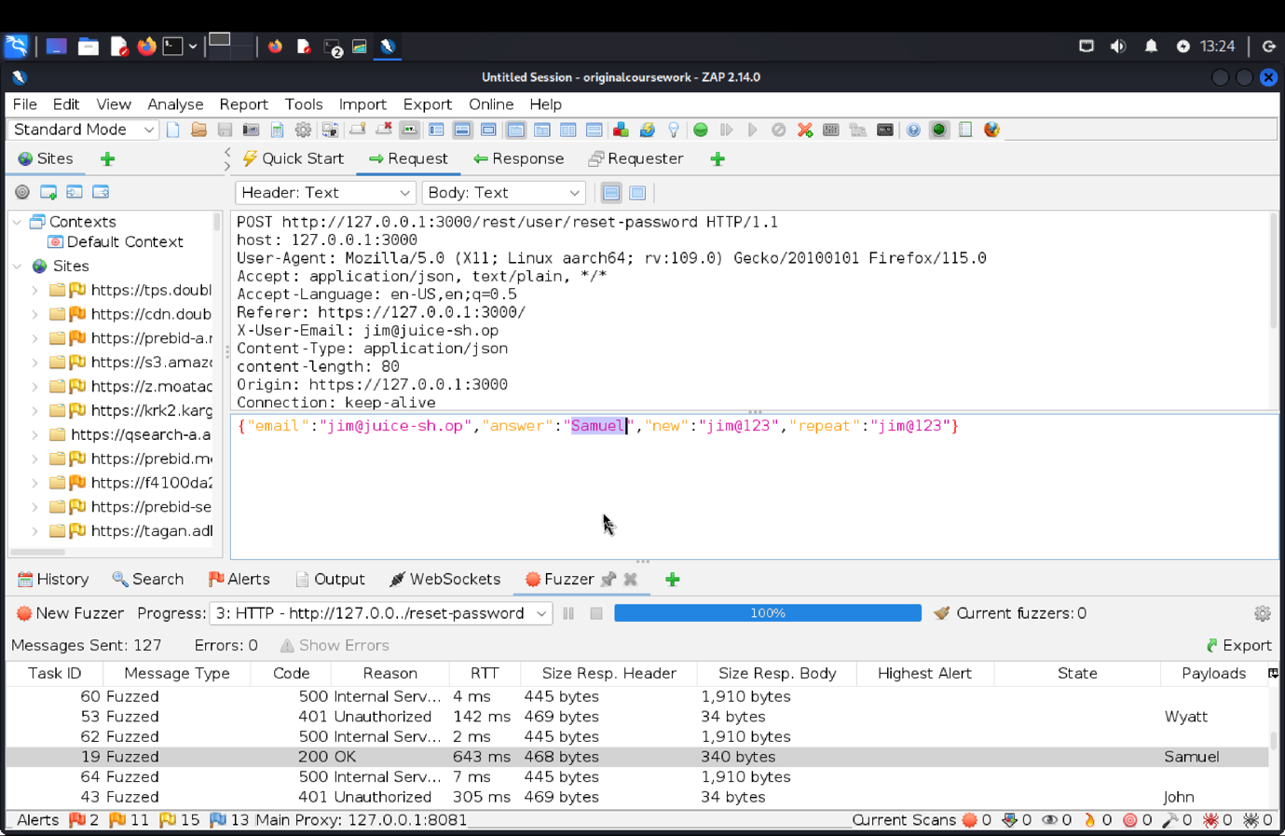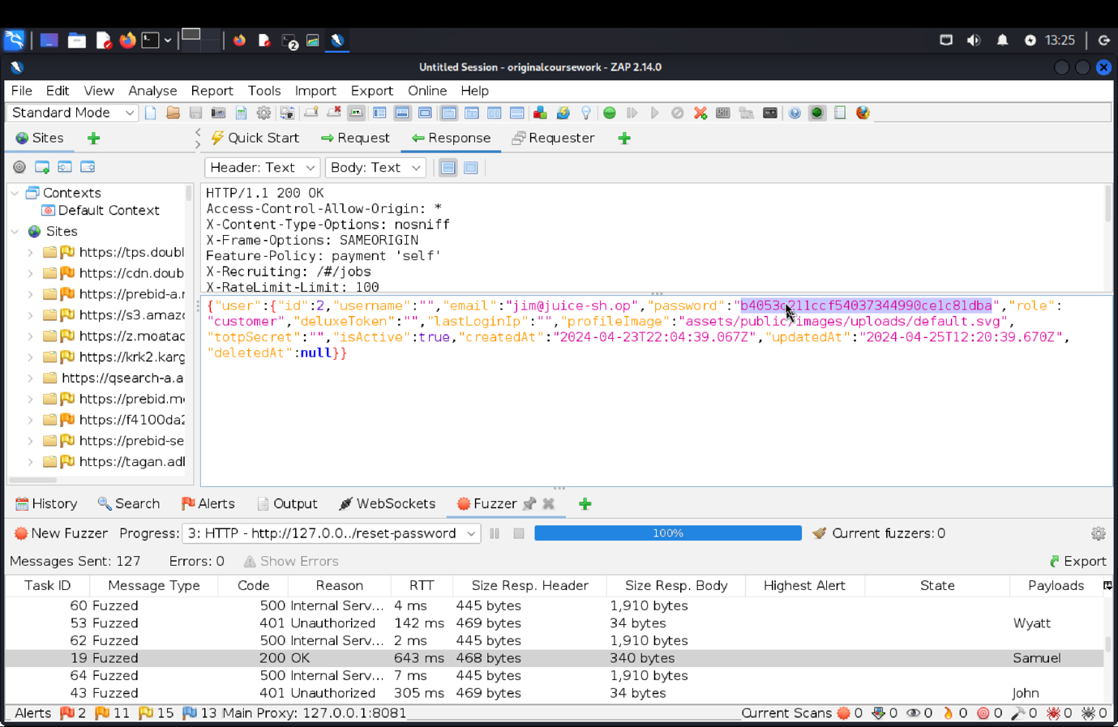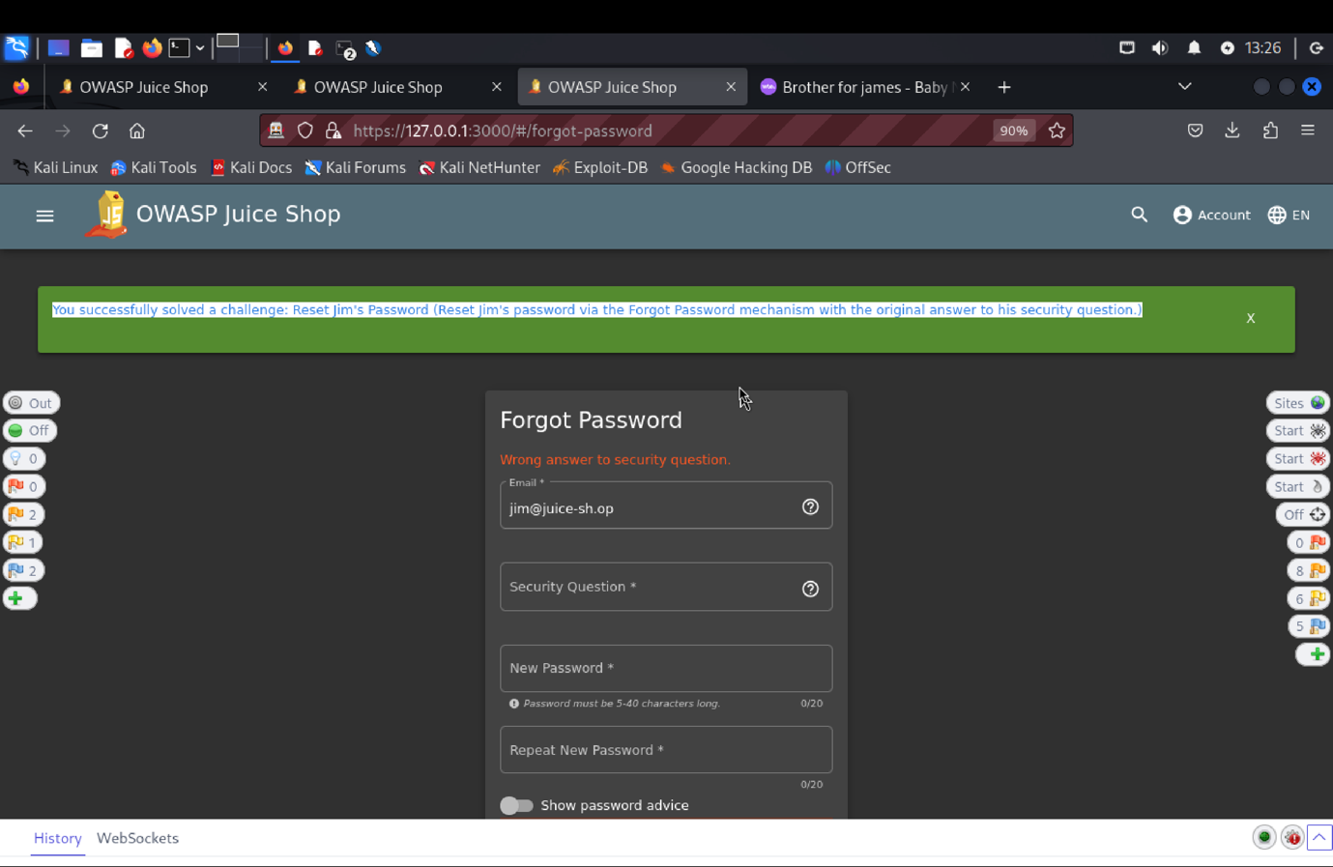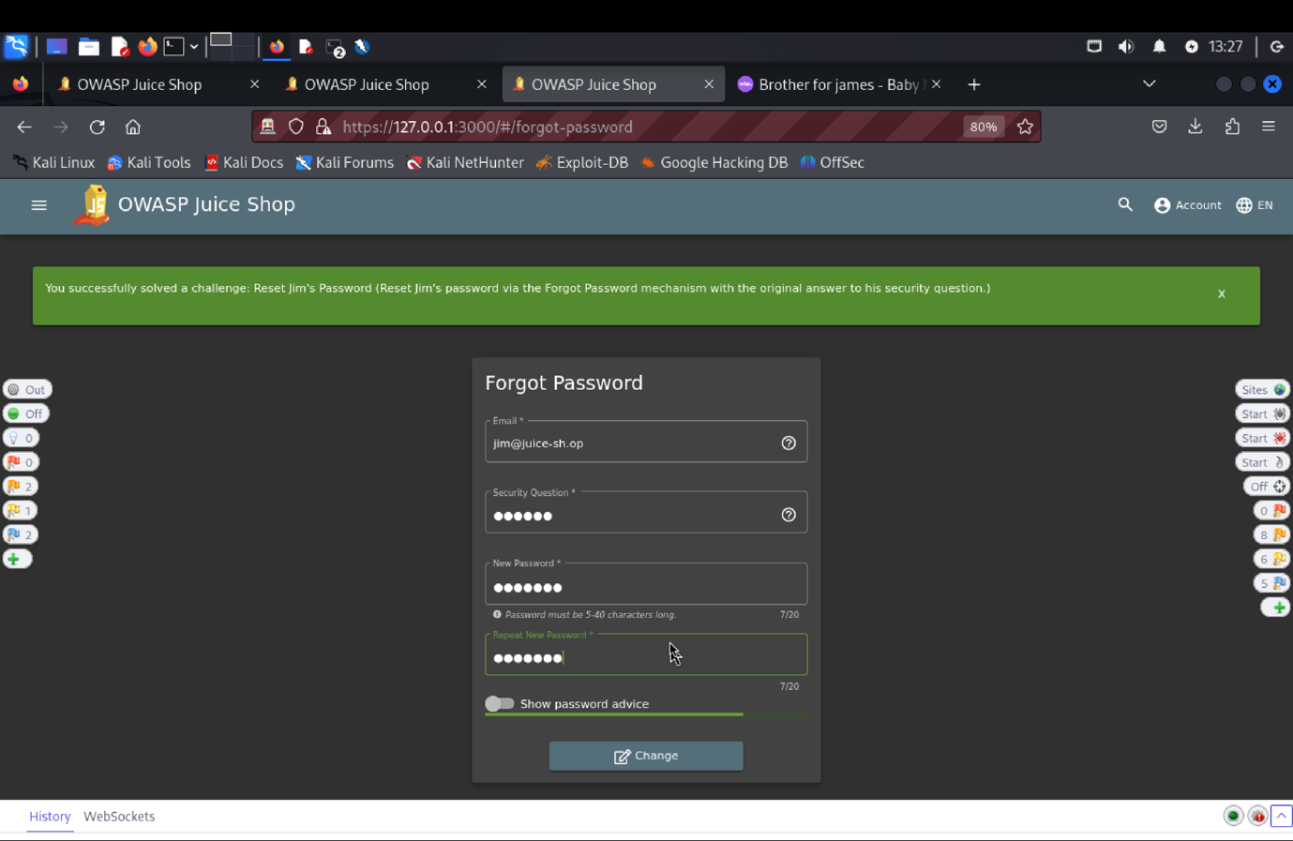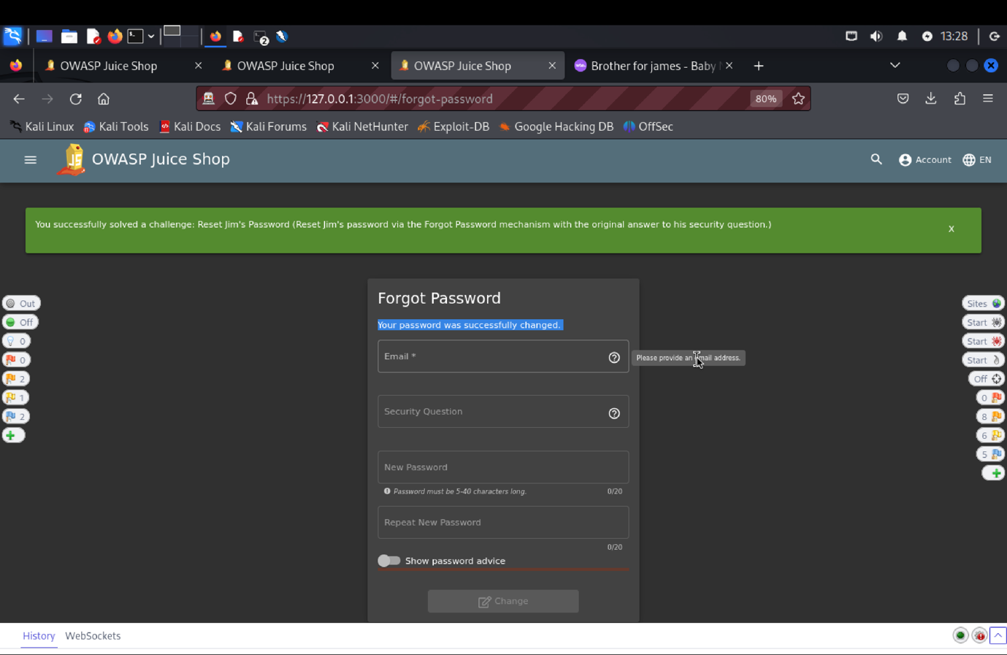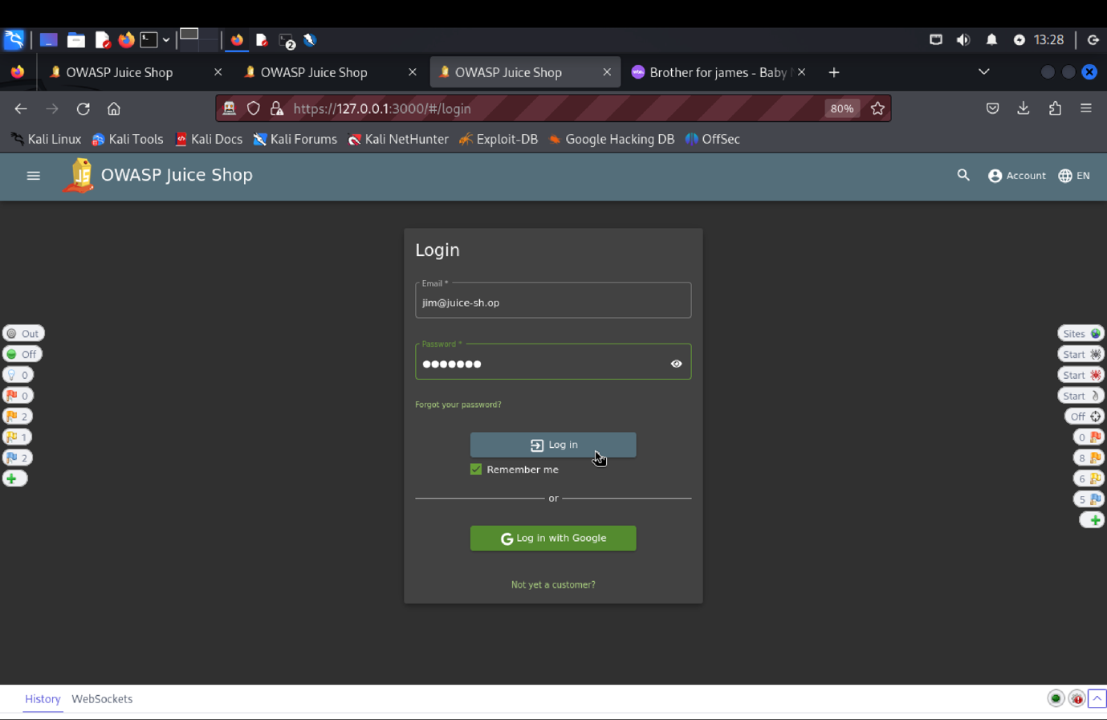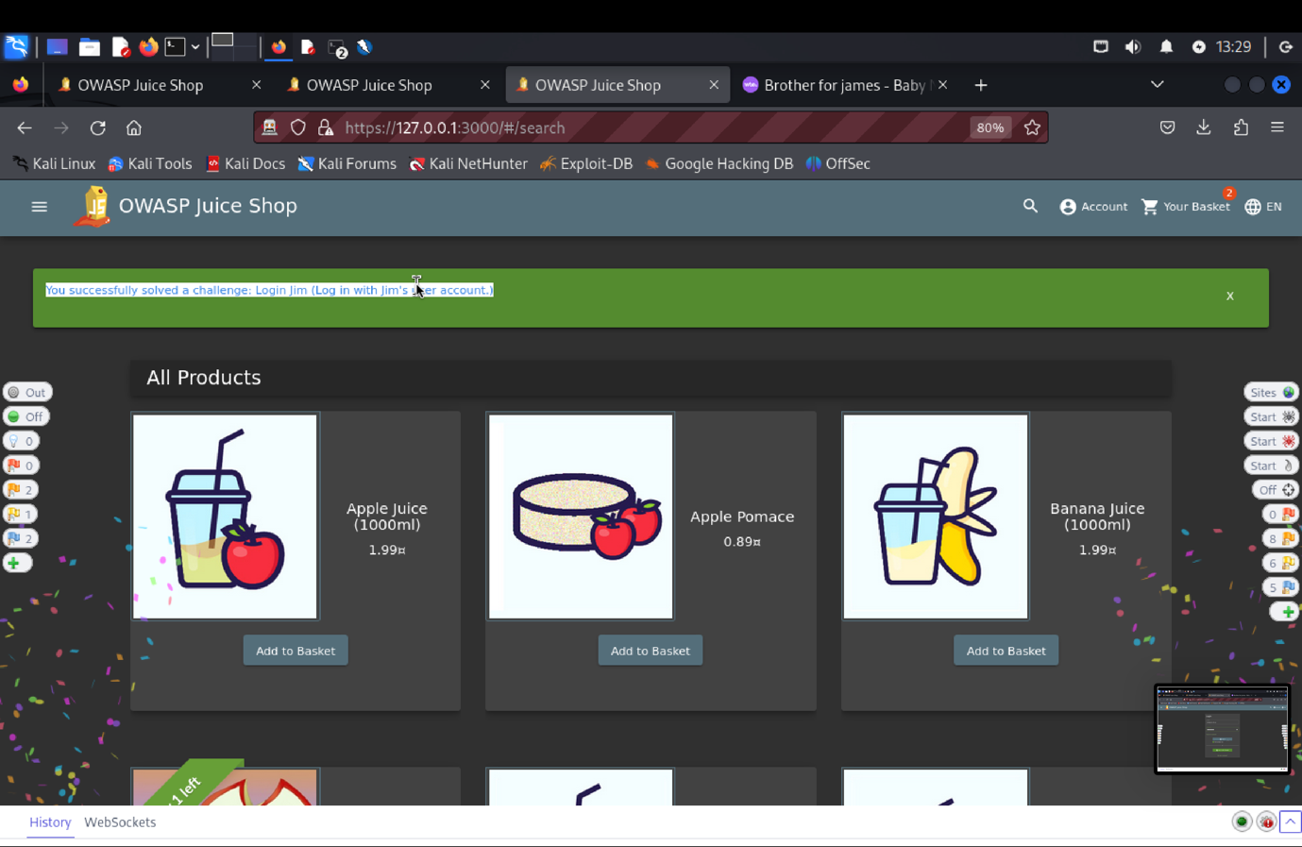
15. **Explanation of how the evidence included in (b) proves that FDP_ACC.1.1 is violated**:

We found Jim's email under the Green Smoothie item or logged in with admin credentials to assess the target of evaluation's (TOE) security function requirement (SFR). Next, we tried resetting Jim's password using the "Forget Password" tool, trying out various responses to the security question. We found that "Samuel" answered the security question properly using a fuzz attack, allowing us to reset the password. This demonstrates a flaw that allows unauthorized users to compromise access control by resetting the password by stealing authentication information from another user.

1. **SFR Identifier:**

* **FIA_UAU 3.2: T**he TOE shall prevent use of authentication data that has been copied from any other user of the TOE.

**Related Vulnerability Challenges: -**

1. Reset Jim’s Password
2. Reset Bender’s Password

**Tested Vulnerability Challenges: -**

1. **Reset Jim’s Password:** Reset Jim’s password via the Forgot Password mechanism with the truthful answer to his security question.
2. **Description of penetration testing that was carried out.**
3. Logged in using admin email Id as shown in Admin Section or use= asd@asd.com, password = asd@123 to find the email of user Jim.
4. Or Under the Green Smoothie item, find Jim’s id as “**jim@juice-sh.op**”
5. Next, we click on Login->Forget Password
6. Using the above Jim’s email id, Security question answer as anything you want (I have entered Apoorva), new password = jim@123, repeat password = jim@123.
7. Click on change.
8. The request json object will be **{“email”: “jim@juice-sh.op”, “answer”:”Henry”, “new”:”jim@123”, “repeat”:”jim@123”}.**
9. 401 Unauthorized error is triggered which says, “**Wrong answer to security question**”.
10. We search for list of sibling names of James on google basically the idea is to try as many names as possible I almost gave 100-150 names.
11. Using these values we create a Fuzz attack payload by selecting security question value field.
12. One of the values i.e. **“Samuel”** gets 200 Ok response. This indicates Jim’s eldest sibling name is Samuel.
13. In this way, Jim’s password reset was successful by copying the authentication data for another user of the TOE.
14. **Outcomes/Evidence of the Penetration Testing**
15. **Explanation of how the evidence included in (b) proves that FDP_ACC.1.1 is violated**:

We found Jim's email under the Green Smoothie item or logged in with admin credentials to assess the target of evaluation's (TOE) security function requirement (SFR). Next, we tried resetting Jim's password using the "Forget Password" tool, trying out various responses to the security question. We found that "Samuel" answered the security question properly using a fuzz attack, allowing us to reset the password. This demonstrates a flaw that allows unauthorized users to compromise access control by resetting the password by stealing authentication information from another user.

**Reset Bender’s Password**

1. **Description of penetration testing that was carried out.**
   1. Login to admin as shown in *admin section task* or make a user and give them admin rights. This step is done to find out Bender’s email id. Admin will list all the existing users or in the home click on the products and see if Bender has written any review and take that id.
   2. Now after getting his email id click on ‘Forgot Password’ we need to answer the security question which is what your first job was.
   3. I went to score-board and took hint from there which said Futurama and I googled it and went to Wikipedia link and under occupation found his first job.
   4. Went to that link in again in Suicide Booth. Under Futurama I found Stop-and-Drop.
   5. I went to zap and create fuzz attack.
   6. I made permutation and combination like Stop-n-Drop, Stop-and-Drop, stop-and-drop, stop-n-drop, Stop‘n’Drop and stop‘n’drop.
   7. This gives 200 fuzz in response and solves our challenge.
2. **Outcomes/Evidence of the Penetration Testing**

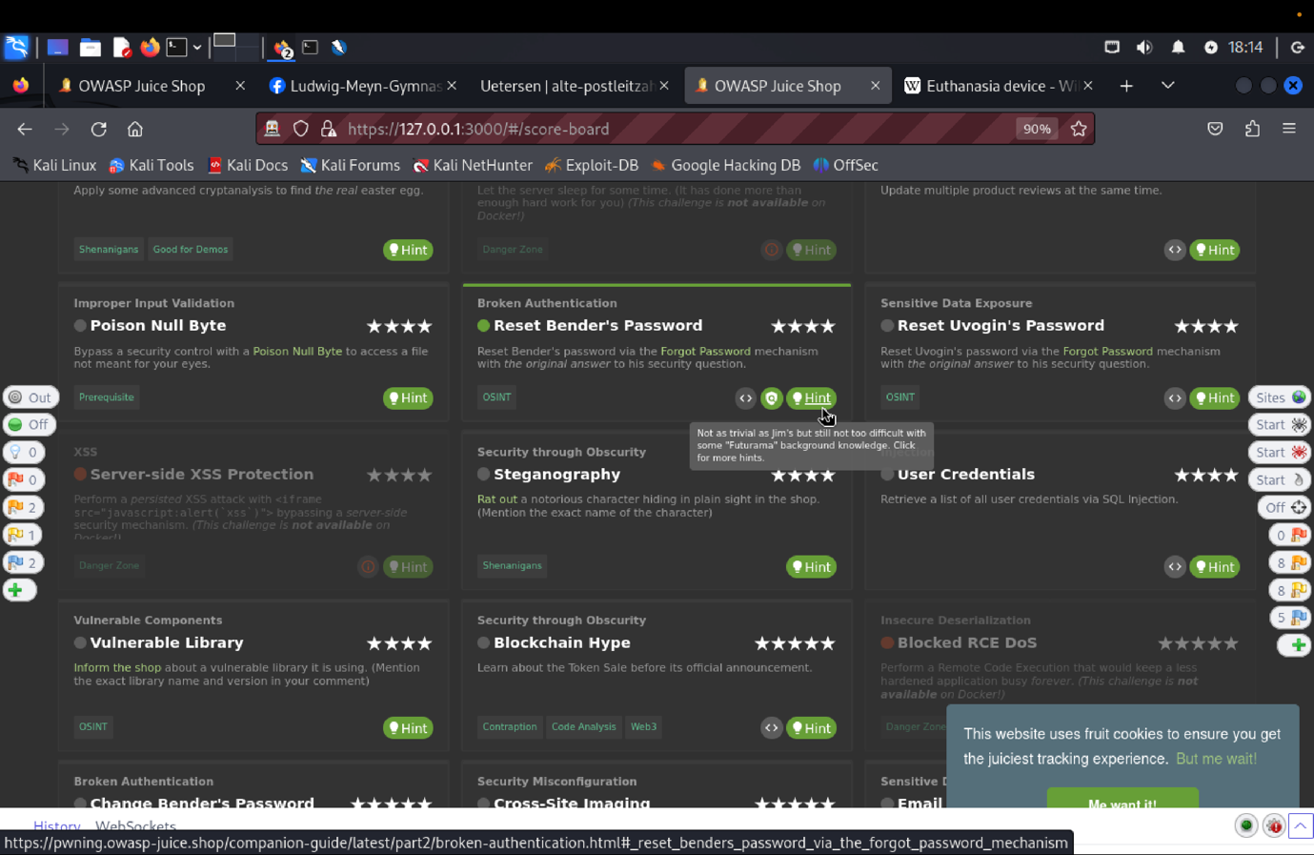

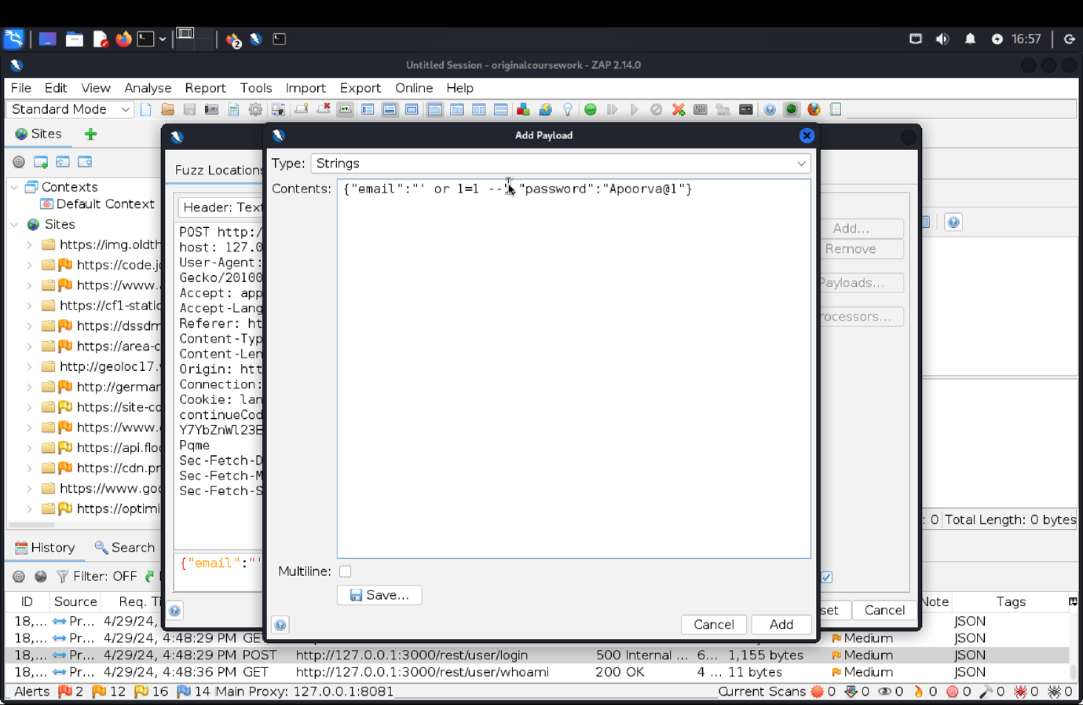 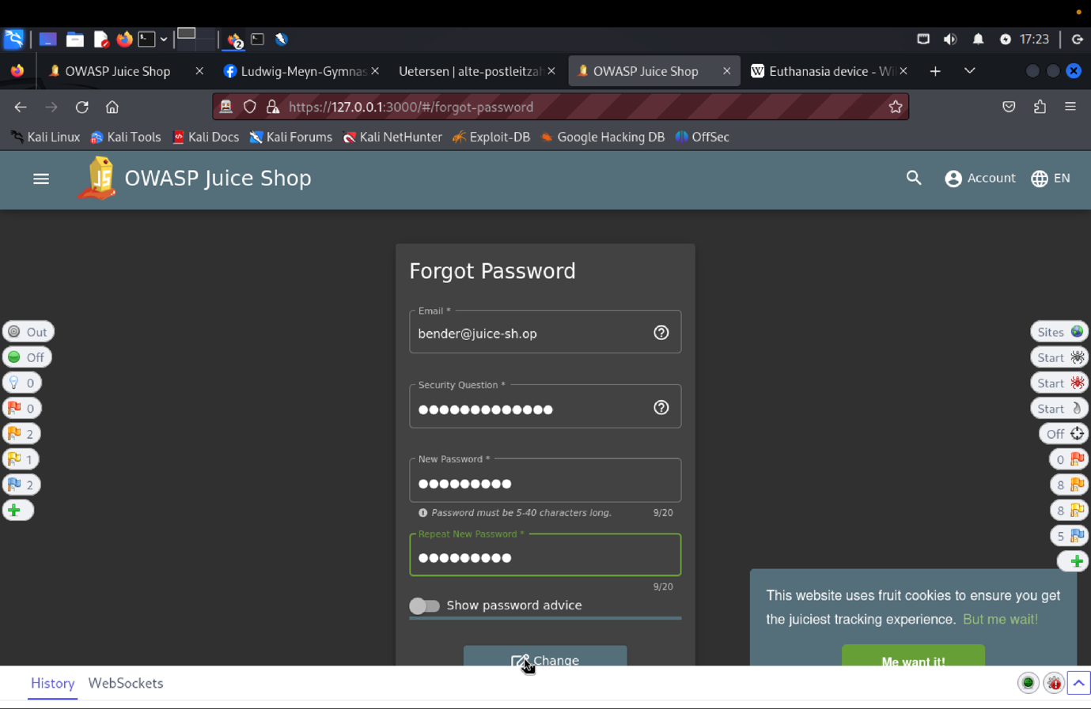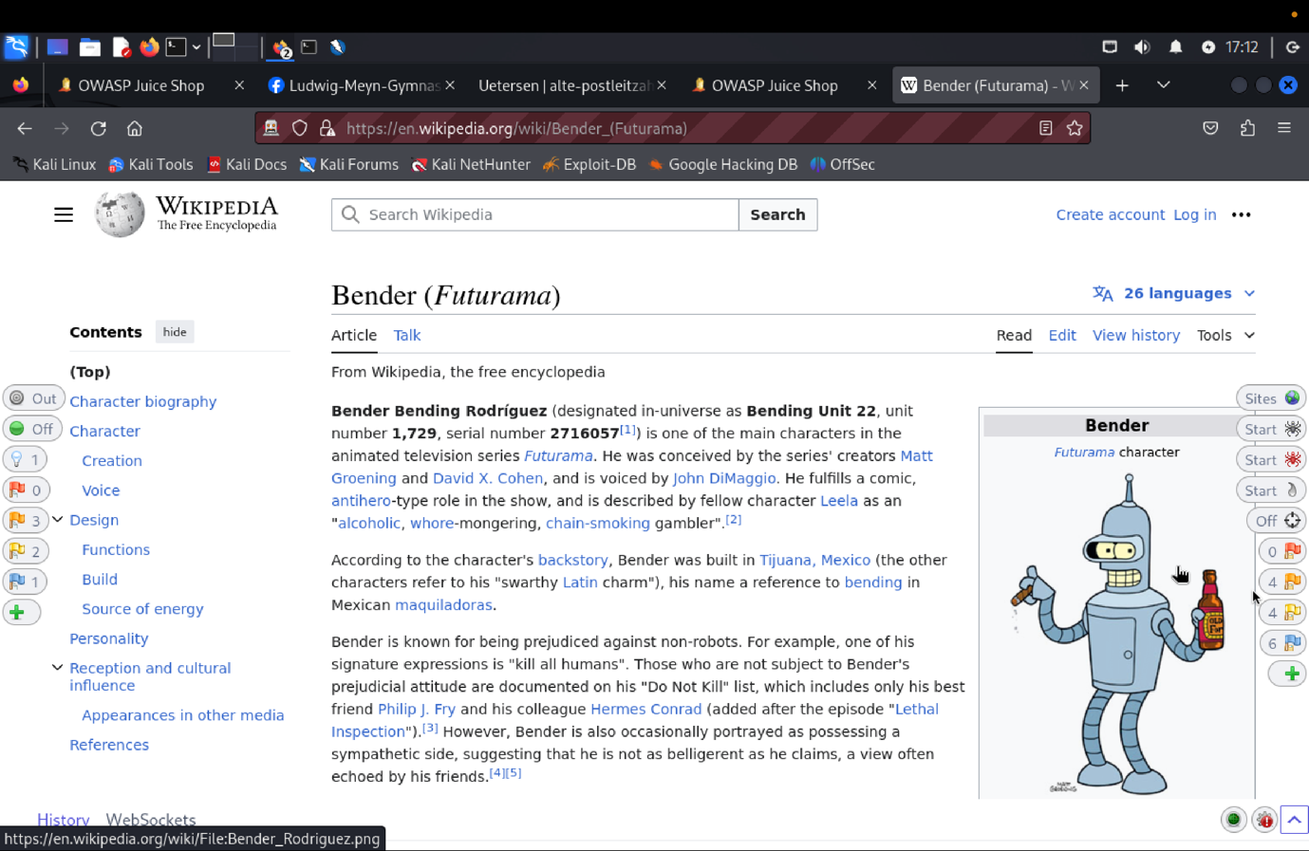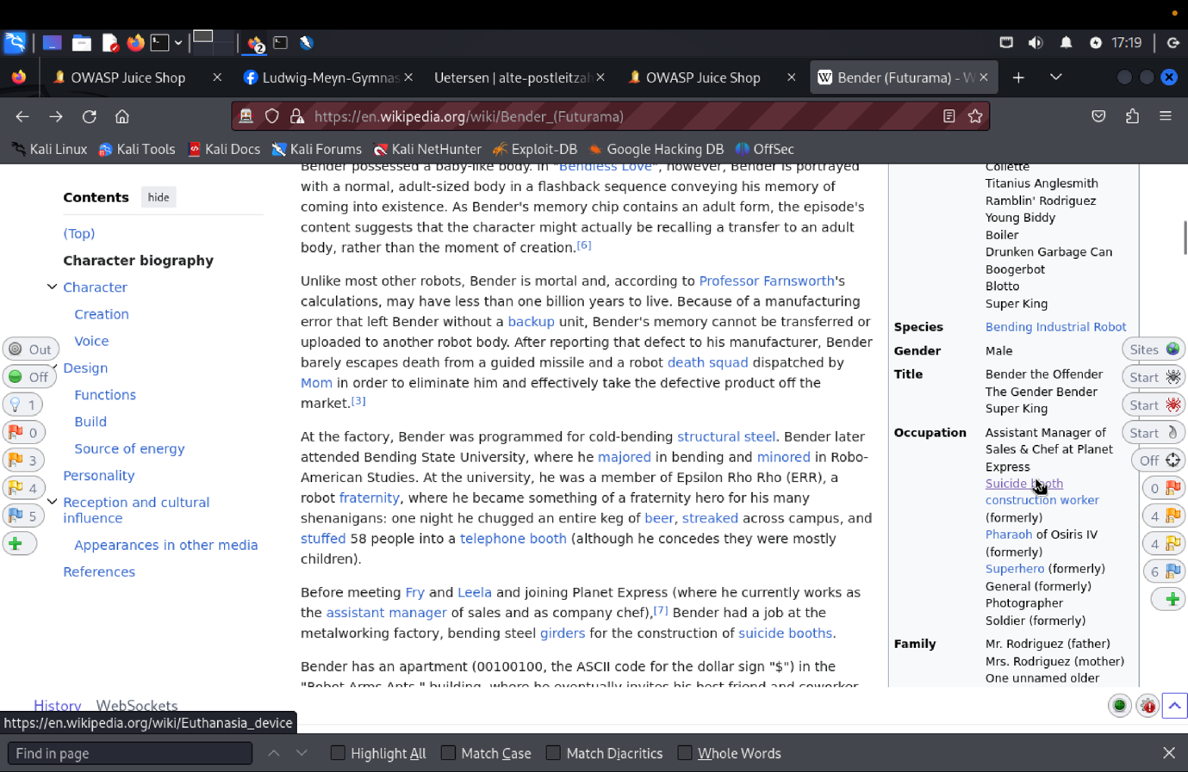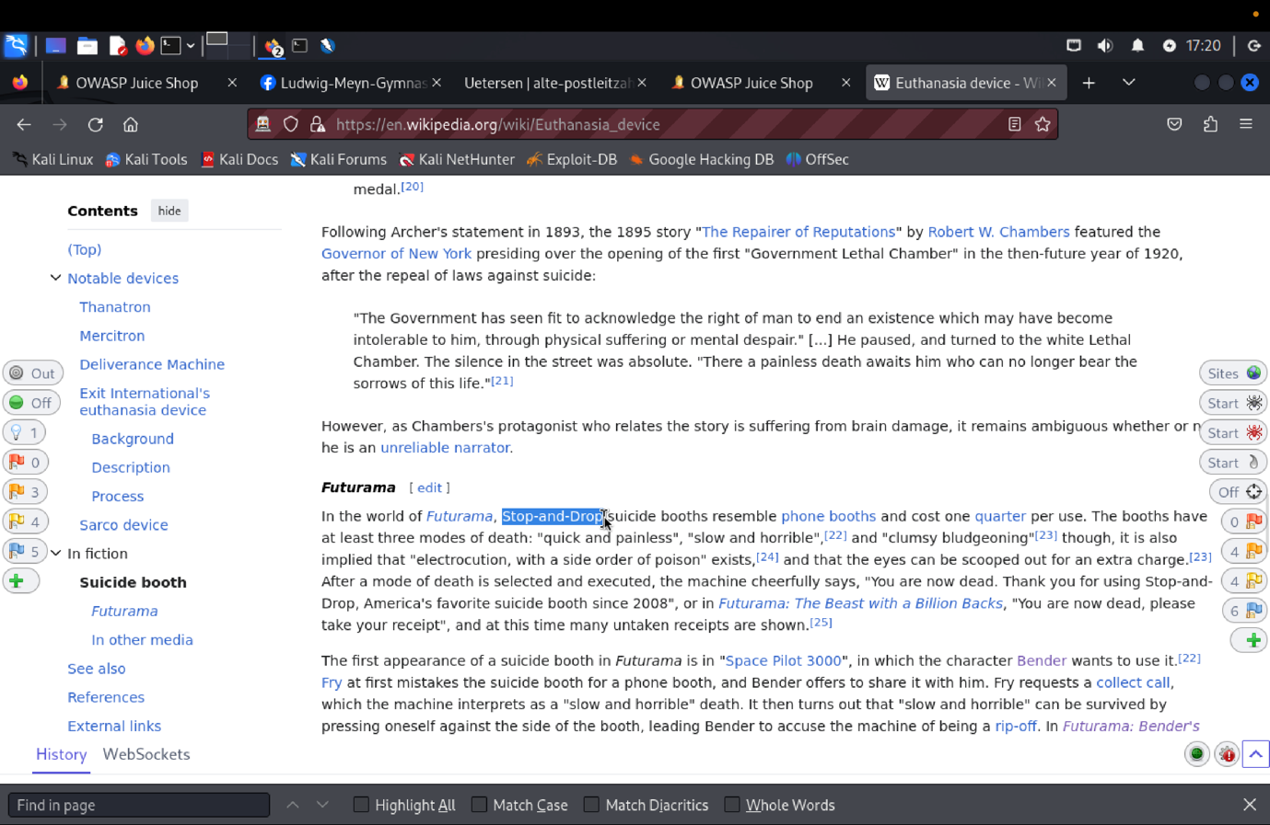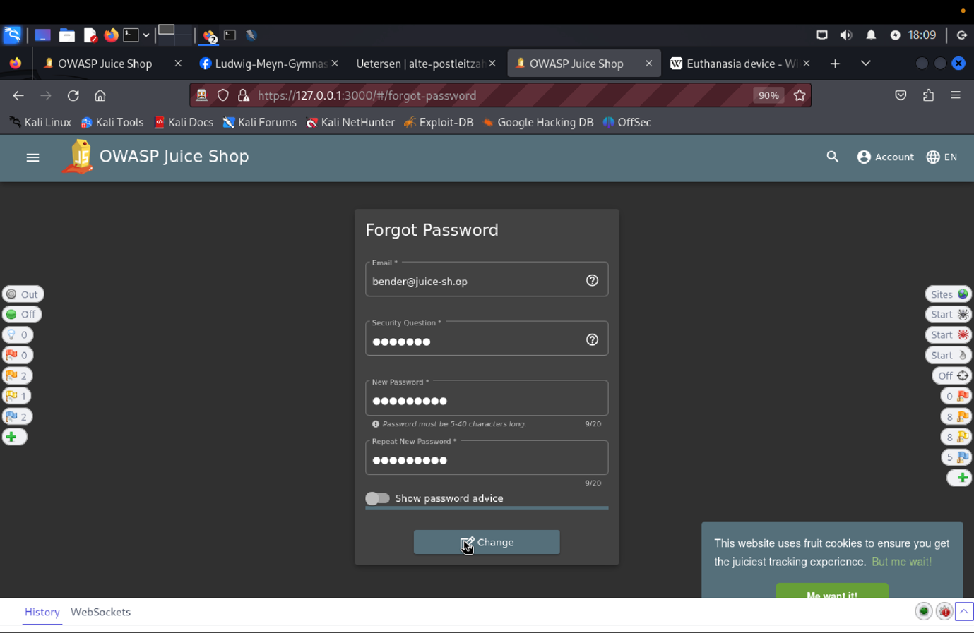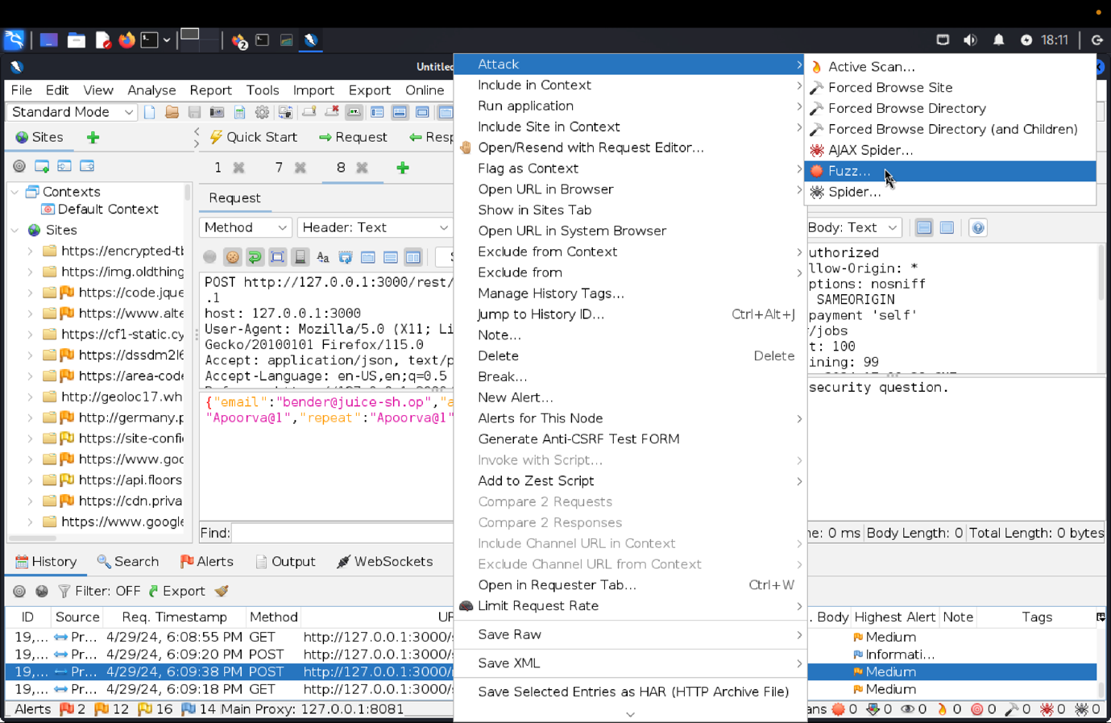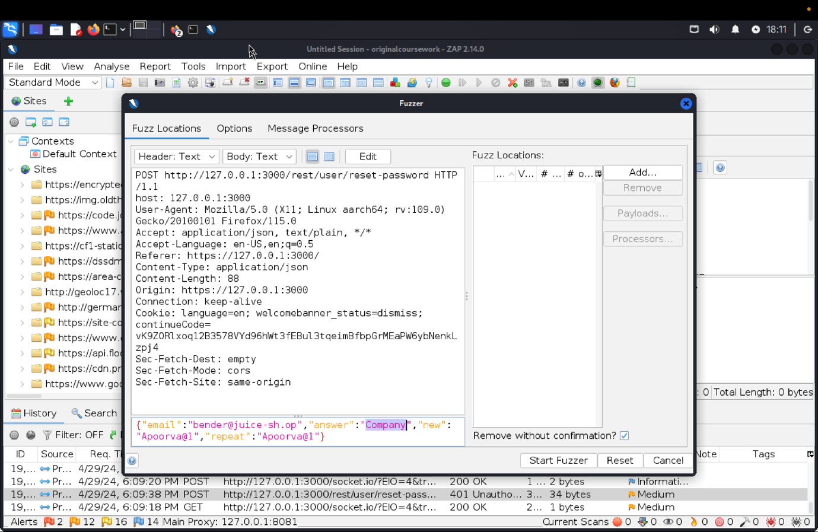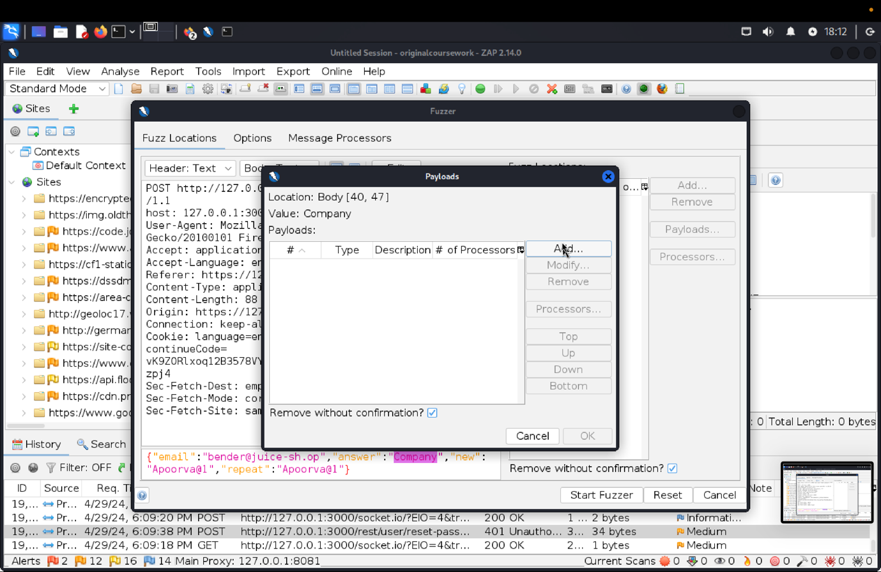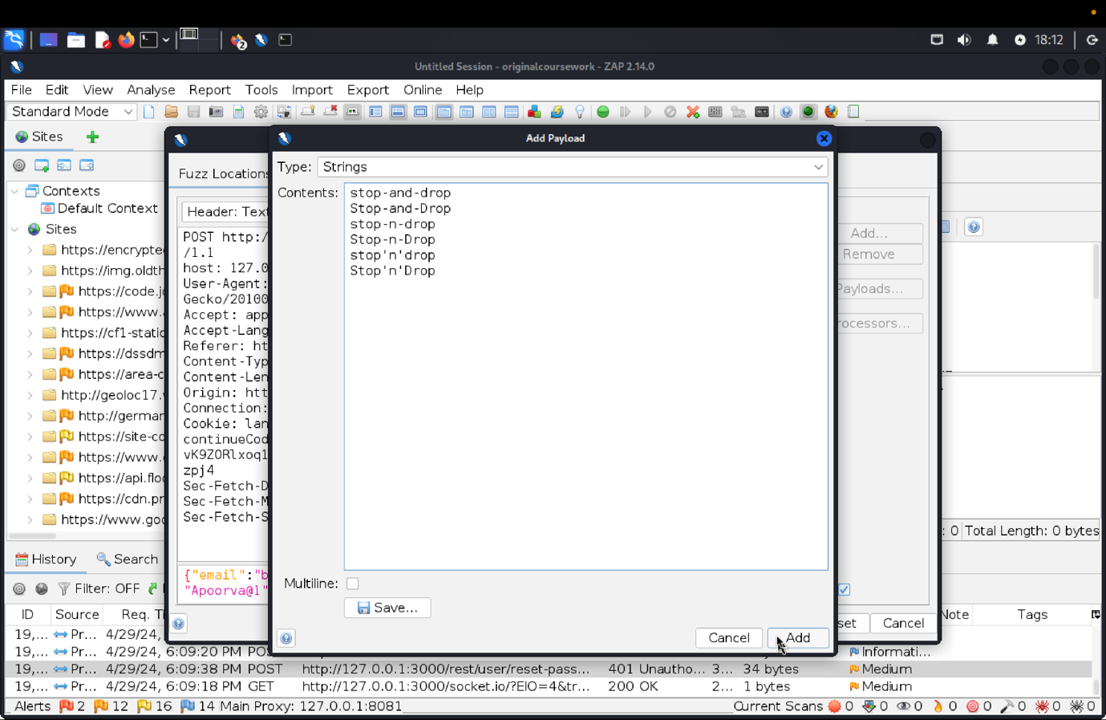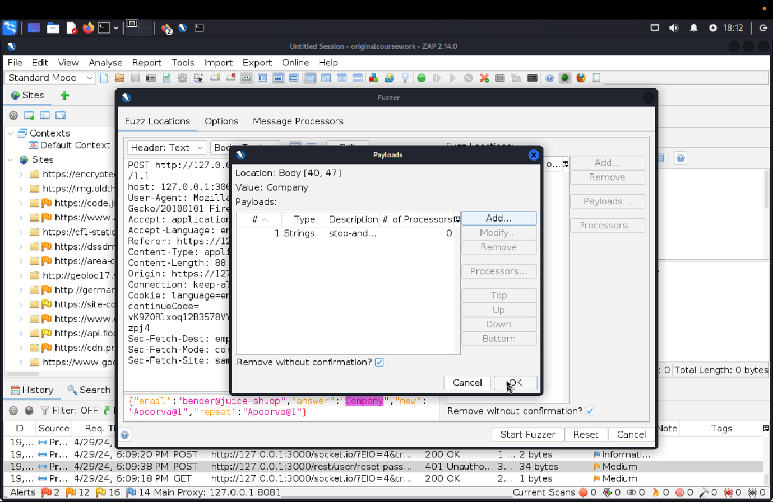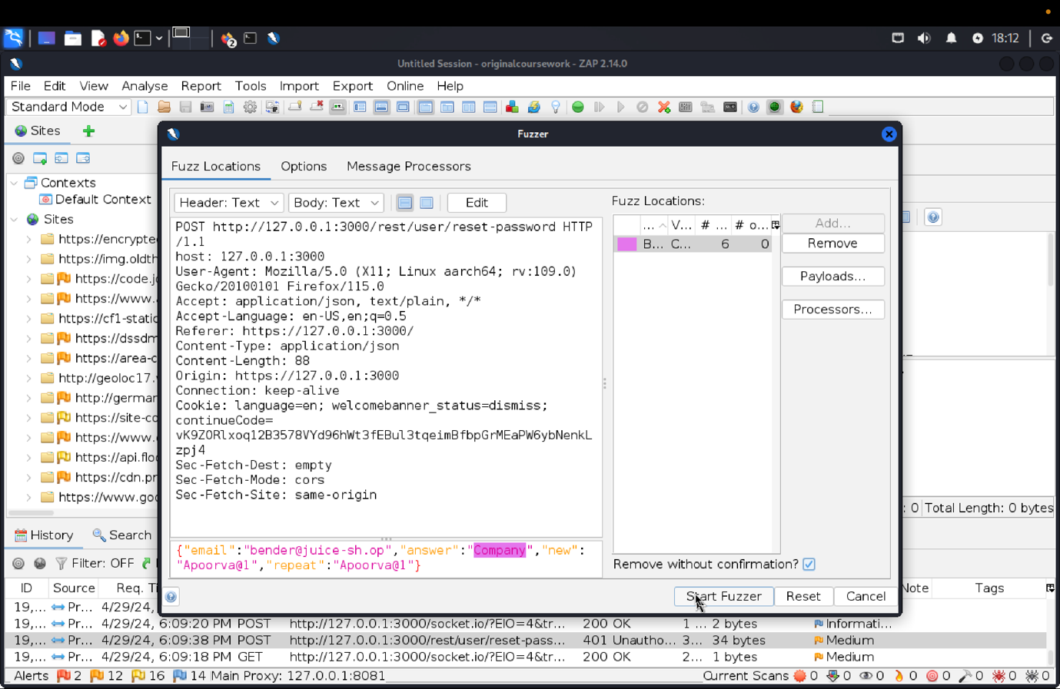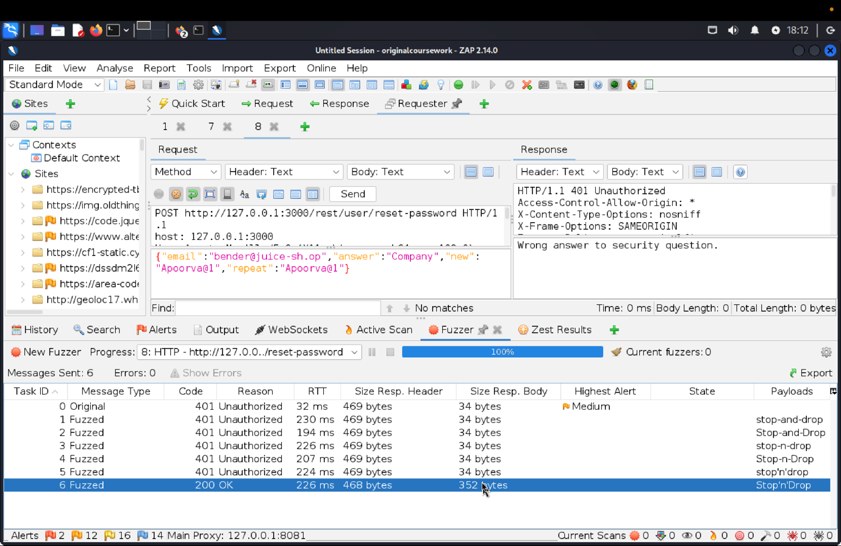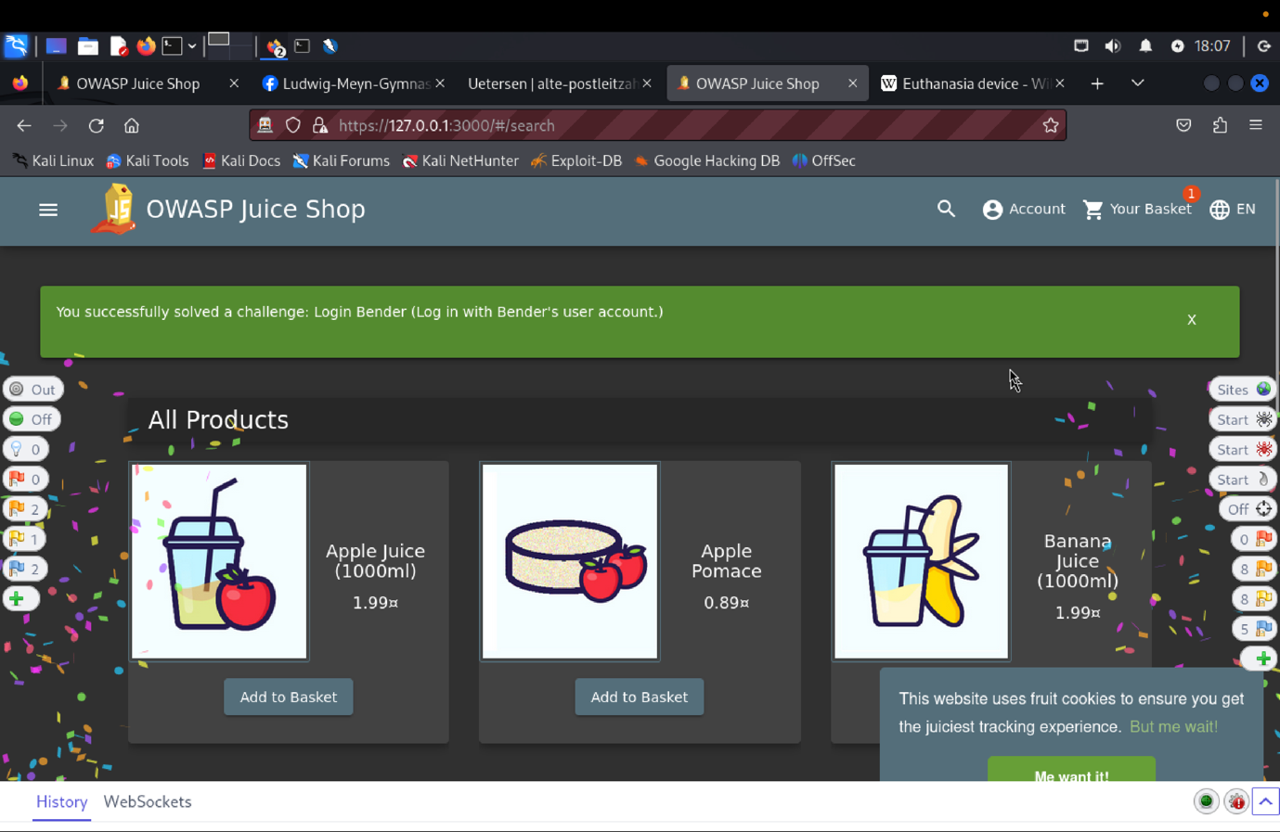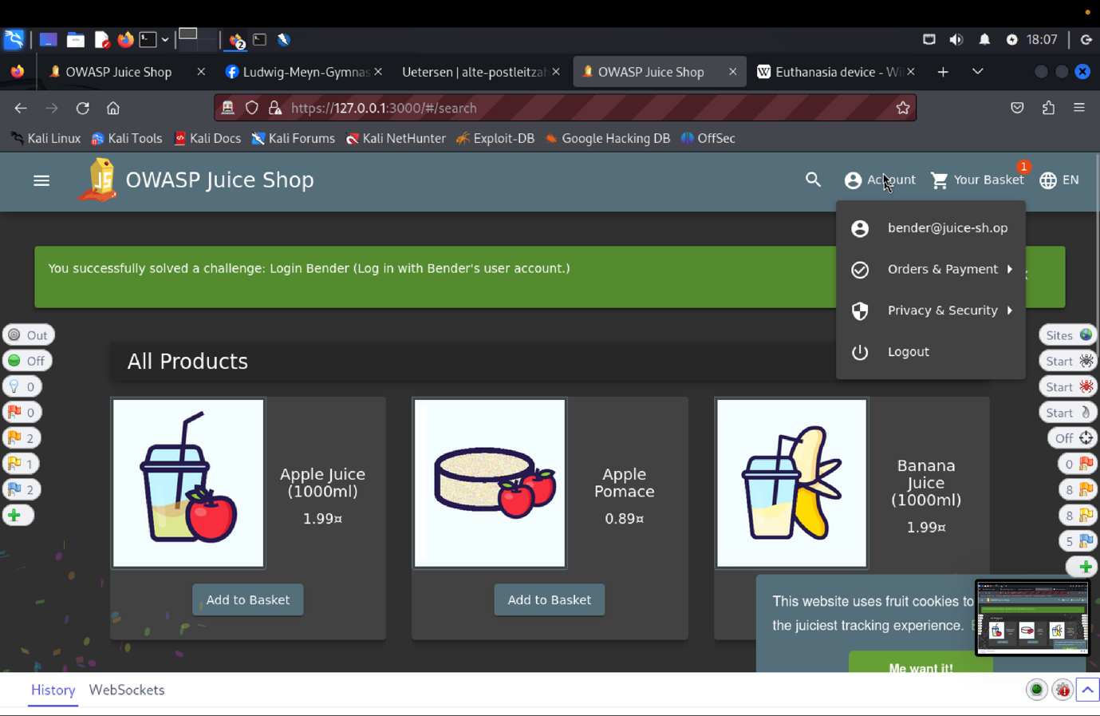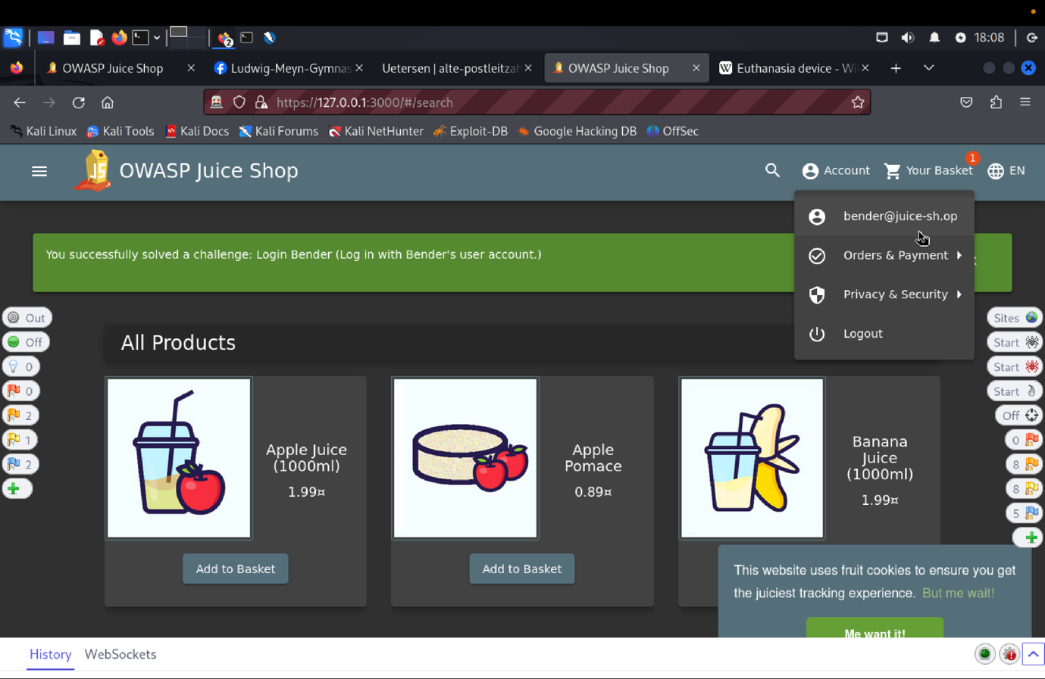

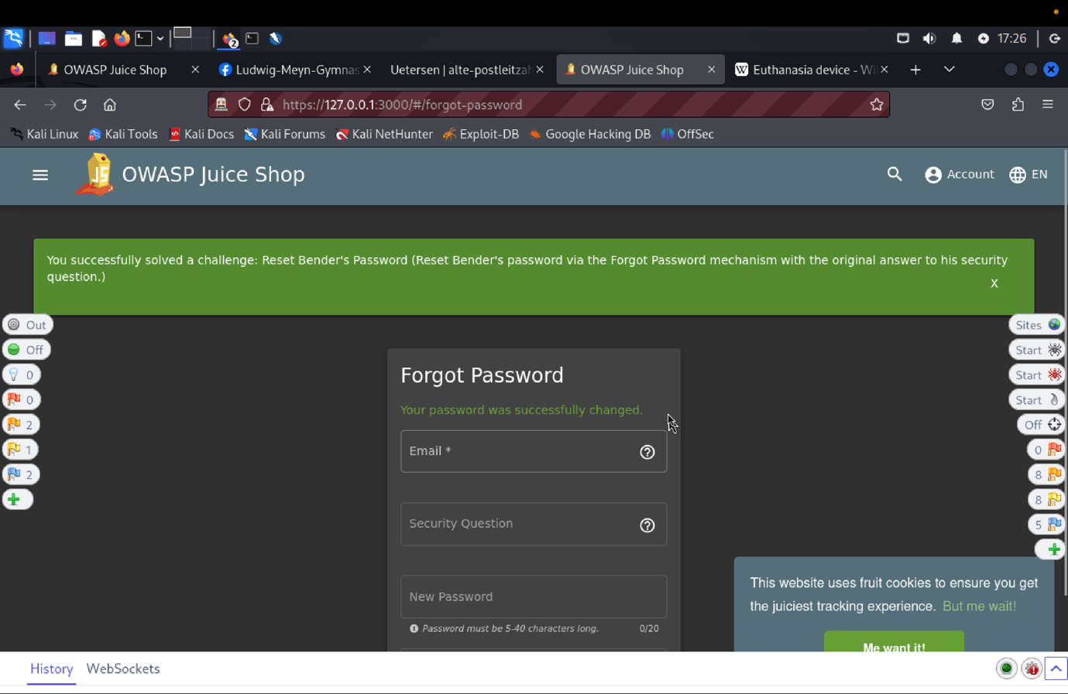

1. **Explanation of how the evidence included in (b) proves that FDP_ACC.1.1 is violated:**

In order to find Bender's email address, we first created a user with admin credentials or logged into the admin part of the Target of Evaluation (TOE) . Then, we used "Forgot Password" feature and Bender's first employment security question. We found the right response by consulting Wikipedia and following the scoreboard's cues. After that, we used ZAP to conduct a fuzz attack and test different variations of "Stop-and-Drop." The Security Functional Requirement was compromised when the TOE responded with a 200 status code (SFR).

**FMT_MSA.1.1**

**VC: Change Bender's Password**

1. **Description of penetration testing**:
2. Go the Login page, then click on the **“Forgot your Password?”**.
3. Make any random current password and a new password.
4. I have entered current password as “**asd**” and new password as “**qwerty@1**”.
5. Click on change button, this triggers 401 Unauthorized error “**Current password is not correct**”.
6. In ZAP, Click on the GET request http://127.0.0.1:3000/rest/user/change-password?current=admin&new=qwerty@1@123&repeat=qwerty@1
7. Use Ctrl+W or simply Copy-paste the entire request header part in requester and remove the current=admin field.
8. Removing the current password field skips the matching of data from the user-database resulting in updating of password in user-database.
9. In this way, the Bender’s Password can be changed without successfully authenticating the user.
10. For this scenario we can give slrumCl4assic.
11. **Outcomes/Evidence of the Penetration Testing**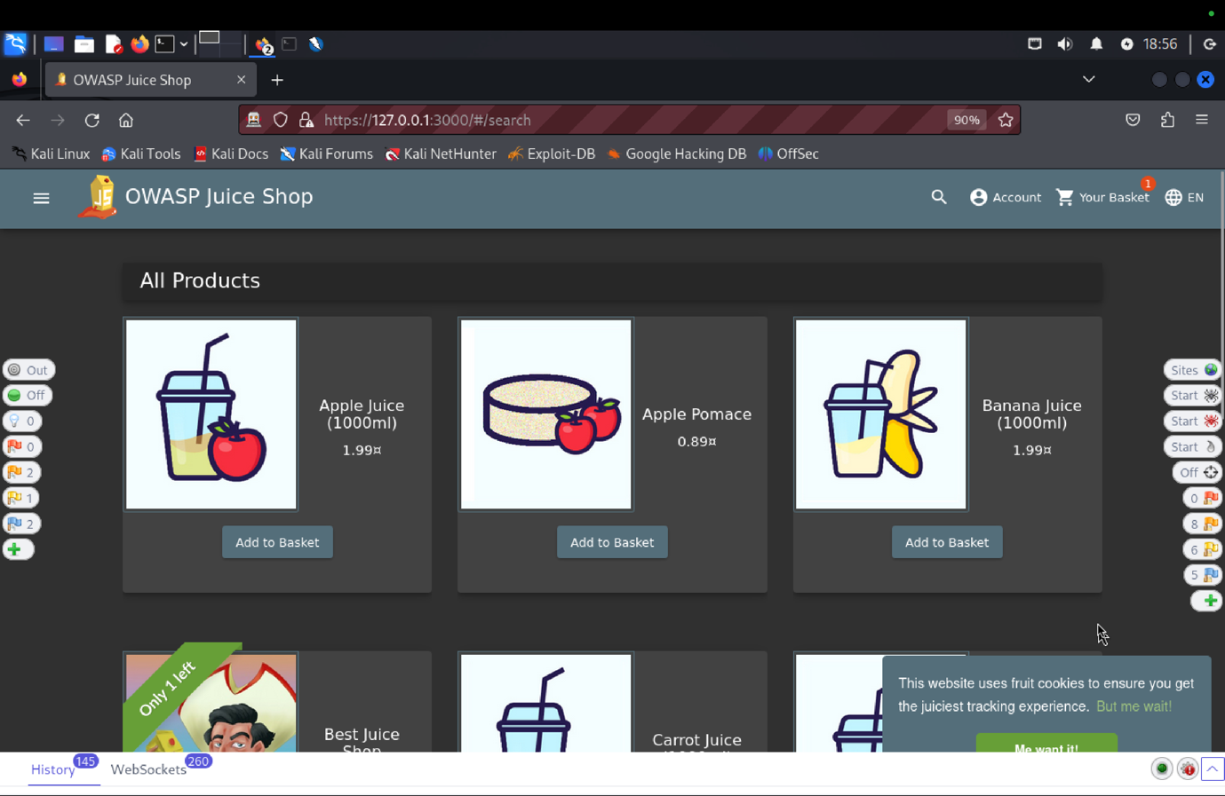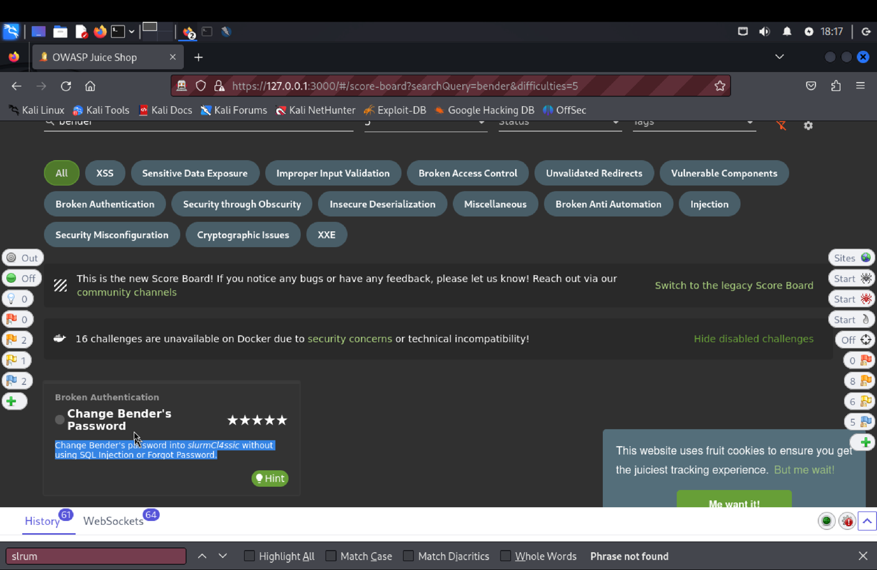

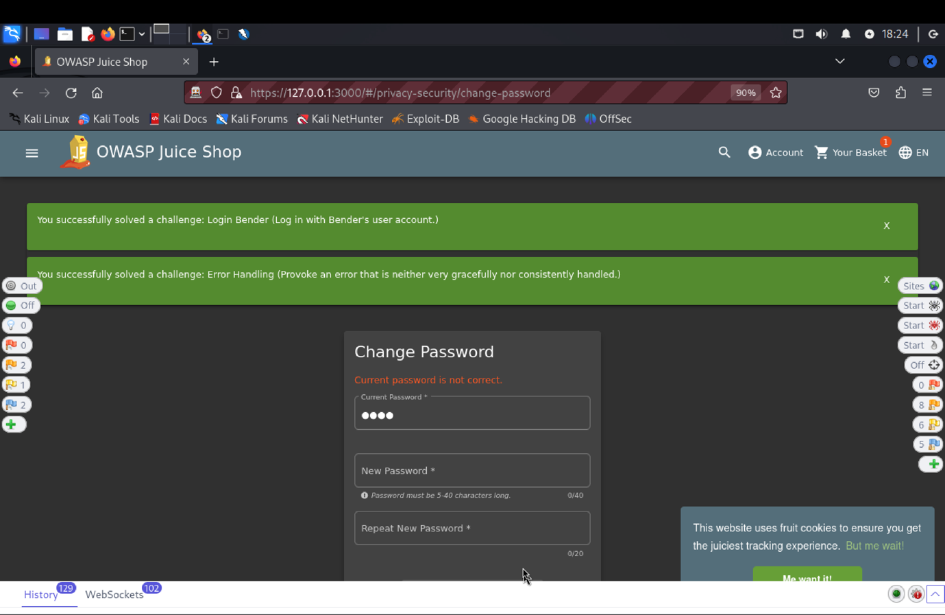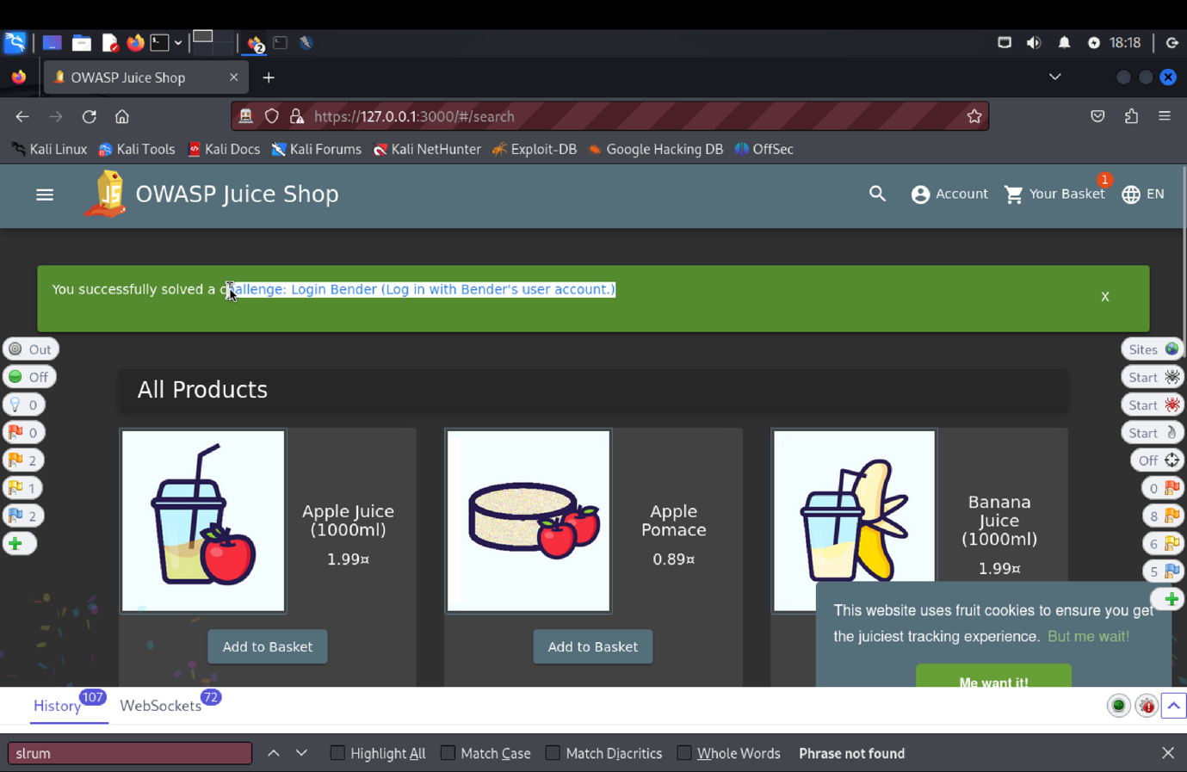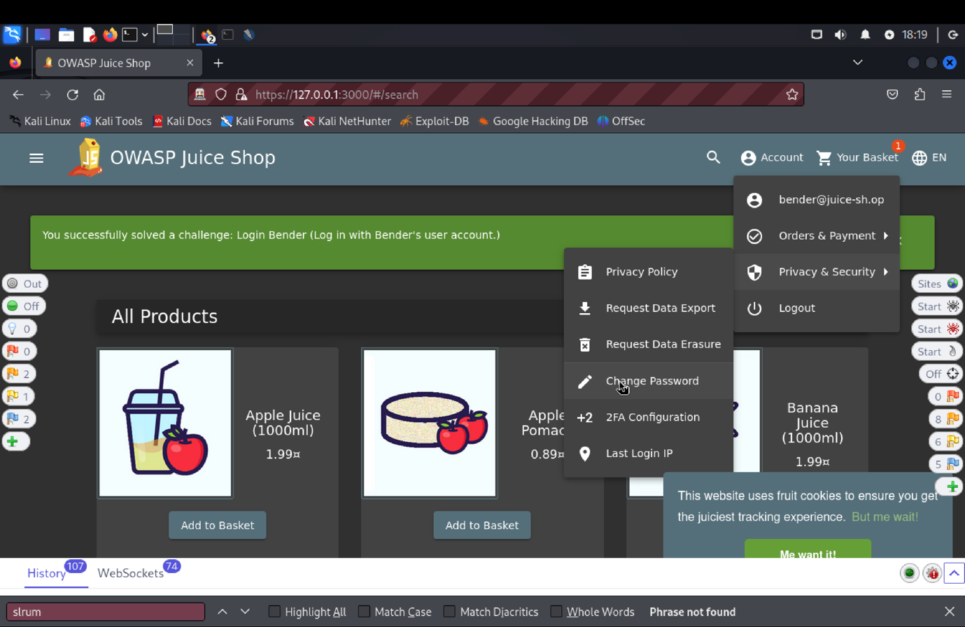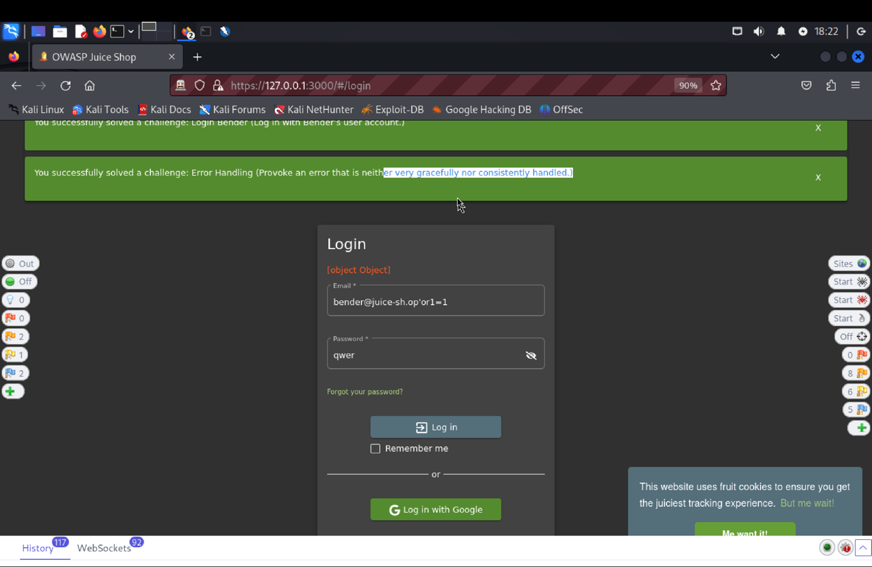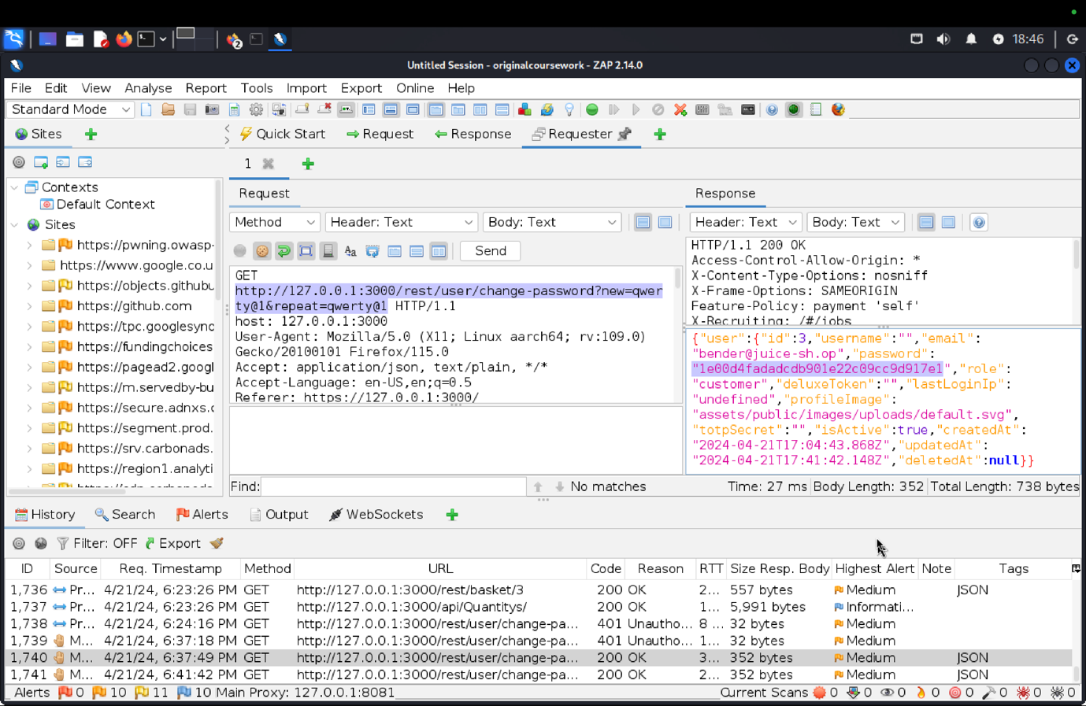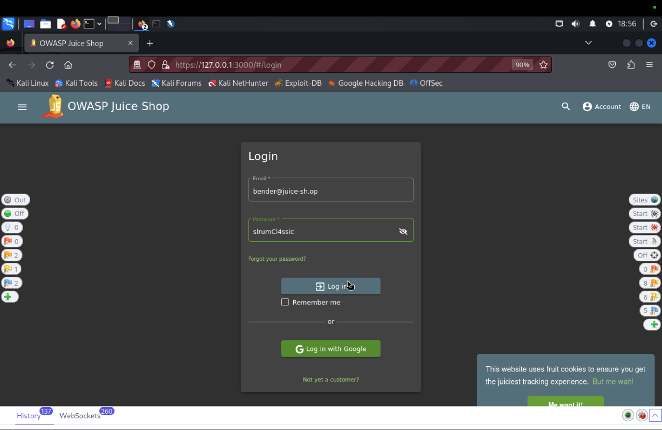

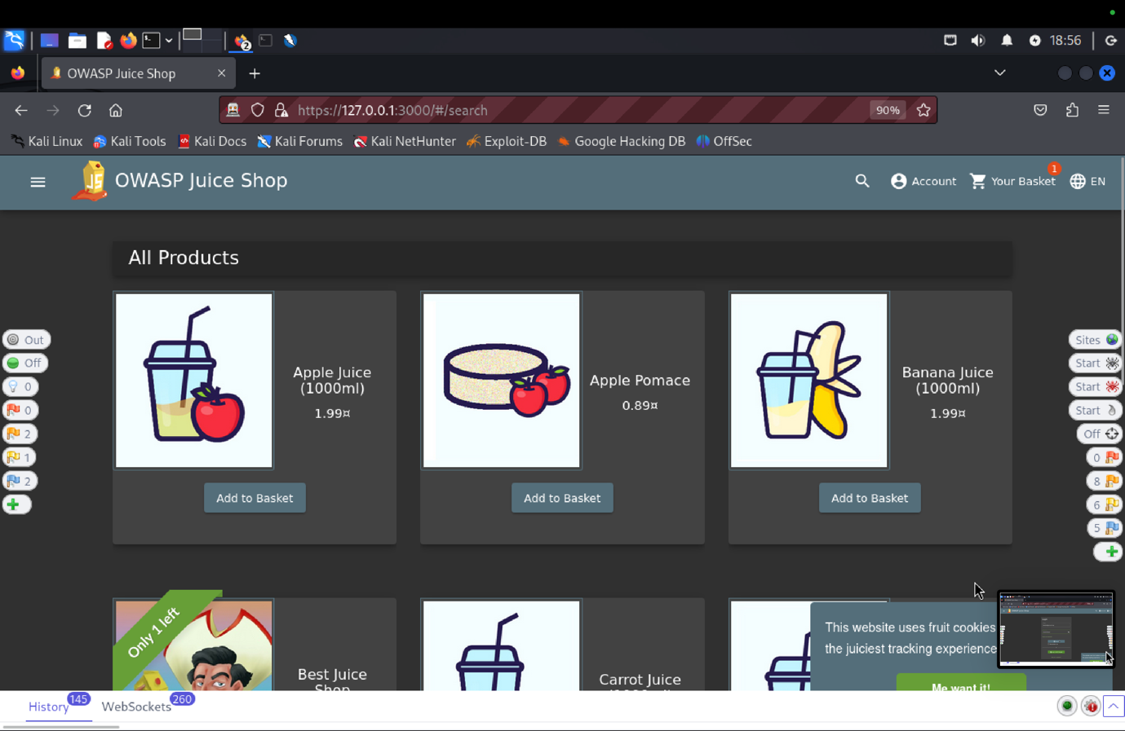

1. **Explanation of how the evidence included in (b) proves that FDP_ACC.1.1 is violated:**

We used the login page and the "Forgot your Password?" option to test the Target of Evaluation (TOE). We created a new password and a random current password, which led to an invalid credential error (401 Unauthorized). We got the change-password endpoint using the OWASP ZAP tool, copied the request header, and deleted the current password parameter. We were able to alter Bender's password without requiring authentication. This vulnerability highlights a problem with the Security Functional Requirement (SFR) for user authentication in the TOE.

**FMT_MSA.1.1** The TOE shall enforce the access control SFP(s), to restrict the ability to change, and delete the security attributes username and user password to admin users.

**Related Vulnerability Challenges: -**

1. Admin Registration
2. Change Bender’s Password
3. Reset Bender’s Password
4. Reset Bjoern’s Password
5. Reset Jim’s Password

**VC: Admin Registration**

1. **Description of penetration testing**:
2. There are few way we can do this task.
3. First, register as a new customer. Fill email:Apoorva@juice.com, password:Apoorva@1 set security answer: Avanish. Then click Register.
4. Now using the new email click on Login using above credentials. This triggers the api: api/Users / in ZAP.
5. Now in ZAP we can see the request body for this. Send this to requester.
6. When send through requester it gives error saying that Validation error, email must be unique.
7. In requester there are 2 ways:
   * 1. So, we can remove the email field and send which solves the error.
     2. Or, use the field “role”: “Admin” or “isAdmin” : true.
8. One more way is to change the email as [Apoorva.admin@juice.com](mailto:Apoorva.admin@juice.com)
9. This will give the users admin rights and Admin Registration is done.
10. **Outcomes (evidence) of the penetration testing in (a)**: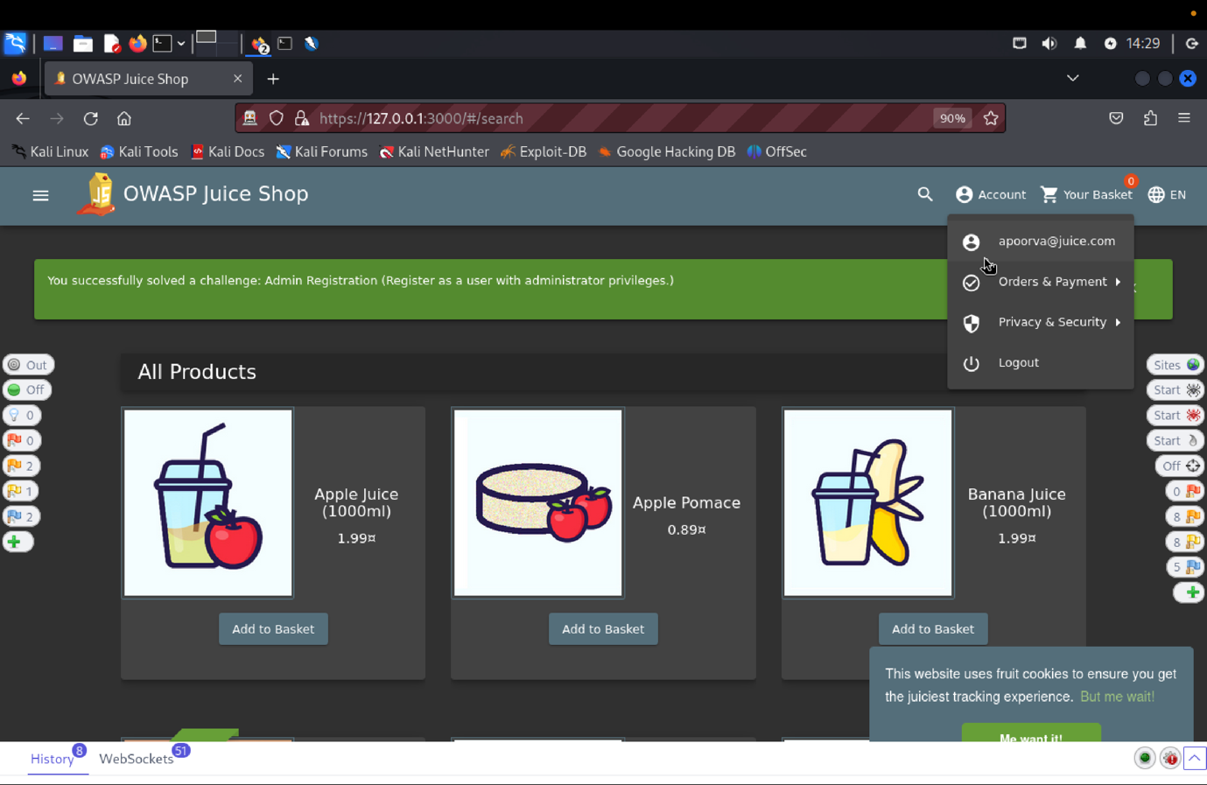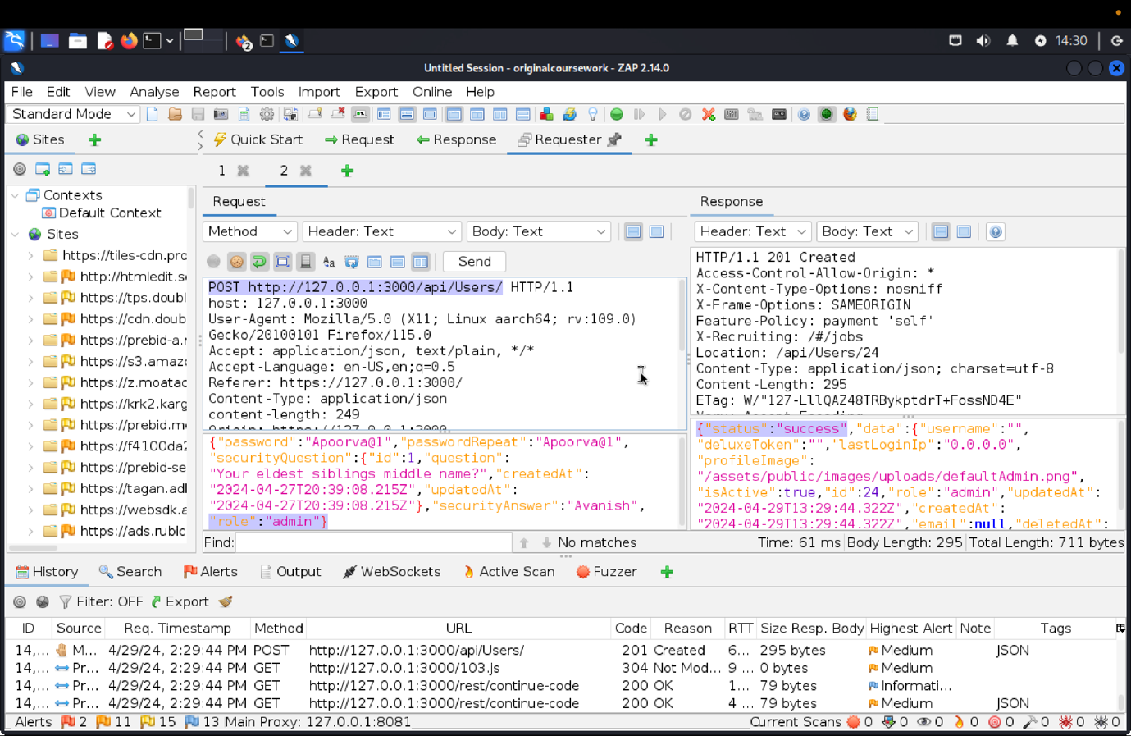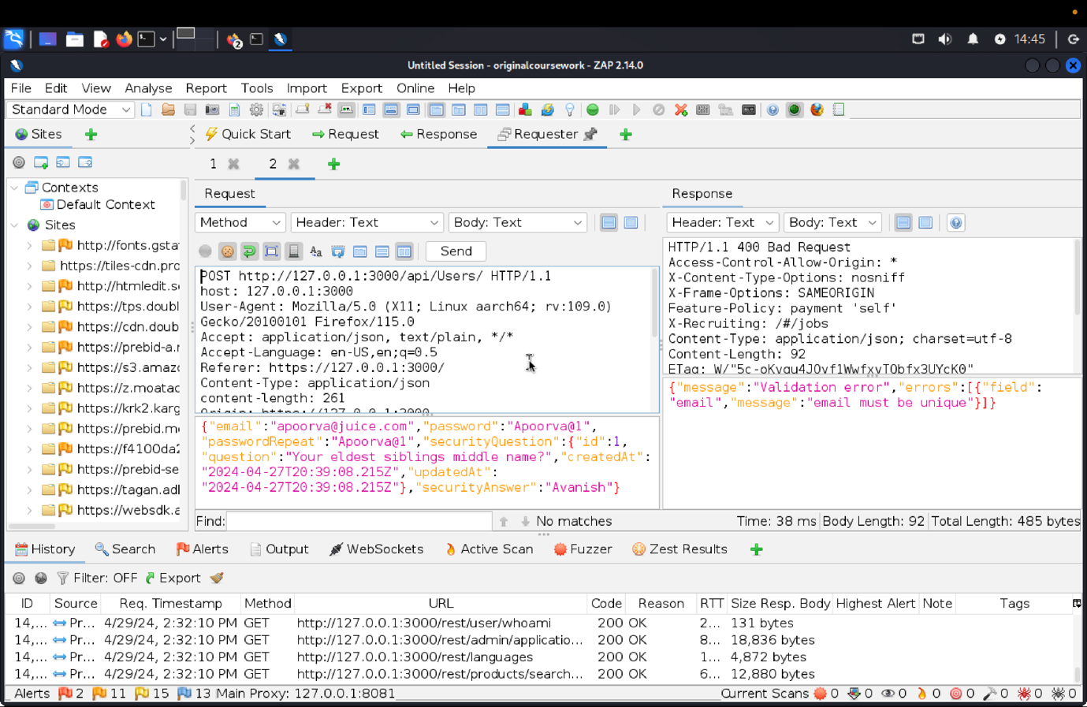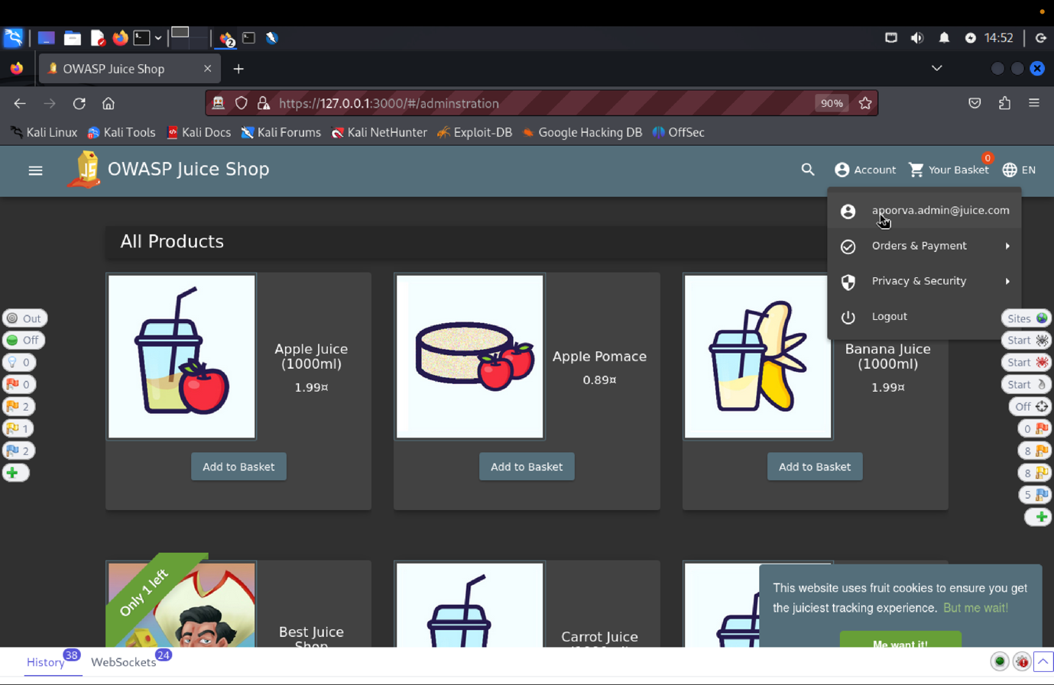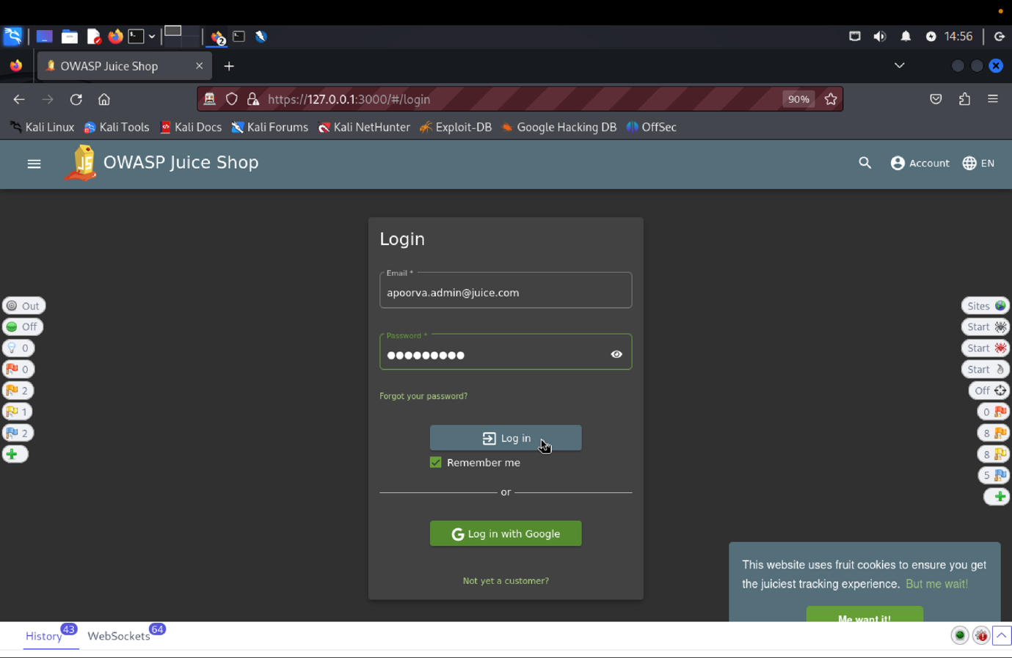
11. **Explanation of how the evidence included in (b) proves that FDP_ACC.1.1 is violated:**

We initially registered new customers using the email Apoorva@juice.com, the password Apoorva@1, and the security answer "Avanish" in order to test the "Admin Registration" functionality of the TOE. The ZAP API /api/Users/ was fired up following login. A validation error stating that the email address must be unique was encountered when we attempted to send this request to the requester. Either deleting the email field or changing the role to "Admin" or isAdmin to true fixed the error. As an alternative, you can obtain the SFR by changing the email to Apoorva.admin@juice.com, which grants admin permissions.

**FMT_MTD.1.1 The TOE shall restrict the ability to reset user passwords to root and admin users.**

**Related Vulnerability Challenges: -**

1. Reset Bjoern's Password
2. Reset Jim's Password
3. Reset Bender’s Password

**Reset Bjoern’s Password:**

**Tested Vulnerability Challenges: -**

1. **Description of penetration testing that was carried out.**
2. Login to admin as shown in *admin section task* or make a user and give them admin rights. This step is done to find out Bjoren’s email id. Admin will list all the existing users or in the home click on the products and see if Bjoern has written any review and take that id.
3. Now after getting his email id click on ‘Forgot Password’ we need to answer the security question which is the pin/zip code of the place when he was younger.
4. I went to google and searched him online and found him in facebook and saw his teenage place and I clicked his place and found Uetersen, Germany.
5. Now, I found the zip code in the google, which was a bit tricky because I had to find the nomenclature of zipcode in Germany. Finally, I found it as West-2082.
6. Copy and Paste in the ‘Security Answer’. Set New Password and Confirm Password.
7. This Solves our Reset Bjeorn Password.
8. **Outcomes/Evidence of the Penetration Testing**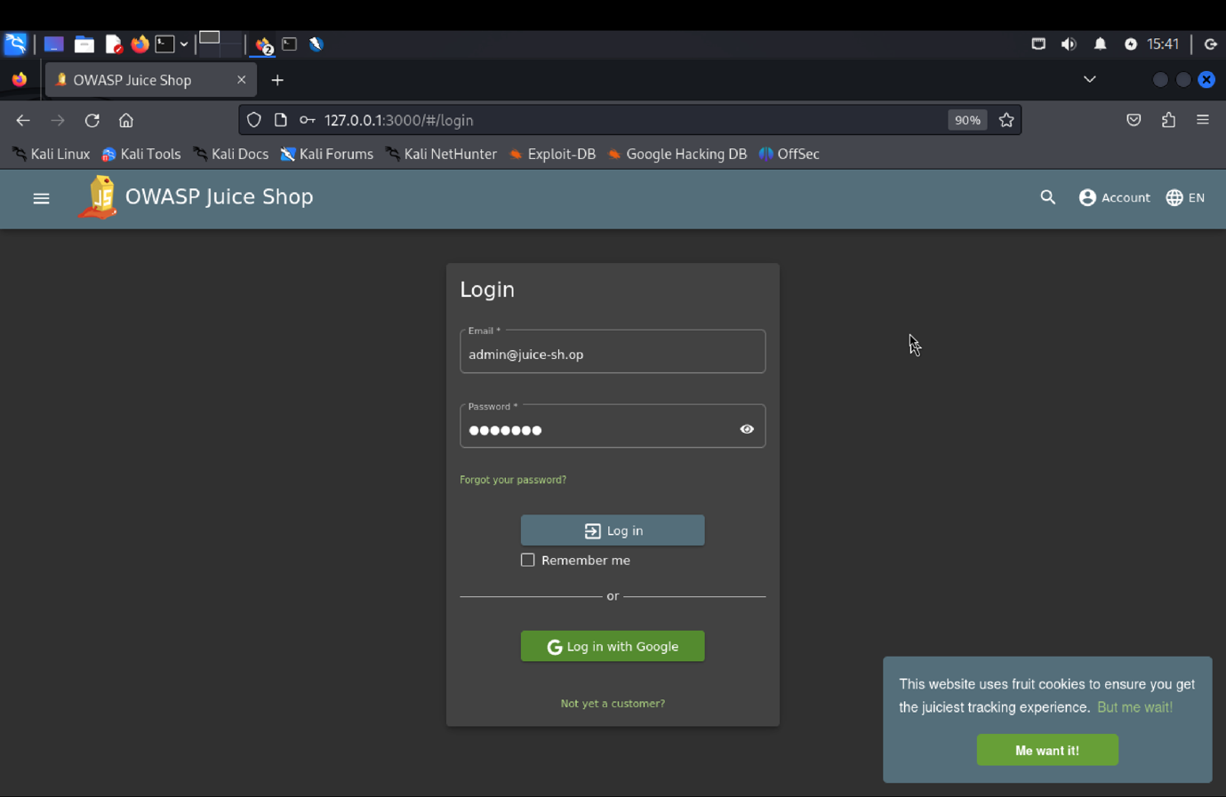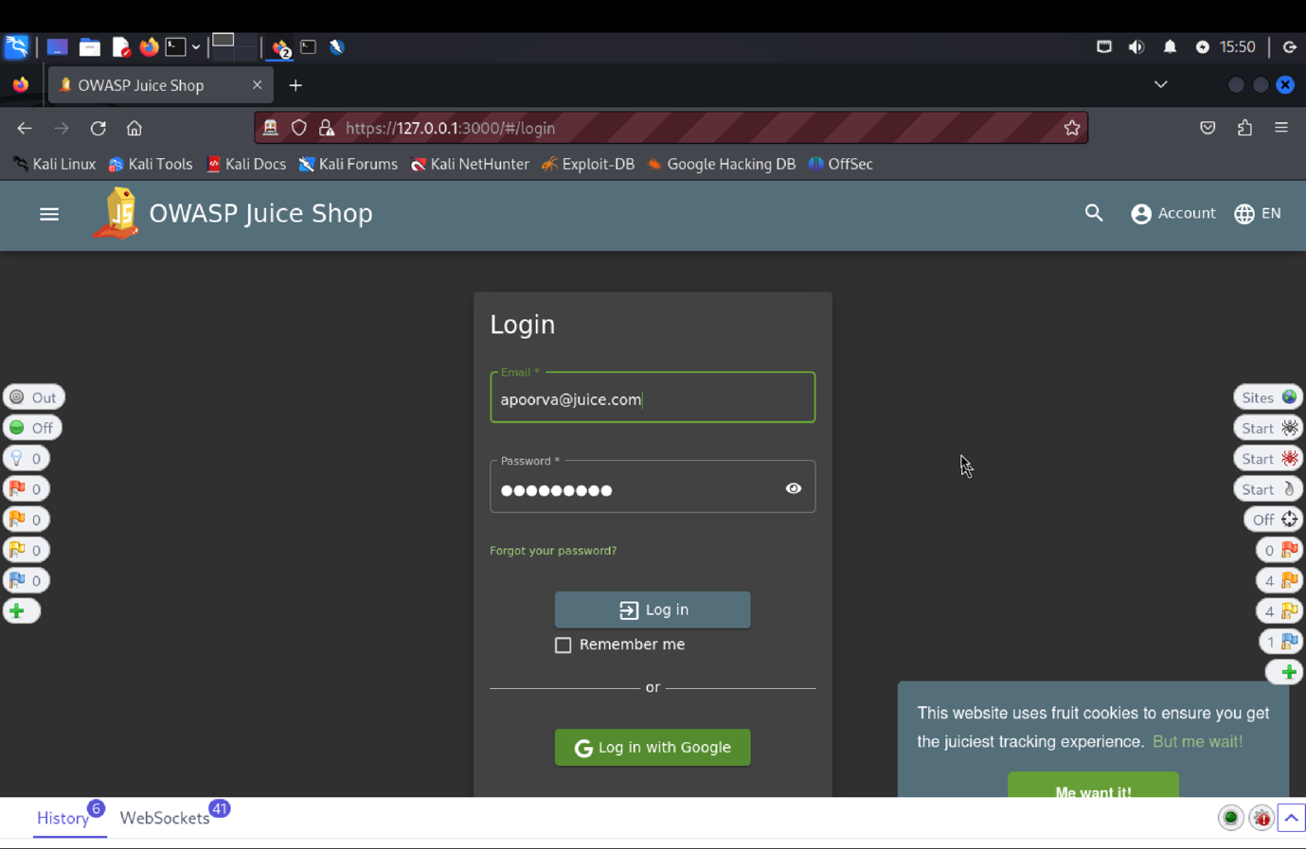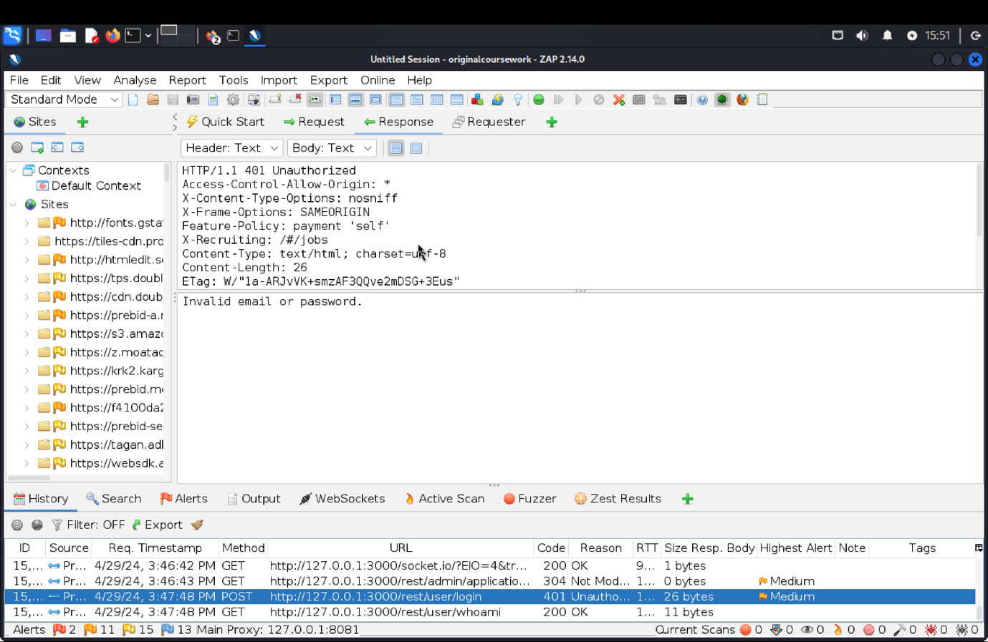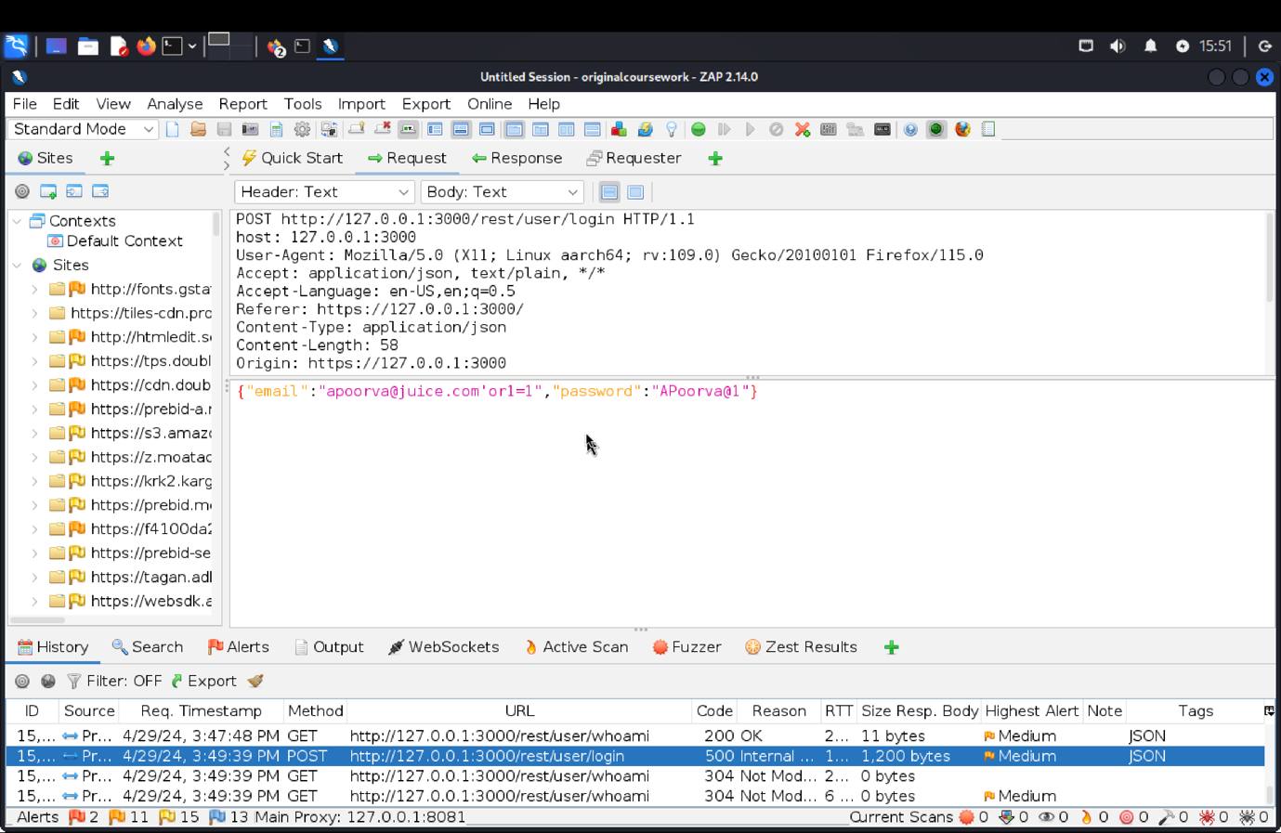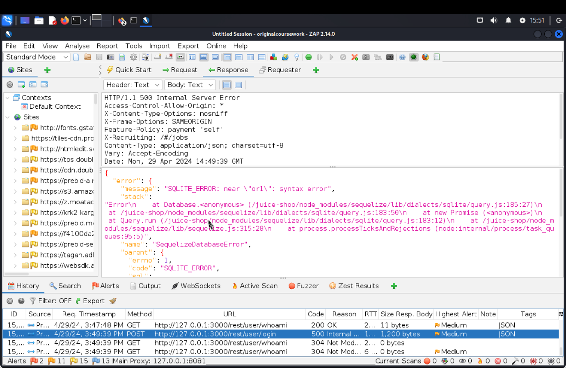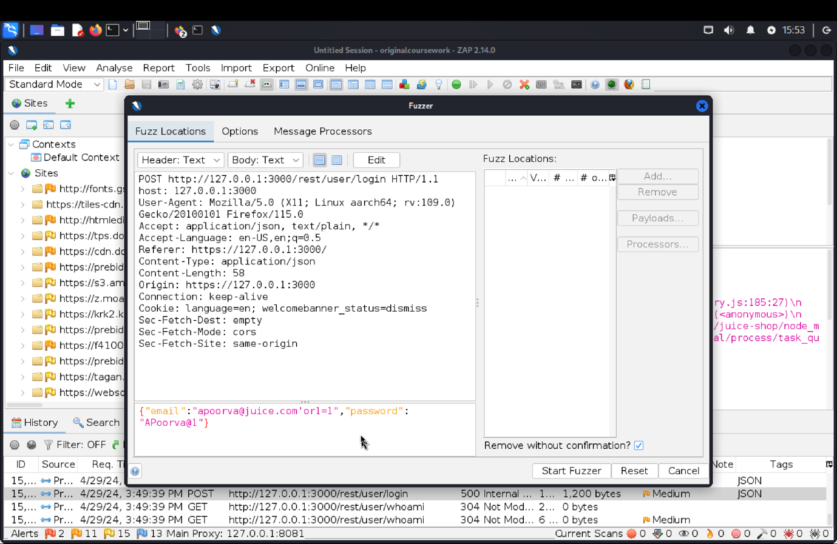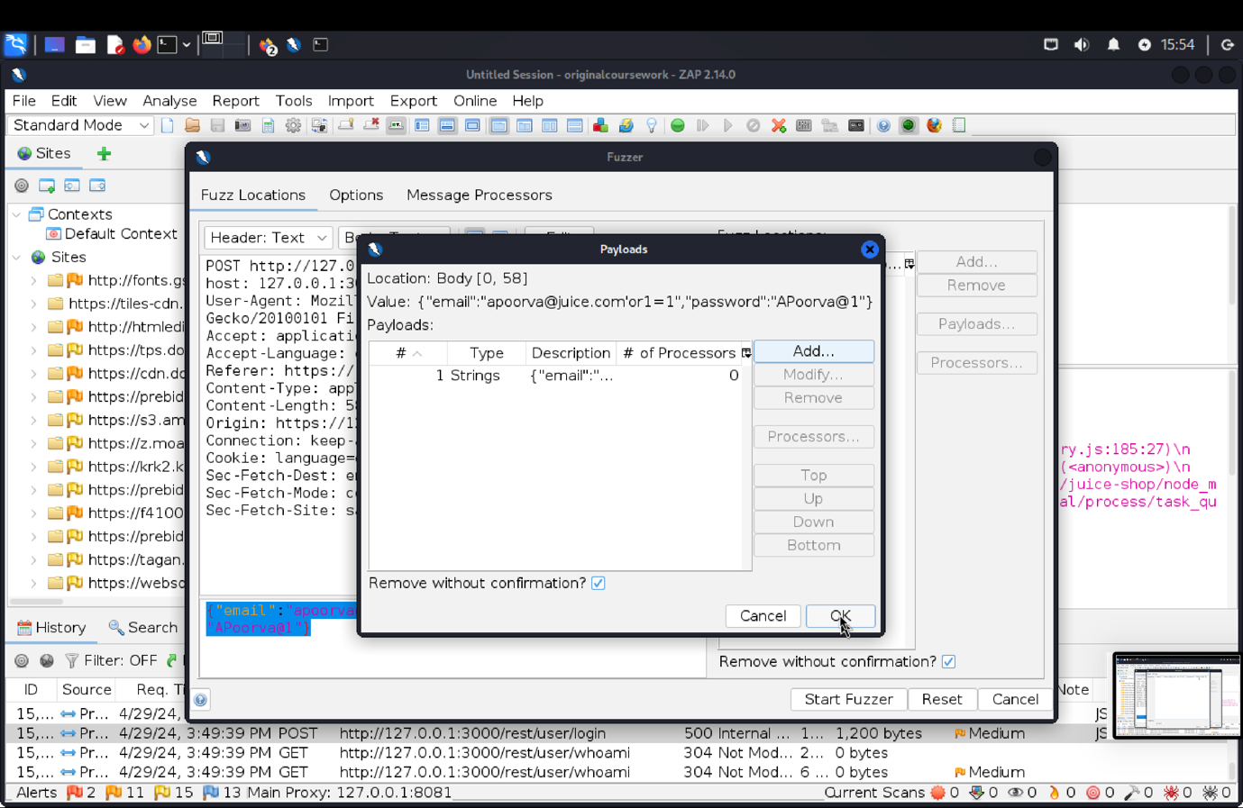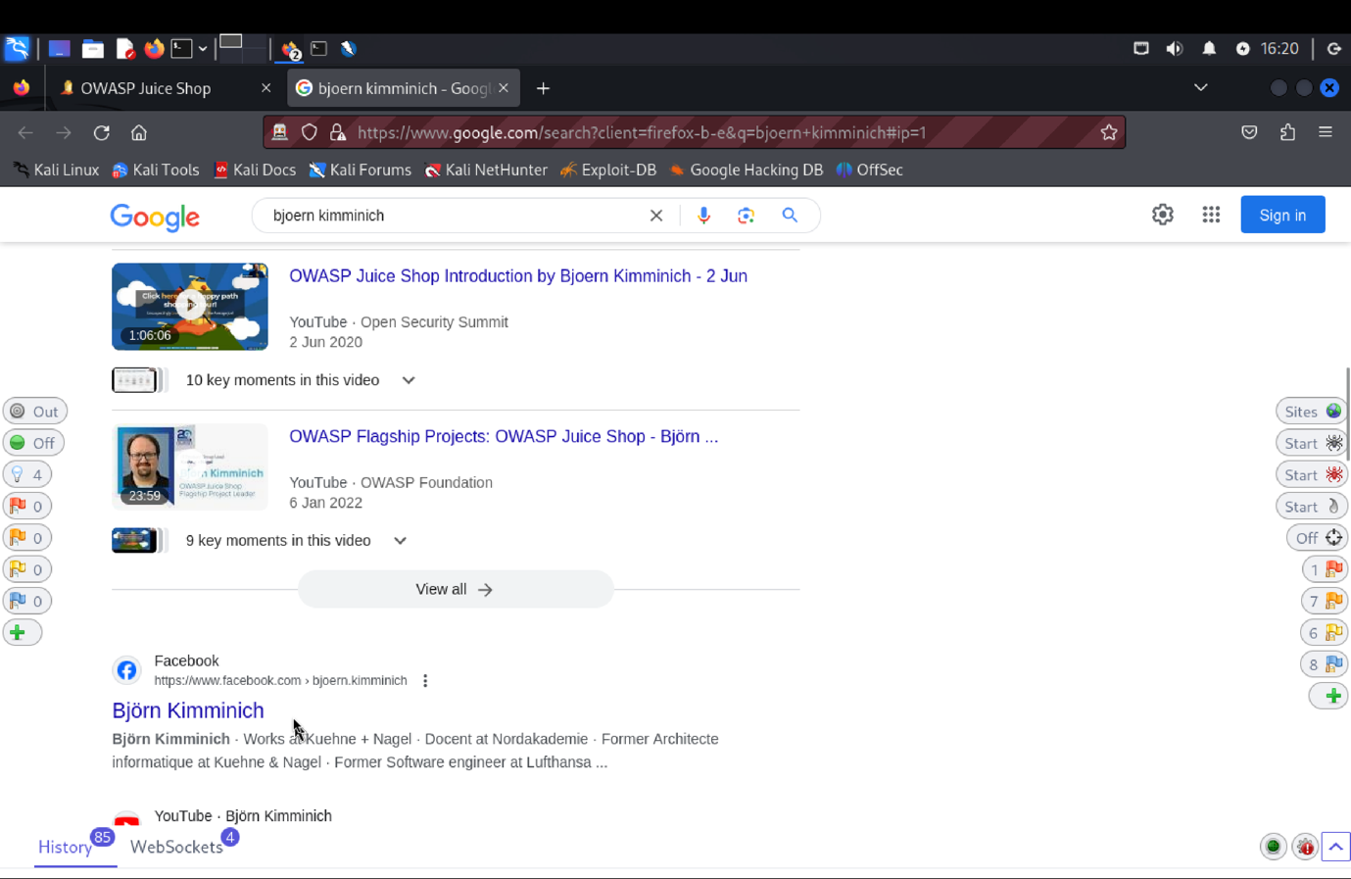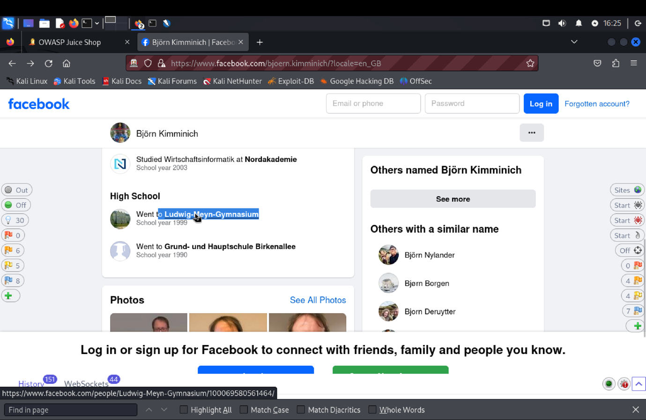 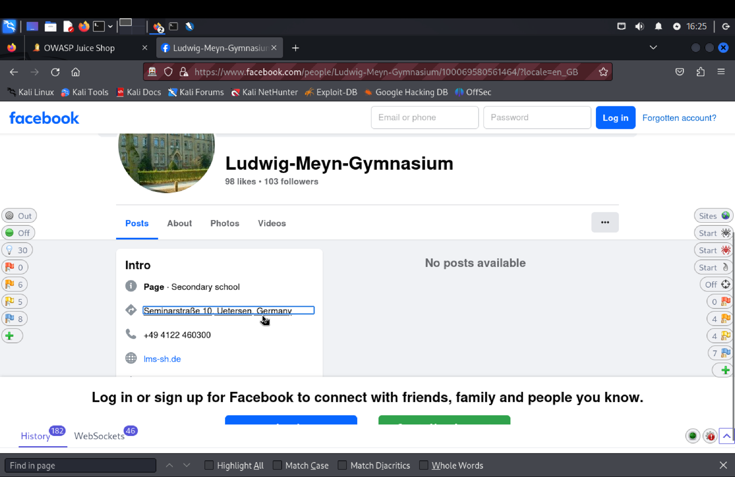

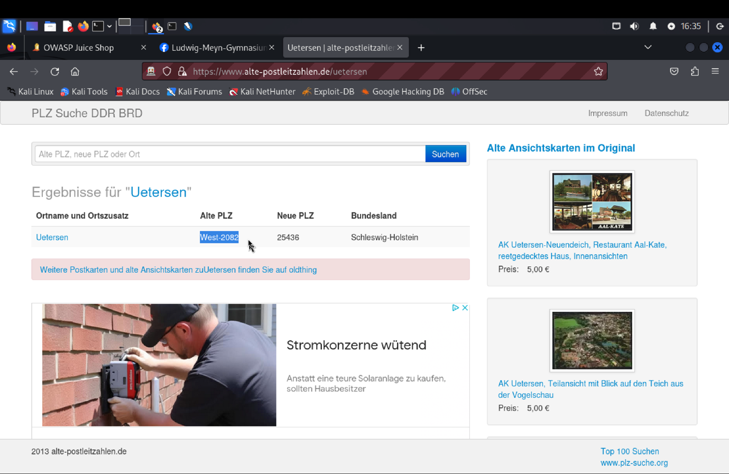

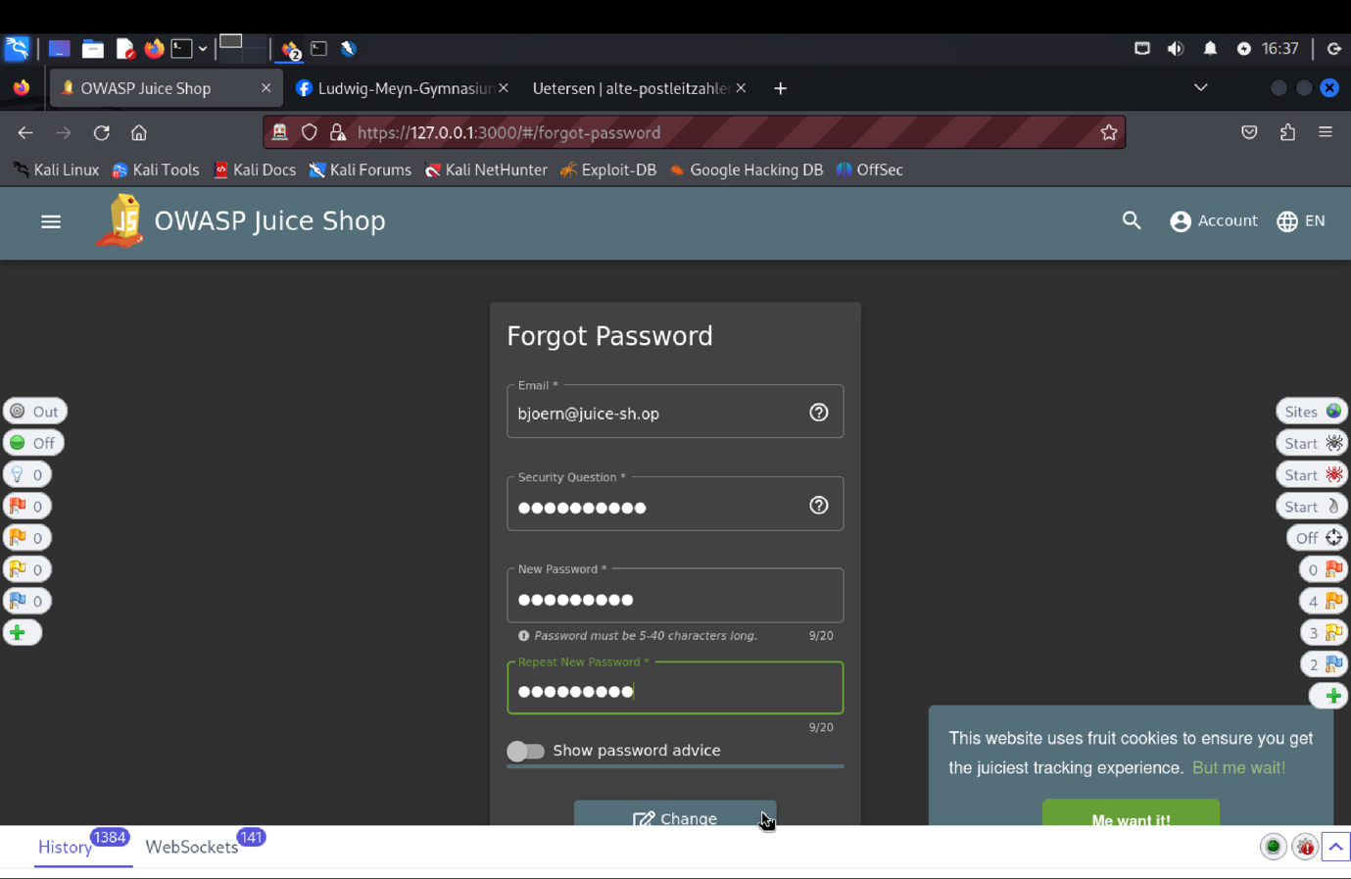

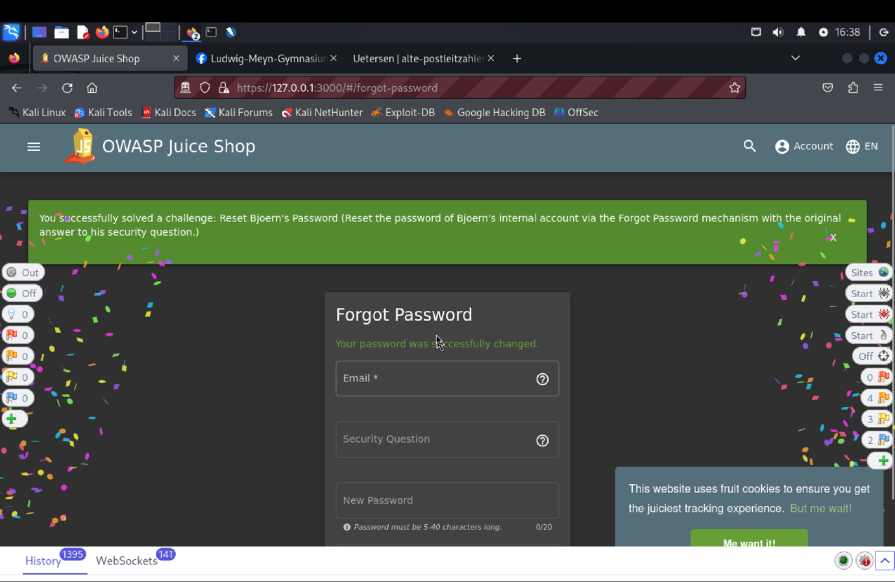

1. **Explanation of how the evidence included in (b) proves that FDP_ACC.1.1 is violated:**

We created a user with admin permissions or signed into the Target of Evaluation (TOE) as an admin user in order to determine Bjoern's email address in order to test the "Reset Bjoern's Password". Using the "Forgot Password", we had to respond to a security question pertaining to Bjoern's pin/zip code from his early years. We found his teenage location in Uetersen, Germany, and calculated the zip code (West-2082) by checking Facebook and Google. We were able to successfully demonstrate the weakness in the Security Functional Requirements (SFR) of the TOE.

**Reset Jim’s Password:** Reset Jim’s password via the Forgot Password mechanism with the truthful answer to his security question.

1. **Description of penetration testing that was carried out.**
2. Logged in using admin email Id as shown in Admin Section or use= asd@asd.com, password = asd@123 to find the email of user Jim.
3. Or Under the Green Smoothie item, find Jim’s id as “**jim@juice-sh.op**”
4. Next, we click on Login->Forget Password
5. Using the above Jim’s email id, Security question answer as anything you want (I have entered Apoorva), new password = jim@123, repeat password = jim@123.
6. Click on change.
7. The request json object will be **{“email”: “jim@juice-sh.op”, “answer”:”Henry”, “new”:”jim@123”, “repeat”:”jim@123”}.**
8. 401 Unauthorized error is triggered which says, “**Wrong answer to security question**”.
9. We search for list of sibling names of James on google basically the idea is to try as many names as possible I almost gave 100-150 names.
10. Using these values we create a Fuzz attack payload by selecting security question value field.
11. One of the values i.e. **“Samuel”** gets 200 Ok response. This indicates Jim’s eldest sibling name is Samuel.
12. In this way, Jim’s password reset was successful by copying the authentication data for another user of the TOE.
13. **Outcomes/Evidence of the Penetration Testing**
14. **Explanation of how the evidence included in (b) proves that FDP_ACC.1.1 is violated**:

We found Jim's email under the Green Smoothie item or logged in with admin credentials to assess the target of evaluation's (TOE) security function requirement (SFR). Next, we tried resetting Jim's password using the "Forget Password" tool, trying out various responses to the security question. We found that "Samuel" answered the security question properly using a fuzz attack, allowing us to reset the password. This demonstrates a flaw that allows unauthorized users to compromise access control by resetting the password by stealing authentication information from another user.

**SFR Identifier:**

FAU_SAA.3.1: The TOE shall be able to maintain an internal representation of the following signature events EVENT1, EVENT2, …, EVENT n that may indicate a violation of the enforcement of the SFRs.

**Related Vulnerability Challenges: -**

1. Email Leak
2. Exposed Metrics
3. Access Log
4. Confidential Document
5. Leaked Access Logs
6. Leaked Unsafe Product
7. Forgotten Developer Backup

**VC: Access Log:**

1. **Description of penetration testing that was carried out.**
2. In the score-board find the Access log, we have to access log file of the server.
3. In the url type /ftp removing score-board to find file logs.
4. In the ftp find incient-support.kdbx and download it. Click on it and choose it to open application.
5. In downloads open terminal there, then use cat command and open the same file.
6. In the url replace ‘/ftp’ with ‘/support/logs’ and then find the latest one and download and open it.
7. Here you can find all the logs. Go to dashboard or score-board. This solves the challenge.
8. **Outcomes/Evidence of the Penetration Testing**

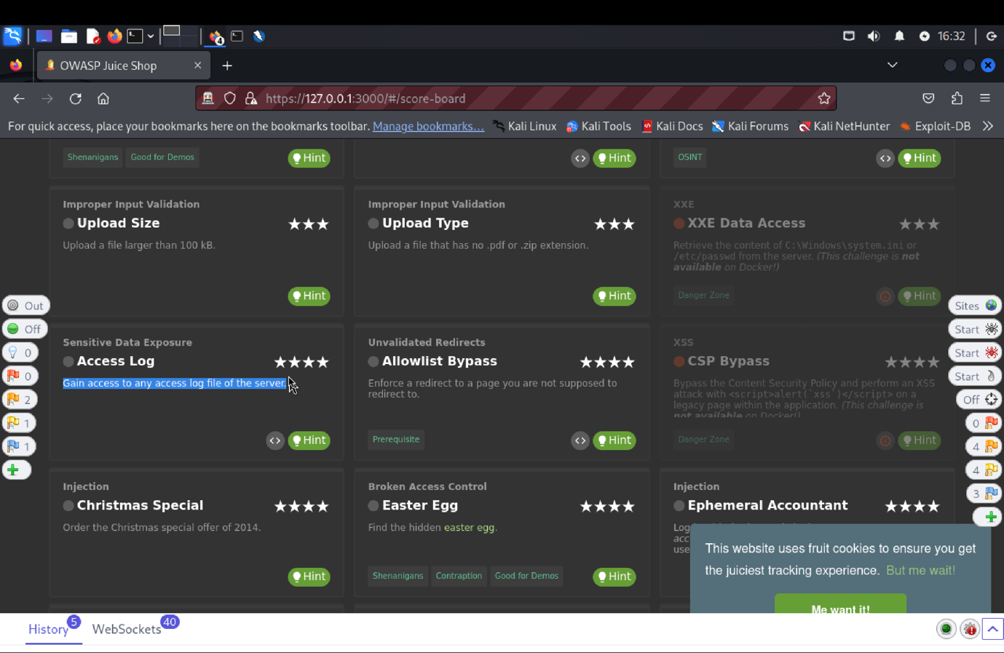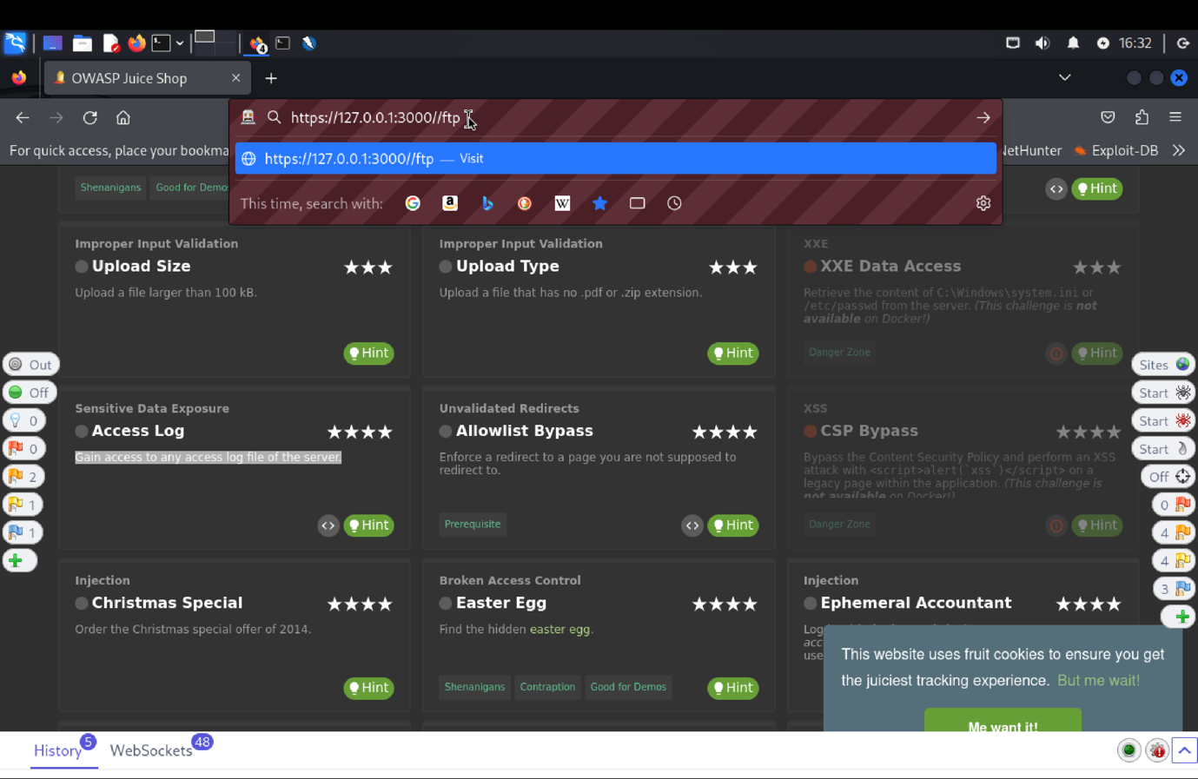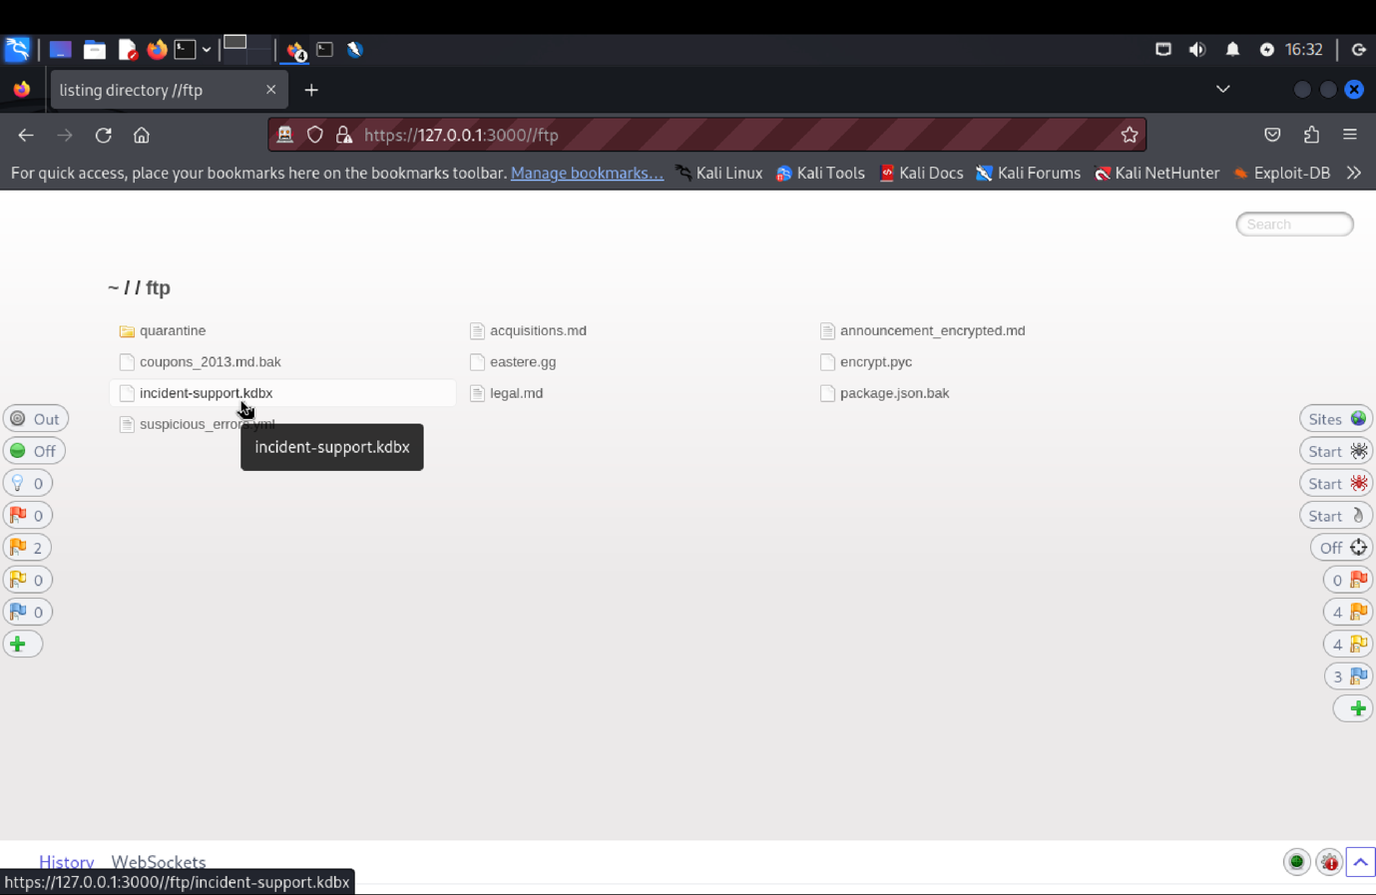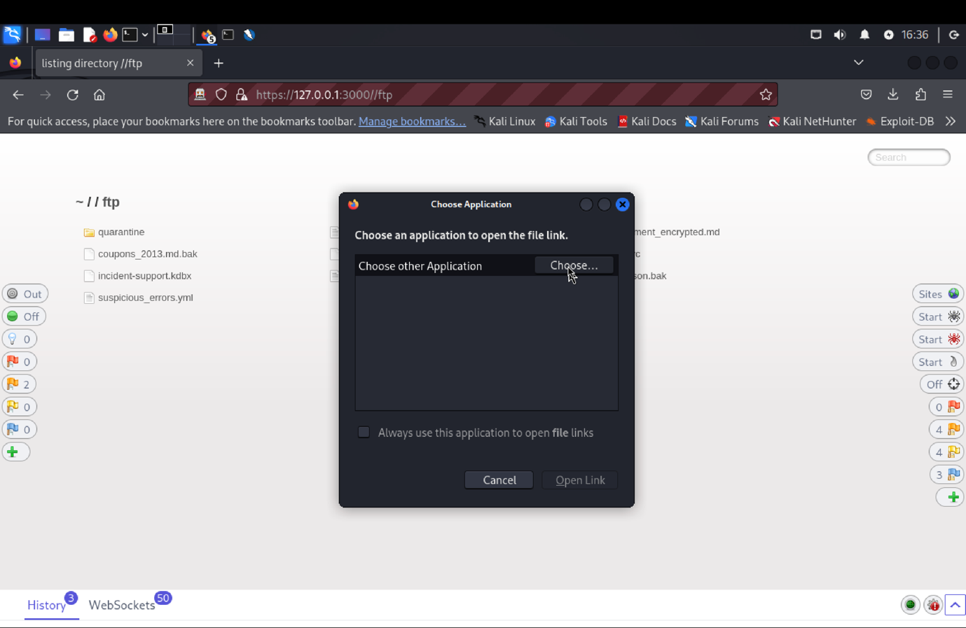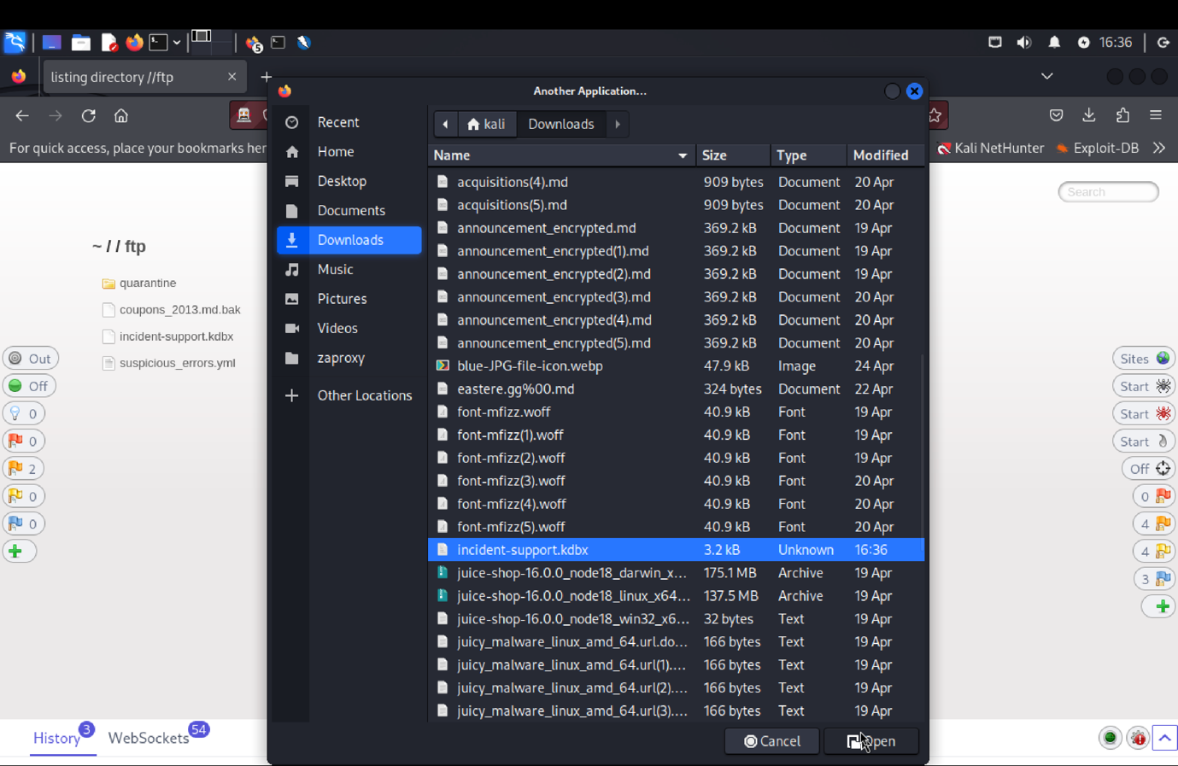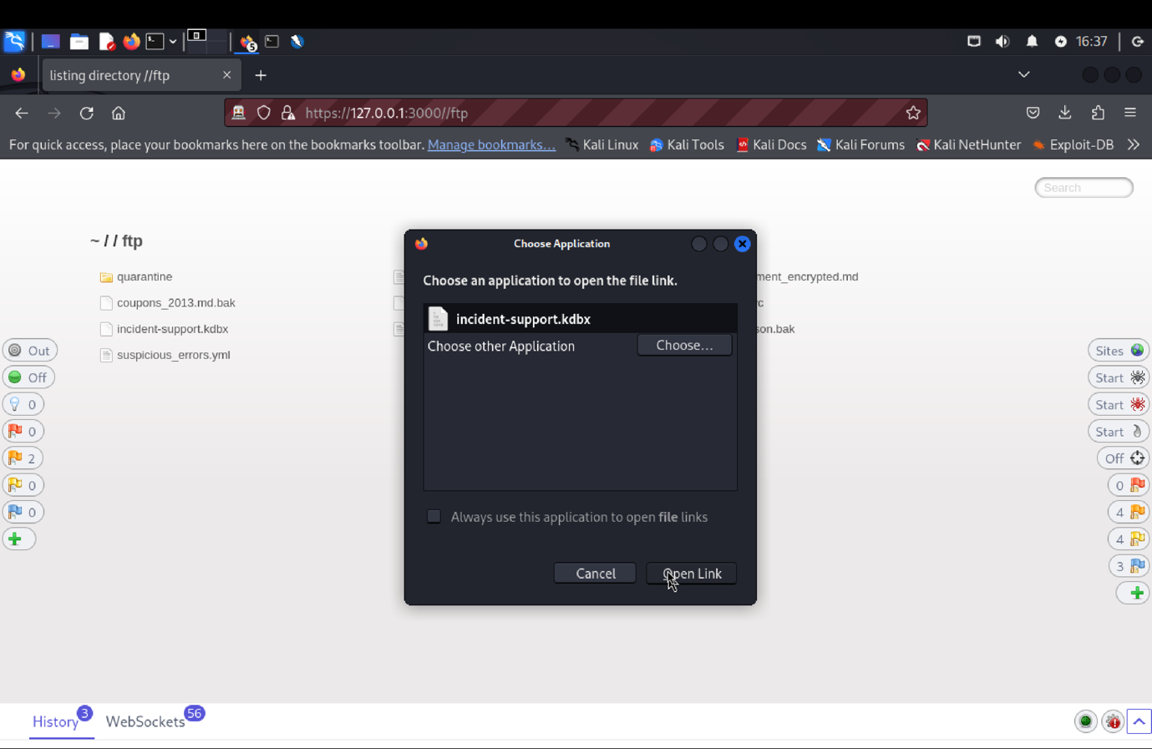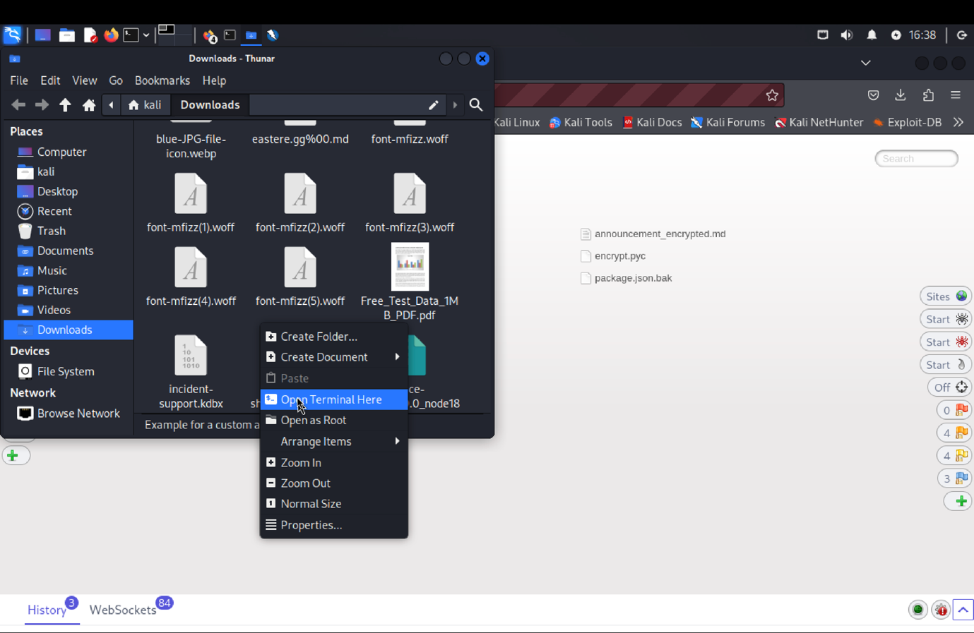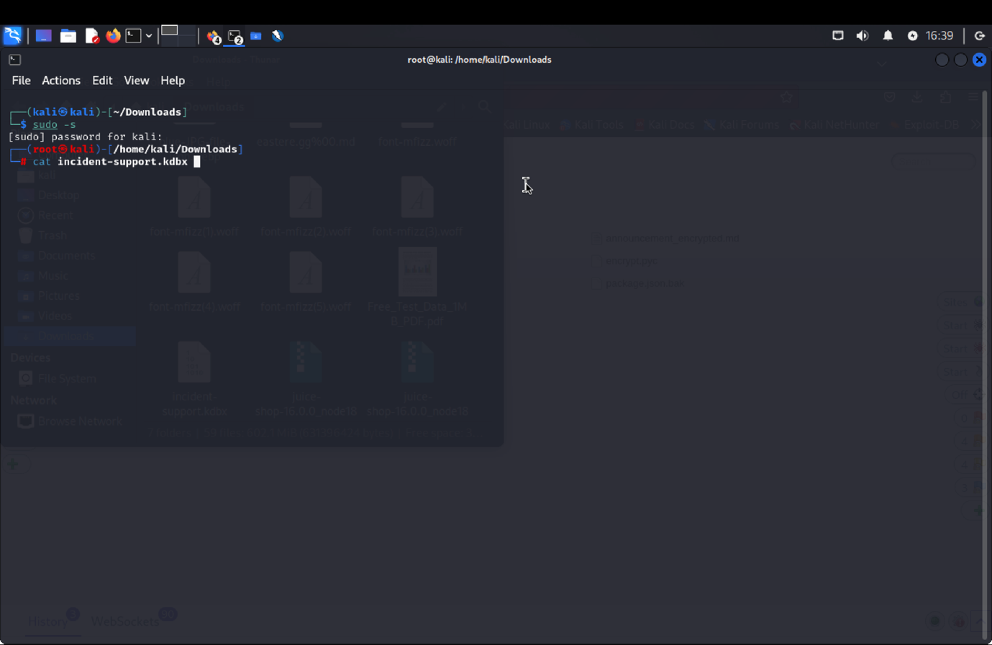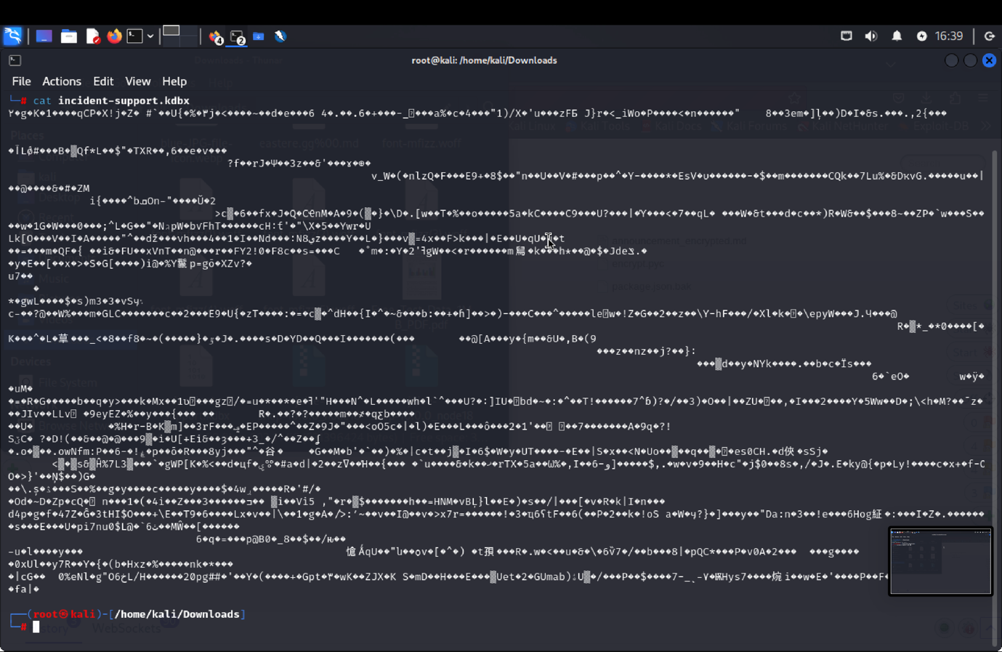 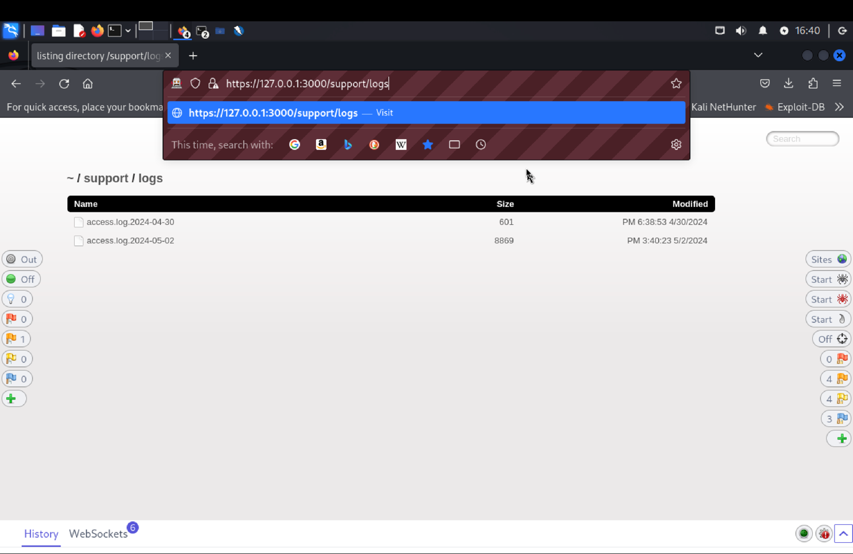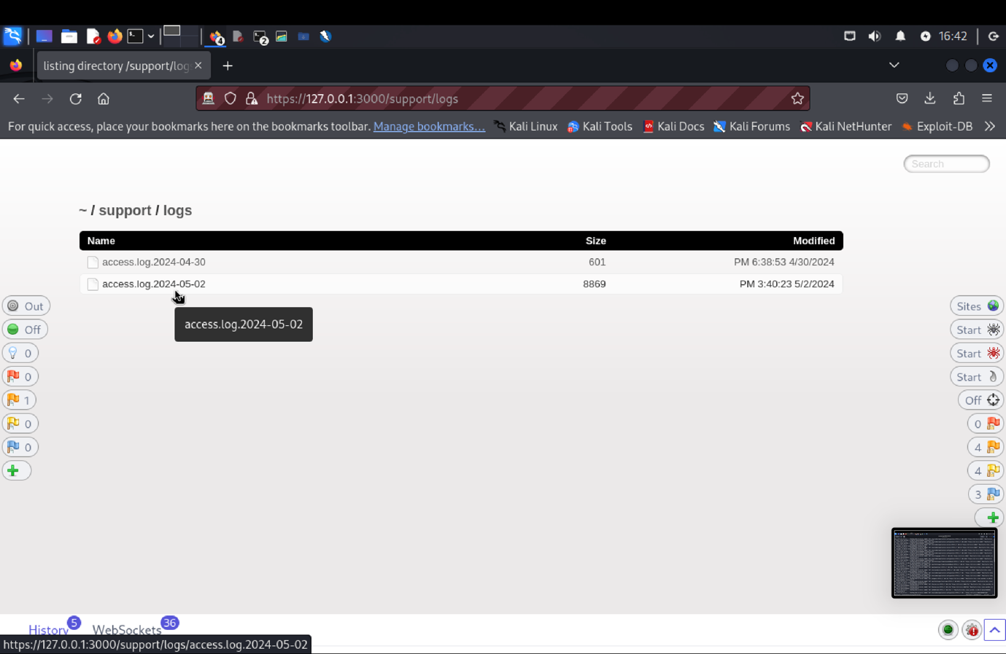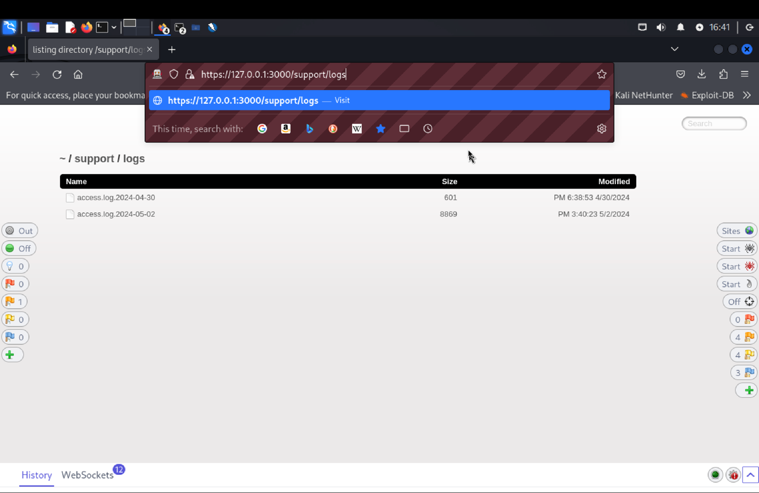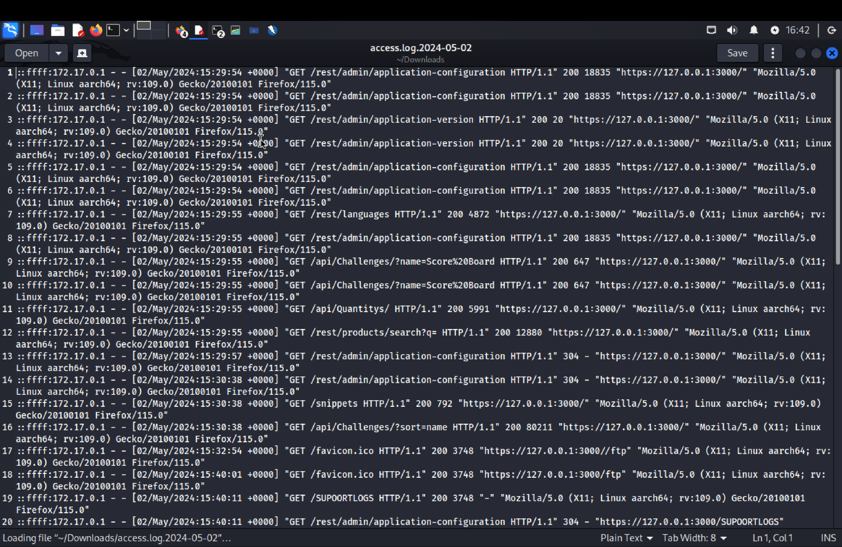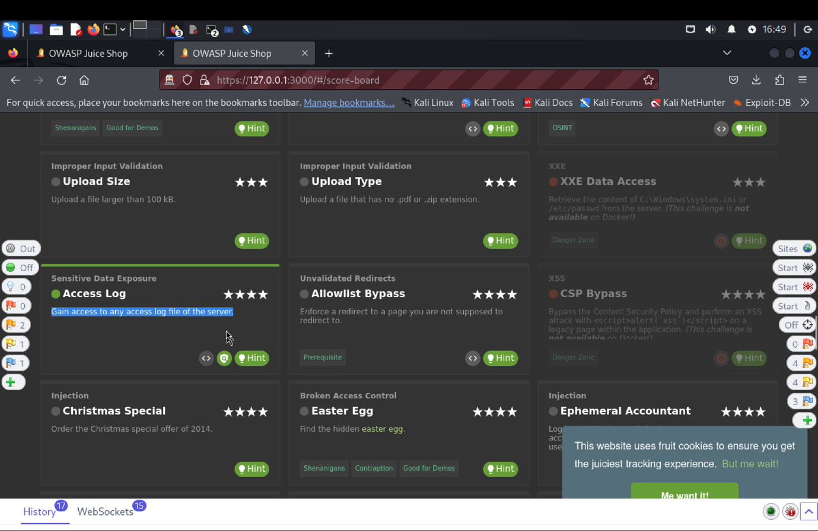

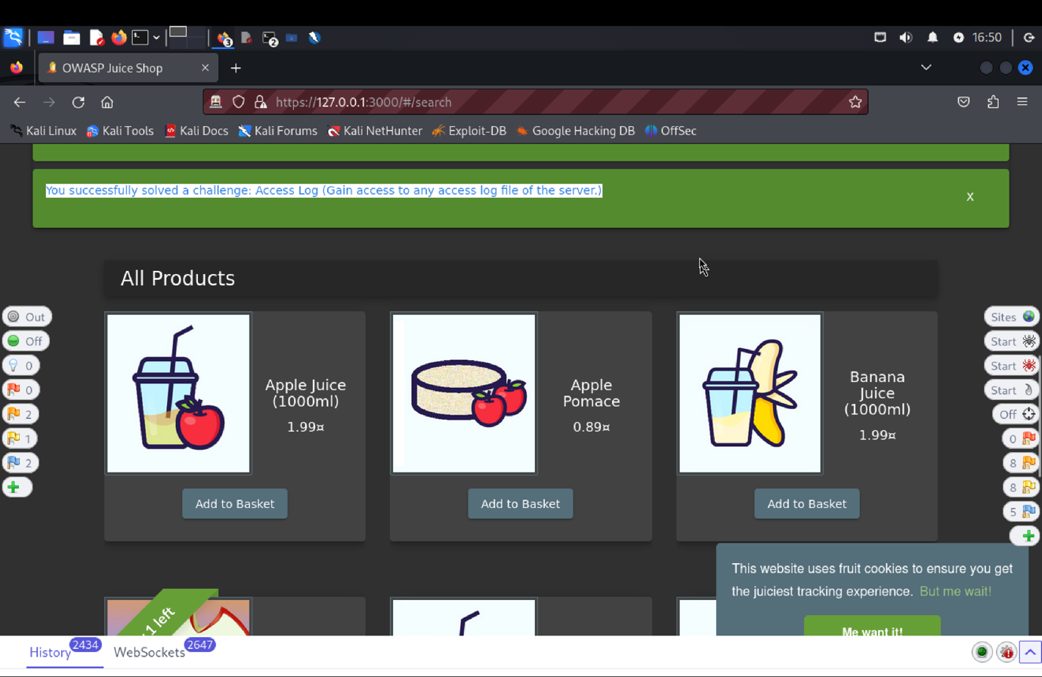

1. **Explanation of how the evidence included in (b) proves that FDP_ACC.1.1 is violated:**

We verify that the Access Log functioned in accordance with the designated Security Functional Requirement (SFR) throughout our penetration testing of the Target of Evaluation (TOE). By some manipulation of the FTP directory's URL, we were able to locate incident-support.kdbx and retrieve server log files. By using the cat command in the terminal, we were able to gain access to private records and show that there may have been a security breech. This challenge emphasizes how important it is to prevent unwanted access to internal log files because our solution got around standard security protocols and exposed sensitive server information.

**VC: Email Leak**

1. **Description of penetration testing that was carried out.**
   1. Login to the juice shop using the email [asd@asd.com](mailto:asd@asd.com) password: asd@1
   2. Go to ZAP and find /rest/user/whoami. Send this to the requester tab.
   3. In the requester tab find the api, add to /rest/user/whoami?callback=admin.
   4. Once this gives success message we see that the API response is a JavaScript fragment (JSONP), rather than a JSON object.
   5. This asynchronous API callback returns the user information for the currently logged-in users.
   6. We solved the email-leak challenge.
2. **Outcomes/Evidence of the Penetration Testing**

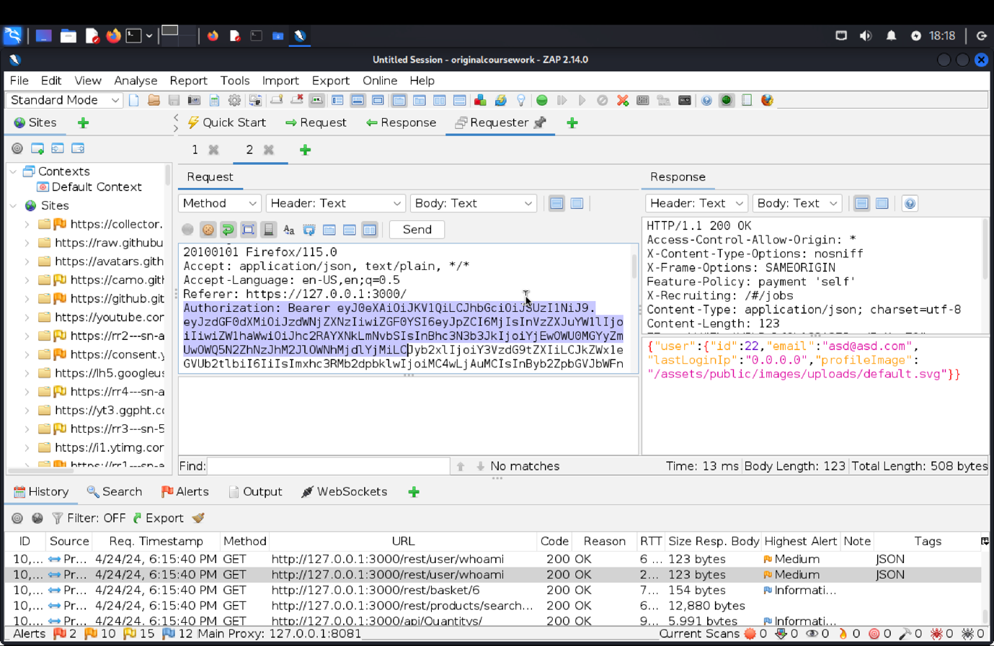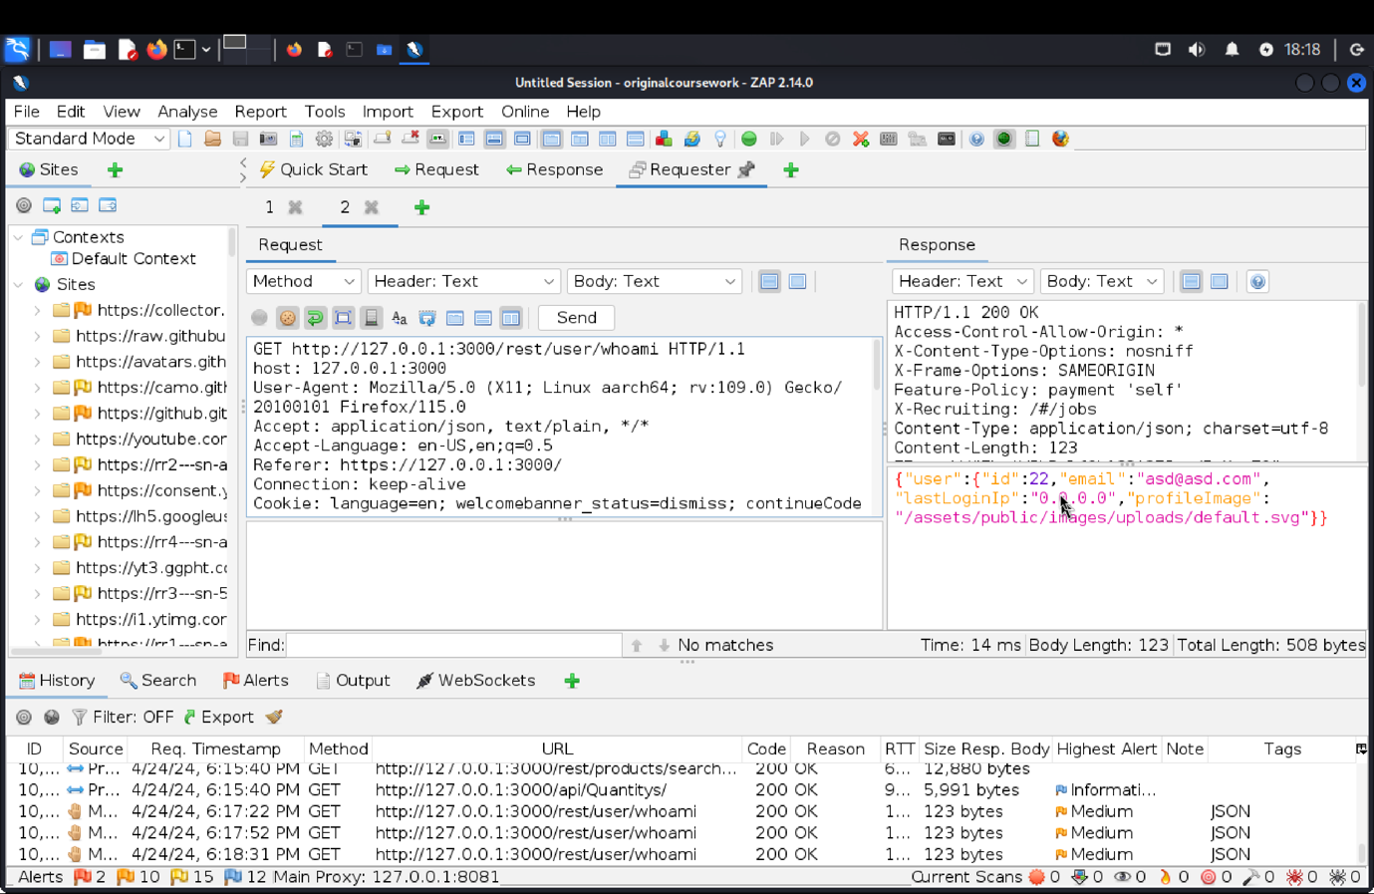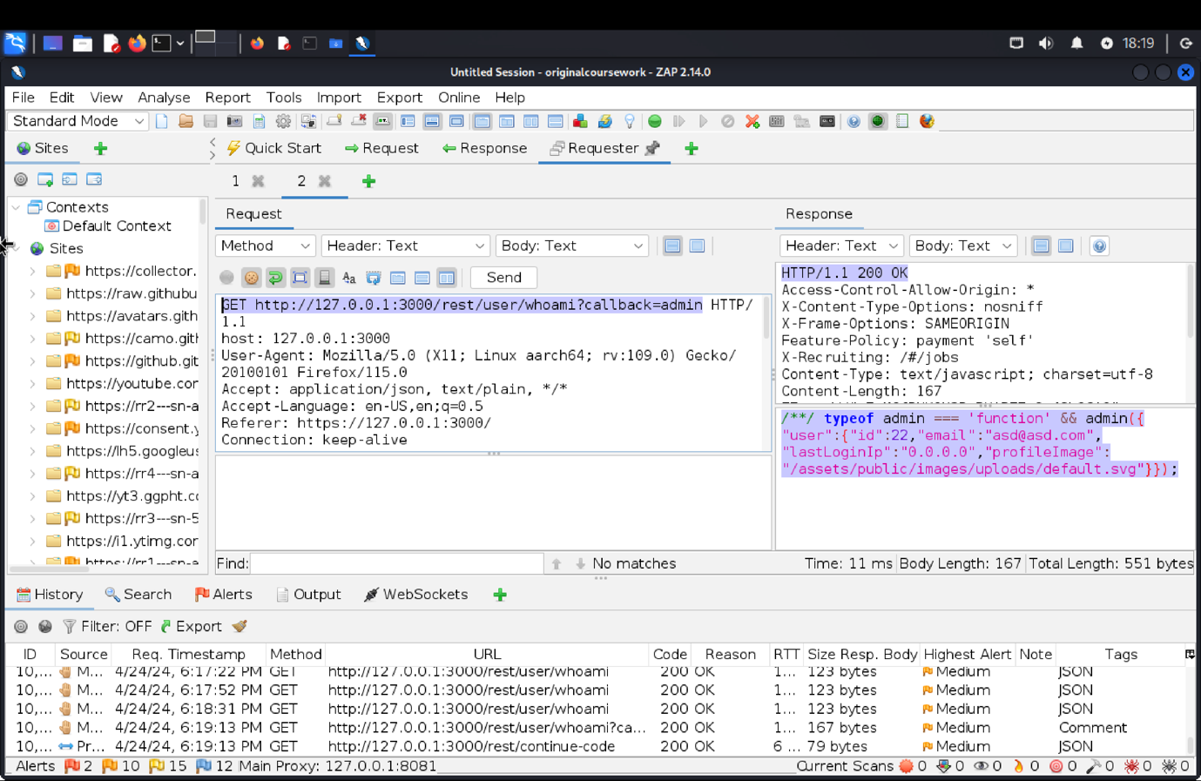

1. **Explanation of how the evidence included in (b) proves that FDP_ACC.1.1 is violated:**

Upon successfully logging in with asd@asd.com and asd@1, we found /rest/user/whoami using ZAP. We added?callback=admin to the API endpoint and transmitted this to the requester tab. This returns the current logged in users information. This strategy successfully addressed the email leak issue by allowing illegal access to user data.

**VC: Exposed Metrics**

1. **Description of penetration testing that was carried out.**
   1. In this challenge we need to find the end point of that server usage.
   2. For this I went to the score-board in there we have the link to git hub code.
   3. In the description there is the link for the metrics configuration.
   4. In that link find that path is /metrics at line number 25.
   5. Navigating back to the OWASP Juice Shop in the address bar go to <https://127.0.0.1:3000/metrics>
   6. In this link all the log of metrics is listed. Navigating back to the score-board/homepage I get the prompt that challenge is solved.
2. **Outcomes/Evidence of the Penetration Testing**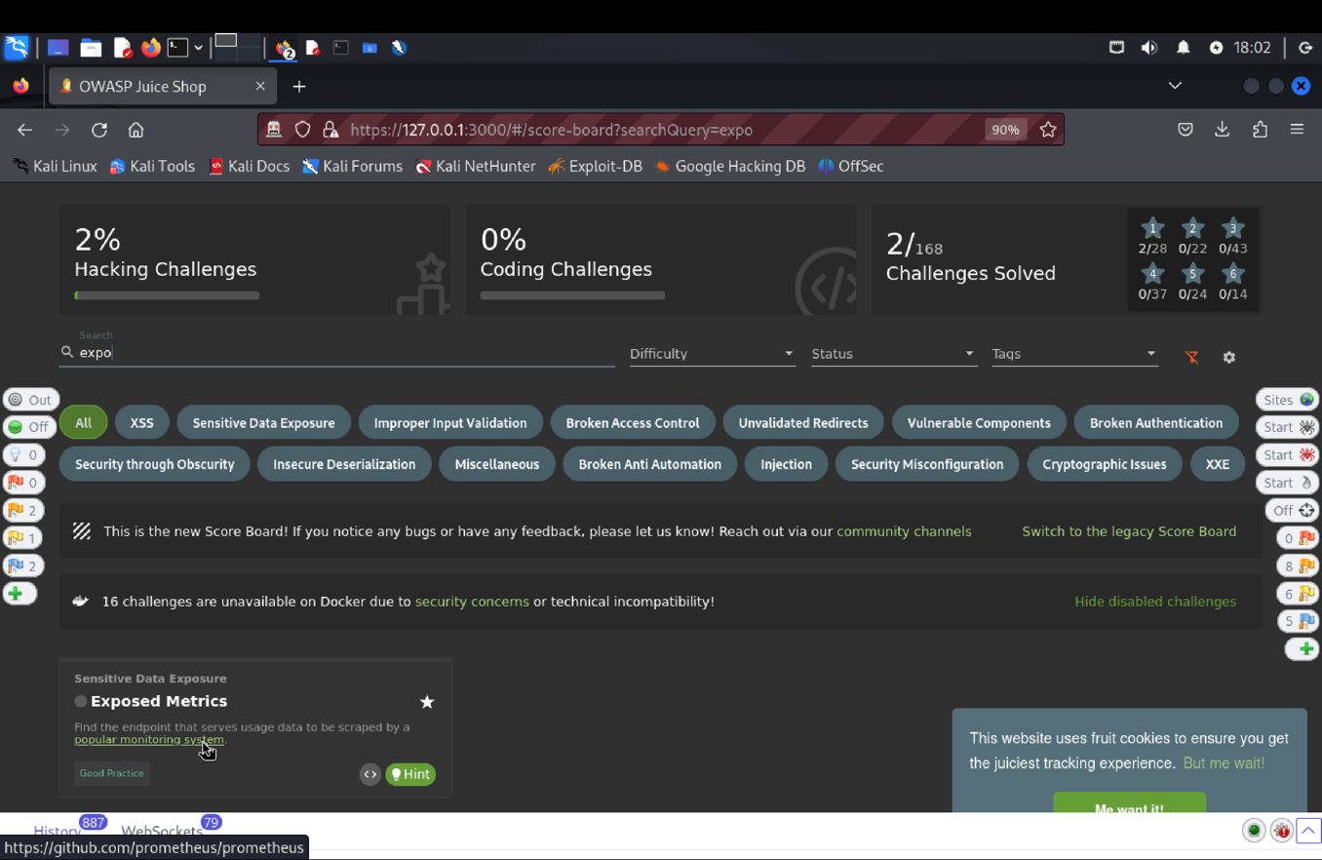

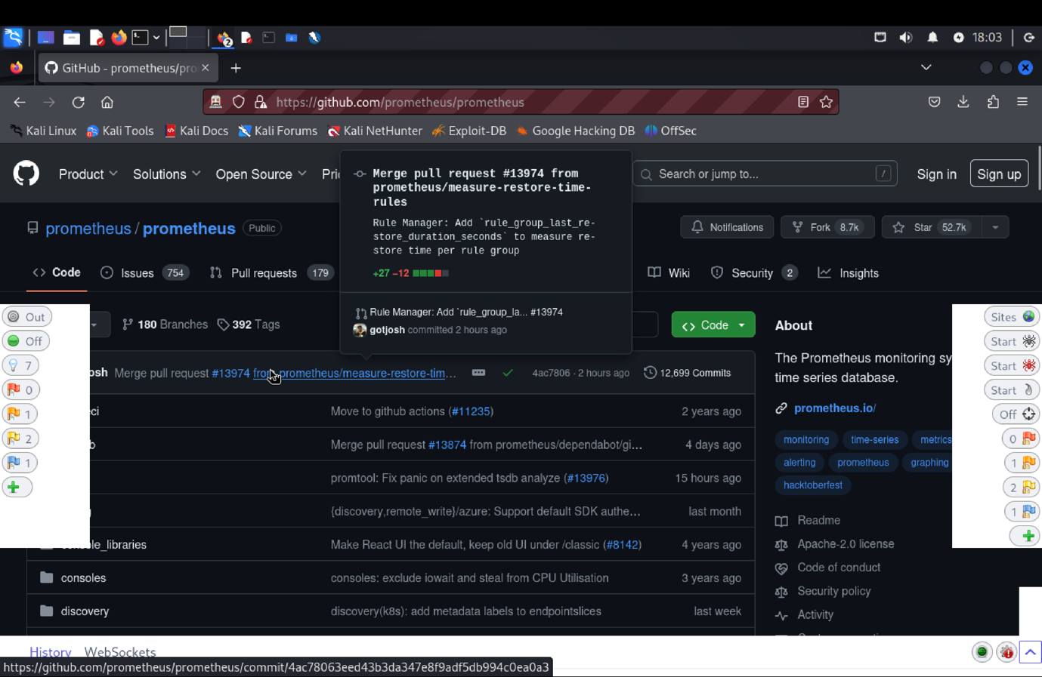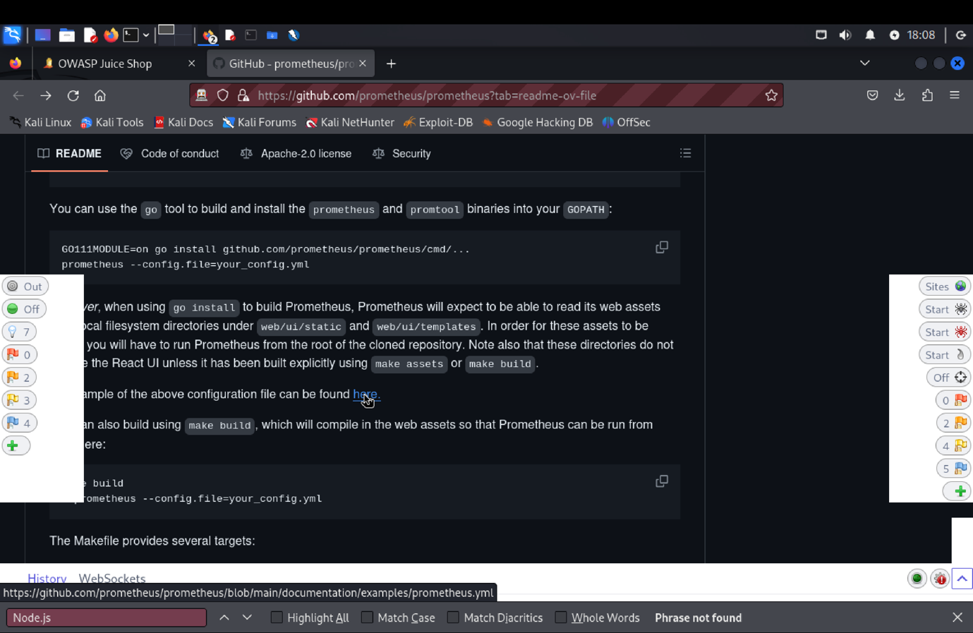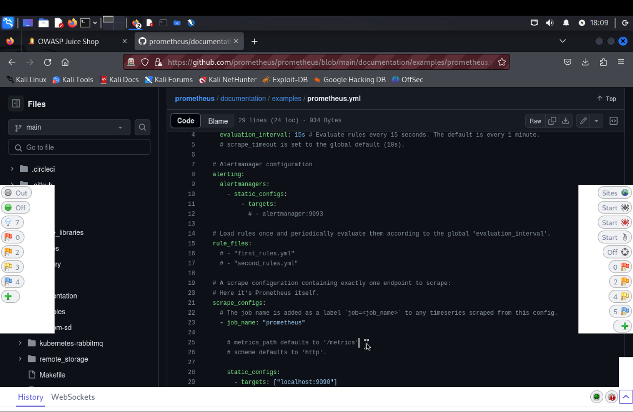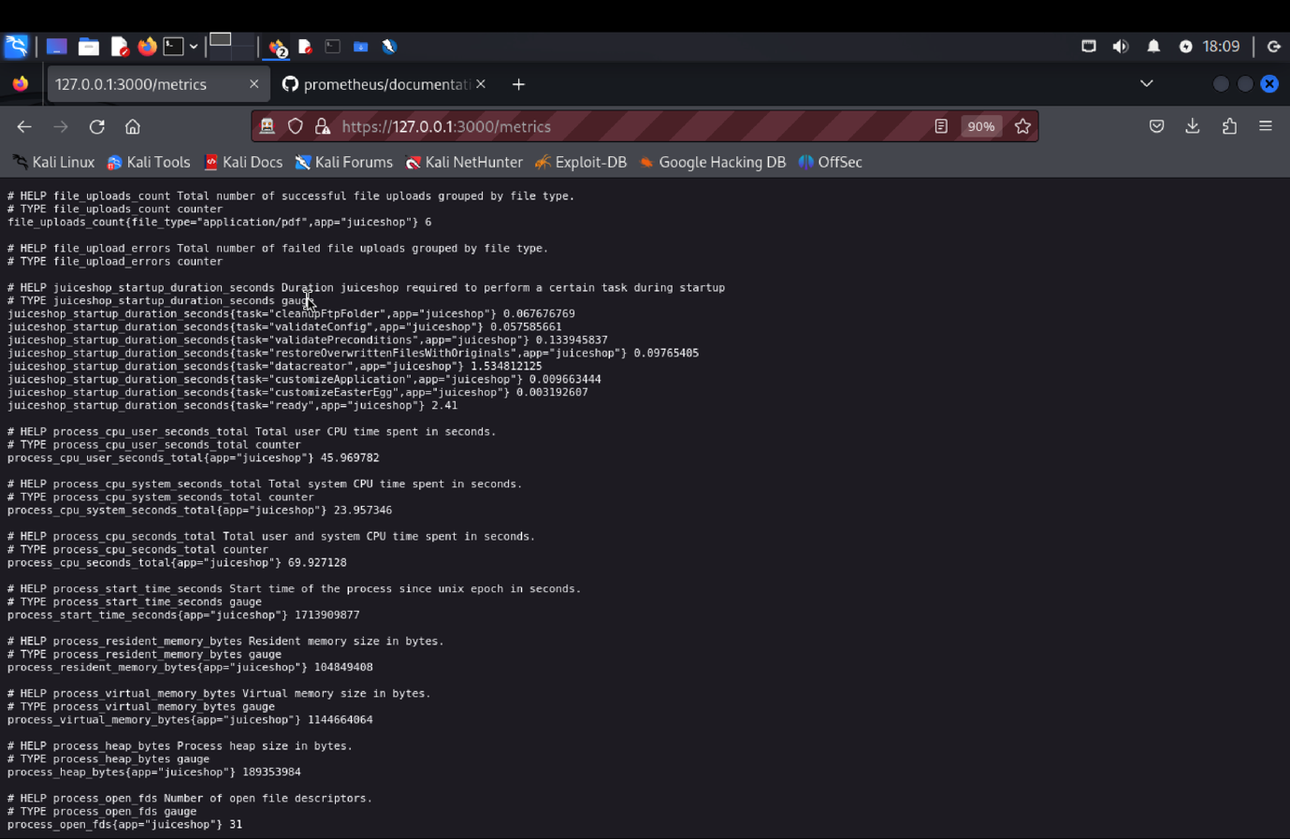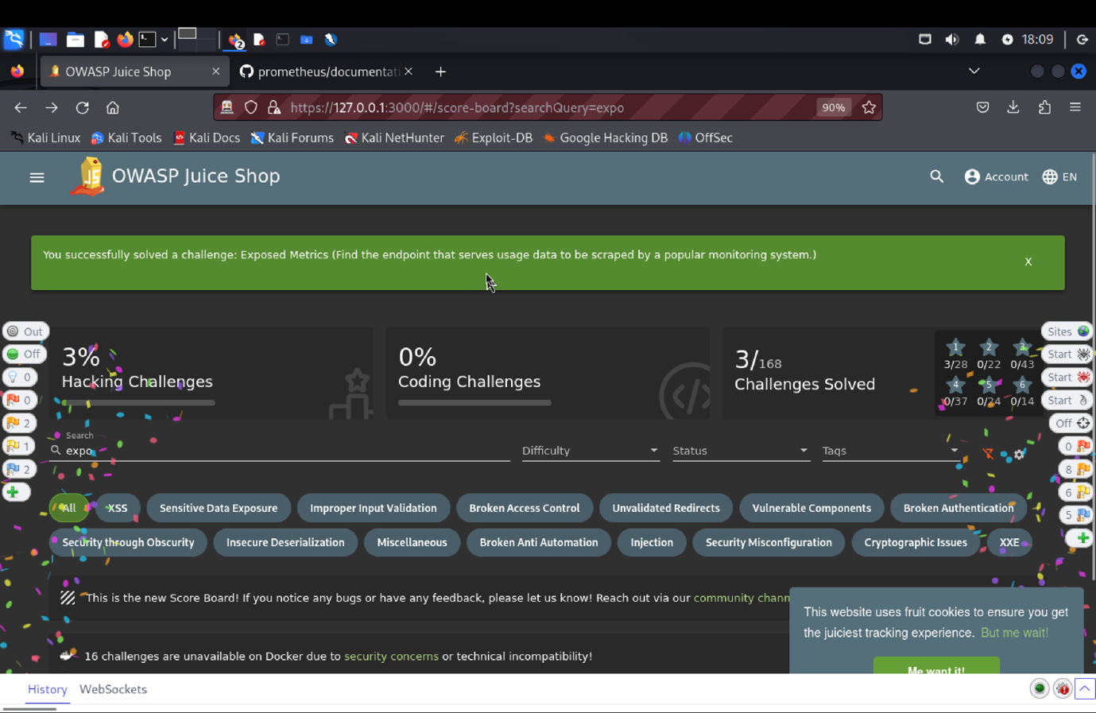

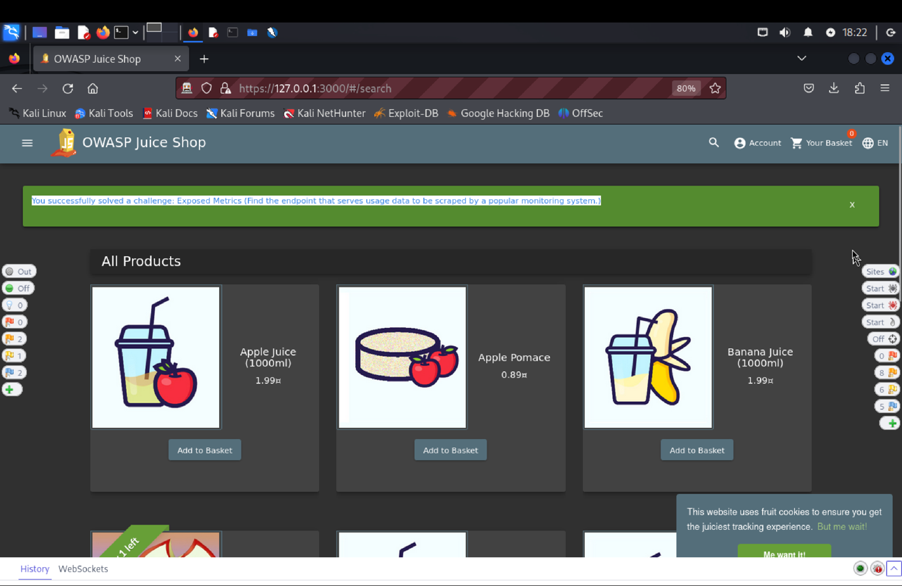

1. **Explanation of how the evidence included in (b) proves that FDP_ACC.1.1 is violated:**

Our goal in doing this penetration test was to locate the server usage endpoint. After looking through the scores, we found a link to the GitHub code. We located the path /metrics at line 25 in the description of the metrics settings. To view a list of all metric logs, we returned to the OWASP Juice Shop and went to https://127.0.0.1:3000/metrics. We were notified that the challenge was finished when we went back to the scoreboard. This test highlighted the need for improved SFR to protect internal data by showcasing our proficiency navigating the TOE and revealing critical information.

**9) SFR Identifier:**

FAU_SAA.3.3 The TOE shall be able to indicate a potential violation of the enforcement of the SFRs when a system event is found to match a signature event that indicates a potential violation of the enforcement of the SFRs.

**Related Vulnerabilities:**

1. Deluxe fraud
2. Login Bender
3. CSFR
4. Forged Feedback
5. Forged Review
6. Manipulate Basket
7. Forged Coupon
8. Admin Registration
9. Repetitive Registration
10. Login Admin
11. Login Bender

**Tested Vulnerability Challenges: -**

1. **Deluxe fraud: Obtain a Deluxe Membership without paying for it.**

(a) **Description of penetration testing**:

1. Navigate to Deluxe Membership by clicking on the top-left corner option button.
2. Initially the **Pay:49.00** button is disabled.
3. Right click and go to inspect hover the pay button to find the html and enable it.

<button ngcontent-amb-clol type= submit color= primary

mat-raised-button class="mat-focus-indicator btn mat-raised-button mat-button-base mat-primary mat-button-disabled" style="float: right;" disabled="true”>

1. Remove to disabled field to make the Pay button visible.
2. Now, click on pay button.
3. A 400 Bad request will be received in Zap history with **{“paymentMode”: “wallet”}** json object.
4. And a response message with **{“status”:” error”,”error”:”insufficient funds in wallet”}** json object.
5. Copy/send POST **“ http://127.0.0.1:3000/rest/delux-membership”** request to requester and edit the payment method as “paid”**.**
6. Click on send.
7. A 200 Ok success response is received with **“Congratulations!! You are now a deluxe member**”.

(b) **Outcomes (evidence) of the penetration testing in (a)**: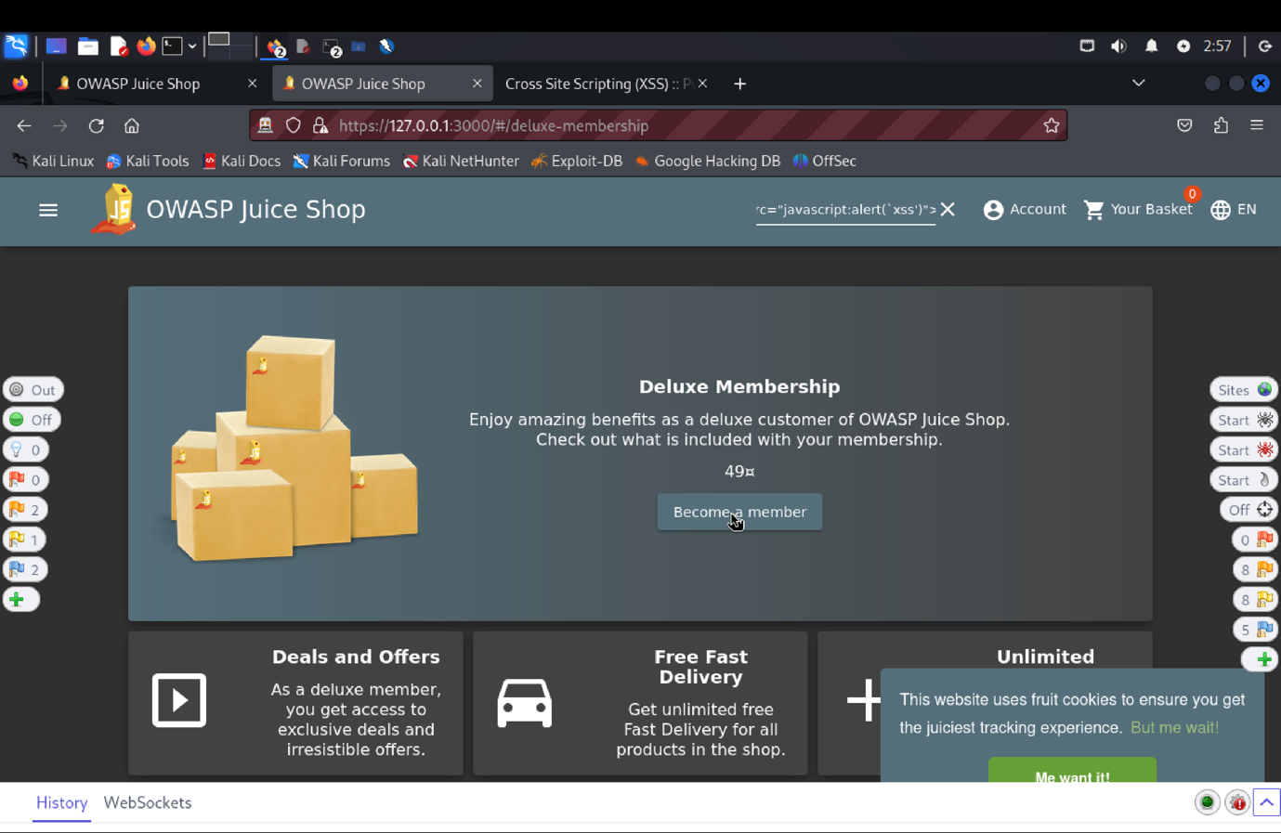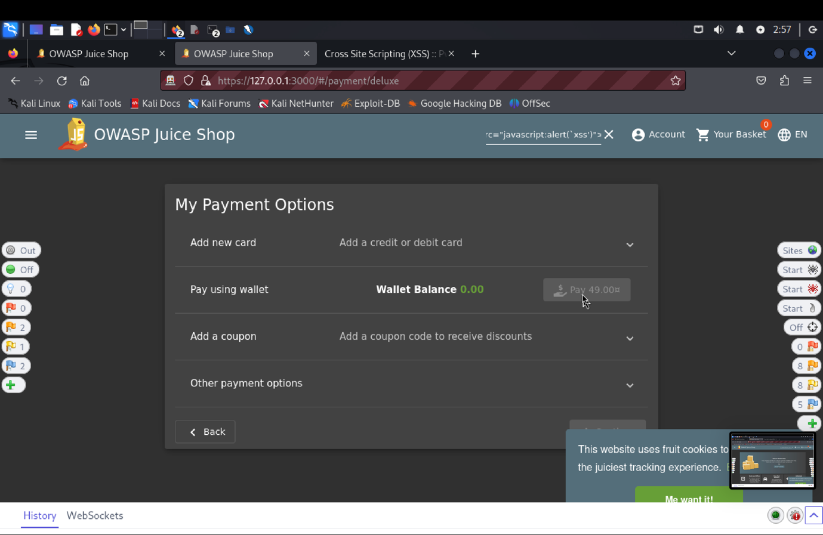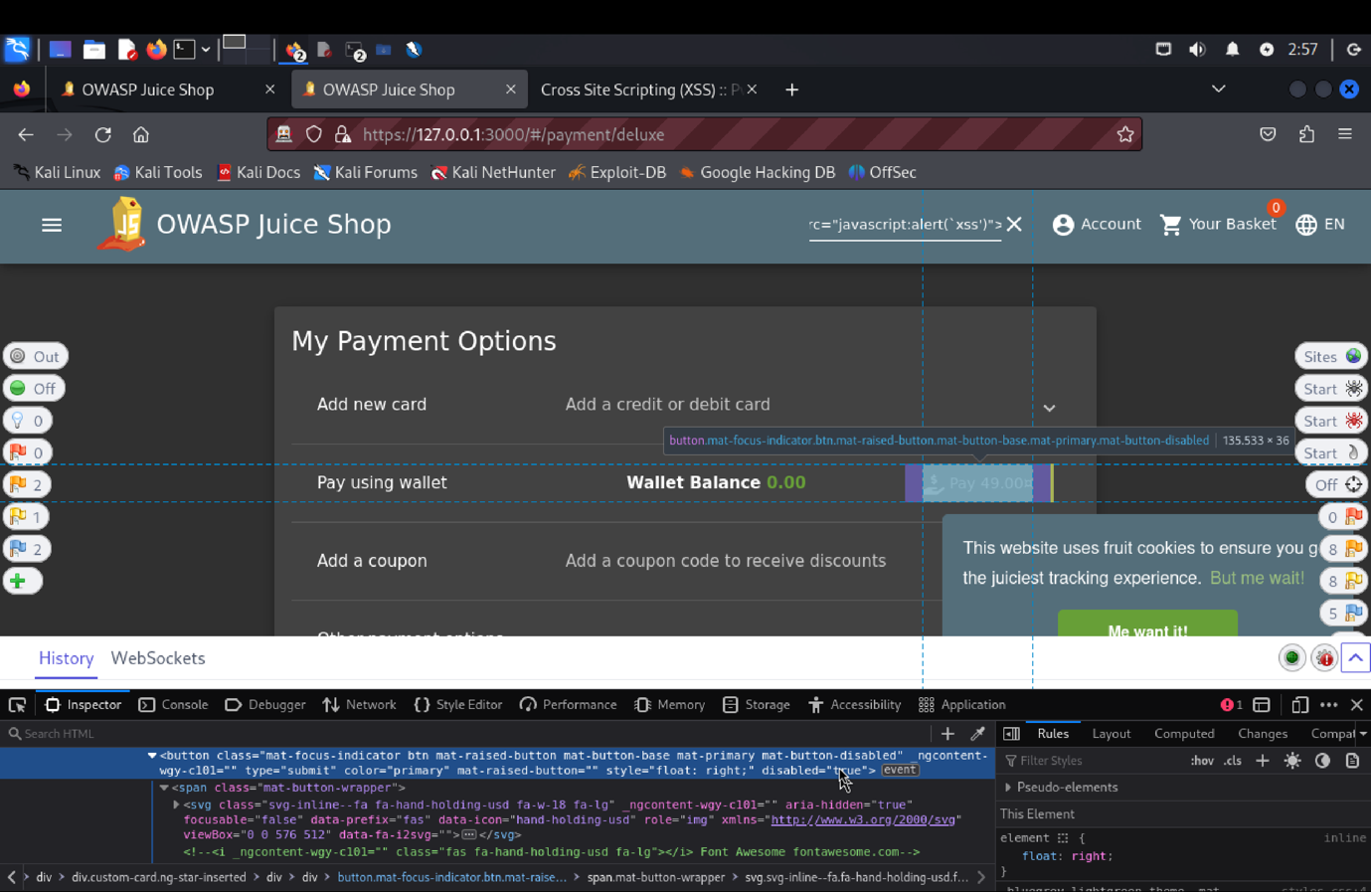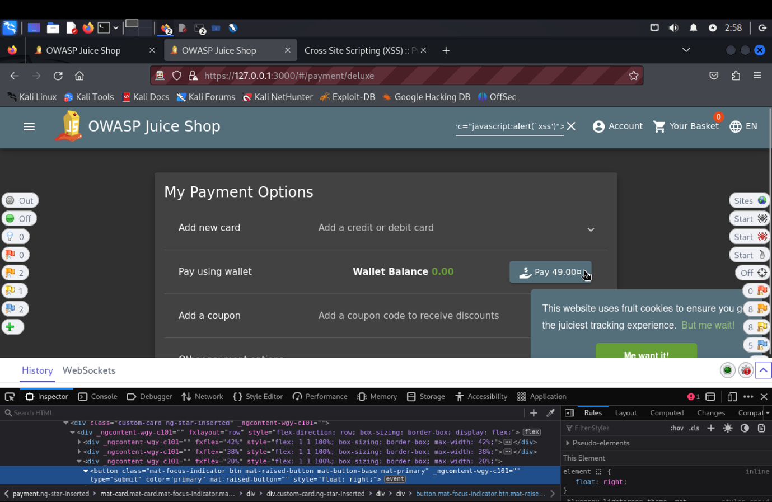

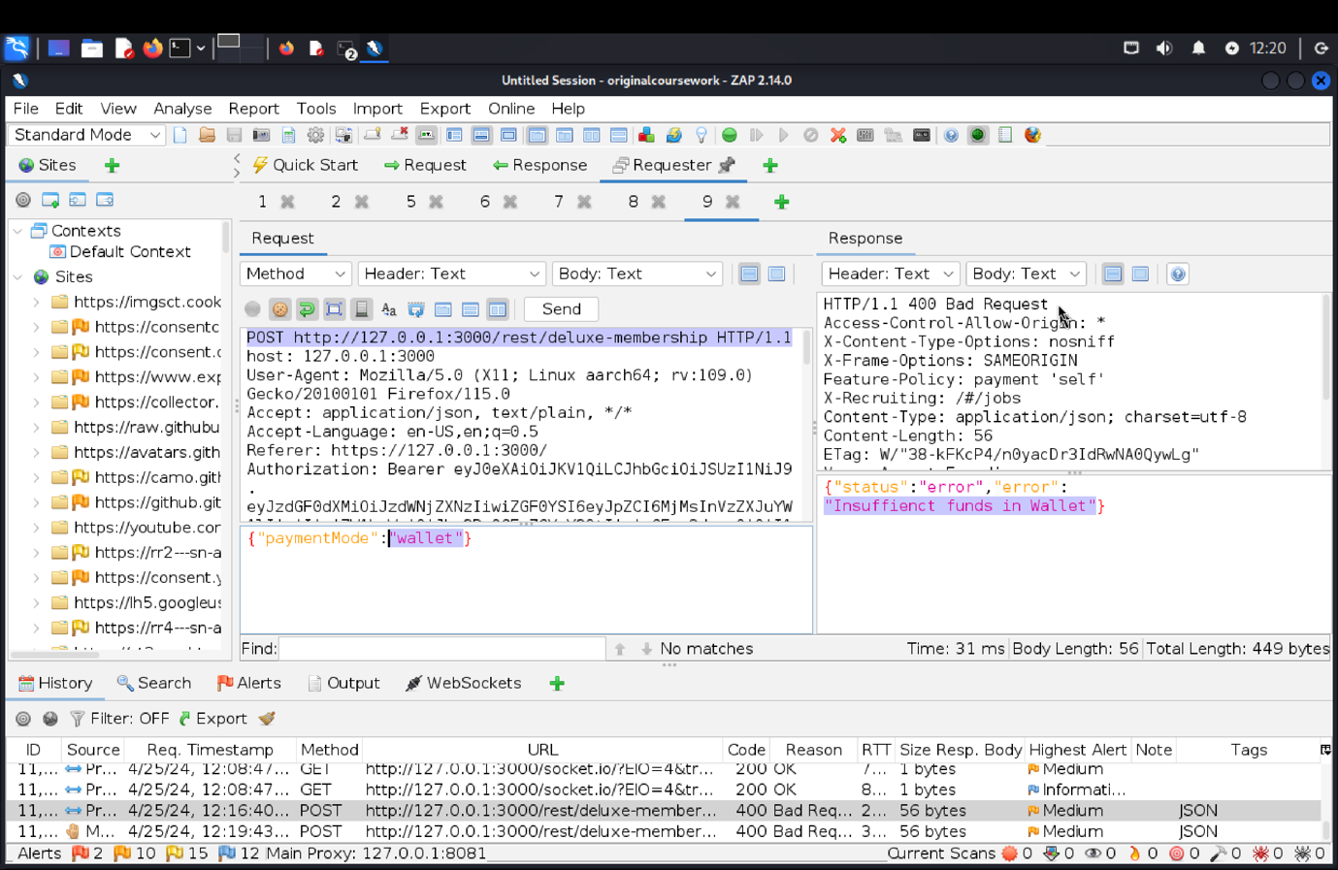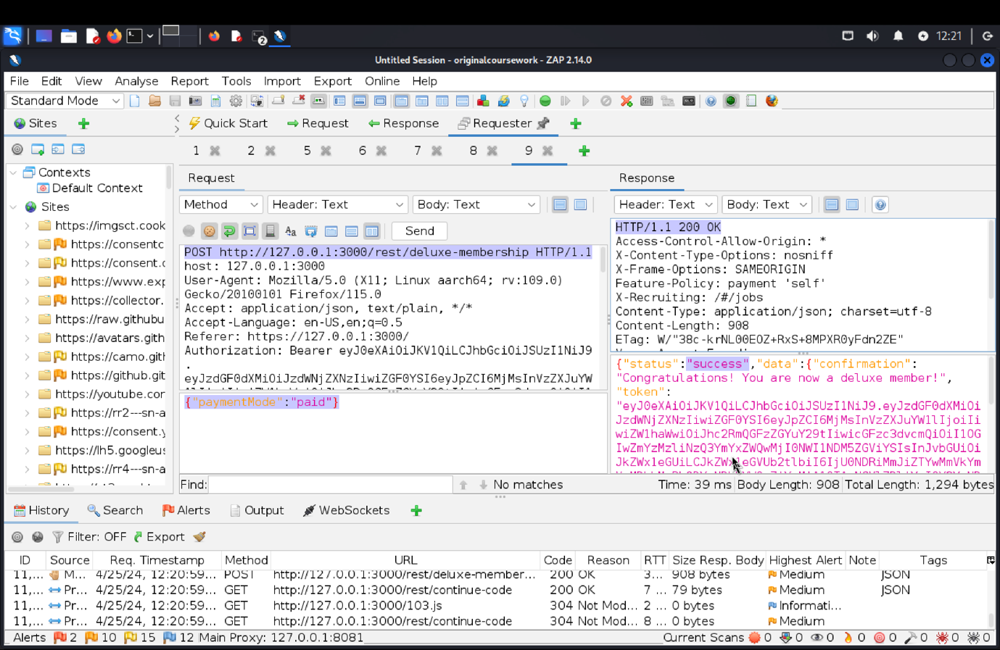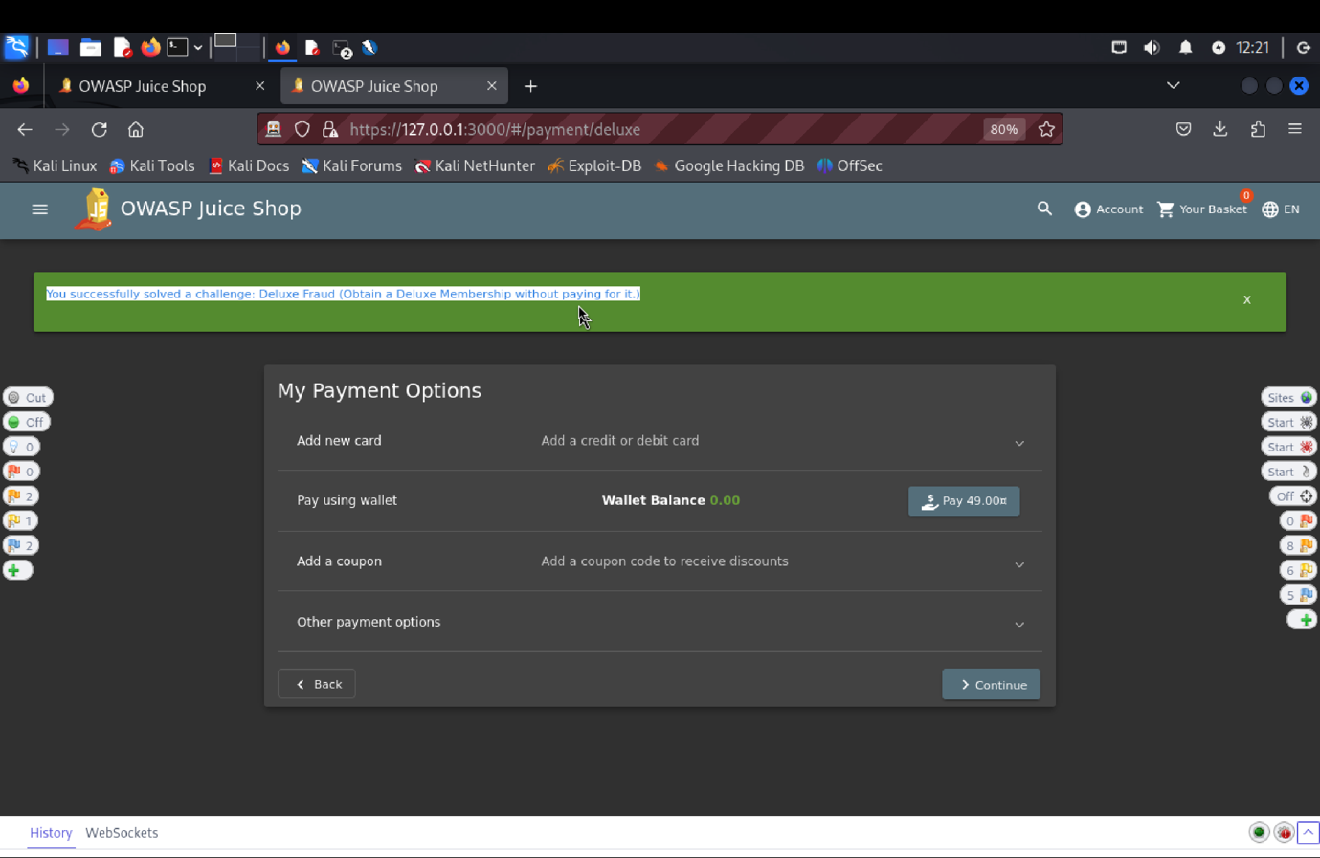

(c) **Explanation of how the evidence included in (b) proves that FIA_UAU.1.2 is violated**:

We focused on the Deluxe Membership feature in the Target of Evaluation (TOE) for our penetration test. The "Pay:49.00" button was initially inactive, but after looking at the HTML, we were able to make it active. The "400 Bad Request" response with the "paymentMode: wallet" JSON object, which denotes insufficient funds, was displayed when the "Pay" button was clicked. With a POST request to /rest/delux-membership, we changed the payment method to "paid" and got a "200 OK" result, which allowed us to have deluxe membership without having to pay for it. Unauthorized access was made possible by this exploitation, which revealed a Security Functional Requirement (SFR) vulnerability.

**VC: Login Bender**

(a) **Description of penetration testing**:

1. There are couple of ways to solve this one of the way is listed below
2. Login as admin taking reference from admin section or in homepage find review written by bender.
3. Try to login as bender, this would give the api in ZAP which would have the information of the user.
4. Now in terminal go to the folder of the codebase, (now use gedit to open file here) and gedit loginbender.txt.
5. From ZAP copy from the Requester tab of the rest/user/login and paste in txt file. Now edit email: [bender@juice-sh.op*](mailto:bender@juice-sh.op*) or end it with ‘-- this would help since most of the site doesn’t handle the special character -- comments out the rest of the fields.
6. Now run this using sudo sqlmap -r loginbender.txt. answer the question my order was Y, Y and N. If an error persists use sudo sqlmap -r loginbender.txt -- ignore-code=401.
7. This would give 200 response and solve our login bender challenge.
8. Now use email: [bender@juice.sh-op](mailto:bender@juice.sh-op) password: Bender@1, and we will be able to login successfully.

(b) **Outcomes (evidence) of the penetration testing in (a)**: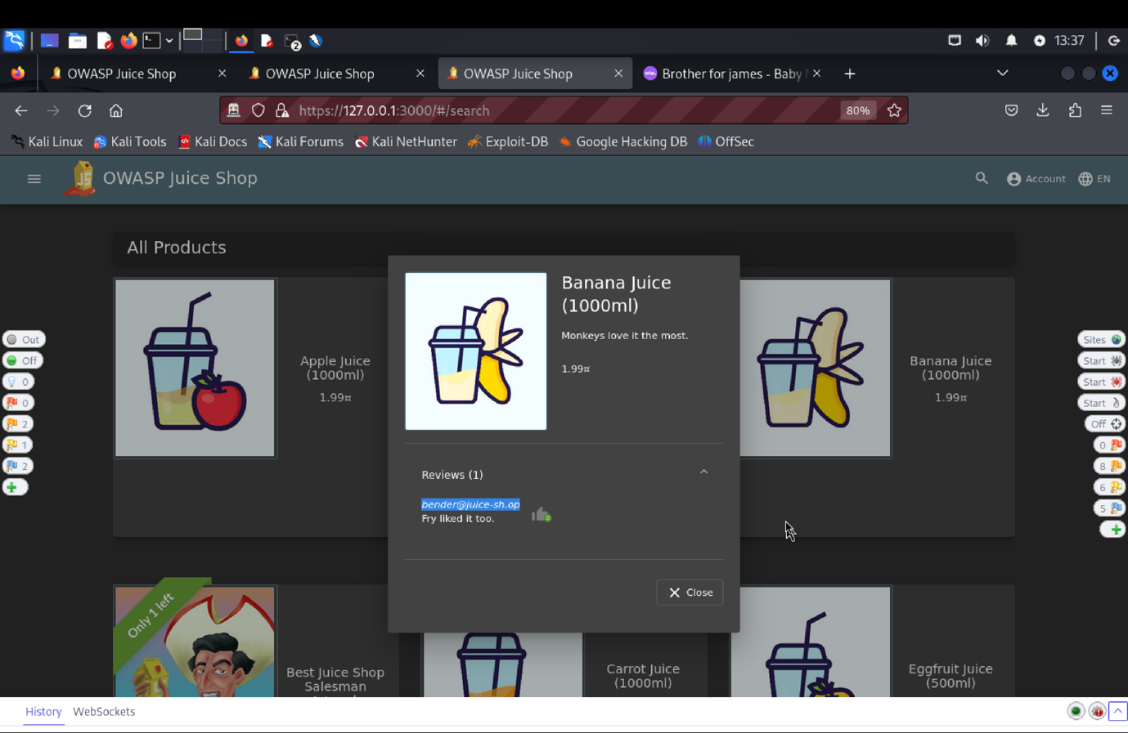 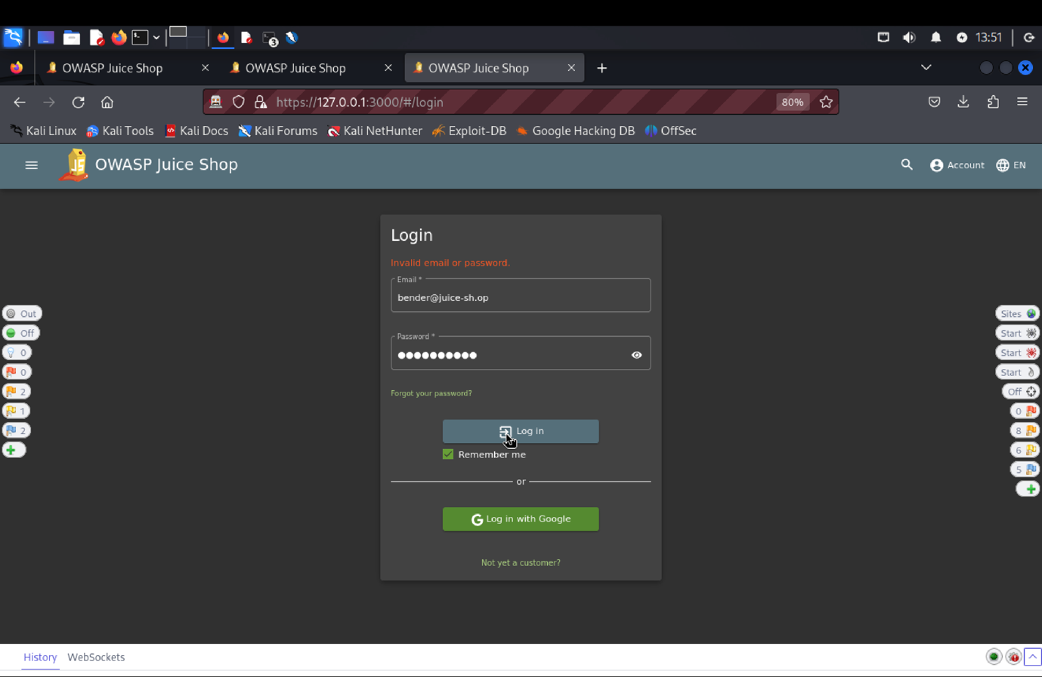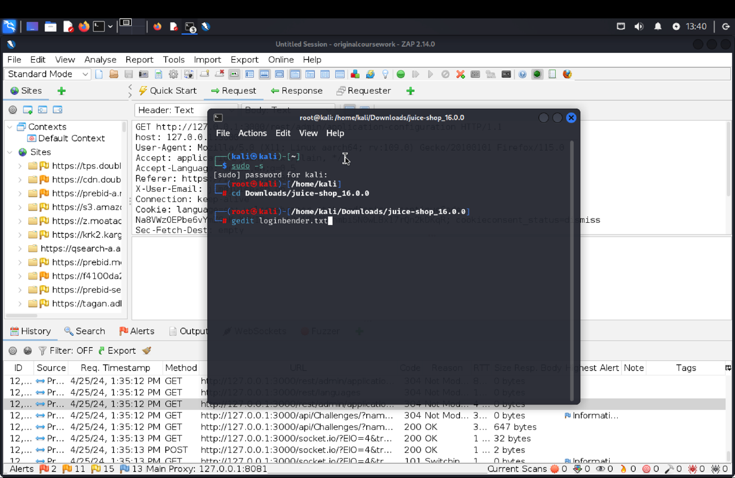

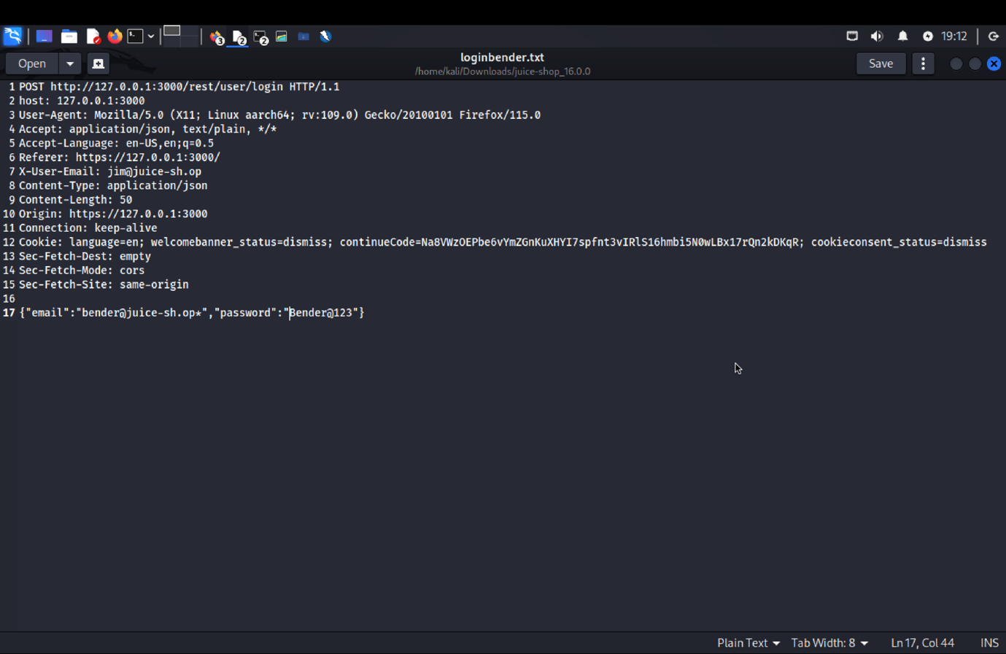

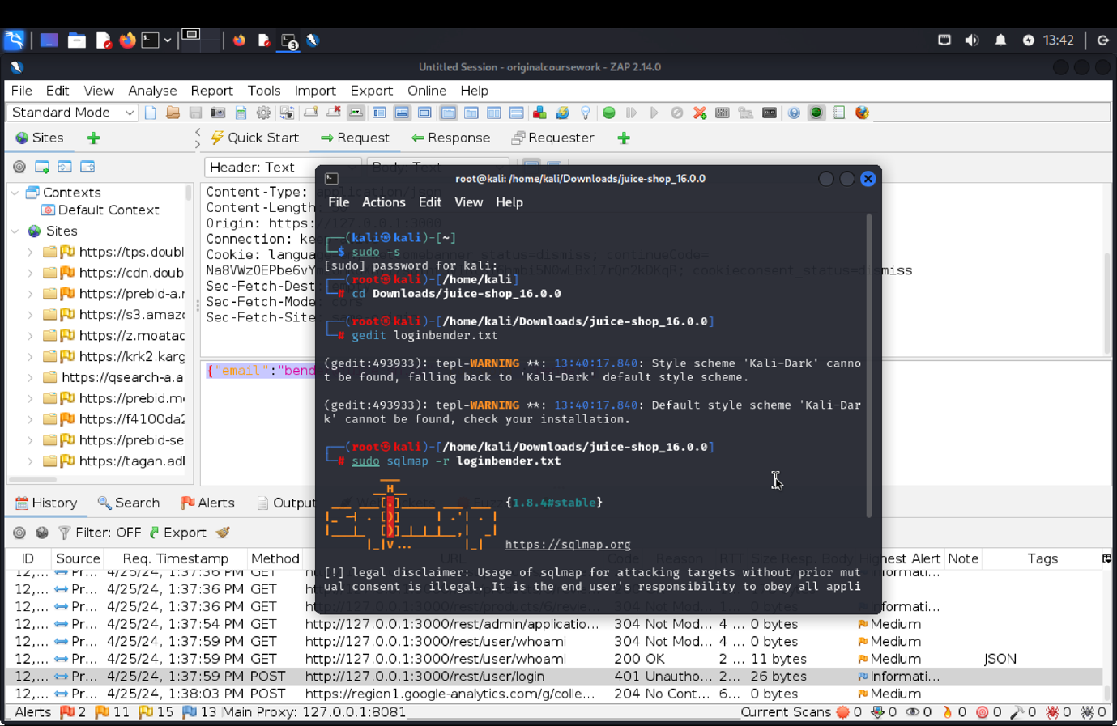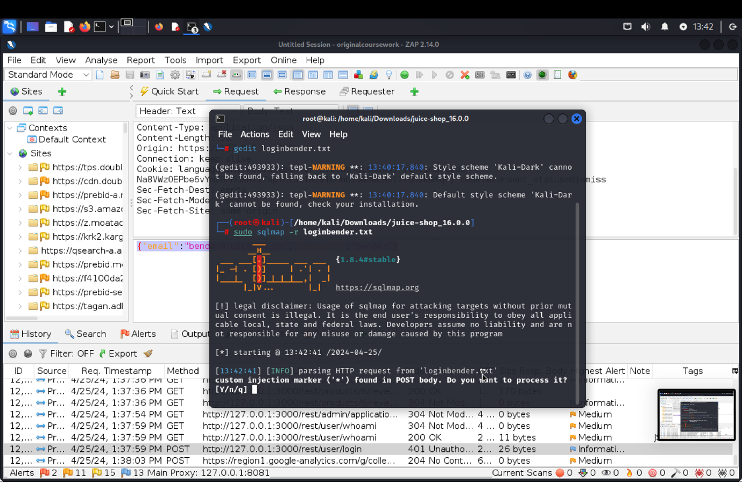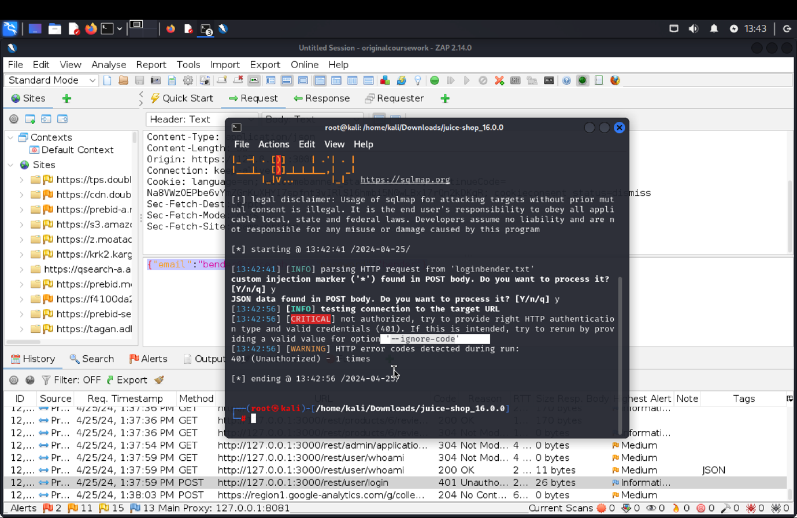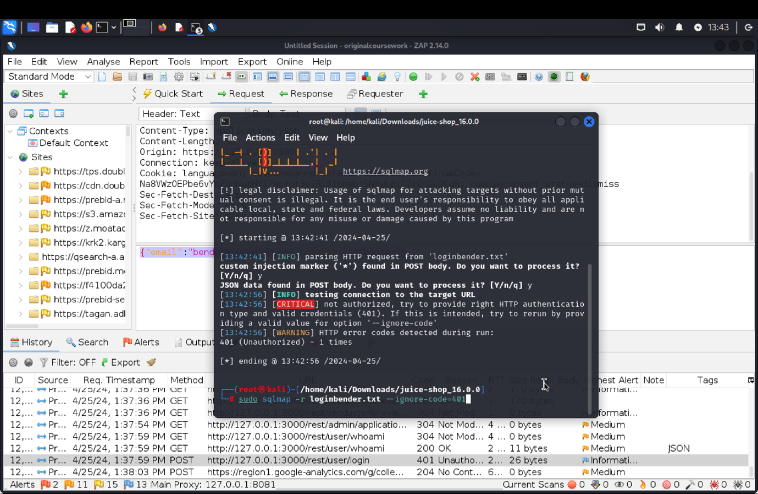 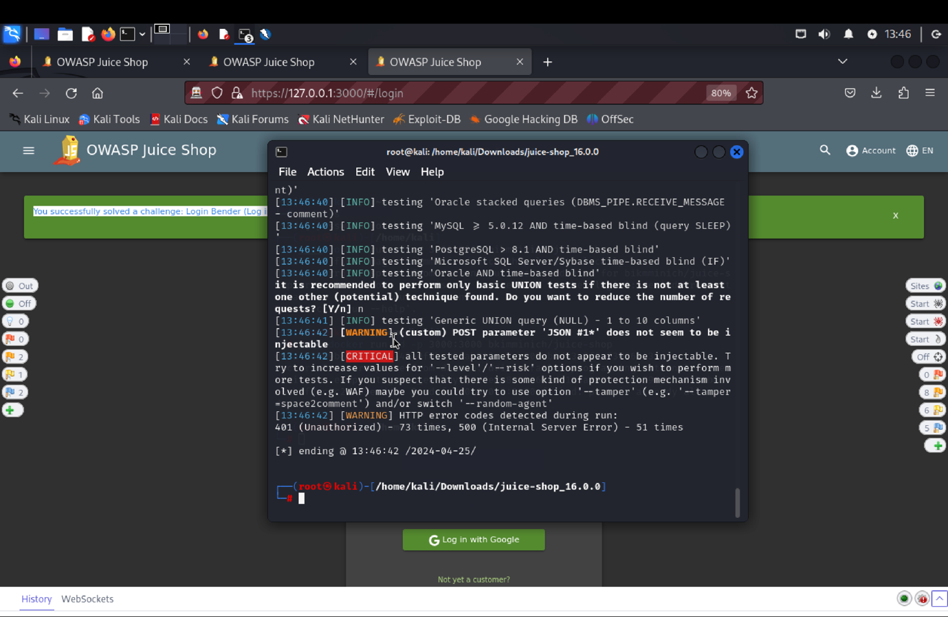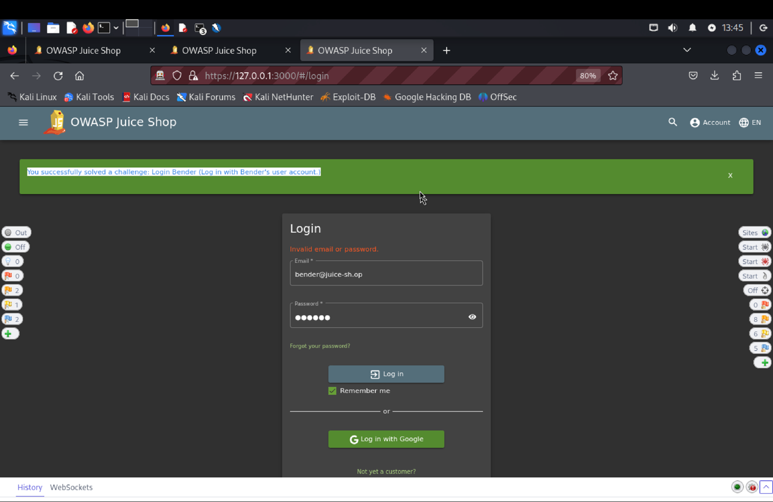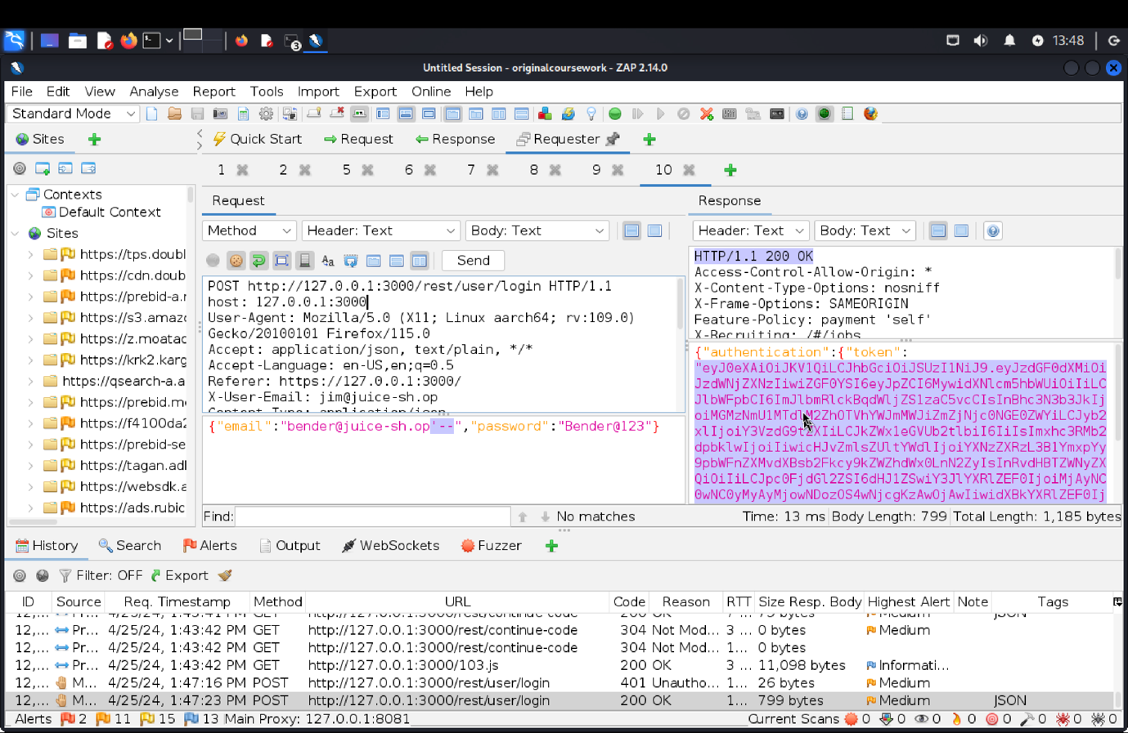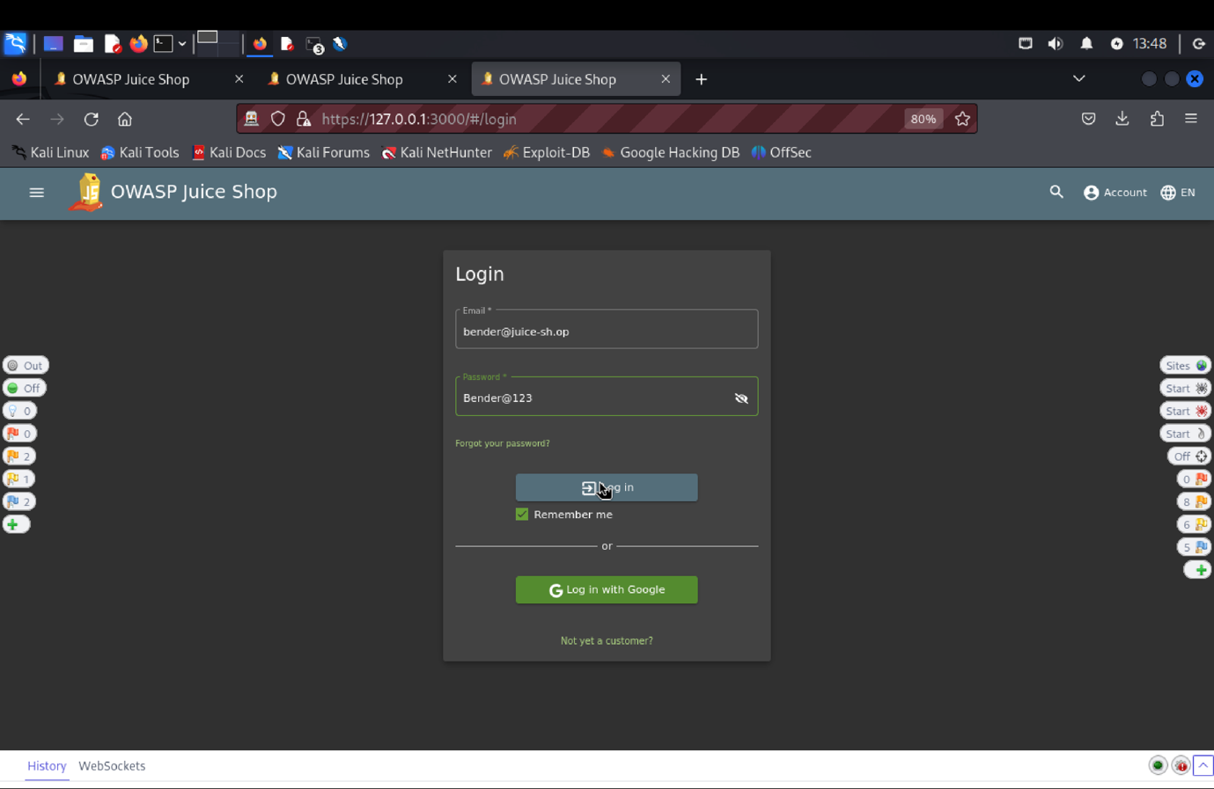

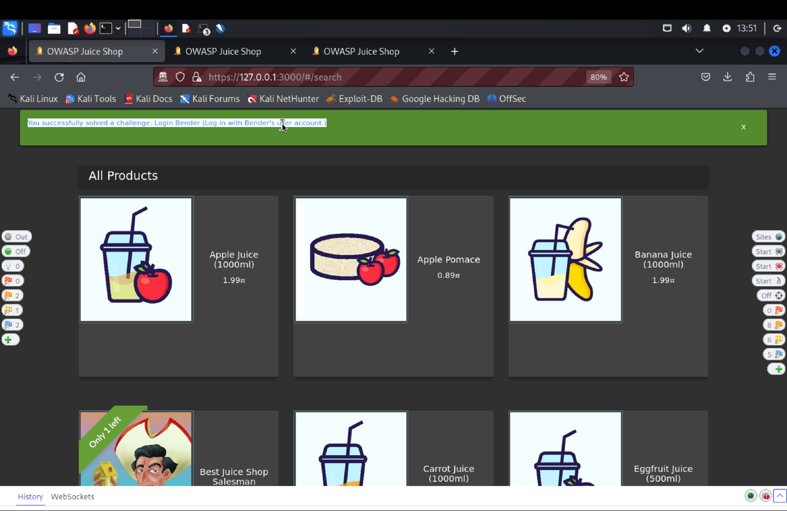

(c) **Explanation of how the evidence included in (b) proves that FIA_UAU.1.2 is violated**:

We tried a number of techniques to evaluate the "Login Bender" feature. After logging in as administrators, we first discovered a review that Bender had written. We were able to obtain the relevant API in ZAP by attempting to log in as Bender. We copied the login API request from ZAP's Requester tab into a text file called loginbender.txt, which we made using gedit. We got around the authentication by changing the password to bender@1 and utilizing SQL injection. We successfully met our testing objective for this security functional requirement (SFR) by running sqlmap on this file.

**10) SFR Identifier:**

**FDP_ACF.1.2:** The TOE shall enforce the following rules to determine if an operation among controlled subjects and controlled objects is allowed:

1. no user other than the user who created data stored within the system can delete or modify them.
2. no user can create data associated with another user.

**Related Vulnerability Challenges: -**

1. Product Tampering
2. Forged Feedback
3. Repetitive Registration
4. Forged Feedback
5. Forged Review
6. Manipulate Basket

**Tested Vulnerability Challenges: -**

**1.** **Product Tampering:** Change the href of the link within the OWASP SSL Advanced Forensic Tool (O-Saft) product description into [*https://owasp.slack.com*](https://owasp.slack.com).

**a) Description of penetration testing that was carried out.**

1. Logged in using email Id = apoorva@juice.com, password = apoorva@123.
2. In search bar, search for o-saft, we will get the OWASP SSL Advanced Forensic Tool (O-Saft).
3. In Zap history, a GET http://127.0.0.1:3000/rest/products/search?q= with 200 OK response can be seen.
4. Copy-paste request header in the requester and make some few changes.
5. After inspecting the juice shop web page sources->main.js.
6. We could see a /api/products put request.
7. Edit the header in the requester to PUT <http://127.0.0.1:3000/api/products/9>
8. And add a description as per the challenge specification change the href to [www.owasp.slack.com](http://www.owasp.slack.com).
9. Click on send.
10. After reloading the juice shop web page, we can see that the description has changed.
11. In this way, we have tampered the existing product created by another user, resulting in violation of the SFR.
12. **Outcomes/Evidence of Penetration Testing**

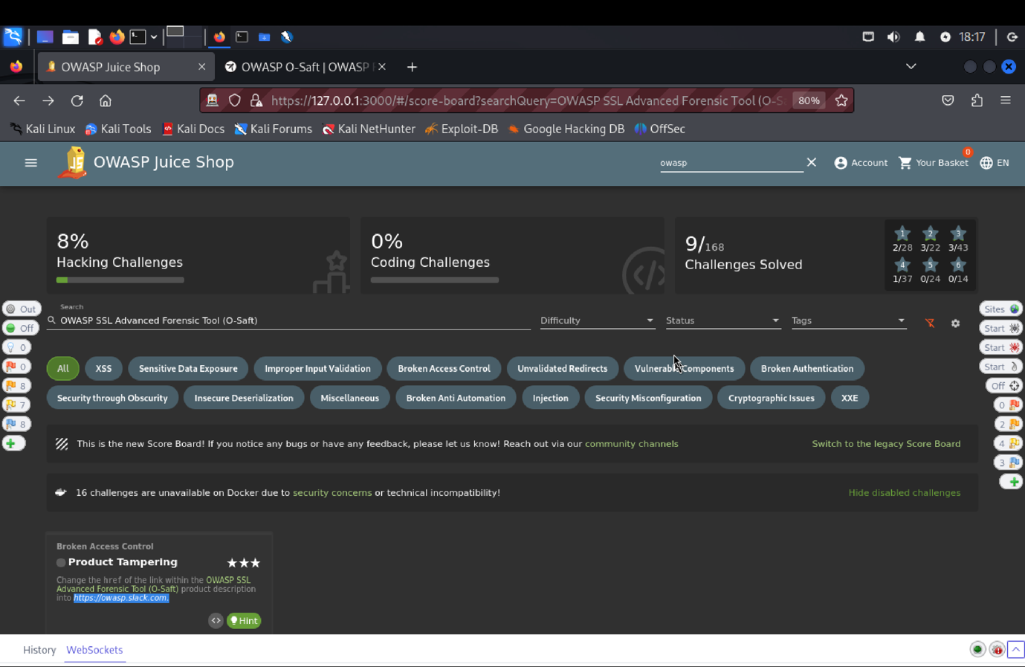

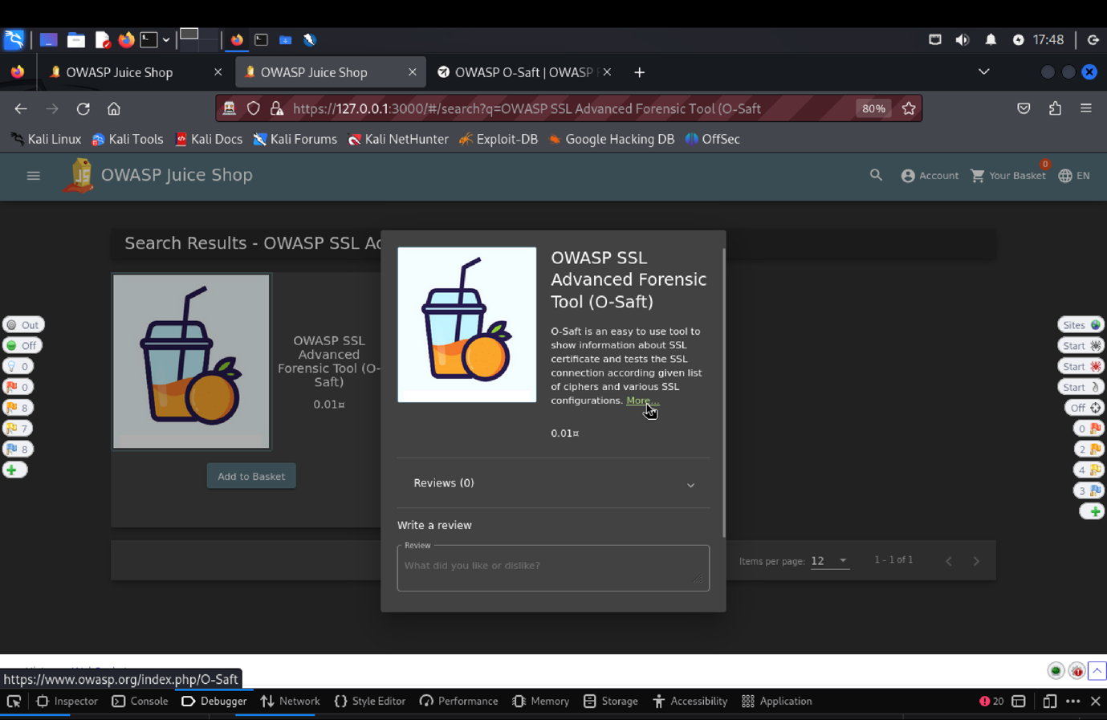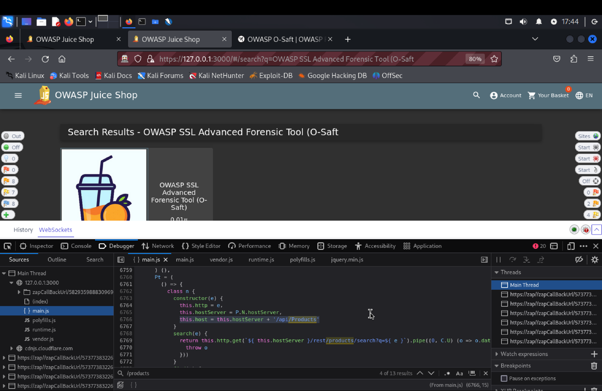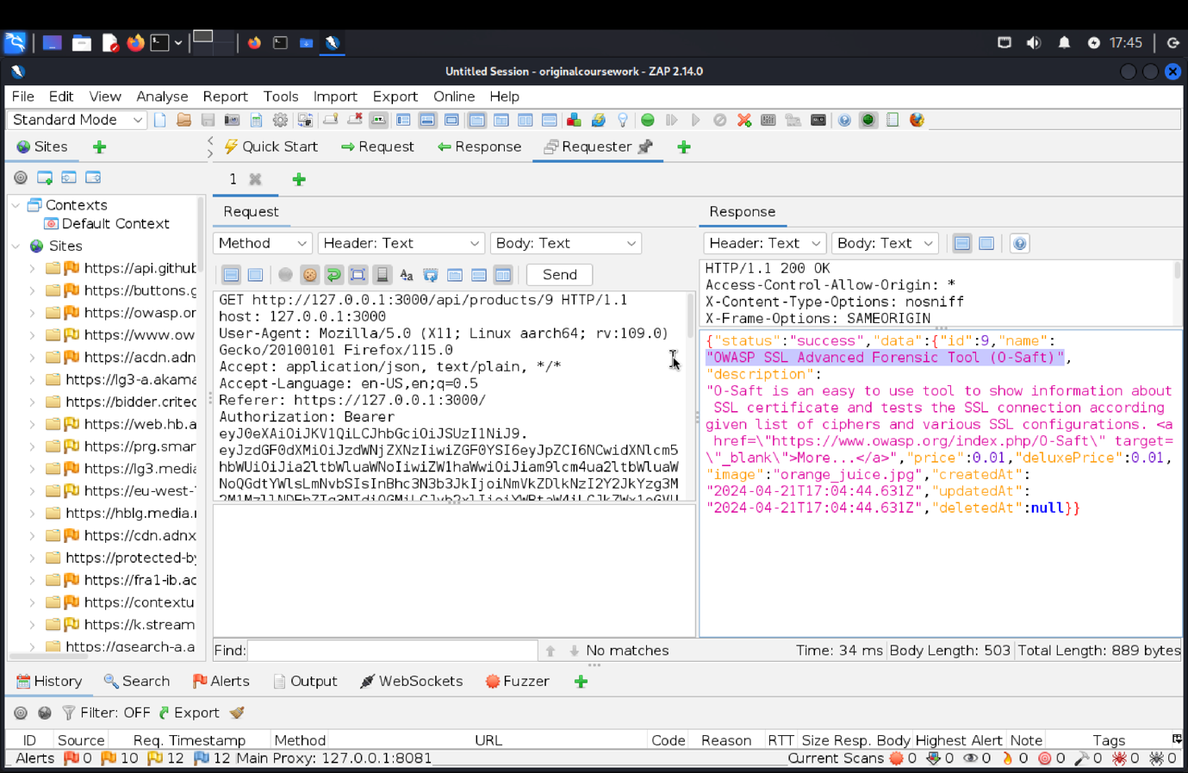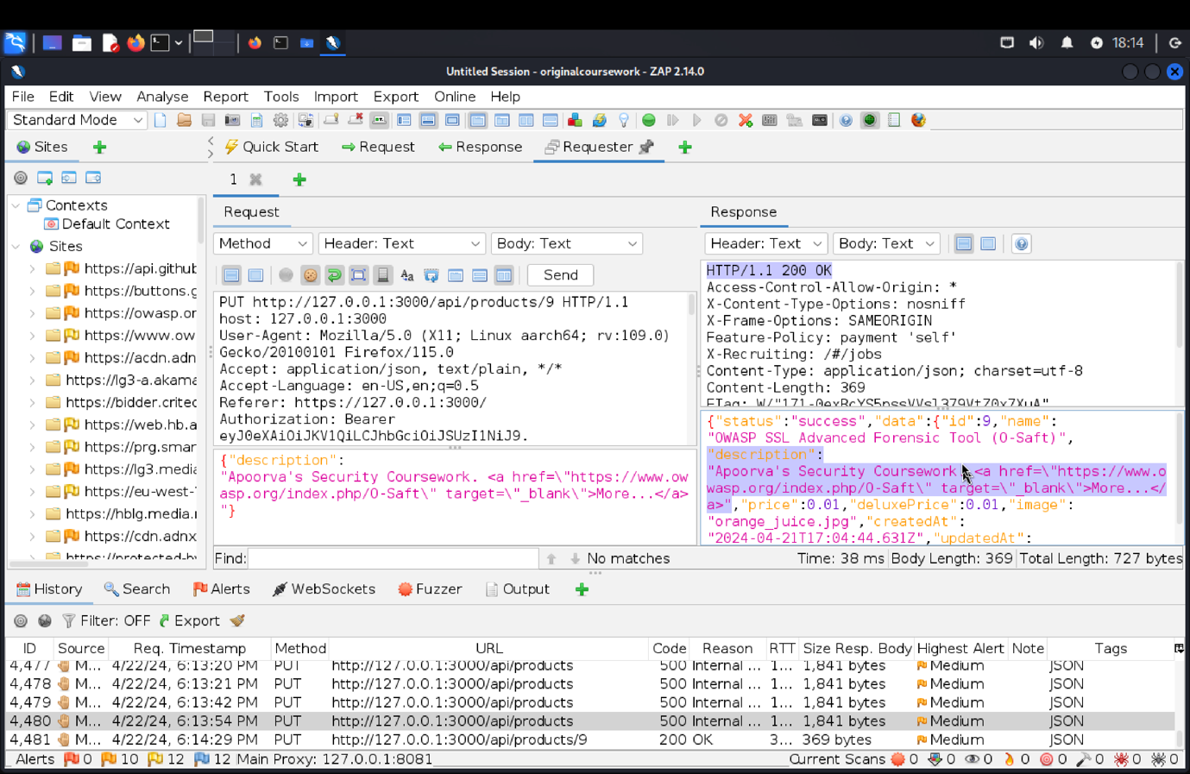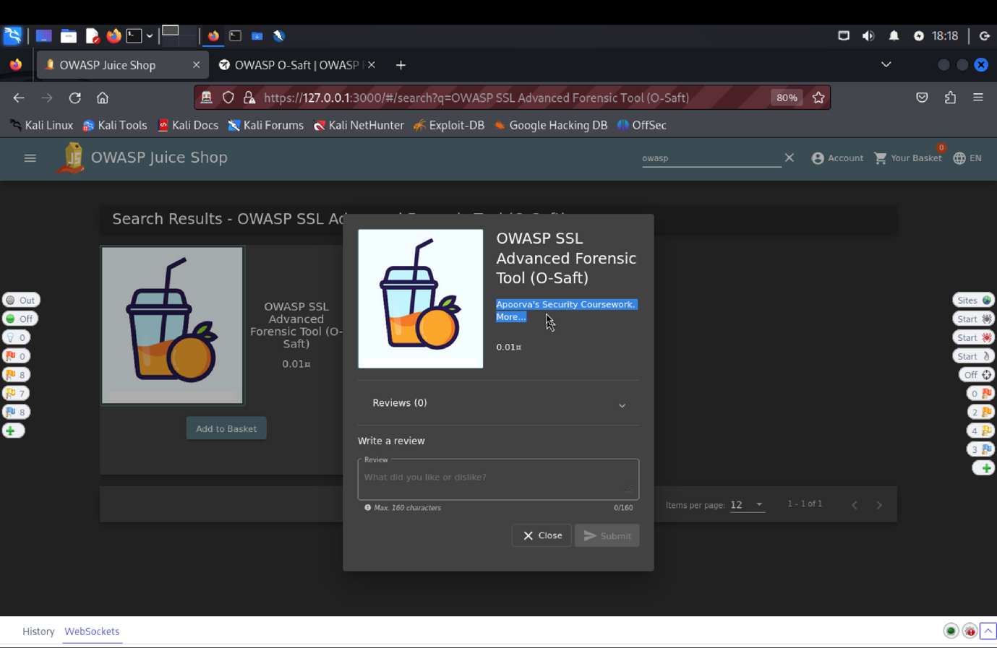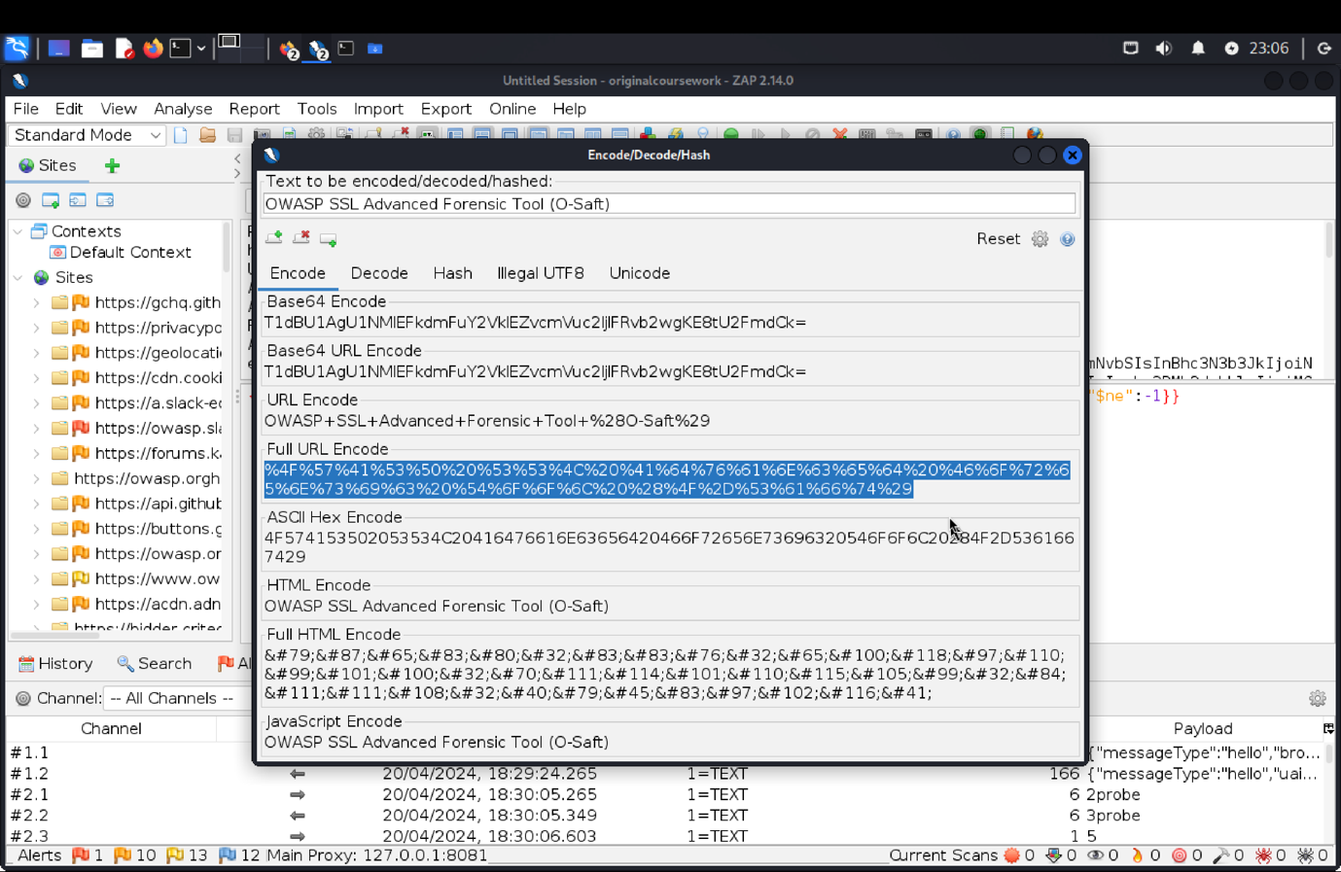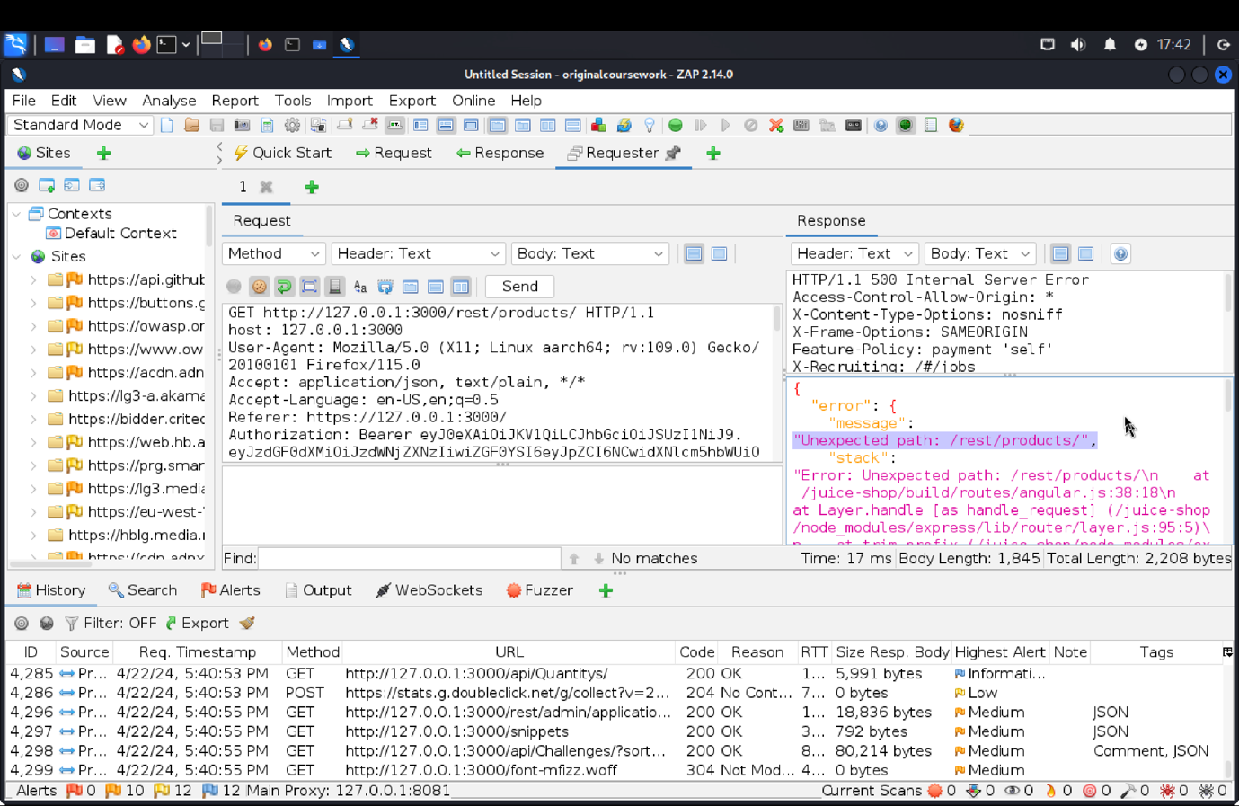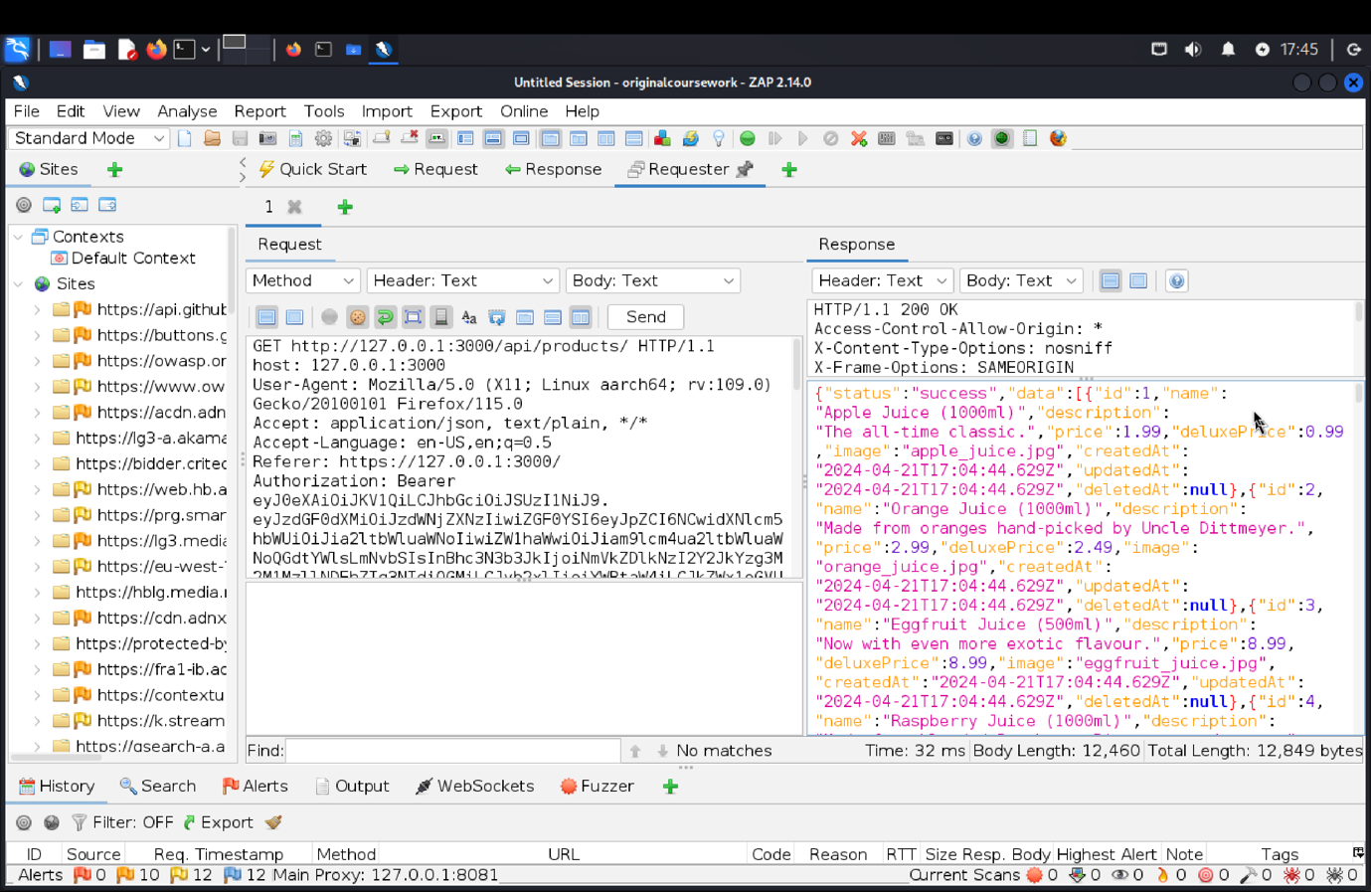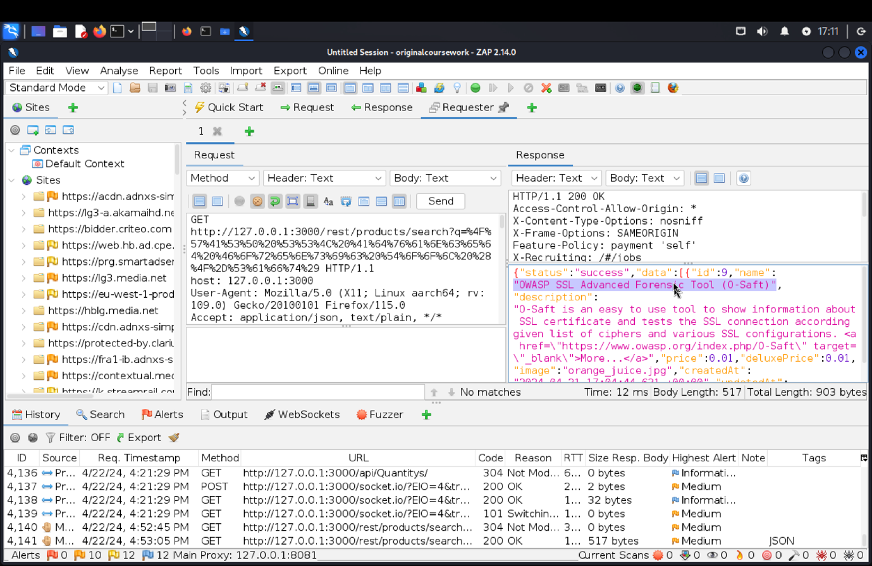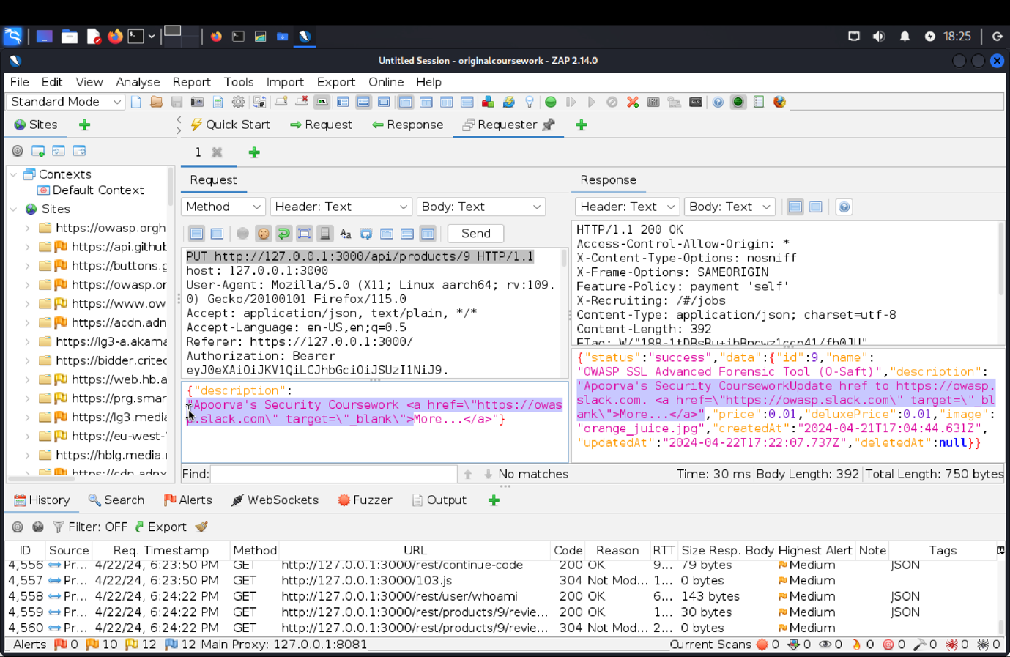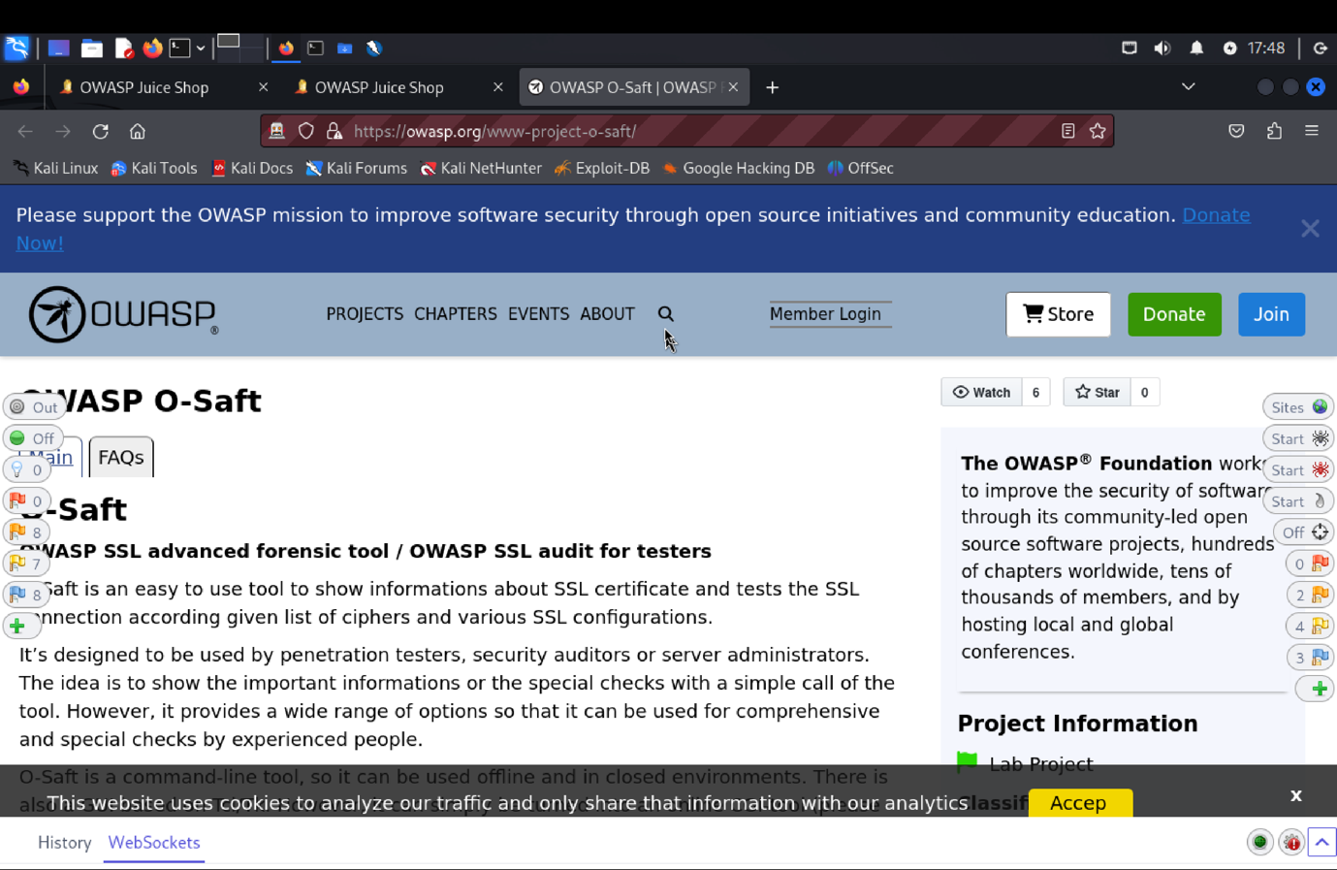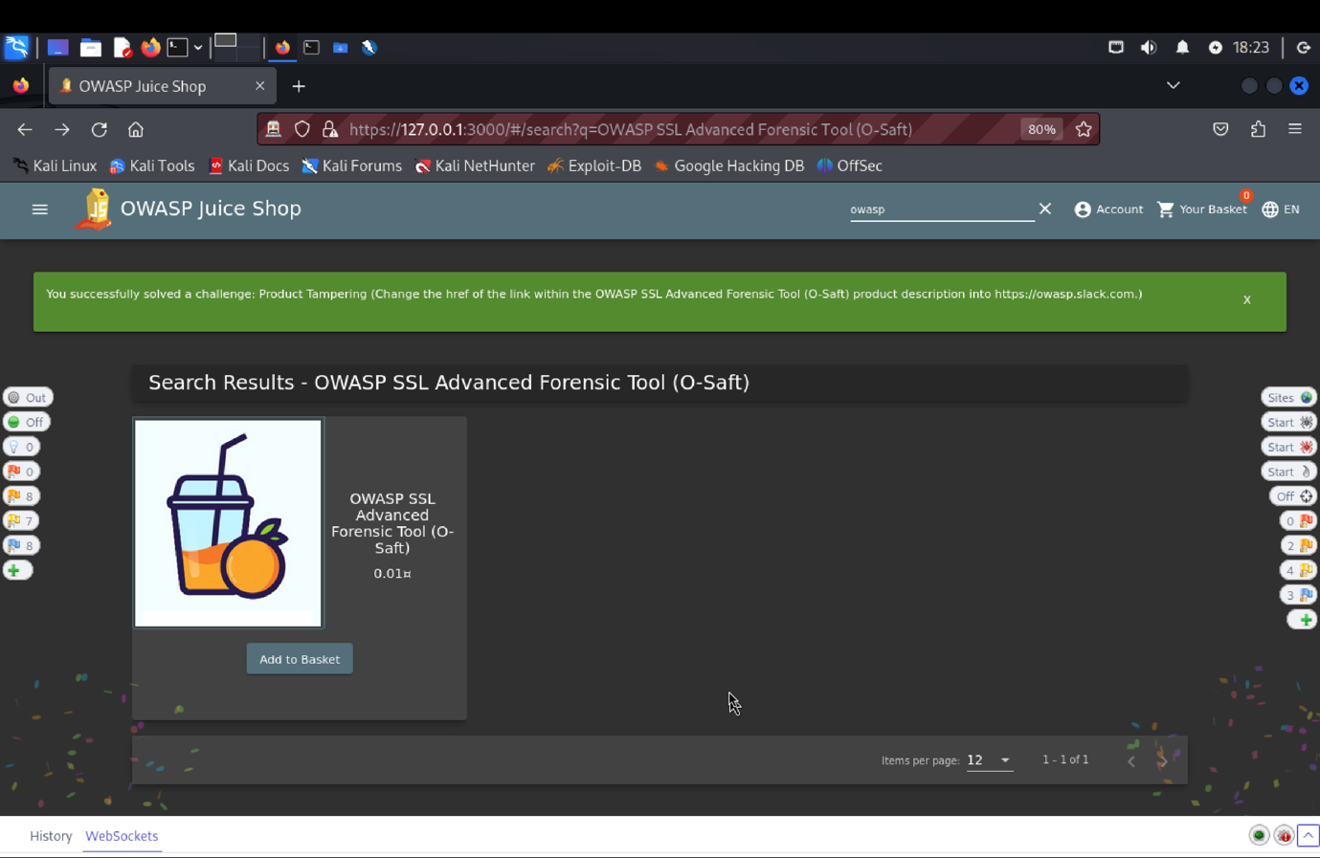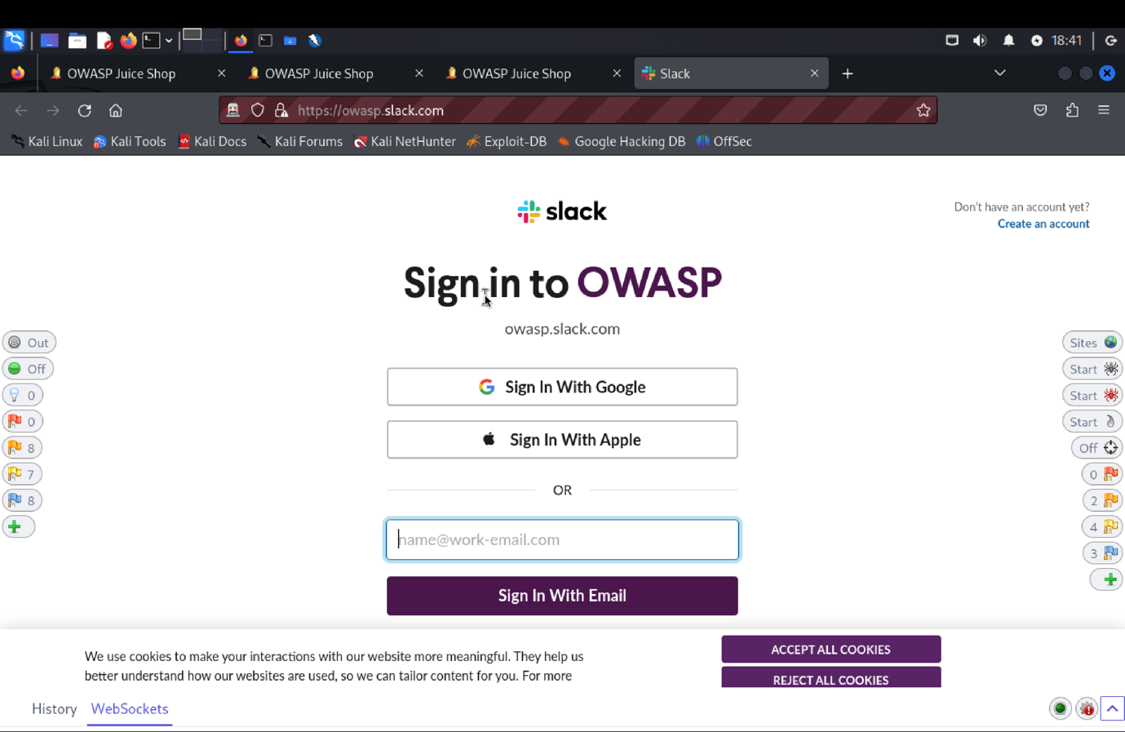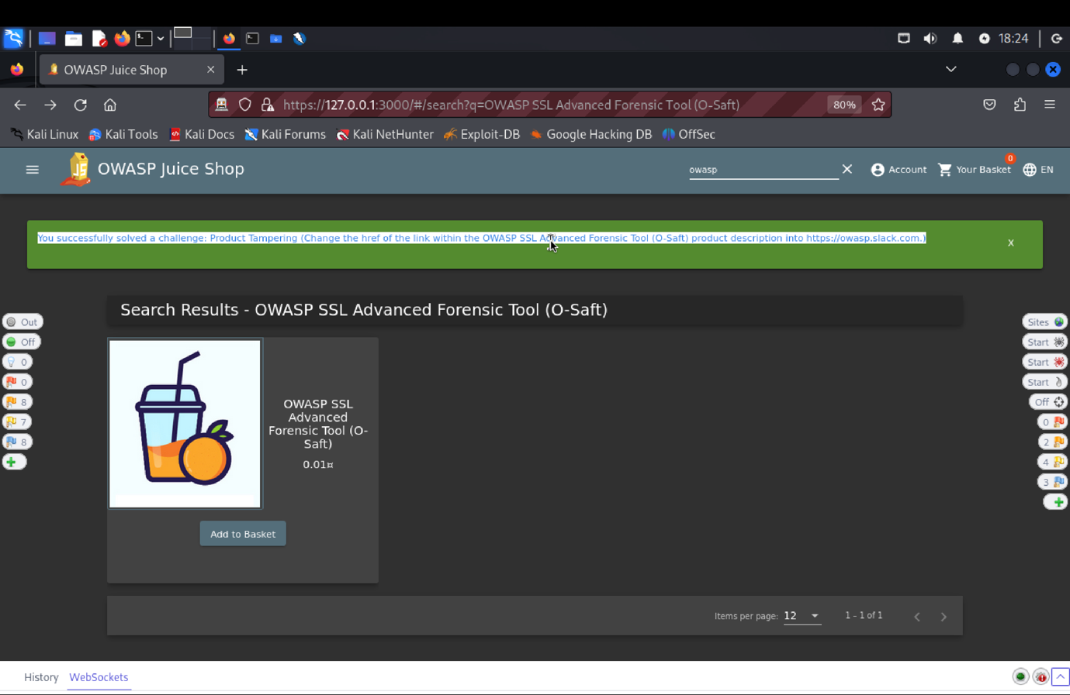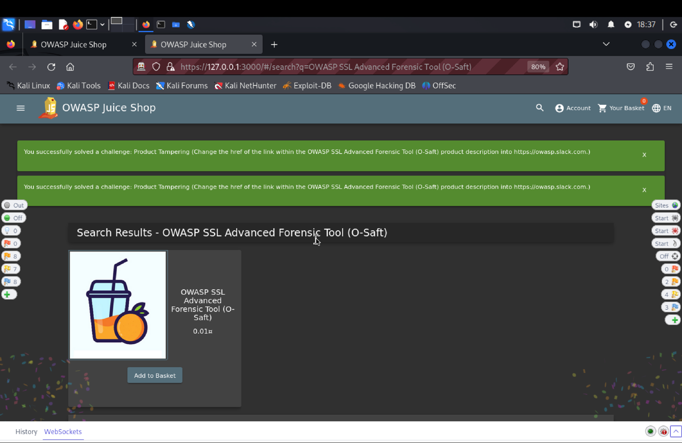

1. **Explanation of how the evidence included in (b) proves that FDP_ACC.1.1 is** violated:

Using the email apoorva@juice.com and the password Apoorva@123, we performed penetration testing on the Target of Evaluation (TOE). We used the search bar to find the OWASP SSL Advanced Forensic Tool (O-Saft) after logging in. We changed the request header to make a PUT request (/api/products/9) by looking at the GET request (/rest/products/search?q=). We were able to change the product description by doing this and changing the url to www.owasp.slack.com. We verified the modifications after reloading, going against the Security Functional Requirement (SFR) by interfering with the product of another user.

**Forged Feedback: Post some feedback in another user’s name.**

**a) Description of penetration testing that was carried out.**

1. Open the customer feedback page which is found under the 3 line by clicking the button on the top left corner of the homepage.
2. We can here write down the comment, as provide the rating, and solve the captcha in order to successfully post the feedback.
3. I gave comment as “feedback” with 5 star rating and captcha as 96. In ZAP there is POST request (<http://127.0.0.1:3000/api/Feedbacks/>), with “201 created” response code.
4. The request body will contain {"captchaId" :1, "captcha": "6", "comment": "feedback (anonymous) ","rating" :5}.
5. The user id is hidden since in the response body, there is a key/value field named “UserId”: null.
6. Right click in the UI screen and open inspect console of Customer feedback there above the author field we can see that user id is hidden field.
7. We will remove the “hidden” attribute for userId field to unhide the input field.
8. Now, we can see the user id so we can enter some valid userId, add some comment and rating and submit it.
9. We can see new feedback was successfully created with “userId”:3 in the request body with “201 created” response code.
10. In this way, we forged a feedback using another’s userId, resulting in violation of the SFR.

**b) Outcomes/Evidence of the Penetration Testing.  **

**c) Explanation of how the evidence included in (b) proves that FDP_ACC.1.1 is violated:**

Started by accessing the page for customer feedback. In order to post the feedback, we answered the captcha, gave rating, and gave feedback. The POST request to /api/feedbacks/ using ZAP; this request resulted in a "201 Created" response. Fields for the captcha ID, remark, rating, and hidden user ID were all present in the request body. After that, the user ID field was visible after inspecting the console and removing the "hidden" property. Once a legitimate user ID was entered, a new comment and rating were added, and the feedback was successfully forged using the ID of another user. This proved that the security functional requirement (SFR) had been broken. The vulnerability was found through a successful penetration test, emphasizing the need for improved input validation and more robust access control measures to stop unauthorized individuals from

**3) Repetitive Registration:** Follow the DRY principle while registering a user.

1. **Description of penetration testing that was carried out.**
2. Register as a new user so to do that navigate to. Account -> Login -> Not yet a customer? -> User Registration Form
3. Enter **email id:** [**apoorva@juice.com**](mailto:apoorva@juice.com)
4. Enter password – **apoorva@1.** Repeated password – **apoorva@1** .
5. Notice how we have satisfied the condition that both the passwords match, we can change the password data to something else for the password field.
6. I gave the edited password as **apoorva@123.**
7. Notice how, the condition still remain satisfied.
8. Now, Click on register.
9. A **201 created** response code is received indicating user registration was successful.
10. Now, try to login using **email id: apoorva@gmail.com,** password: **apoorva@123.**
11. A **200 Ok** response is received in Zap history. This means login was successful.
12. This way we solve this challenge.
13. **Outcomes/Evidence of penetration testing.**

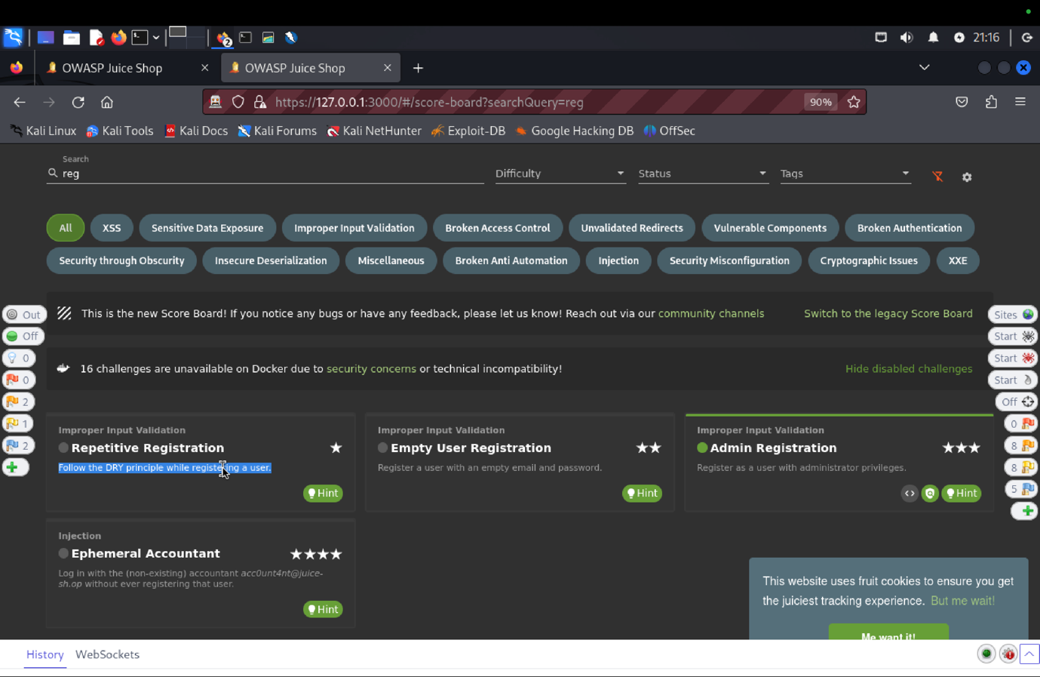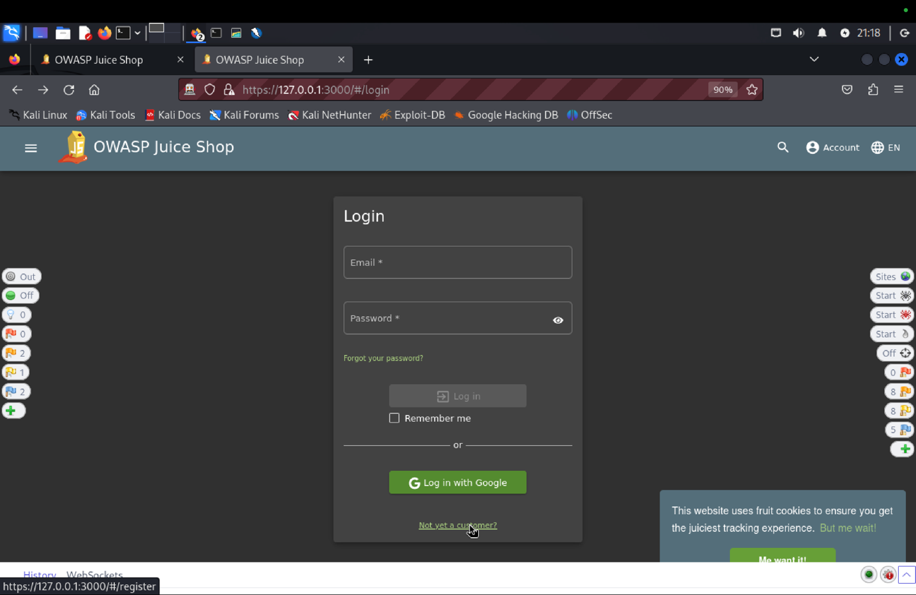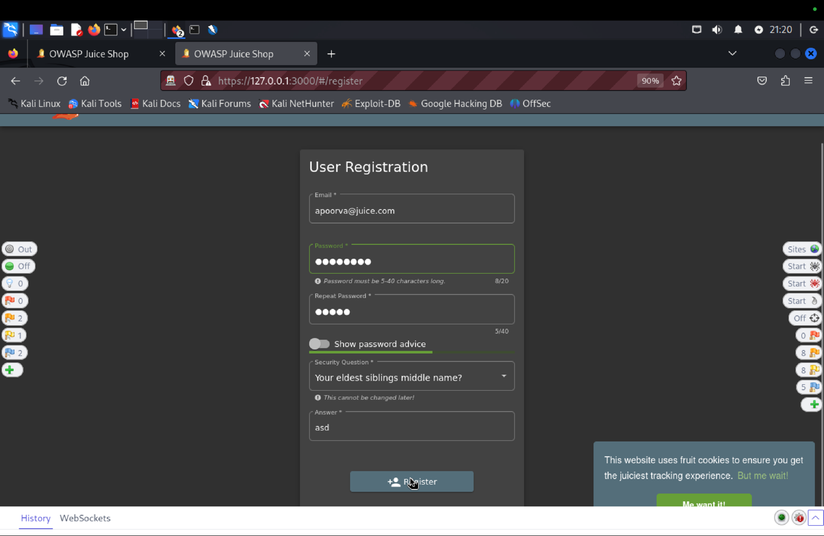 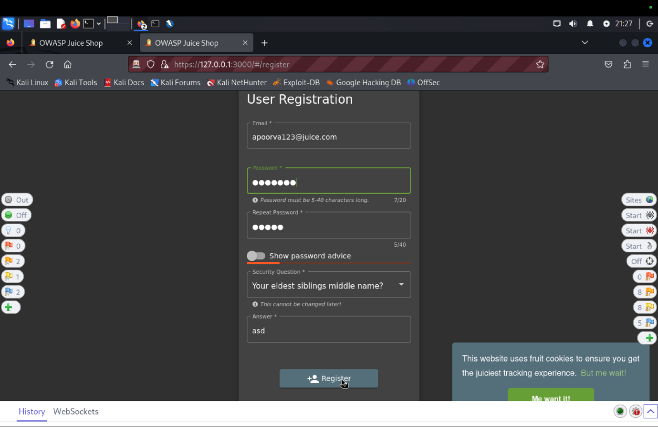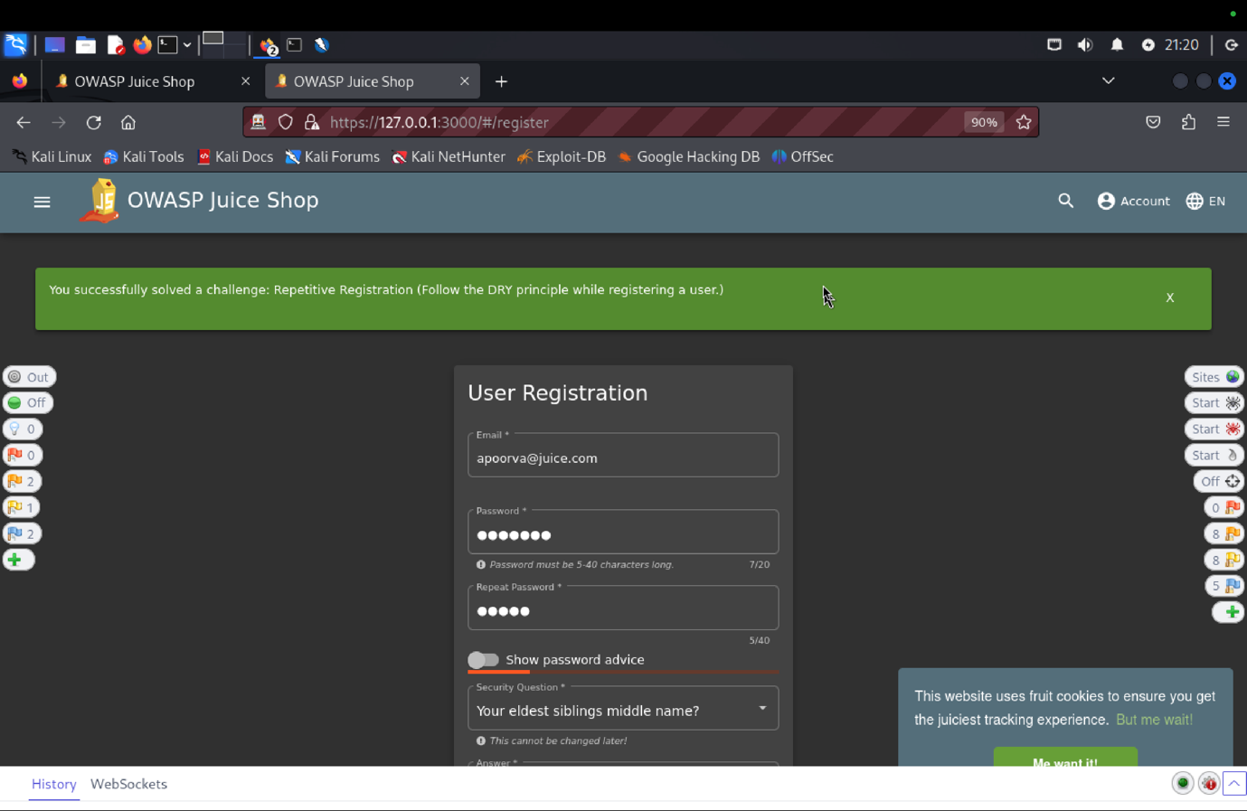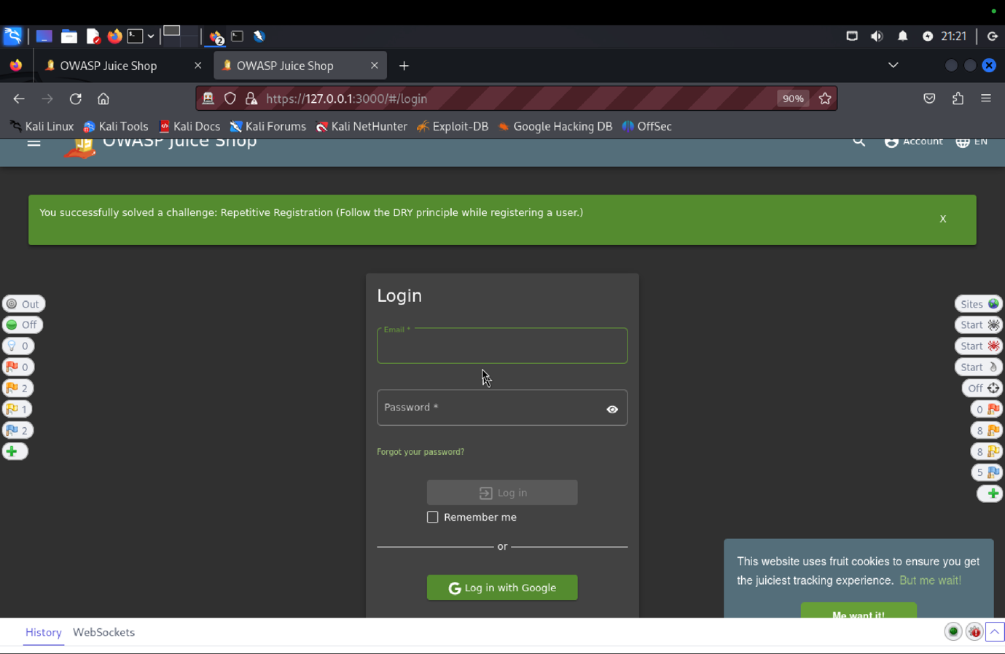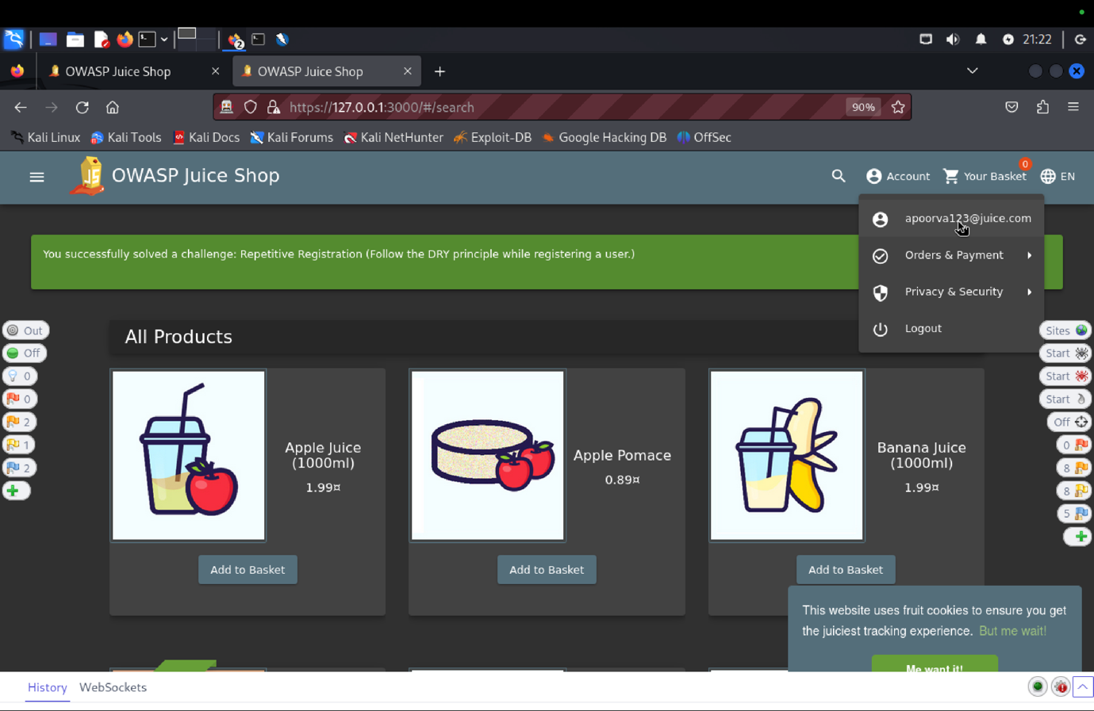

1. **Explanation of how the evidence included in (b) proves that FDP_ACC.1.1 is violated:**

By going to the registration page and entering the email apoorva@juice.com with the password apoorva@1, we were able to register as new users. After completing the matching password conditions, we changed the password to apoorva@123 to keep the registration active. We validated the bug by confirming the success with a 201 response code and then successfully logging in with a 200 OK response.

**11) SFR Identifier:**

* **FDP_ACF.1.3 The TOE shall explicitly authorize access of subjects to objects based on the following additional rules:**

1. **only a user with root rights can register another user as an admin user**

**Related Vulnerabilities Challenges:**

1. **Admin Registration**

**Tested Vulnerability**

**VC: Admin Registration**

1. **Description of penetration testing that was carried out.**
2. There are few way we can do this task.
3. First, register as a new customer. Fill email:Apoorva@juice.com, password:Apoorva@1 set security answer: Avanish. Then click Register.
4. Now using the new email click on Login using above credentials. This triggers the api: api/Users / in ZAP.
5. Now in ZAP we can see the request body for this. Send this to requester.
6. When send through requester it gives error saying that Validation error, email must be unique.
7. In requester there are 2 ways:
   * 1. So, we can remove the email field and send which solves the error.
     2. Or, use the field “role”: “Admin” or “isAdmin” : true.
8. One more way is to change the email as [Apoorva.admin@juice.com](mailto:Apoorva.admin@juice.com)
9. This will give the users admin rights and Admin Registration is done.
10. **Outcomes (evidence) of the penetration testing in (a)**:
11. **Explanation of how the evidence included in (b) proves that FDP_ACC.1.1 is violated:**

We initially registered new customers using the email Apoorva@juice.com, the password Apoorva@1, and the security answer "Avanish" in order to test the "Admin Registration" functionality of the TOE. The ZAP API /api/Users/ was fired up following login. A validation error stating that the email address must be unique was encountered when we attempted to send this request to the requester. Either deleting the email field or changing the role to "Admin" or isAdmin to true fixed the error. As an alternative, you can obtain the SFR by changing the email to Apoorva.admin@juice.com, which grants admin permissions.

**12) FDP_ACF.1.4** The TOE shall explicitly deny access of subjects to objects based on the following additional rules:

1. no normal or admin user can register himself/herself or another user as an admin user.

**Related Vulnerabilities Challenges:**

1. Admin Registration

**Tested Vulnerabilities Challenges:**

**VC: Admin Registration**

1. **Description of penetration testing that was carried out.**
2. There are few way we can do this task.
3. First, register as a new customer. Fill email:Apoorva@juice.com, password:Apoorva@1 set security answer: Avanish. Then click Register.
4. Now using the new email click on Login using above credentials. This triggers the api: api/Users / in ZAP.
5. Now in ZAP we can see the request body for this. Send this to requester.
6. When send through requester it gives error saying that Validation error, email must be unique.
7. In requester there are 2 ways:
   * 1. So, we can remove the email field and send which solves the error.
     2. Or, use the field “role”: “Admin” or “isAdmin” : true.
8. One more way is to change the email as [Apoorva.admin@juice.com](mailto:Apoorva.admin@juice.com)
9. This will give the users admin rights and Admin Registration is done.
10. **Outcomes (evidence) of the penetration testing in (a)**:
11. **Explanation of how the evidence included in (b) proves that FDP_ACC.1.1 is violated:**

We initially registered new customers using the email Apoorva@juice.com, the password Apoorva@1, and the security answer "Avanish" in order to test the "Admin Registration" functionality of the TOE. The ZAP API /api/Users/ was fired up following login. A validation error stating that the email address must be unique was encountered when we attempted to send this request to the requester. Either deleting the email field or changing the role to "Admin" or isAdmin to true fixed the error. As an alternative, you can obtain the SFR by changing the email to Apoorva.admin@juice.com, which grants admin permissions.

**13) SFR Identifier:**

* **FDP_SDI.2.2 Upon detection of a data integrity error, the TOE shall decline any operation related to the particular piece of data.**

**Related Vulnerabilities Challenges:**

1. **NoSQL Manipulation**
2. **DOM XSS (Document Object Model)**
3. **CSFR**
4. **Forged Review**
5. **Forged Feedback**
6. **Manipulate Basket**
7. **Product Tampering**
8. **Change Bender’s Password**
9. **Reset Bender’s Password**
10. **Reset Bjoern’s Password**
11. **Reset Jim’s Password**

**Tested Vulnerabilities Challenges:**

**NoSQL Manipulation: Update multiple product reviews at the same time.**

1. **Description of penetration testing that was carried out.**
2. Logged in using email id: apoorva@gmail.com, password: apoorva@123.
3. Click the item apple juice, under reviews we can see on existing review from admin@juice-sh.op as “I bought it and would buy it again”
4. I have added on more review as “Not a fan of it”.
5. A 200 ok response code was received with GET http://127.0.0.1:3000/rest/products/3/reviews api endpoint.
6. So to update multiple reviews, so we need an api endpoint that updates multiple reviews.
7. In server.js file, I found an api

app.patch('/rest/products/reviews', security. isAuthorized(), updateProductReviews()).

1. Inside the updateProductReviews.ts files a code snippet

db. reviews.update(

{_id: req.body.id }, forgedReviewChallenge { $set: { message: req.body message } }, { multi: true }

8. Copy/send GET the http://127.0.0.1:3000/rest/products/3/reviews request to the requester and edit the method to PATCH and remove the 3 i.e. the productid, to update multiple products review.

9. It should look like PATCH <http://127.0.0.1:3000/rest/products/reviews>.

10. Update the request body to

{“message": "Not a fan of it Apoorva", "id": {"$ne": -1}}

11. $ne will compare two values and returns: True if the values are not comparable. False when the values are equal.

12. This will update multiple reviews under different items to “Not a fan of it Apoorva”, resulting in NoSQL manipulation.

1. **Outcomes/Evidence of Penetration Testing**

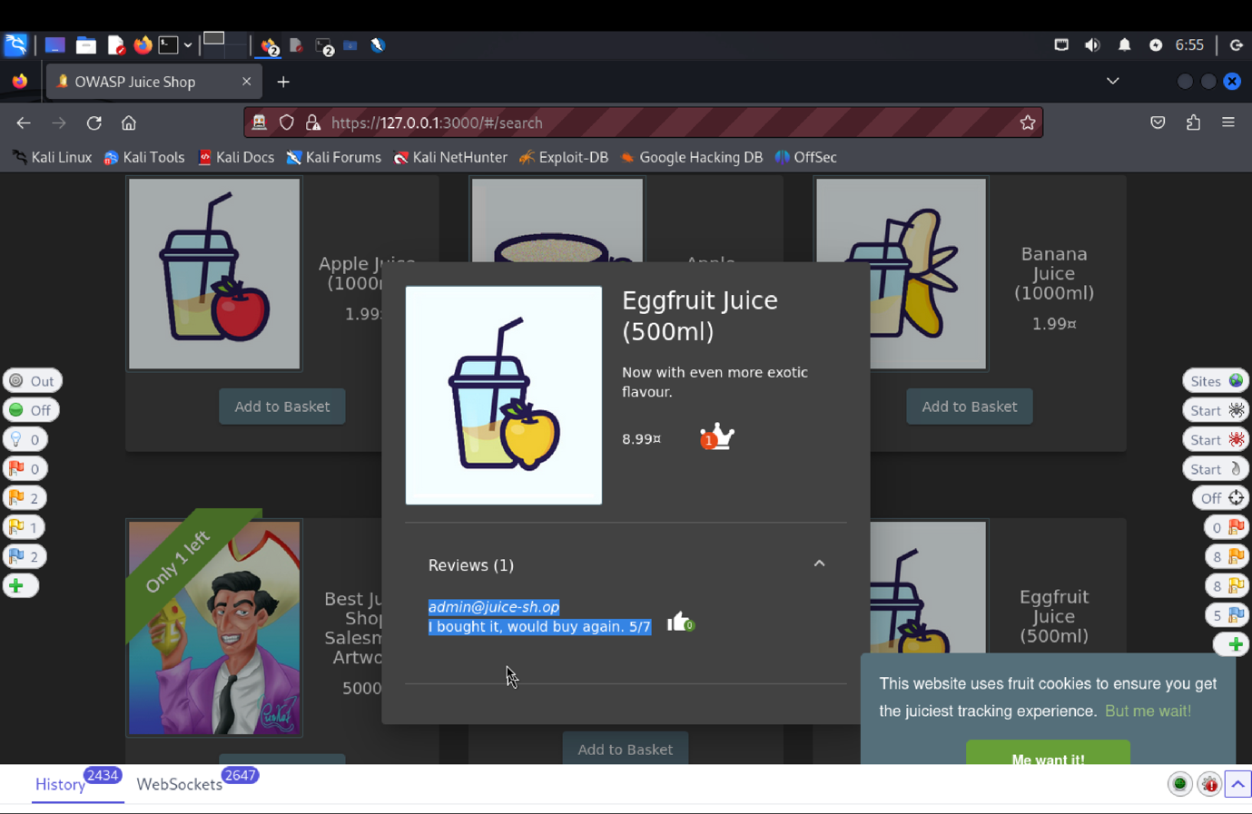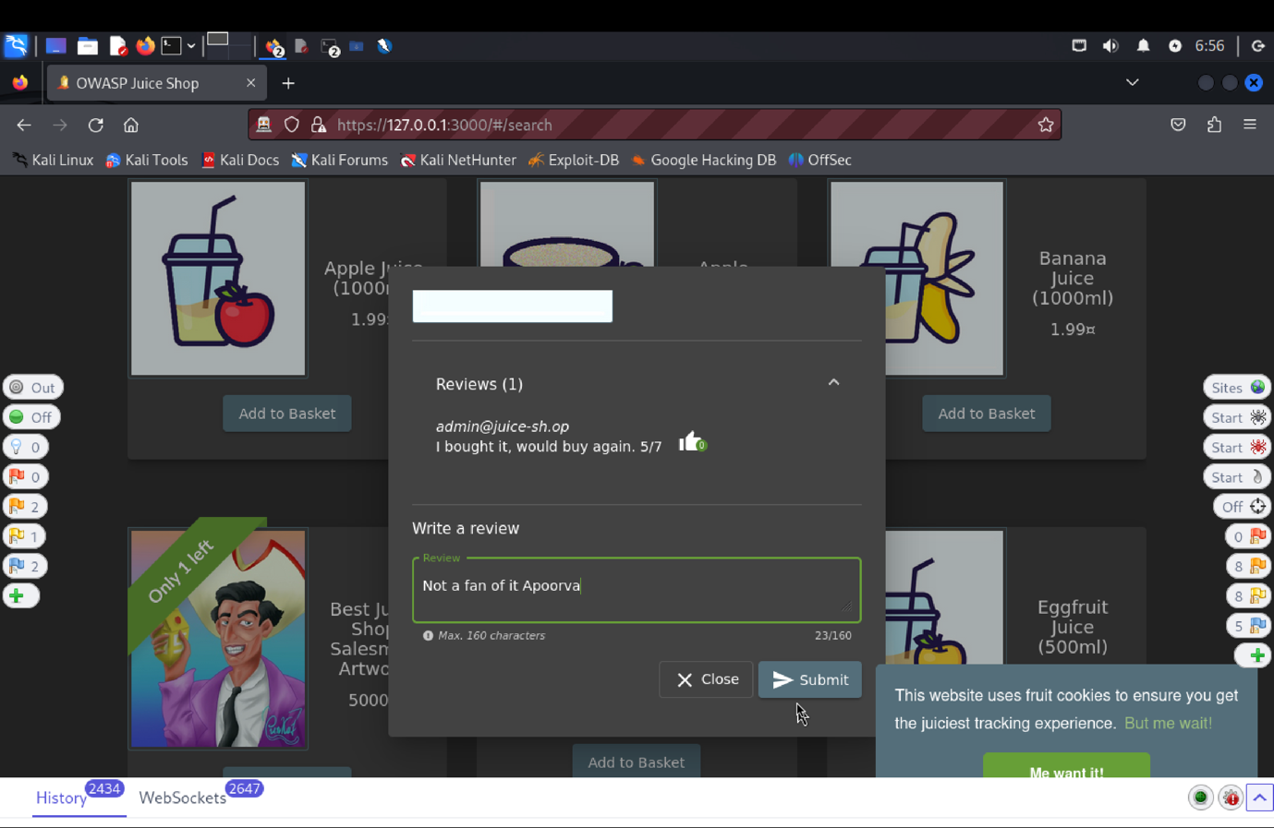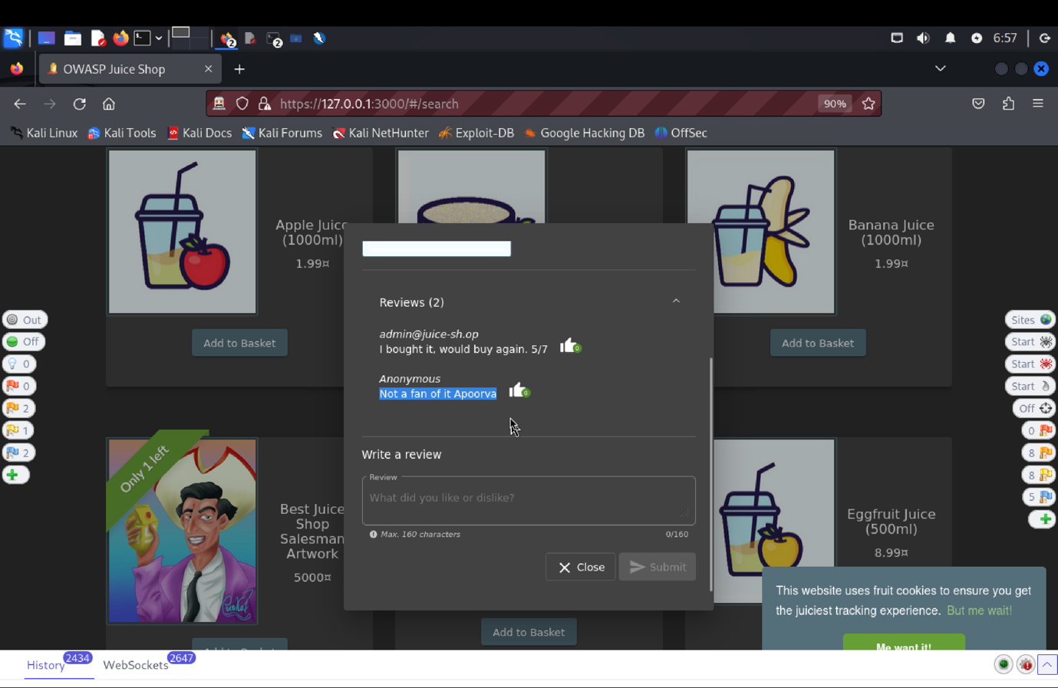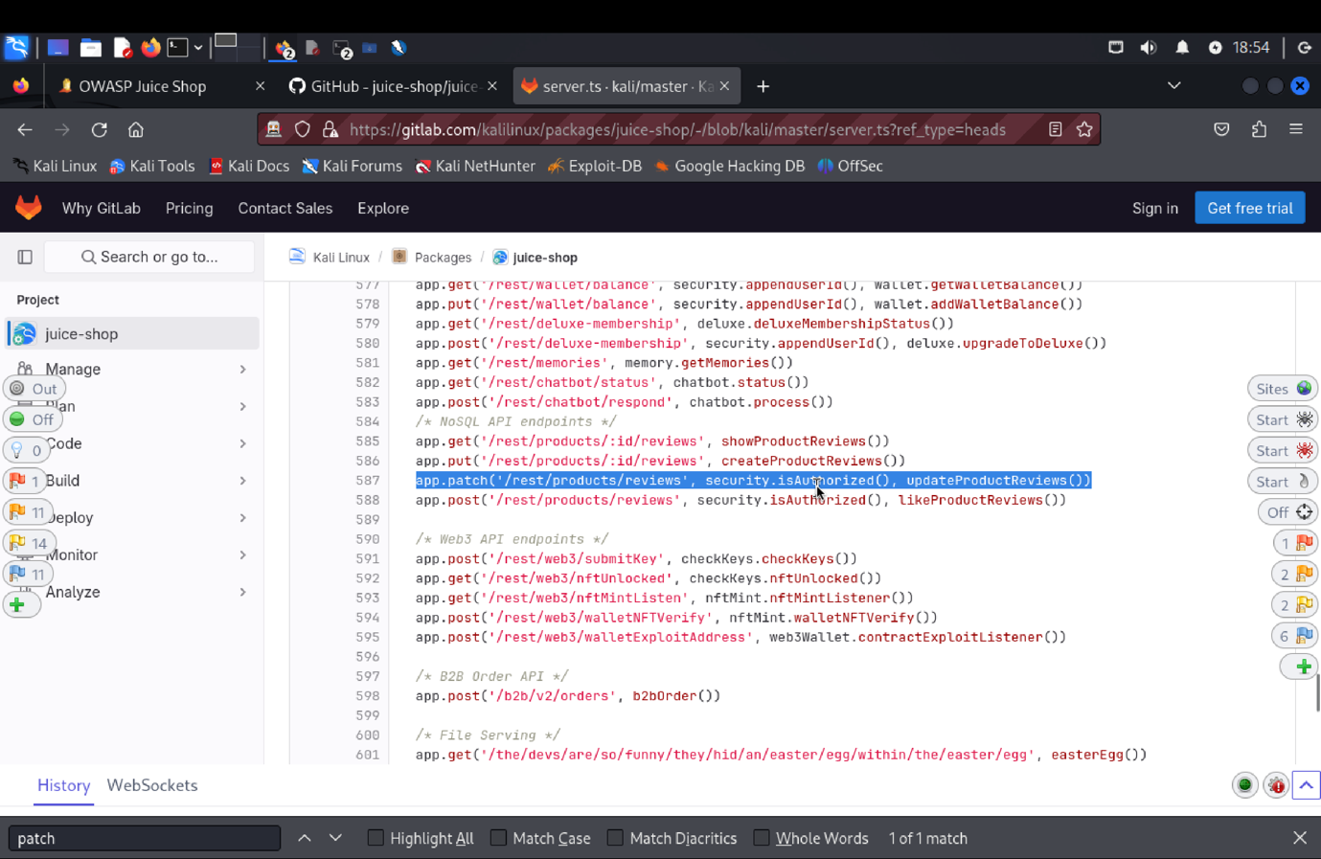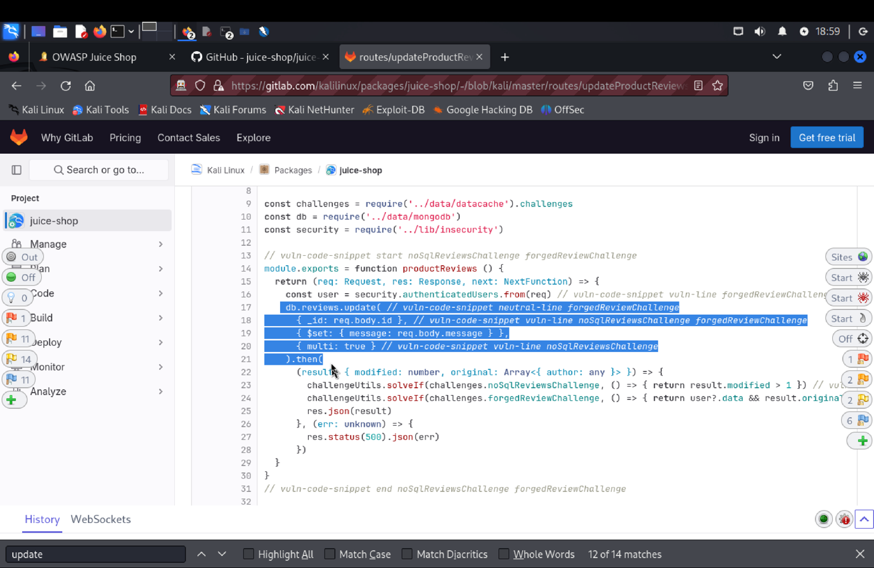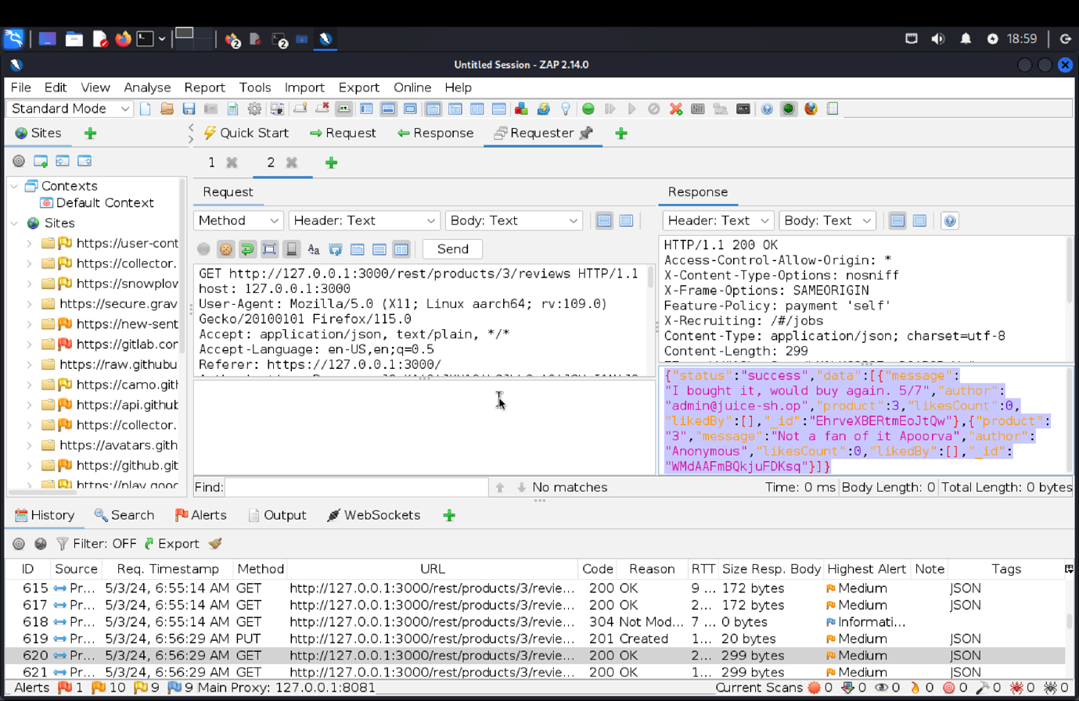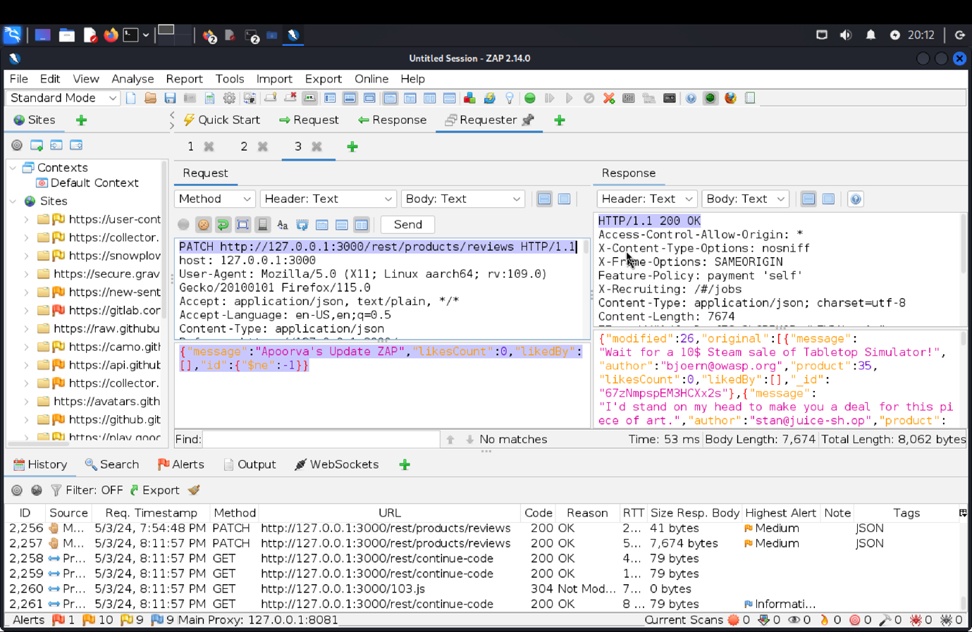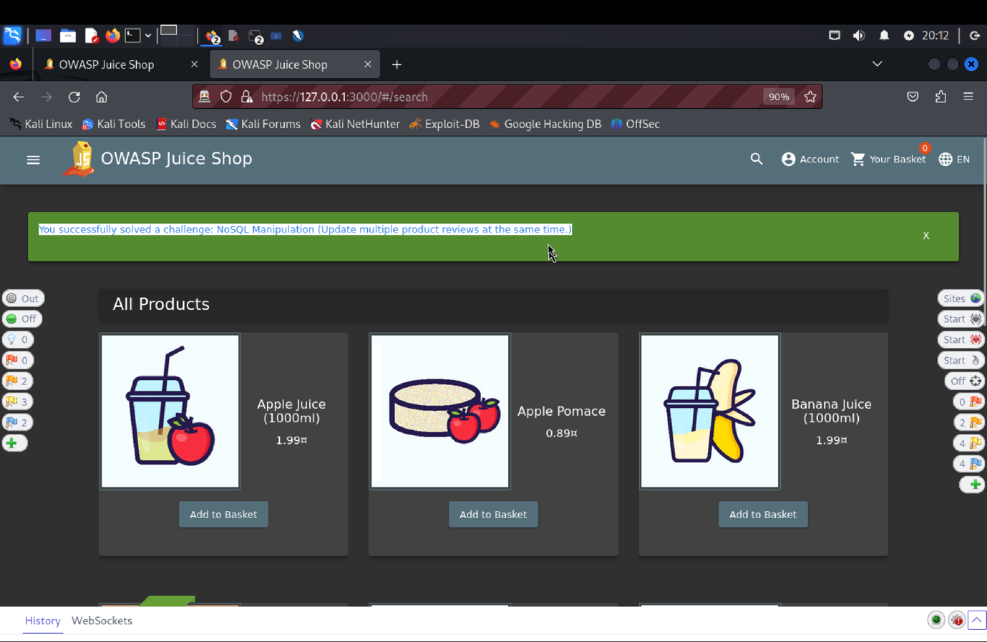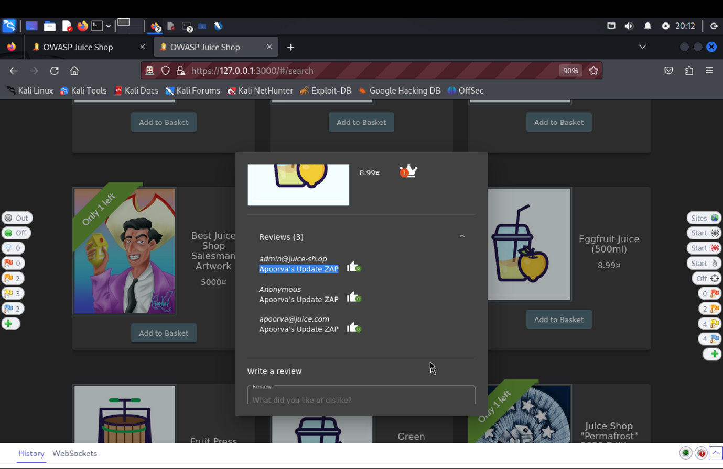

1. **Explanation of how the evidence included in (b) proves that FDP_ACC.1.1 is violated:**

At first, we added a review to an Apple Juice product and signed in using an already-existing email address. We were able to change several reviews by locating an API endpoint in the server.js code (app.patch('/rest/products/reviews', security.isAuthorized(), updateProductReviews())). We tested a NoSQL modification vulnerability by creating a PATCH request with this endpoint and setting the message field to "Not a fan of it Apoorva" for all reviews. This revealed that the SFR (Security Functional Requirement) had been broken.

**2. DOM XSS (Document Object Model): Perform a *DOM* XSS attack with <iframe src="javascript:alert(`xss)">.**

1. **Description of penetration testing that was carried out.**
2. In the score-board find XSS Dom, under hint find DOM payload which is <iframe src="javascript:alert(`xss)">.
3. This is of great help because this payload can be used to probe XSS vulnerabilities.
4. Copy/paste the payload in juice shop search box and press enter.
5. This instantiates a pop-up box with XSS written inside it.
6. Open inspect and inside page elements search for XSS.
7. A successful DOM XSS attack is performed.
8. **Outcomes/Evidence of Penetration Testing**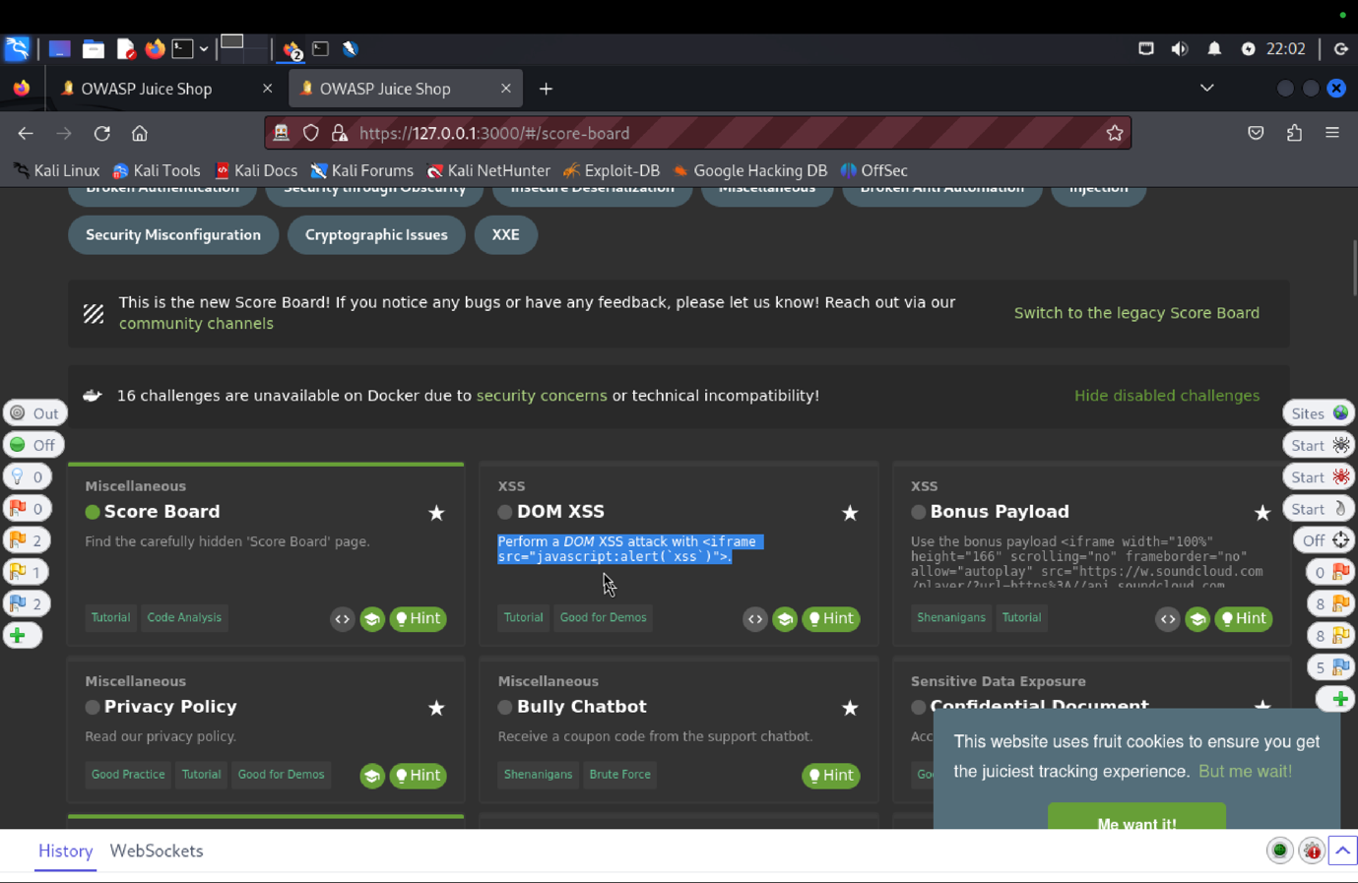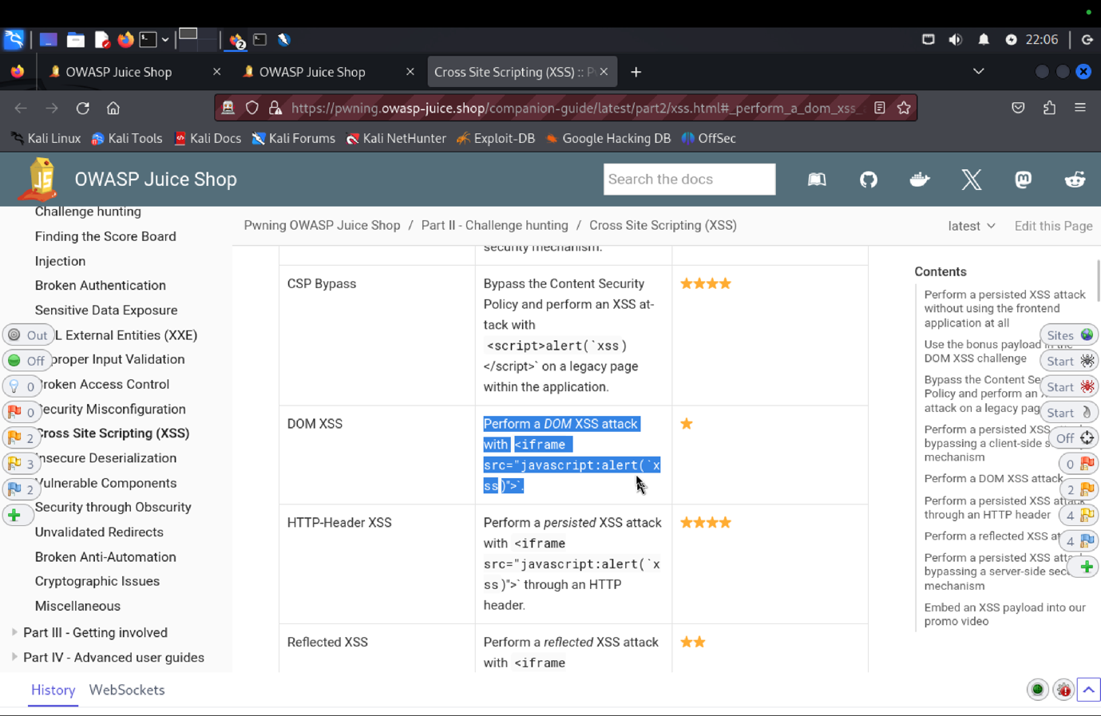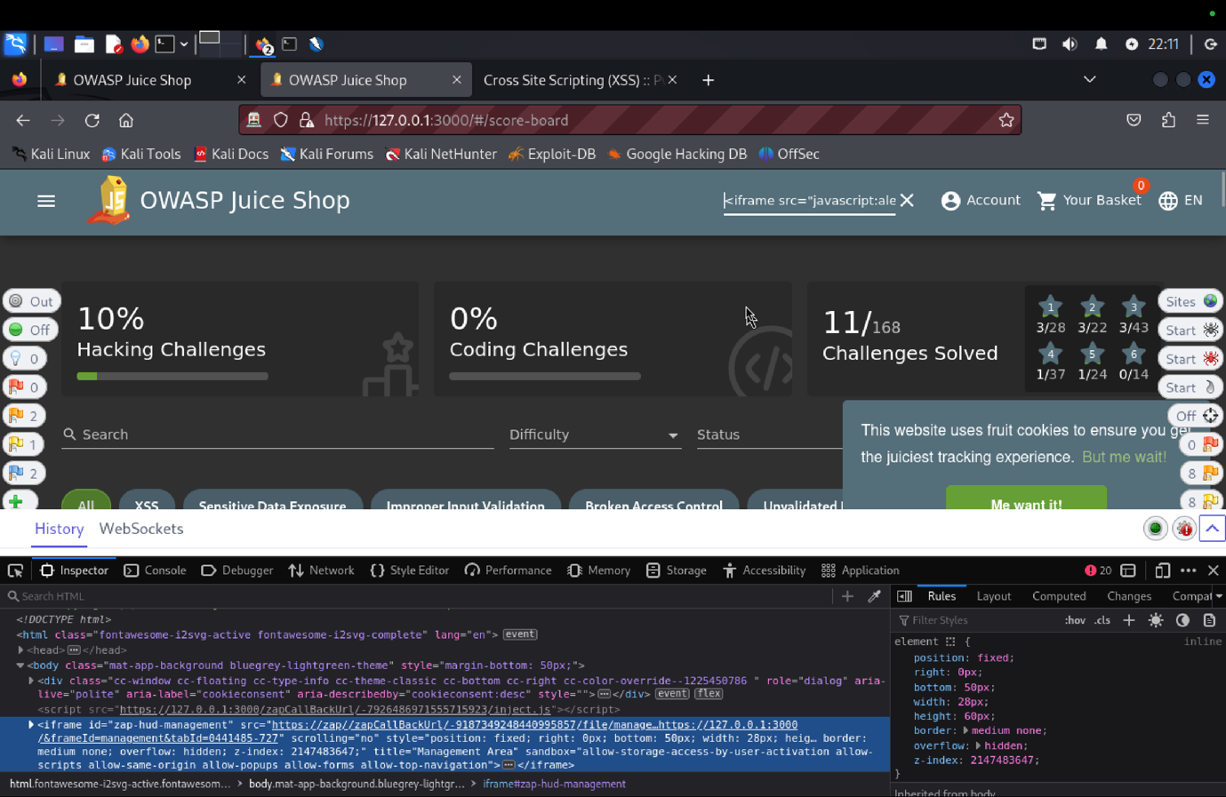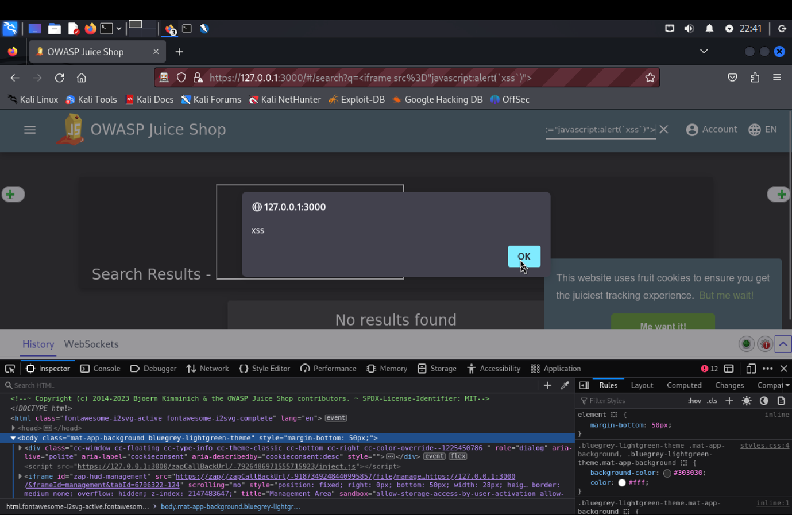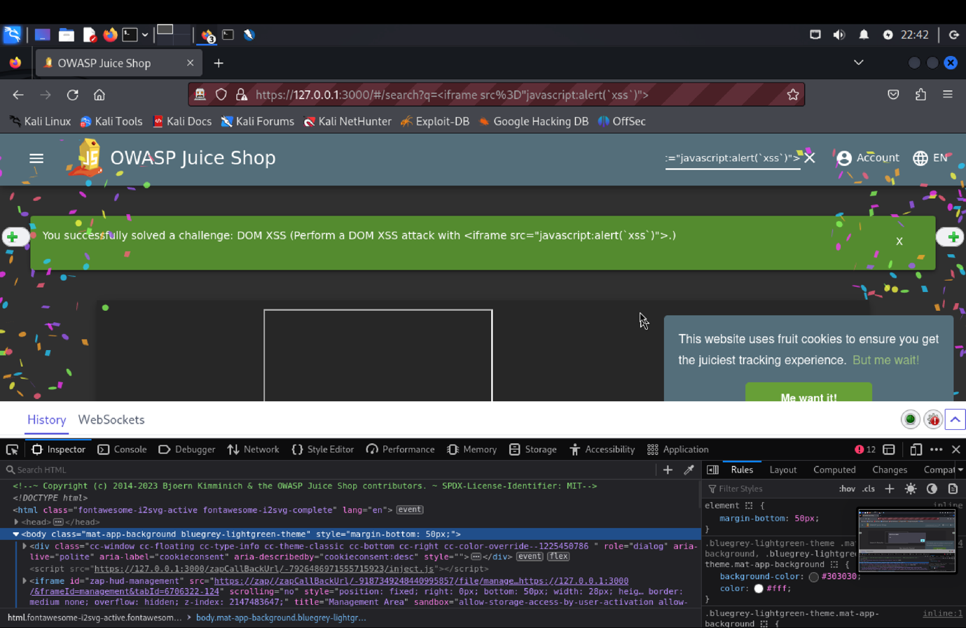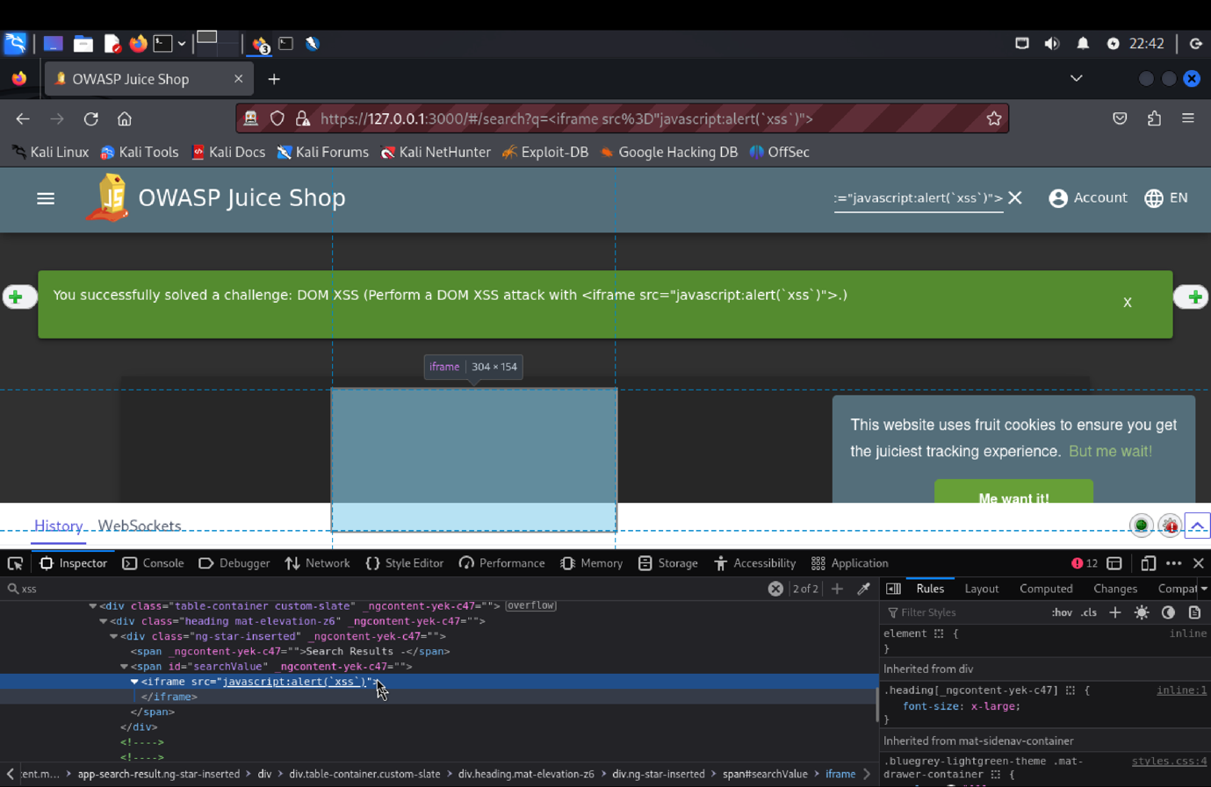
9. **Explanation of how the evidence included in (b) proves that FDP_ACC.1.1 is violated:**

For looking into XSS vulnerabilities, the payload proved useful which we found in score-board. When we entered this payload into the Juice Shop search field, a pop-up box with the message "XSS" appeared. By examining the page elements, we were able to confirm the existence of the XSS and the success of the DOM XSS attack. This revealed a potential security risk and exposed a weakness in the Security Functional Requirements (SFR) pertaining to input validation